


  - Signal Labs Talent New User Fundamentals
User Guide

Release Date: March 2020

The information contained in this document is the property of Signal Labs Talent Inc. Except as specifically authorized in writing by Signal Labs Talent Inc, the holder of this document shall: (1) keep all information contained herein confidential and shall protect same in whole or in part from disclosure and dissemination to all third parties and, (2) use same for operating and maintenance purposes only.
The information contained in this document is the property of Signal Labs Talent Inc. Except as specifically authorized in writing by Signal Labs Talent Inc, the holder of this document shall: (1) keep all information contained herein confidential and shall protect same in whole or in part from disclosure and dissemination to all third parties and, (2) use same for operating and maintenance purposes only.

The information contained in this document is the property of Signal Labs Talent Inc. Except as specifically authorized in writing by Signal Labs Talent Inc, the holder of this document shall: (1) keep all information contained herein confidential and shall protect same in whole or in part from disclosure and dissemination to all third parties and, (2) use same for operating and maintenance purposes only.
The information contained in this document is the property of Signal Labs Talent Inc. Except as specifically authorized in writing by Signal Labs Talent Inc, the holder of this document shall: (1) keep all information contained herein confidential and shall protect same in whole or in part from disclosure and dissemination to all third parties and, (2) use same for operating and maintenance purposes only.

Table of Contents

Introduction 7
Chapter 1: Getting Started 8
Chapter Overview: 8
Objectives: 8
Accessing and logging in to BrassRing 9
Complete the addresses for your Talent Suite sites here: 9
Accessing Talent Suite 9
Password Protection 10
Forgot Password? 10
Preparing to Use BrassRing within Talent Suite 10
Browser Support 11
Clearing Your Cache 11
Clearing Your Cache – Internet Explorer 11
Clearing Your Cache – Google Chrome 12
Clearing Your Cache – Firefox 12
Navigating within BrassRing 12
User Types 12
BrassRing Home Page 13
Persona Groups 14
Quick Search 15
Welcome Message 16
Quick Links 16
BrassRing Support Community 17
Chapter 2: Managing Reqs 21
Chapter Overview: 21
Objectives: 21
Overview of Reqs 22
Navigating within BrassRing 22
Life Cycle of Reqs 22
Initiating a Req 23
New Req 24
Elements of the Req 25
Approving or Declining a Req 32
Chapter 3: Talent Gateways 42
Chapter Overview: 42
Objectives: 42
Overview of Talent Gateways 43
Types of Talent Gateways 43
Elements of Talent Gateways 43
Posting of Talent Gateways 44
Pre-qualifying Questions 46
Posting a Req to the internet 47
Chapter 4: Routing & Processing Resumes or CVs 52
Chapter Overview: 52
Objectives: 52
Overview of Resume or CV Routing 53
Overview of Candidate Submission 53
Elements of Candidate Submissions into BrassRing 53
Candidate’s Experience with Talent Gateways 54
Overview of Recruiter Submission into BrassRing 59
Elements of Recruiter-based Submissions 59
Stacking Duplicate Talent Records 61
Candidates in Queue & Referrals in Queue 62
Using Codes to Track Resumes or CVs 63
Erase a Candidate or Candidate Application 64
Chapter 5: Screening Candidates 68
Chapter Overview: 68
Objectives: 68
Overview of Output Grid 69
Output Grid Management 69
Elements of Output Fields and the Output Grid 69
Candidate Notes 73
Initiating HR Status 76
Candidate Tiers 79
Chapter 6: Tracking Candidates 85
Chapter Overview: 85
Objectives: 85
BrassRing Forms 86
Elements of Forms 86
eLinking Candidates 88
What is an eLink? 88
Elements of an eLink 89
Sending Communication 93
Elements of Communication 93
Document Template 100
Create a document for candidate 100
Candidate Zone 102
Chapter 7: Closing the Hiring Cycle 109
Chapter Overview: 109
Objectives: 109
Continuing the Hiring Cycle 110
Final Disposition 110
Closing a Req 111
Canceling a Req 112
Chapter 8: Getting Organized 115
Chapter Overview: 115
Objectives: 115
Overview of Folders 116
Benefits of Organizing with Folders 116
Understanding Folder Types 116
Chapter 9: Searching for Candidates 125
Chapter Overview: 125
Objectives: 125
Quick Search 126
In Name Search 126
Overview of Candidate Search Screen 127
Elements of Search 127
Elements of Search Fields 128
Running a Search 128
Candidate Types 129
Initiating a Search 129
Filing to Folders 135
Attaching Candidates to Reqs 137
Appendix A: Standard Reports 142
Appendix Overview: 142
Objectives: 142
BrassRing Standard Reports 143
Categories of BrassRing Standard Reports 143
Elements of BrassRing Standard Reports 144
Running BrassRing Standard Reports 144
Reports Queue 148
Appendix B: Scheduling Interviews 151
Appendix Overview: 151
Objectives: 151
Scheduling Interviews 152
Elements of Scheduling 152
Appendix C: Managing Talent Comparison Profiles 155
Appendix Overview: 155
Objectives: 155
Talent Comparison Summary 156
Check Your Skills Answer Key 158

Introduction

Welcome to New User Fundamentals for BrassRing and Talent Gateways on Talent Suite

About This Course
This course and workbook provide an introductory walk-through of BrassRing from the perspective of “A Day in the Life of a Recruiter.” You work with reqs, organize your folders, search for candidates, and track candidates through your hiring process. You find tips for navigating successfully and shortcuts for working more efficiently with BrassRing.
BrassRing is a highly customizable Talent Management solution. Reqs, forms, and HR Actions are some of the tools that were customized for your company’s process. It is likely that the examples in this workbook look a little different from your company’s own BrassRing site.

About BrassRing Training
This course is the first step in becoming proficient in using BrassRing on Cloud. We encourage you to take advantage of online Help available within BrassRing and pursue additional training opportunities. Signal Labs Talent Management Solutions offers several tools such as instructor-led and self-study courses to help support your company’s specific learning needs.

Chapter 1: Getting Started

Chapter Overview:

Before we start creating reqs and managing candidates, it is important to dedicate time to some basics. BrassRing is a web-based application. In other words, it is accessed from a web browser and run over the internet.

This first chapter focuses on accessing, logging in to, and basic navigation within BrassRing through your Talent Suite site.

Objectives:

At the end of this chapter you can:

- Log in to BrassRing from Talent Suite.
- Navigate through BrassRing.

Accessing and logging in to BrassRing
Accessing BrassRing is similar to accessing any site on the internet. Type in the web address and the browser takes you to your requested destination.

Your organization has two BrassRing sites: one used exclusively for testing and training that is called a staging site and one for real, day-to-day recruiting called a production site.

Complete the addresses for your Talent Suite sites here:

The staging site URL, used for training and testing only is:
https://2x-staging.kenexa.com/wps/portal/$tenant/CLIENTID/SWF/login

The production site URL for actual, day-to-day recruiting is:
https://2x.kenexa.com/wps/portal/$tenant/CLIENTID/SWF/login

Note: The CLIENTID in the URL is what is unique to your organization.

Accessing Talent Suite
- Open your browser and enter your company’s unique address as shown in Figure 1-1.
- Press Enter on your keyboard. This takes you to the Talent Suite log in page where you enter your username and password. See Figure 1-2.

Figure 1- 1: Entering your Talent Suite address

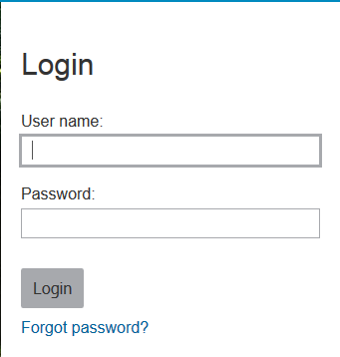
Figure 1- 2: Talent Suite log in page

Password Protection
Your company might have decided to apply certain password protection options to Talent Suite.

- For training, you always log in to your company’s staging site.
- It is best practice to click the Forgot password link on the log in page if you have unsuccessfully attempted to log in to BrassRing twice. This prevents you from being locked out, as you can reset your password by using the email that you receive. Note: This does not apply if you use Single-Sign-On (SSO).

Forgot Password?
If you have forgotten your password, the only way to regain access to your account is by clicking the link marked Forgot Password? This link is found on the Talent Suite log in page. Refer to Figure 1-2. To reset your password:

- Click the Forgot password? link (see Figure 1-2) and enter your username.
- Open the Password Recovery email that you receive.
- Use the link marked “Click here to reset your password” to create a new password.
- Signal Labs Talent Talent Representative cannot provide usernames or passwords. Should you forget your password, use the Forgot Password? link on the log in page to reset your password. If you need your username, contact your system admin (Super User).

Preparing to Use BrassRing within Talent Suite
To take maximum advantage of BrassRing, do a quick check to ensure that your computer and browser are configured with the appropriate desktop and browser settings. If attempts to use BrassRing are troublesome, you are encouraged to first walk through these steps before seeking additional help.

Browser Support
Web browsers should be configured to accept cookies and allow popups, with browser security settings set to medium or lower. Alternatively, the applications can be added to the trusted sites list for the browser.
- Full Support | - Limited Support | - Mobile Devices Limited Support
- IE11 | - IE9 | - Android 4.4, 5+ (incl. support for mobile Chrome browser on Android)
- Firefox 38ESR+/47+ |  | - iOS 8+ (incl. support for mobile browsers Safari, and Chrome on iOS.
- Safari 5, 6, 8 and 9
- Chrome 43, 52+ |  | - Mobile Devices
Table 1-1: Browser Compatibility

More details about Support Browsers can be found on the Signal Labs Talent Knowledge Center.

- Because BrassRing is a Windows-based application, make sure to turn off your browser’s pop-up blocker for your BrassRing site.
- Your desktop might already be set up properly with colors; however, pixel size can be edited to allow for proper text size within BrassRing. This addresses an unnecessary scrolling up and down to read text on a page.

Clearing Your Cache
Your browser's cache stores the contents of all the web page addresses that you have visited during a session. To ensure that you have the most updated information within BrassRing, follow the steps noted below.

Clearing Your Cache – Internet Explorer
Have you ever clicked a link to a website and found that the page did not load completely? Perhaps graphics failed to appear, or the page seems to be frozen?

Your browser retains within its memory, or cache, all the different pages you visit when navigating through different websites. The previously mentioned issues are symptomatic of your cache being full. By taking a minute to clear your cache once a week, you ensure pages both within BrassRing and other websites load properly.
To clear the cache for Internet Explorer (might vary depending on the version of your IE Explorer):

- From the Internet Explorer menu bar, click Tools internet Options.
- Click the General tab.
- Under Browsing history, click Delete.
- Click OK.

Clearing Your Cache – Google Chrome
To clear the cache for Google Chrome:

- Open the Google Chrome browser and navigate to the Customize and Control Google Chrome menu.
- Select Settings * Advanced * Clear browsing data.
- From the Clear browsing data page, you can clear the Browsing history, the Cookies, other site data, and Cached images and files. Make your selection and click the Clear data button.

Clearing Your Cache – Firefox
To clear the cache for Firefox:

- Open the Firefox browser and navigate to the Tools menu (for Windows users) or the Firefox menu (for Mac users).
- View the drop-down menu display and choose Options (for Windows) or Preferences (for Macs). A new dialog box appears.
- Click the Privacy icon to get to the cache options. Now you can click the 'Clear Now' button.
- A drop-down box appears with numerous checkable boxes. Check Cache and press the Clear Private Data Now button.
- Press the OK button (Windows) or simply close the preferences box (Mac). Your cache is now cleared.

- If your cache is not clearing properly, you might not see database updates that you made a few minutes before, or your forms might not display properly.

Navigating within Signal Labs Talent
Now that we have setup your computer and browser, we briefly review the user type access within BrassRing.

User Types
User types define the functions that one has access to within BrassRing, assigned in accordance with the roles and responsibilities of those individuals that use BrassRing within your company. BrassRing administrators, sometimes referred to as Super Users, designate these user types. Because of this, there might be features that are included in this workbook to which you do not have access.

BrassRing Home Page
The BrassRing home page is mobile responsive with a landing portal that improves your work experience. This section provides a brief overview of how to navigate to the BrassRing section of Talent Suite, and what is common within each area you can access from the home page portal itself.

Once you log on to Talent Suite, click the following Hiring icon to access BrassRing.


The BrassRing Homepage appears (Figure 1-3).

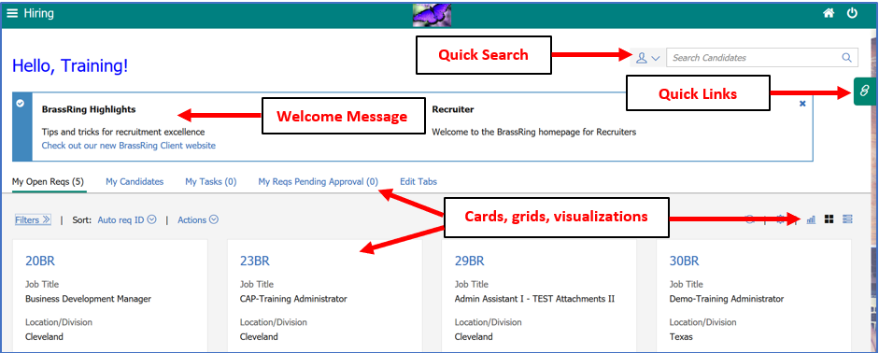
Figure 1- 3: BrassRing home page
Req info is now listed on the Filter section of the candidate listing screens. Users can switch between requests (Figure 1-4).

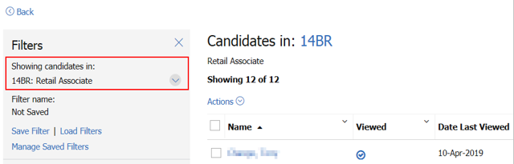
Figure 1- 4: Req Details in Candidate Listing

Persona Groups
The home page is designed to display cards, grids, visualizations, and welcome messages specific to five different personas:

- Recruiter
- Hiring Manager
- Administrator
- HR User
- Reporting / Analytics
The BrassRing home page user experience is based on persona designation. Each persona provides the users with the view of the data that works best for them. Users can personalize the view of the home page depending on their day-to-day tasks and needs.

Additional Elements to Consider:
- The HR Status Categories must be mapped in order for visualizations to work on the home page and within the req folders.
- Based on configuration and appropriate privileges, the home page for users with recruiter persona displays information specific to their requisitions in individual containers. The containers come with multiple view options and the provisions to refresh and update data in them.
- Users can switch to grid view and to visualizations (Figure 1-5) that provide pictorial representation of the data about time to fill and req aging.
- You might add up to 20 fields for display in the My Open Reqs grid views.

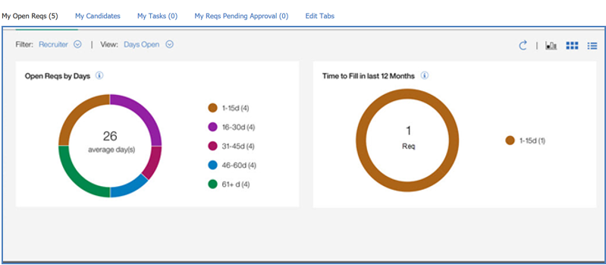
Figure 1- 5: BrassRing home page

The overall view defaults to My Reqs and the Card View by personas are as follows:
- Recruiter – Req #, Job Title, Location, Department, Posting icon, New, and Total Candidates.
- Hiring Manager – Req #, Job Title, Location, Department, Recruiter, New, and Total Candidates.
Note: Currently, your Workbench administrator can configure different default fields for the My Open Reqs card and grid views, and the My Candidates grid view that only applies to any new users to BrassRing. The Recruiter persona is used for the remainder personas, which is updated with persona-specific configuration in future Releases.

A quick view of information can be found under the following links:
- All Open Reqs – details about all open reqs (typically for BR Admins).
- My Open Reqs – details about open reqs for which the user has a ‘My’ relationship.
- My Candidates – details about candidates who applied to My Open Reqs.
- My Tasks – pending approvals of req and candidate form; users open the tasks tab to complete their tasks right from the home page. Refer to Figure 1-6. It can also provide access to HR Status Aging, which provides the user with visual indicators for acceptable (green), cautionary (yellow), and unacceptable (red) based on the number of days a candidate has been assigned to an HR Status. The HR Status Aging feature is enabled in Workbench.
- My Reqs Pending Approval – details about reqs with pending approval for which the user has a ‘My’ relationship.

Note: Edit Tabs allows each user the select what view of links they prefer to show on their home page. Refer to Figure 1-6.

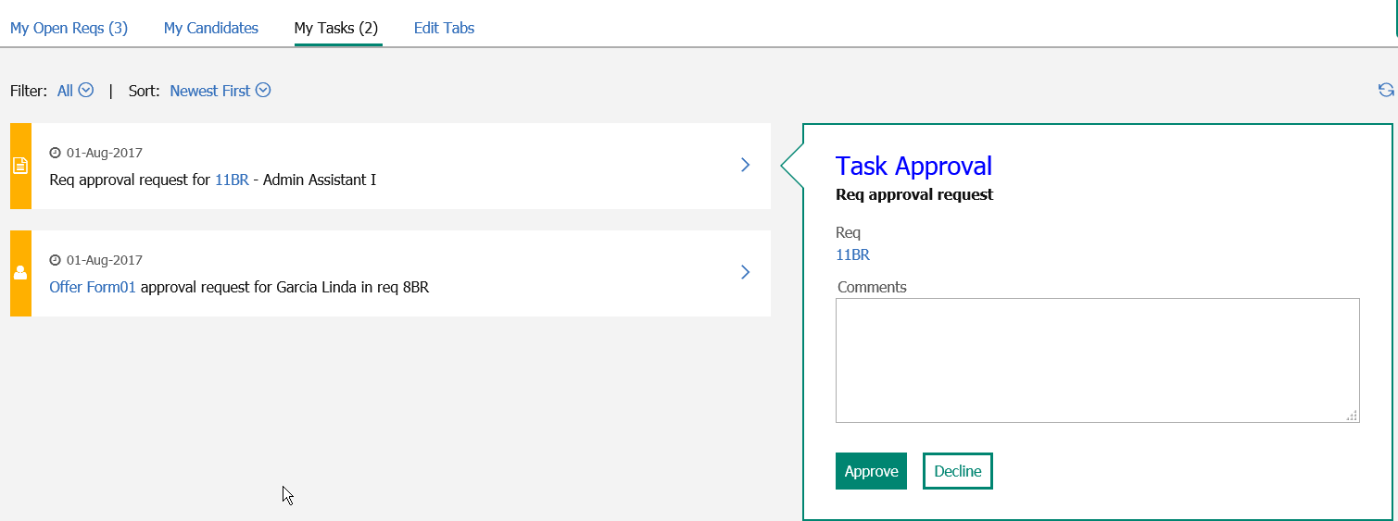
Figure 1-6: My Tasks

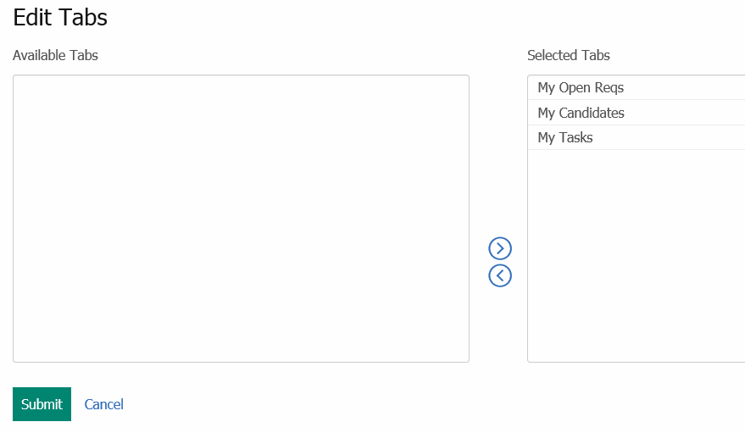
Figure 1-7: Edit Tabs

Quick Search
Quick Search is available on the home page and other internal pages in BrassRing. You can quickly search for candidates, reqs, or candidates in reqs. Refer to Figure 1-8.
To run a Quick Search:

- Select the type of search by clicking on the drop-down arrow icon .
- Depending on the type of quick search you want to complete, you enter the Candidate name, Req ID, or Candidate name within specific Req in the search field.
- Click the Search icon .
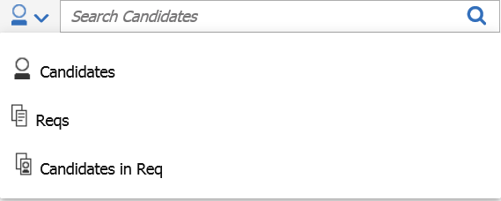
Figure 1-8: Quick Search

Welcome Message
Two welcome messages can be presented to the users on the home page: client message and Signal Labs Talent message. The client message is customizable by the Administrator to include important internal company updates. The Signal Labs Talent message is a system message that might include details about releases, maintenance, etc. Clients can turn-off either one or both messages. Home page administration allows you to configure the client messages and associate each message with one or multiple personas. For example, if a client wants recruiters to take a specific action, the message can be configured and only displayed for the recruiter persona.

When users read the message and select X to close the message, the message is dismissed and no longer displays. If either message is updated the next time the BrassRing user logs-into BrassRing, the new message displays.

Quick Links
The Quick Links panel provides links to external or internal websites. Refer to Figure 1-8. Your user type access defines what hyperlinks are defaulted for you. To access the Quick Links panel, click the Quick Links icon  . Each user can use the Edit Links button to add additional links to the Quick Links panel.
Note: The Quick Links panel is accessible from the home page and other internal pages.

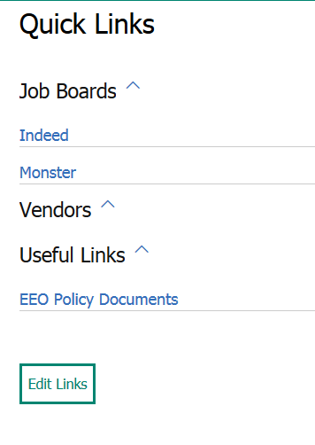
Figure 1-9: Quick Links

The following table describes the icons and links available on the Hiring Navigation icon  .

Icon or Link |  | Description
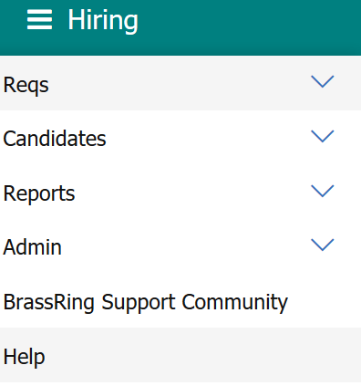 | - Hiring – Click here to expand or close the navigation menu.  - Reqs – Click here to access requisitions.  - Candidates – Click here to access candidates, folders, run candidate searches, access saved searches, candidates in queue, and To Do’s.  - Reports – Click here to run, schedule, and administer report schedules.  - Admin - Click here to access Administrator features.  - BrassRing Support Community - Click here to display resources available to you on the BrassRing Support Community. This website provides user documentation, information on training, user groups and events, announcements, and other valuable information about talent management.  - Help – Click here to load the Knowledge Center, which contains user documentation and training material for Signal Labs Talent Talent Management Solutions and Watson Talent.

BrassRing Support Community
The BrassRing Support Community is an online resource providing information for users of BrassRing. To access the Signal Labs Talent Support Community, click BrassRing Support Community on the Hiring menu.
Some of the elements of the BrassRing Support Community include:

- Support: View FAQs and provide feedback on BrassRing and suggestions for new functions.
- Talent Management: Learn about ways in which companies are using Signal Labs Talent products and services to further their staffing vision.

Chapter Summary
- It is important to confirm that your computers and web browsers are configured with the appropriate desktop settings and browser requirements.
- Your super users might provide assistance with usernames; Signal Labs Talent Talent representatives cannot.
- When using BrassRing, you should open only one browser.

Check Your Skills
Answer these True or False Questions:
- If I forget my password, I can ask Signal Labs Talent representative for that information.
- To clear my computer’s cache, I access the BrassRing Support Community.

Select the best answers:
- The following information is available on the BrassRing Support Community:

- Signal Labs Talent course offerings
- Signal Labs Talent Quick Reference Guides (QRGs)
- Self-Study Courses
- All of the above
- None of the above

Chapter 2: Managing Reqs

Chapter Overview:

At most organizations, recruitment begins with the creation of a job requisition (req) form. The Reqs module within BrassRing helps your organization manage the entire lifecycle of a req, from creation and approval to posting to your company’s website and more. Using BrassRing, your req process is streamlined and efficient.

This chapter focuses on managing reqs, the typical first phase of the recruiting process.

Objectives:

At the end of this chapter you can:

- Navigate through lists of reqs.
- Recognize the various lifecycle statuses of reqs.
- Access and complete a req form.
- Save an incomplete req form as a draft to allow you to complete later.
- Approve or decline a req that is sent for online approval (optional feature).
- Review a req Addendum form (optional feature).
- Search for a req.
- Open a req.
- Evergreen req.

Overview of Reqs

Navigating within BrassRing
To access reqs, click Reqs from the Hiring Navigation icon (refer to Figure 2-1). From here you can add, search for, or view a list of reqs that are assigned to a certain req lifecycle status-such as Open or On Hold.
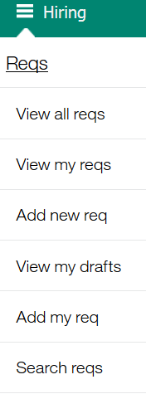
Figure 2- 1: The reqs menu
You might have access to view all reqs in BrassRing (View all reqs) or only those reqs that you are associated with (View my reqs). Reqs appearing within your My reqs option are those reqs that you created, were selected as the recruiter on the req form, were selected as a req team member on the req form, and were named as the Hiring Manager. Although many organizations do not need their hiring managers to log in to BrassRing, as they use eLink technology to manage reqs and view resumes or CVs.

- An eLink is an email message that is sent from BrassRing embedded with a hyperlink to a req, resume or CV and candidate form. More to come in Chapter 6: Tracking Candidates.
- If your organization is not using the online approval routing features of BrassRing, the req skips the Pending status and is automatically assigned to the Approved lifecycle status after it has been created.

Life Cycle of Reqs
In BrassRing, a req typically goes through at least four different stages. Here is a typical progression:

Pending → Approved → Open → Closed

A req can also be assigned to the stages of On Hold, Cancelled, Deleted, or Declined.

Below is a description for each stage of a req:

Pending req- one that has been created and is in the process of being approved online, as defined by your company’s specific approval process.

Approved req- has received every required approval. When the final approval is granted, BrassRing automatically updates the status of the req from Pending to Approved and sends an email to the recruiter, who might open (and post) the req.

Open req- is available for recruiting. The approved req is moved manually to the open status (typically by the recruiter) by using a link within an email they receive once the final approval has been granted. Once opened, BrassRing automatically generates a req folder that is used to track candidates for the job. The req can be posted by the recruiter to your corporate website by using a Talent Gateway or to a job board on the internet. Lastly, when the req is opened, the time to fill clock begins counting.

Closed req- has been filled.

On Hold req- needed to be temporarily suspended. Doing so pauses the counting of days that the req is considered open. The req is also unposted from any Talent Gateways it was previously posted to.

Cancelled req- is no longer recruited for due to reasons such as budget constraints, headcount changes, or job level changes. Your organization defines when a req should be cancelled. Cancelling a req unposts that req from any Talent Gateways it was previously posted to.

Deleted req- used infrequently, when a req was entered erroneously. Typically, only Super Users can delete or reinstate a req. Deleted reqs are not truly deleted but instead moved to a Deleted status. They remain stored within BrassRing.

Declined req- was declined during the approval process. Reqs might have an accompanying Addendum form, allowing the person who declined to indicate the reasons why they declined the req.

- From On hold, a req might be moved to the stages of Open, Closed, Cancelled, or Deleted.

Initiating a Req
Now that we have some background information on navigating through the Reqs menu, we can discuss how a req is created.

BrassRing offers five methods to initiate and complete a req. Of the five ways, two take place within BrassRing, and three happen outside of BrassRing.

Select the ways in which your company is going to initiate reqs:

- A recruiter logs in to BrassRing to add a new req.
- A recruiter logs in to BrassRing and uses eLink blank req to send a blank job requisition form to a hiring manager, who then completes it.
- A hiring manager goes to your company’s intranet and accesses a blank req form by clicking a hyperlink.
- A hiring manager goes to your company’s intranet and requests that a blank req form be sent to their email address by using the eLink blank req functions.
- Your company imports completed reqs from your HRIS into BrassRing.

- If you are creating a multi-language req, you might select or deselect checkboxes for each language to create the req in, and toggle between each hyperlinked language.
- An eLink is an email message that is sent from BrassRing embedded with a hyperlink to a req, resume or CV and candidate form. More to come in Chapter: Tracking Candidates.

New Req
Below are steps for adding a req from within BrassRing.

Adding a Req
- From the Hiring Navigation icon , click Reqs Add new req. Your company might have multiple req templates to choose from. If so, choose the template you want to complete and you are taken to that particular form.
- If you are using more than one language, select the languages for the requisition.
- Select Add new.
- To access the list of Job Codes, type the job title or job code into the job code field. Choose the job code that matches the position.
- Using the text editor, customize the Job description field.
- Select a Recruiter and a Manager. Make one selection for each.
- Confirm the value appearing for the Number of Positions field.
- Complete the remaining fields for the req.
- Choose any Req Team members.
- If applicable to your company, select the appropriate Approval Routing for your req.
- Notify Upon Approval Completion - This field indicates who receives an email once all approvals were received for the req. Typically, the recruiter is selected here, as they are responsible for posting the req. The email includes a link to post the req.
- Click Save and continue>>. This allows you to enter an email message to (only) the first approver and (if wanted) the Req team. To copy the Req team, click the CC: req team checkbox.

- During training, be sure to select only users who are part of the training as a Recruiter, Manager, and Req Team Members.
- Any field with a red asterisk (*) is required.
- When adding a req, some fields might be read only, meaning they cannot be edited.

Elements of the Req
The req form that you complete not only includes standard fields, such as job title and location, but also has custom fields to fit your company’s needs. Below we discuss some of the fields on your req form.

Job Codes
In selecting a pre-defined job code, you are also selecting its associated job title and oftentimes its job description. In addition, your company might have chosen to associate other information with the Job code, such as a specific job grade. In short, when you select a Job code, some or all the fields on your req form might populate with such pre-defined information. The process is referred to as Job Code Default Data (JCDD). See Figure 2-2 regarding the selection of a Job code.

- If you would like to select a different job code, click job code on the req form, and select another job code. Making a new selection from the req form might or might not update the pre-defined information, depending on your organization’s configuration.
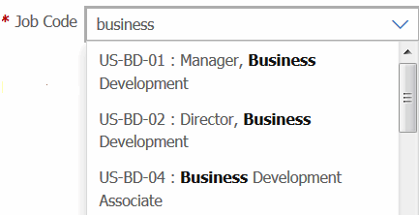
Figure 2- 2: Selecting a job code
- Click Edit req to make changes to a req form. Track any changes in the Req notes field.

Job Description
The job description field allows the user to enter specific job details of the req. These details can be made available to the candidate on the Talent Gateway. If the field is associated with the job code, it pre-populates based on the job code selection.

If your organization has enabled Embedded URL, you can embed URLs to videos in the job description field when adding or editing your req form. The video then is available to your candidate from the job details page of the Talent Gateway. Candidates do not have to be logged in to the Talent Gateway to watch the video.

To embed a video to a req:
- Go to Reqs * Add new Req * Select Req Form.
- After completing any fields before the job description field, enter the job description details, if they do not automatically pre-populate based on the job code selection through the JCDD (Job Code Default Data).
- Position the cursor in the job description field where you want the video to display.
- Click the Embed URLs hyperlink. The Embed URL dialog box displays.
- Select Video from the drop-down list.
- Enter the full URL format, and click Preview. The Video preview opens in the dialog box.
- If wanted, adjust the video pixel size, width, and height.
- Click OK. This adds the video merge token into the Job Description field. The candidate reviews the video wherever the token is located.

- BrassRing supports the following video sources: YouTube, Vimeo, and Matacafe.

Recruiter and Manager
Select one recruiter and manager per req. Those selected have access to the req from Reqs>My Reqs and have similar privileges as the req creator and Req Team (discussed in more details below).

The individual selected as Manager typically does not have such privileges, as most companies do not allow their hiring managers to log in to BrassRing. Most of their interaction with BrassRing occurs through eLinks directed to their email. This is discussed in greater detail in Chapter 5: Screening Candidates.

Number of Positions
This field typically defaults to one, meaning one candidate can be hired for this position. Hiring that one person changes the 1 to a 0.

If your company is using auto-countdown, you are permitted to edit the number of positions field and enter the total number of candidates that are hired for this position. BrassRing automatically decreases the number of positions whenever a candidate is hired for this req until 0 is reached, at which point the req might be closed.


Figure 2- 3: Number of positions

Set Proximity Coordinates
The fields in the Set Proximity Coordinates section allow the recruiter to enter location information specific to the requisition. Candidates, in turn, can search for positions within a certain distance of their location in the US and internationally on the Talent Gateways.

Req Team
Req team members are those individuals who might assist you in filling a req. It might be a colleague who covers the req while you are away from the office or perhaps an HR Generalist.
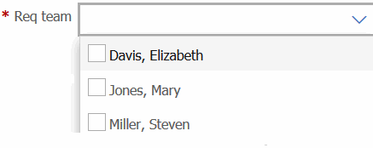
Figure 2- 4: Req team
Req team members, req creators and those selected as the recruiter for a job req are given certain privileges. Typically, they are permitted to:

- Receive emails regarding a req, such as when it is opened or put on hold.
- Access and update HR statuses of candidates associated with the req.
- Search and locate those reqs for which they are team members.
- Edit or modify the req form.

- In BrassRing, to select more than one person in a multi-select list, hold down CTRL (not Shift) while making selections.

Turn off Autofiler Notification for this Req
Selecting this checkbox prevents email notifications from being sent to the members of the req should a candidate be auto-filed to the req folder to which they have applied.
This option might be selected for reqs where a high volume of resumes or CVs are expected to be received. Deselecting this checkbox does not prevent candidates from being filed, but stops the confirmation email message from being sent to members of the req (the recruiter or req team members).
- Turning off autofiler notification on a req form does so for only that particular req, not any other reqs.

Notify Upon Approval Completion
This is most often the recruiter. When all approvals have been submitted, the person who is selected in this field receives an eLink indicating that the req has been approved, allowing the person who is selected to open and post the req.

Your Company’s Fields
The req form has been customized for your organization. As a result, some fields might be familiar to you, while others might be new. You might also notice how the selection of one field impacts options in another field subsequently available as you complete the req form.

Approval Routing-Options
Note: If your company is not using BrassRing’s online approval routing feature, proceed to the Save Req as Draft section.
There are three possible options you might see when selecting req approvers:
Use… | When…
Bypass approval | An approval for this req is not necessary or required from this approval group (ex. CEO).
Non-system user | Used when an approver’s name is not found in the drop-down list of approver names. This option allows you to type in the email address of the intended approver.
Name in list | The approver is included in and selected from a list of names.
Table 2- 1: An example of approval routing options
- The options for each approver have been customized to best meet your company’s needs. Thus, you might not have all options for each approver.

Completion of the Req Form
Once the requisition has been completed you can click the Save button at the bottom of the Req Form.
BrassRing assigns a unique req number for every req that is created, whether the req is opened or not. See Figure 2-5.
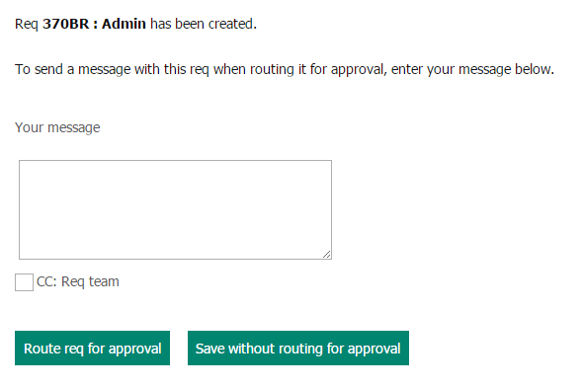
Figure 2- 5: Routing the req for approval

Adding a Req in multiple languages
If multiple languages were purchased, reqs can be initiated/created in more than one language. Creating a requisition in multiple languages allows you to post that requisition in the languages you select. Candidates can then search for, view, and apply to those requisitions in the language of their choice.
To create a requisition in multiple languages:
- From the home page, select Actions Add Req 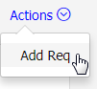. . Your company might have multiple req templates to choose from. If so, choose the template you want to complete, and you are taken to that form.
- Select the checkboxes for each language in which you want to create the requisition (refer to Figure 2-6).
- Select Add new.
- The req form appears in the first language you selected to be completed. Once the req was completed click Save>>.
- The req form now appears in the next language you chose to be completed. Once completed click Save>>. A language button at the top of the req is available for the user to toggle between each language.
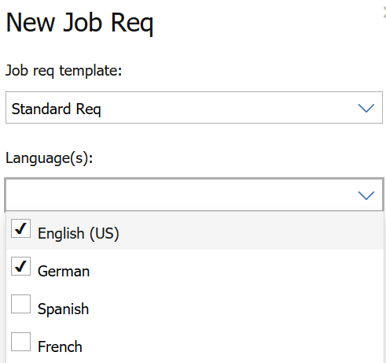
Figure 2- 6: New multi-language job req

There are a few things to know about Multi-language Reqs:
- Fields filled out when creating the requisition in the first language only populates to subsequent languages if they are one of the below field types:
  - Single-select fields
  - Radio button fields
  - Multi-select fields
  - Checkbox fields
  - Date fields
- Text, Text Area, email address, and Numeric fields do not carry over to the subsequent languages unless defaulted by Job Code Default Data (JCDD) or Req Field Association (RFA).

Save Req as New
Save as new is a shortcut for creating a req by duplicating a req that is already in BrassRing. All information is copied including: job code, recruiter, manager, req team and approval routing. This copied information might be edited.

To save an existing req as new:

- Select the req that you want to duplicate and click Save as new from the list of Actions.
- Edit any req form fields as necessary.
- Click Save and continue. See Table 2-2 for saving options for reqs.

If approvals were: | Then, your options are to: | Or
All bypassed | Open req | Save req to approved reqs
Assigned to approvers | Route req for approval | Save without routing for approval (req assigned to Pending status)
Table 2- 2: Saving options for reqs
Note: Workbench administrators can determine on the req form attribute in Workbench the user types that should not have access to data of certain fields
Save as Draft
Should you ever begin completing a req and want to finish it later, click the Save as draft button at the bottom of the req form.

Later, to access saved drafts for completion:

- Go to Reqs View my drafts, and select the draft req of your choice.
- Click Edit from the Actions menu and make your updates.
- Click Save and continue to route for approval or save the req without routing.

- To save a req as a draft, you must first complete the job title field.
- You cannot eLink a draft req to be completed by another individual.
- External users that use the eLink req option to create a req cannot use the Save as a draft feature.

Set or Edit My Req Defaults
BrassRing allows you to establish default req data as a template for yourself, thus saving time if you often create similar types of reqs. This feature must be enabled in Workbench.

To set a default req template for you:

- Go to Hiring Navigation icon , click Reqs Add my req Set my req default
- From the Actions menu, click Add new defaults. A new window opens.
- From Select Req Form, select the req form for which you want to set defaults Continue.
- Complete the fields of your choice for your default.
- Click Save and continue. You receive a confirmation message when the defaults have been saved.
The template is now available to use in the future. To create a requisition using your template, navigate to Hiring Navigation icon , click Reqs Add my req and then click the req form that you would like to create.

- Creating a req using your req defaults results in your defaults overriding the fields that would normally be populated by Job Code Default Data.
Routing and Approving/Declining Req eLinks
If your company is not using BrassRing’s online approval routing feature, proceed to Opening a Req.

Approval Routing Workflow
Using eLinks, the req one creates is sent by using email to your company’s approvers. Req approvals are sent in sequential order- the first approver must approve the req before the second approver receives the eLink to approve the req, and so on.

- The options for each approver have been customized to best meet your company’s needs. Thus, you might not have all options for each approver.

Approving or Declining a Req
Reviewing the Req eLink in Approval Routing
Req approvers receive an eLink to the req in their email inboxes. To respond to the approval request:

- Open the email as you normally would. Click the link marked View req details. See Figure 2-7. Note: The link might be either embedded in the email text, or available as an attachment.
- Within the window that is launched after clicking the link, review the information on the req.
- Type a Message to the next approver, if wanted.
- Click Approve, Decline, or Save Edits and Restart Approvals. Note: If you are the first approver, the option to Approve & Re-Route does not display.
If declining the req and if your company is using an Addendum form, it now appears in a new window. It contains options to indicate why the req is being declined.

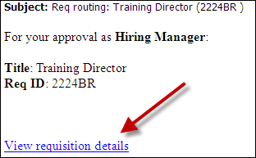
Figure 2- 7: The req elink
- If your company is not using the Req Decline feature, provide instructions to your approvers on how to process the req.
Approving or Declining the Req eLink
The first approver has the option to Approve or Decline the req as is. Subsequent approvers have three options:

Approve
Decline
Save Edits and Restart Approvals

- If an approver is going to approve the req and wants to include a brief comment, the comment should be added to the Req notes field. This is the only req field that might be modified during approval routing that does not result in the req being rerouted back to the first approver.
- If an approver is declining the req, the req approval process is immediately halted. Your company might have an Addendum form that automatically pops up to be completed, detailing why the req was declined. The form is attached to or available from the req form moving forward.
- If the approver chooses Approve and reroute, the req is sent through the approval process again starting at first approver. See Figure 2-8.

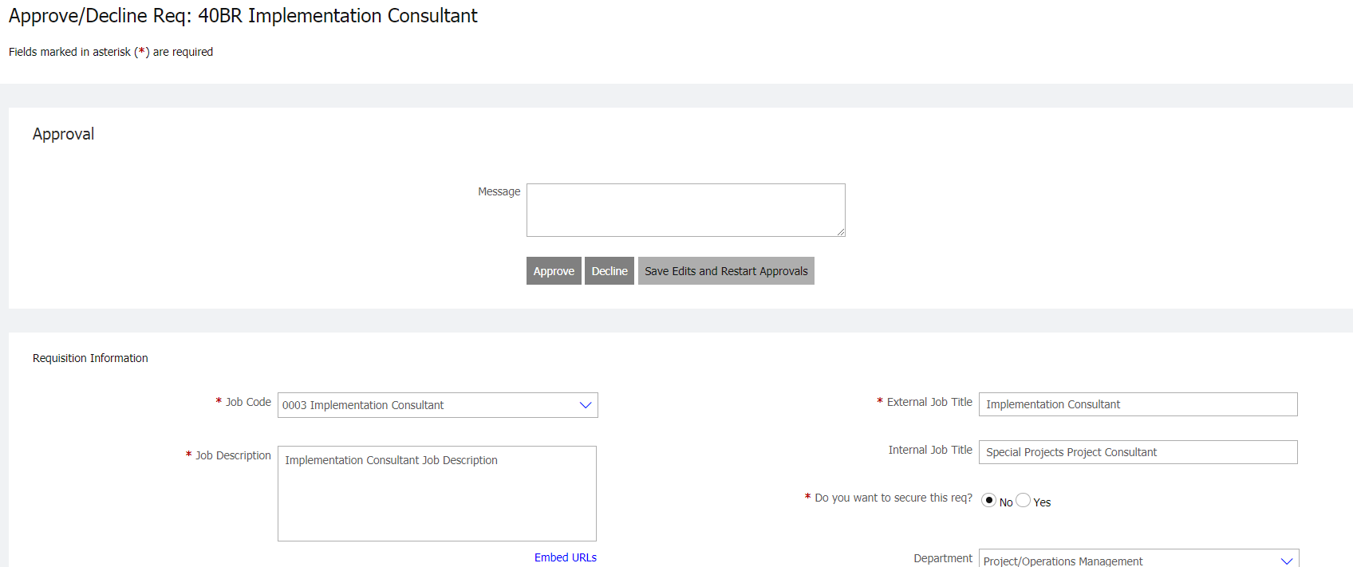
Figure 2- 8: Approving or declining a req
Approving Reqs by using BrassRing Responsive UI My Tasks Tab
To approve a req or candidate form that is pending approval:

- Navigate to the My Tasks tab (see Figure 2-9).
- Select the req that you choose to respond to.
Optionally you can select the req number to review the details of the req before responding.
- If your organization allows or requires comments while approving/declining the requisition, enter a message accordingly.
- Select Approve or Decline. The requisition is then removed from your My Tasks tab as it is no longer pending your approval.

- Reqs for which you do not have a My req relationship, but require your approval, show in the My Tasks tab.

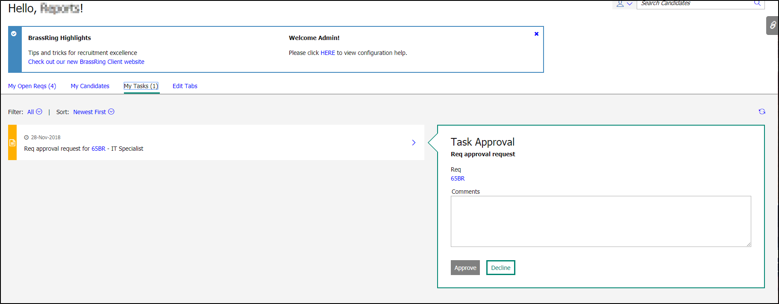
Figure 2- 9: Approving or declining a req from My Tasks tab

Tracking Approval Routing
To track the approval process to determine who has yet to approve the req:

- From the Hiring Navigation icon , click Reqs View my reqs Pending or View all reqs Pending.
- View the req by clicking the link of the req number.
- Scroll to the bottom of the req form to the Approval routing section. A date stamp appears next to the name of the person who has approved the req.
- Click Cancel to close the window.

A few things to know about tracking the approval process:
  - If a req has all the necessary approvals, it automatically updates from the status of Pending to the next req status of Approved.
  - When blank space displays next to an approver’s name under Date, it means that they have not yet approved the req. This is the approver who is holding up the approval process.
  - If an approval level was initially bypassed, the date the req was originally completed and the date the approval was bypassed displays.
  - If a req is declined during the approval process, it automatically updates from the status of Pending to the status of Declined.
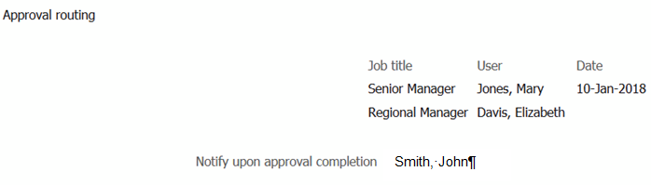
Figure 2- 10: The approval routing bottleneck. Regional Manager, Elizabeth Davis, has not yet approved the req.

- When an approver modifies a req, these modifications replace the original information that is entered on the req.
- Your company might have notification emails that are distributed when a req changes status, such as to Open or to Declined.
- Req approvers that use mobile devices have three ways to access the eLinked req:
1. The standard link View Requisition Details
2. The actual http link.
3. Copy the http link and paste it into the browser’s address bar. Note: You
must copy the entire http address, including any characters at the end, such as the = sign.

Reviewing a Req Addendum Form
Your company might be using a Req Addendum form for declined or cancelled reqs. To view the form:

- From Hiring Navigation icon , click Reqs View my reqs Declined or View all reqs Declined.
- View the req by clicking the req number, which is hyperlinked.
- In the Req history tab, click View addendum.
- Review the form. Click Close when finished.

- Your Addendum form might have a unique name, such as Reason for Decline form. This form is still accessed by using the View addendum form link.

Req Routing Troubleshooting
Here are some troubleshooting tips and for routing of reqs:

To… | In BrassRing, you should…
Stop the approval process | Update the status of the req to Cancelled. This inactivates the eLinks sent to approvers.
Resend the approval email to the approver it is pending with | From the list of Pending reqs, select the req click Route for approval. A new eLink is sent only to that approver who has stalled the process.
Manually approve the job req from within BrassRing | From the list of Pending reqs, select the req Edit req. Scroll to the Approval routing section on the req form. Click the checkboxes next to the approval levels you want to manually approve. Indicate why you took this action in the Req notes field. Save after making any changes to the req form.
Table 2- 3: Req Routing Troubleshooting
Opening a Req
Once a req is approved, you need to open it, so you can begin your recruiting efforts. Opening a req is a trigger for a few key events within BrassRing:

- The time to fill clock starts.
- The req folder appears. With the req folder, the tracking of candidates becomes possible, as it is within this folder that applicant flow is tracked.
- The req can be posted to Talent Gateways.

Before opening a req, keep the following in mind:

- The req must be in the Approved req status.
- Recruiters are typically responsible for opening and posting job reqs.
- You can only open reqs that you have added, or to which you have been assigned as a Recruiter or Req Team member.
- Super Users can also open reqs. This might happen if someone has left your organization. This ability to open reqs allows Super User to get the job posted and then reassign the req to a new recruiter.

Open a Req
There are two ways to open a req:

From within BrassRing:

- Find the approved req that you want to open and select it.
- Click Open req from the Actions menu.
Refer to chapter 3 for additional information on how to post reqs.
From an eLink sent to you:

If your name was selected in the req form field Notify upon approval completion, an email is sent to you when the final job req approval has been granted. This allows you to open a req in the following manner:

- Open the email received and click the link marked Open the req. See Figure 2-11. A window opens allowing you to post the job to your Talent Gateways.
- At the bottom of the page, click OK. This opens the req in BrassRing.
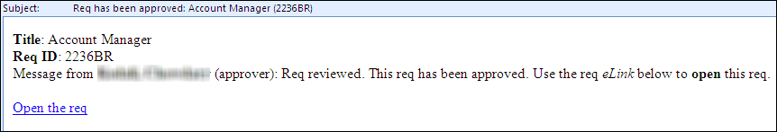
Figure 2-11: Opening req from eLink

- Your company might have opted for eLinks to open reqs. The links are sent as attachments, rather than embedded in the text of the email.

Evergreen Req

Organizations typically use evergreen requisitions for high turn-over roles for which they continually accept applications.
There are a few things to know about Evergreen Requisitions:
- Can be posted indefinitely until manually removed.
- Allow an organization to hire up to 999,999,999 candidates within on req.
- The archive functions can help an organization to manage the candidate volume.
- Ability to exclude Evergreen requisitions and archived candidate for Evergreen requisitions from DIT reports.
- Use the Push and Pull RAM triggers to automate the distribution of candidates.
- Use the Req Reapply functions to allow candidates to apply to requisitions multiple times. Coupled with specific RAM triggers, this function can restrict the timeframe in which the candidates can reapply to specific requisitions

Organizations might have a separate requisition template for evergreen requisitions or use their existing standard requisition template by identifying it as an evergreen requisition. The differences between an evergreen requisition and a standard requisition are as follows:
- User selects ‘Yes’ for the Evergreen Requisition field (see Figure 2-12).
- Infinity sign appears in the Days until posted and the Removal date field on the Posting page (see Figure 2-13).

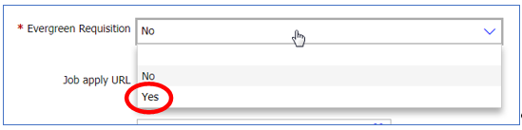
Figure 2- 12: Evergreen Req Field

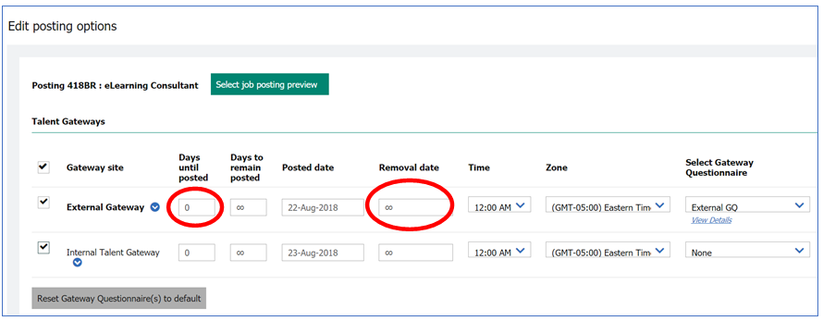
Figure 2- 13: Evergreen Req Infinity Sign for Days to remain posted and Removal date

Standard reqs already opened and posted can be changed to evergreen reqs as follows:
- Unpost the standard req from any Talent Gateway.
- Edit the standard req and change the field for Evergreen Req to ‘Yes’.
- On the Posting page, the infinity sign now appears in the Days until posted and the Removal date field.
To create an Evergreen requisition, follow the steps that are mentioned previously in Chapter 2 on Adding a Req. Click here for more details.

Chapter Summary
- From the Reqs menu, you can add, search, view, and post reqs.
- The typical lifecycle progression for a req is:
Pending → Approved → Open → Closed.
- There are five standard ways BrassRing provides to create a req.
- The req form is composed of standard and custom fields.
- To have complete access to a req, you must be the creator of the req, or selected as a Recruiter or Req Team member.
- Approvers receive reqs for approval by using email. Doing so updates BrassRing.
- Opening a req is a manual step that is taken once the req is approved. It is taken by the individual whose name was selected on the req form in the field that is labeled Notify upon approval completion.

Check Your Skills
Answer these True or False Questions:
- Any req approver can make edits to the req form without having to reroute the req back through the approval process.
- BrassRing automatically updates the status of a Pending req to the Open status when all approvals are submitted.

Select the best answers:
- Which actions are not triggered when a req is opened:
  - The time to fill clock starts.
  - The req folder appears.
  - The tracking of candidates becomes possible.
  - Internet job boards automatically source candidates.
  - None of the above.
- Privileges for members of Req teams typically include:
  - The ability to editing the req.
  - Receiving emails pertaining to the reqs lifecycle status.
  - The ability to update candidates within the req folder.
  - The ability to search for the req.
  - All of the above
Perform these hands-on exercises in BrassRing:
- View the list of Pending reqs. How many are there?
- View the list of Approved reqs. How many are there?
- Save a req as new. Select your Training username as Recruiter, Manager and as a member of the Req Team. Bypass all approvals. Save this req to your approved reqs.
- Save a req as new.
- Open the req that you created in #7. Click Cancel to prevent a positing on the Talent Gateways.
- Search for an open req with your Training username as the Recruiter.

Chapter 3: Talent Gateways

Chapter Overview:

A Talent Gateway is a job site that is hosted by Signal Labs Talent that is dedicated to helping organizations simplify their job posting process and accelerate their online recruiting efforts.

Talent Gateways are typically linked to the careers section of your corporate website. This is referred to as an External Talent Gateway. Another might link to the employee career section of your intranet. This is referred to as an Internal Talent Gateway. Another type of Talent Gateway might be used to help streamline your relationship with your recruitment agencies- the Agency Manager.

Open reqs might be posted to any, or all, of your company’s Talent Gateways, depending on your unique hiring process.

When candidates provide their resume or CV information by using a Talent Gateway, it is transmitted directly into BrassRing for immediate access and follow-up by recruitment.

This chapter focuses on Talent Gateways, the real-time recruiting tool for targeted candidate populations.

Objectives:

At the end of this chapter you can:

- Post a job to a Talent Gateway.
- Assign questions to a Talent Gateway job posting.
- Access resumes or CVs submitted through a Talent Gateway.
- Remove a job posting from a Talent Gateway.

Overview of Talent Gateways

Types of Talent Gateways
There are different types of Talent Gateways, targeting a specific candidate audience. Check or add those that your company is using:

- External Talent Gateway
- Internal Talent Gateway
- Other: _____________________________________________________.

Elements of Talent Gateways
There are a few things to know about Talent Gateways:
- Your company has made many decisions about your Talent Gateways: look and feel, verbiage, default settings and other features.
- When viewing the list of open reqs: an orange pushpin icon appears, meaning the req is currently or about to be posted to a Talent Gateway. A gray pushpin means that the posting has since expired or the req was manually unposted; while no pushpin icon appearing means that the job was never posted.
- Pre-qualifying questions, which are defined by your company, might be available to be posted with each req for candidates to answer when submitting their information.
- When candidates provide their information through a Talent Gateway, they receive an immediate email message confirming their submission.
- Resumes or CVs are tagged with codes identifying: the Talent Gateway that they applied from, the Req number, the Job code they applied to, and sometimes a specific Source showing the site that the candidates came from.
- A posting to a Talent Gateway is automatically removed from the website to which it was posted when it expires or when the req is closed, cancelled, put on hold, or moved to a deleted status.
- Jobs display on your Talent Gateway within 30 minutes of posting.
- There might be default information that displays in the Talent Gateway posting fields. Contact your Super Users with any questions regarding any such defaults.
- When reposting a job, if your organization is using Gateway Questionnaires, those are presented with the req by default when the req is posting again.
- After a req is posted, if a change is made to a req field and that information should be updated on the Talent Gateway, make sure to repost the req.

- Your company might be using an Signal Labs Talent partner for posting jobs to internet job boards (job aggregator). When a job has been posted, the orange pushpin icon displays with an orange circle behind it.

Posting of Talent Gateways
When a req is opened, you are immediately prompted to post your req to a Talent Gateway, as seen in Figure 3-1.

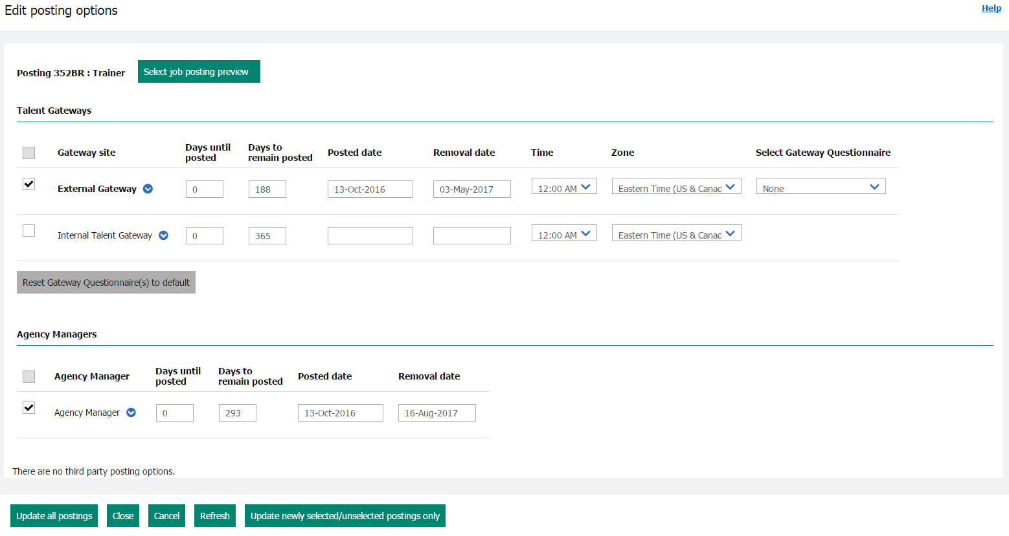
Figure 3- 1: Selecting Talent Gateways

To post a req to a Talent Gateway:
- Select the checkboxes for the Talent Gateways you want your req posted.
- Days until posted - select the number of calendar days you want to have passed until the req is posted to that Gateway. Your organization determines how many days default here.
- Days to remain posted -select the number of calendar days you want the req to stay posted on that Talent Gateway. Your organization determines how many days default here.
- If used by your organization, enter the Time and Zone you would like your req to be removed from that Talent Gateway on the date indicated in the Removal Date column. The Removal Date is automatically populated based on the number of days that are selected in the Days to remain posted field.
- If used by your organization, select the Gateway Questionnaire that you would like to have the candidates complete when applying to the req in the Select Gateway Questionnaire field.
- Edit site options - If you are using the Edit site options functions proceed to Pre-Qualifying Questions. This option can be found by clicking the next to the name of the Gateway.
- Repost - Individually enabled for each Gateway site to which the requisition is posted. To repost the requisition, click the next to the name of the Gateway site. Select Repost from the drop-down list. Examples of when you might use the Repost feature: update individual sites, move the req to the top of the site’s job list, or extend a reqs posting on a site.
- Featured Job - Individually enabled for each Gateway site. Enabling this feature places the requisition on the home screen of the Talent Gateway; thereby tagging the job as a featured job. To make a requisition a featured job, click the next to the name of the Gateway site. Select Featured Job from the drop-down list. A appears next to the Gateway name once enabled.
- Update newly selected or unselected postings only – Posts/removes the req only to or from newly selected TGs and Agency Managers (after they were checked or unchecked) and resets the Posted date for those newly posted.
- Update all postings – Select this button when you edit posting options and want to make them effective on all sites.
- Click the Close button.

- A posting goes up on the Talent Gateways at 12:01 AM. Eastern Time (if an option other than 0 for the Days until posted field is selected).
- The Talent Gateway posting expires at 11:59 PM Eastern Time on the designated expiration date (that is, Days to remain posted date). This is not applicable if the Time and Zone fields are being used or if your organization has changed the default time zone.
- Your req displays on Talent Gateways within 30 minutes of posting the req.

Pre-qualifying Questions
In addition to providing a means to post jobs to your company’s website and intranet, Talent Gateways allow you to select pre-qualifying questions to ask candidates when they apply to your job.

Additionally, you can score these questions so that individuals within your organization are notified immediately by email when a candidate meets or exceeds a target score. Later, you might search for candidates based on their current Talent Gateway (TG) scores.

Your req and pre-qualifying questions display on Talent Gateways within 30 minutes of posting the req.

- From the posting screen, click the arrow next to the Talent Gateway to which you want to add site questions. Select Edit Site Options to assign pre-qualifying questions. The Gateway site questions window appears. Figure 3-2.
- Under Available Questions, you can use the filter icon to access available questions, if the questions are grouped by job function. Select questions to ask your candidates when they submit their resumes or CVs. Drag the question to the right side of the screen. To reorder questions, drag the question to the appropriate location.
- If available, enter a value in the Score field per question for Required for HR Status Update. If the question is essential for updating the candidate’s HR Status, use this field with the HR Status Update Meets or Exceeds Minimum and Question Required Score and Below Minimum or Question Required Score settings.
- The Baseline Highest Possible Score automatically populates as a result of what is added for #3 above.
- If applicable, in the Preferred Candidate section, enter a value for Target score (optional step).
  - Select users or non-system users as appropriate for Notify the following users when a candidate meets or exceeds target (optional step).
- If applicable, enter a value for Minimum Score for HR Status Update (optional step).
  - Select an HR status from the Question Required Score field.
  - Select an HR status from the Below Minimum OR Question Required Score field.

Note: This setting overrides the instafile HR status. Candidates are updated to this selected HR status if they meet the Minimum Score and every Required For HR Status Update score that has been set at the question level selected. If a candidate meets the minimum score but does not meet all the question-specific required scores, they are classified as Below Minimum.
- Click the Copy to Other Gateways button if you want to add the same questions and scoring to other Talent Gateways.
- Click Save.
- Click OK.
- From the Posting Page (the page displaying the different Talent Gateways), finish indicating what Talent Gateways the req is posted to.

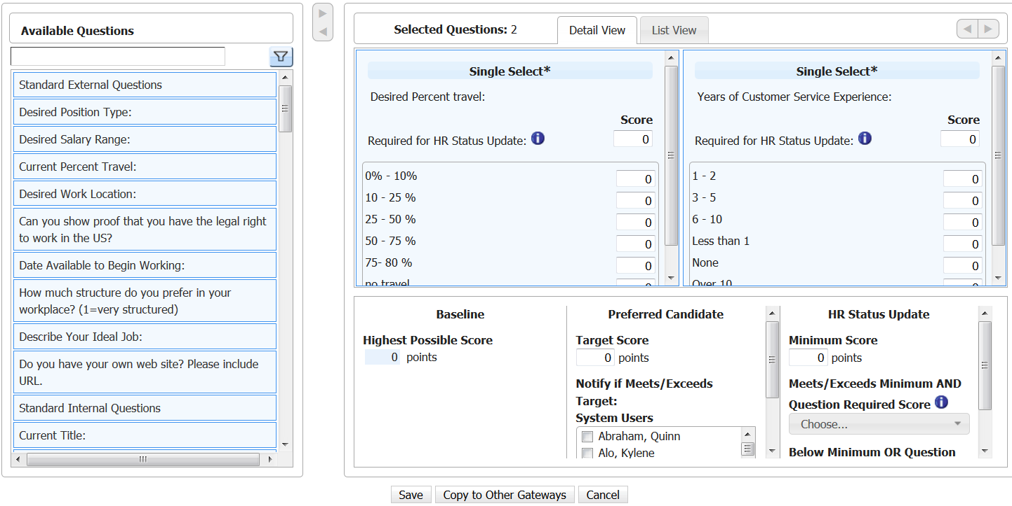
Figure 3- 2: Adding additional Talent Gateway questions. Note the Add a question button at the top center of the page

- To select more than one person in the Notify the following users when a candidate meets or exceeds preferred candidate target field, hold the CTRL key (not Shift) while clicking names.
- You can search for candidates by their scores. If so, the TG Score appears as an option when editing your Search and Output fields. You learn more about how to do this in Chapter 9: Searching for Candidates.
- If you un-cancel a req or remove a req from on hold, the previously attached Gateway Questionnaire is re-attached to the req when the req is re-posted. You can remove that GQ and select a different one if wanted.
- Your company might also have opted to use Community Gateway which enables you to post reqs to Monster or CareerBuilder without using a posting partner.

Posting a Req to the internet
Your company might use BrassRing to help with the posting of req information to job boards on the internet. If this is the case, you notice an additional section in the window for Other posting options. This section includes any Signal Labs Talent partners (Job Board Aggregators) that your organization has chosen to contract with. Their page is launched when clicking the pencil icon (Refer to Figure 3-4). Ask your Super User for information on using this capability.

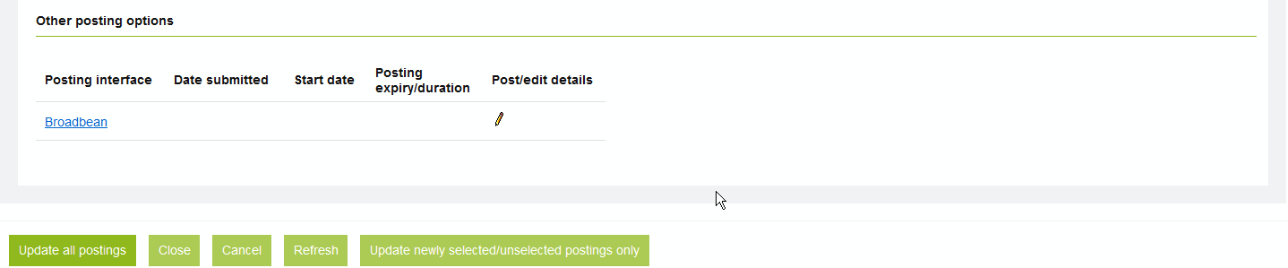
Figure 3- 4: Posting to job boards
Job Posting Preview
After the req is opened, and you have decided which Talent Gateways you post to, you might want to preview the job details as they would appear to a candidate. The job posting preview is available:

- On the Posting options screen
- On the req details screen (available when you click the link of the req number)
- From a list of reqs, select Job Posting Preview from the Actions menu
- To see what the req would look like if posted on a Classic Talent Gateway
To eLink a Job Posting Preview from the Posting Options Screen:
- From the Posting options screen, click the Select job posting preview button
- Click the checkbox for the Talent Gateways your job is posted to.
- Click the Send eLink button. Address and enter a message, if wanted
- Click Send.
- Though the job posting preview is not editable, users can copy and paste the job posting preview text or eLink the preview to a recipient.
- Sending a Job req preview as an eLink creates a job req eLink history, available from the job req details page. This section lists: Sender name, Recipient name/email, eLink sent (date), and eLink opened (latest viewed date).

Viewing Responses to Pre-Qualifying Questions
Candidates’ responses to pre-qualifying questions are easily viewed in BrassRing:

- While viewing the candidate’s Talent Record, click the Forms tab.
- View the form titled Job Response Form. The questions asked of the candidates and their responses display.
- Because candidates can apply to more than one job, they often have more than one Job Response form. To identify the responses the candidate gave to your job questions, find the Job Response form that shows your req number in its title.
- You can also choose to leave a job posted on a Talent Gateway while it is on hold.

Removing a Posting
These are the ways to remove a job posting from a Talent Gateway:

- Set the expiration date at the time of posting the job.
- Close, cancel, delete, or put the job req on hold.
- Manually remove the posting.

To manually remove a posting:

- Locate the req using Search reqs or Quick search.
- Select the req
- Click Open req from the Actions menu.
- Deselect the checkbox for the sites from which you want your posting removed.
- Click Update all postings.

Chapter Summary
- A Talent Gateway is a job site-hosting tool.
- BrassRing prompts you to post your req when it moves from the Approved to Open
- There are different types of Talent Gateways, each targeting a different candidate audience.
- Pre-qualifying questions can be asked of candidates when they submit their resumes or CVs for a job through a Talent Gateway.
- Pre-qualifying questions and the responses to those questions appear on the Job Response form. This form is appended to the candidate’s resume or CV.
- You might access a preview of the details of a job posted to a Classic Talent Gateway and eLink it to others for review.
- You have immediate access to resumes or CVs submitted from a Talent Gateway by using Candidates>Candidates in queue.
- A posting automatically expires based on the status of the req or the date settings of the job posting.

Check Your Skills
Answer these True or False Questions:
- When the field Days until posting is set to 0 days, the job is posted to the selected Talent Gateways within 30 minutes.
- When a job is posted, the pushpin icon changes from gray to blue.
- Candidate responses to pre-screening questions are attached as a form to the Talent Record called a Job Response form.

Select the best answers:
- Pre-qualifying questions can be:
  - Chosen for each req.
  - Scored as candidates submit answers.
  - Attached as a form to the candidate’s resume or CV.
  - All of the above

- Which req lifecycle statuses can automatically remove a job posting?
  - Hold
  - Closed
  - Deleted
  - Cancelled
  - All of the above

Chapter 4: Routing & Processing Resumes or CVs

Chapter Overview:

Your candidates are critical for the success of your recruiting campaigns. It is with this in mind that Signal Labs Talent undertakes the responsibility of processing your candidate’s resumes or CVs with great speed and accuracy.

Signal Labs Talent also strives to be flexible and innovative in providing you and your candidates with numerous methods for submitting resumes or CVs. Your organization has decided which of these methods best support your recruiting efforts.

In this chapter, we review the methods for submitting resumes or CVs, discuss best practices, and address the use of codes.

Objectives:

At the end of this chapter you can:

- Identify different methods for submitting resumes or CVs.
- Add candidate information to BrassRing.
- Create a code string that can be used in advertising.
- Erase candidate or candidate application data.

Overview of Resume or CV Routing

Candidate resumes or CVs can be loaded into BrassRing in one of three ways:

- Most often by the candidates themselves, through a Talent Gateway.
- By recruiters logged in to BrassRing who use Add candidate from the Candidates menu.
- By an external system, sending candidate resumes or CVs and other information in through an integration.

Overview of Candidate Submission

Your candidates use Talent Gateways to seek and apply for jobs online: externally, by using your company website and internally by using your intranet.

Elements of Candidate Submissions into BrassRing
Information about the candidate’s experience with Talent Gateways:

- Candidates can provide resumes by using upload.
- Resumes or CVs submitted by using Talent Gateways appear within BrassRing within minutes, usually seconds. Candidates receive an immediate email confirmation.
- Talent Gateways allow recruiters to ask pre-qualifying questions. The questions and responses to them are referred to as a Job Response Form, appended to the resume or CV and viewable by recruiters.
- Resumes or CVs are tagged with codes to capture the jobs applied to and the source that directed the candidate to apply.
- Your company might have opted to limit the number of jobs a candidate can apply to in a single submission within a Talent Gateway, per req, and within a specific period of time (month, year, specific number if days).
- Your candidates might be required to indicate consent to your company’s data privacy policy.
- Your company might allow candidates to apply for a maximum of 10 jobs at one time.
- Your candidates might be permitted to set up a saved search that informs them about jobs posted that matching their search criteria.
- Candidates might save jobs to a job cart for later to retrieve and apply.
- Your candidates might be permitted to send job descriptions to others by clicking Send to friend.
- Your company might have opted to allow candidates to check the status of their job submissions, or withdraw a submission. Employees who referred to as candidates, can also use this feature to check the status of their referral.

- Supported file attachment types on the Talent Gateways are:
Avi | mp3 | rtf
Bmp | mp4 | swf
Csv | mpeg | tif
doc, docx | mpg | wmv
Gif | pdf | xls
Jpeg | ppt | xlsx
Mov | pptx | xml

Candidate’s Experience with Talent Gateways
When candidates access your company’s corporate website, they are presented with a page that looks similar to Figure 4-1. This is the Candidate landing page.

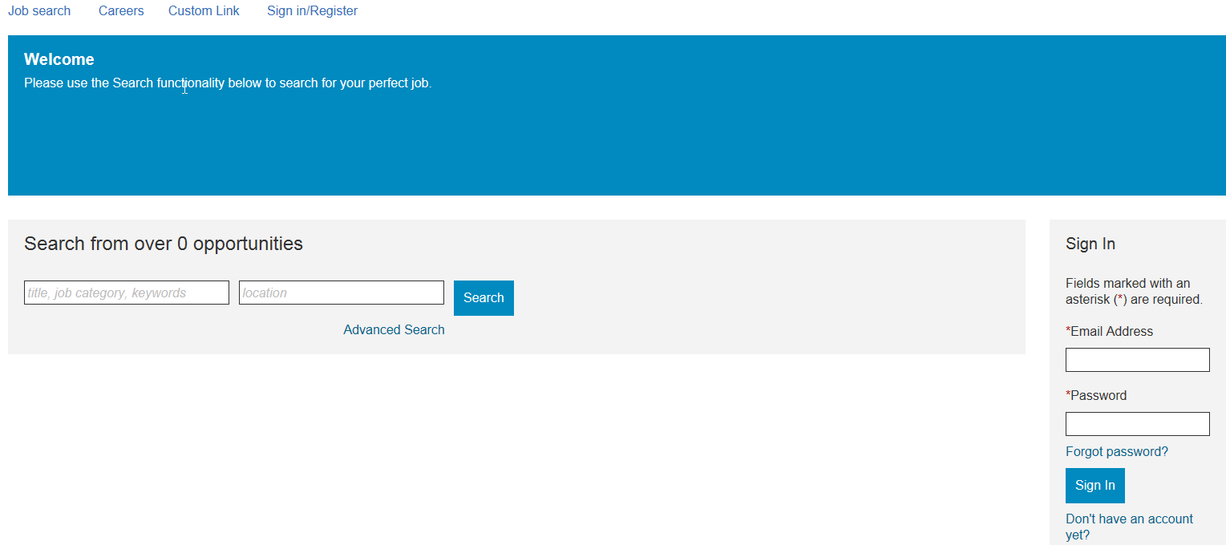
Figure 4- 1: Accessing Talent Gateways –the Candidate landing page

Searching for Available Jobs

Within Talent Gateways, candidates can complete an advanced search for positions they are interested in. These positions are the open reqs within BrassRing that were posted to the Talent Gateway by recruiters:

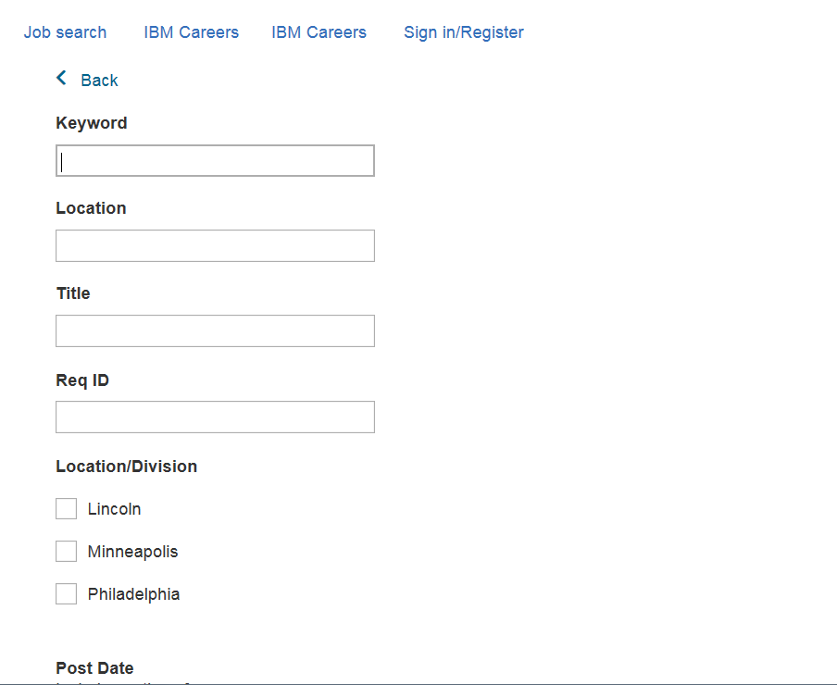
Figure 4- 2: Searching for open jobs

Once search results display, candidates review the rows displaying job information, and view the job titles they are interested in. See figures 4-3 and 4-4.

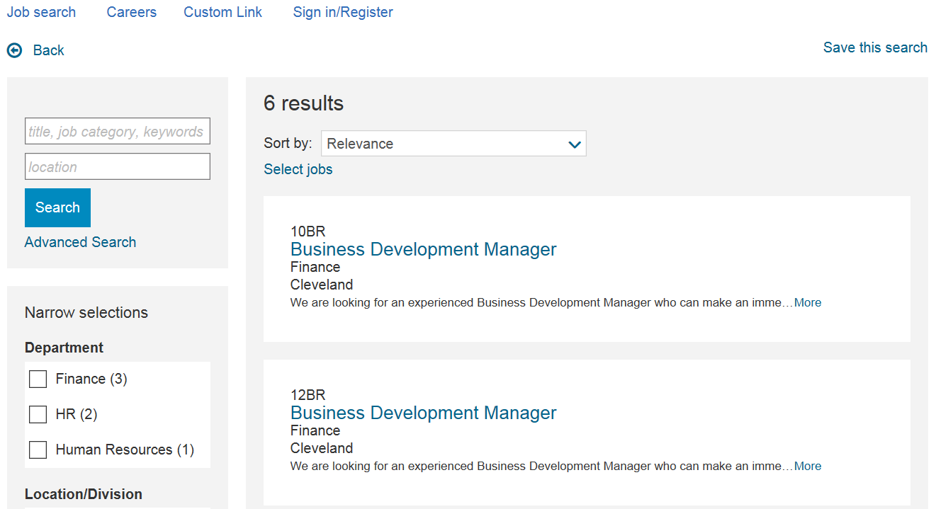
Figure 4- 3: Search results

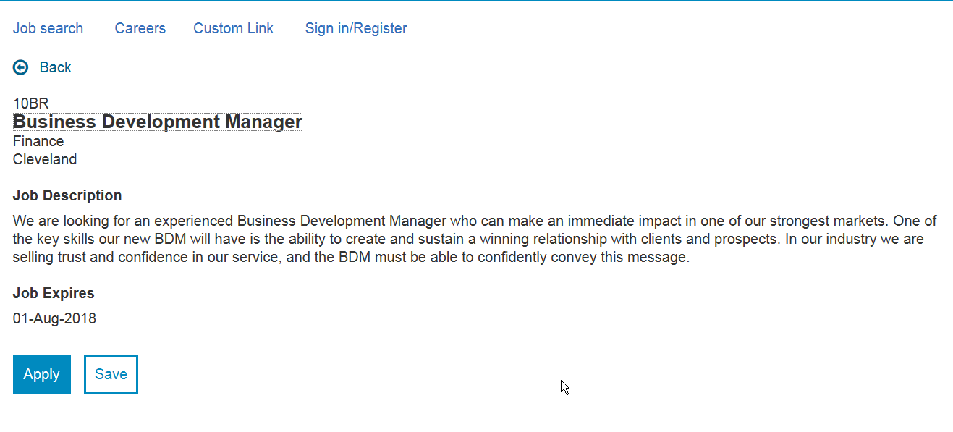
Figure 4- 4: Viewing job details

Submitting a Resume or CV

When ready to apply, the candidate is prompted to create a login and build an account. This enables the candidate to track submissions and maintain multiple versions of a resume or CV online. The candidate is asked to start the application and receives an approximate completion time (Figure 4-5). The candidate then enters a resume or CV. Candidates might choose to import their resumes or CVs (Figure 4-6) or enter their resumes or CVs by typing them.

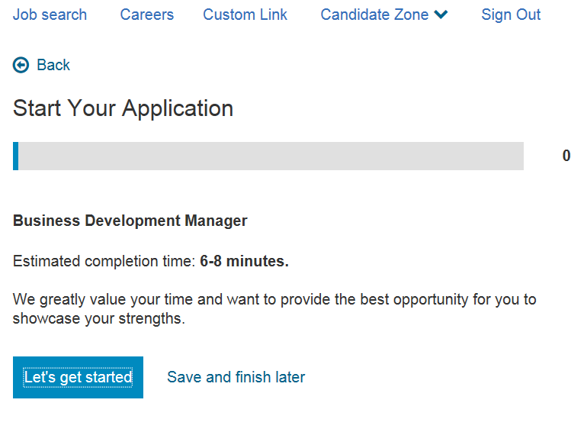
Figure 4- 5 : Start Your Application
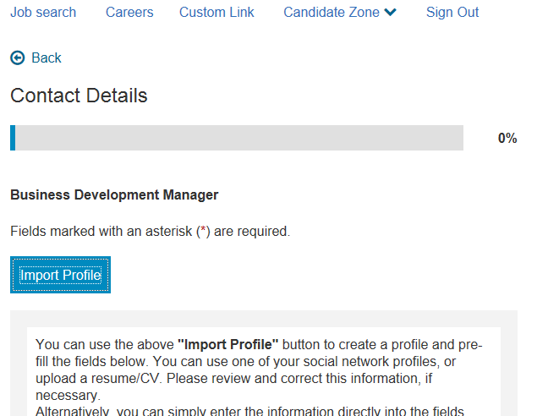
Figure 4- 6: Import Profile

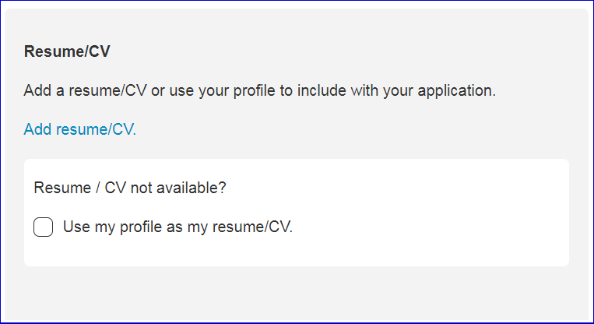
Figure 4- 7: Upload Resume or CV

After uploading the resume or CV, the candidate confirms data extraction of resume or CV information, such as: First name, Last name, Position held, Employer, Educational Institute, Degree, etc. The maximum number of submissions allowed by a candidate on the Responsive Talent Gateway is limited now to 100. There is no time restriction on this. An error message is displayed when the candidate tries to submit after the number of submissions reaches 100.

Candidate Status Check

Candidates can check the status of their job submissions sent through a Talent Gateway. This feature is available under Candidate Zone > Dashboard > Applications > Submitted Applications. It allows the candidate to see where his/her application is within your organization’s applicant flow. Refer to
Figure 4-8.

Elements of Candidate Status Check
- History pertaining to closed and cancelled reqs stops displaying after 6 months.
- The information contained within the Job submission status is updated every 24 hours
- HR Statuses assigned to candidates are masked with the name of the HR Status Category, thus making the terminology more candidate-friendly.
- Candidates can only withdraw a submission to a job if their resume or CV is in that job’s req folder, the proper configurations are enabled, and the candidate is in a designated HR Status allowing them to withdraw.
- When a candidate withdraws their job bid, their HR status is updated automatically to a final status and remains in the requisition folder.
- When a candidate re-activates their job bid, their HR status is updated in BrassRing to the status before the withdrawal.

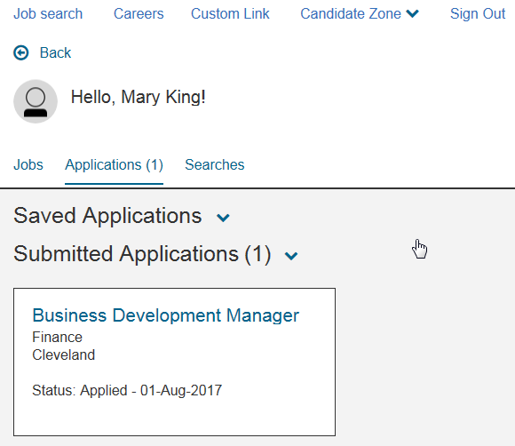
Figure 4- 8: Submitted Applications page

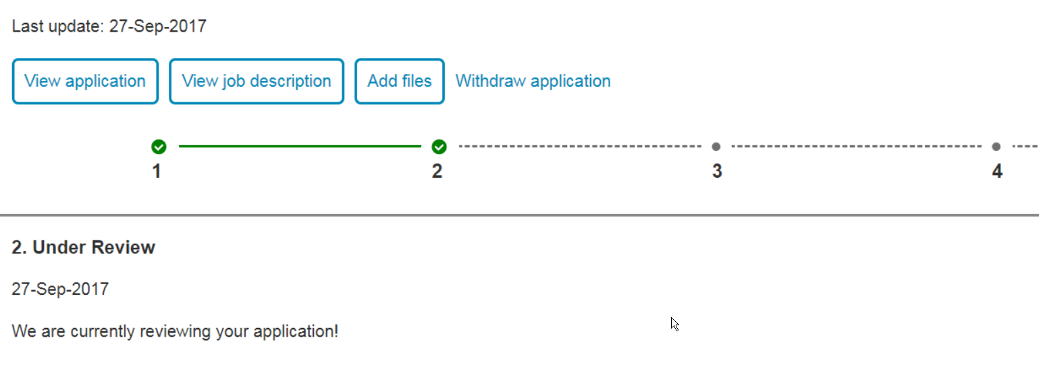
Figure 4- 9: Details of Submitted Applications for Job page

Overview of Recruiter Submission into BrassRing
Recruiters and other users of BrassRing have access to built-in methods for submitting candidates directly into BrassRing: Add candidate.

Elements of Recruiter-based Submissions
- If you have an electronic copy of a resume or CV, or if you have a hardcopy and are willing to type in the information, use Add candidate.
- Your organization might have opted to allow you to associate codes, notes and the ability to review the new Talent Record for resume or CV data entered by using Add candidate.

Adding a Candidate
If you have a hardcopy of a resume or CV and want to either upload, copy and paste it, or manually type in the information, use Add candidate. To add a candidate:

- From the Hiring Navigation icon , click Candidates Add candidate.
- Upload, or copy and paste the candidate’s resume or CV. You might also copy and paste the cover letter in the text area. Click Continue. The extraction engine then populates the resume or CV information into appropriate fields.
- Verify that the information was populated correctly, editing as needed.
- Click Continue. Add any codes and notes to assign to this record, if wanted.
- Click OK.

- Before adding candidates to BrassRing, best practice is to first search the database to see if the candidate already exists. If a candidate already exists, BrassRing automatically finds the duplicate file and merge the information. This is discussed later in details.
- Be sure the spelling is correct for all candidate information.

Duplicate Candidates
- When being loaded into BrassRing, resumes or CVs are automatically parsed into candidate contact fields and those fields are checked to determine if the candidate’s information is already in the system. In this process, BrassRing compares the incoming candidate’s first name and phone number, then the first name and email address against all the other resumes or CVs currently in the system. (The contact fields used to check for duplicates can vary and is determined by your organization.)

- If there is a match of this information, the new resume or CV and other information, such as forms, HR Statuses, and notes are appended to the existing candidate file. This makes the previously submitted (older) resume or CV a duplicate.

- Duplicates can be accessed by clicking the hyperlinked duplicate resume or CV file you want to view. The most recently loaded is listed as the Current file. Any others are listed in reverse chronological order from 1 up to 10.

- If a candidate applies multiple times to the same req, the Talent Record always displays the most recent resume submitted to that req by default.

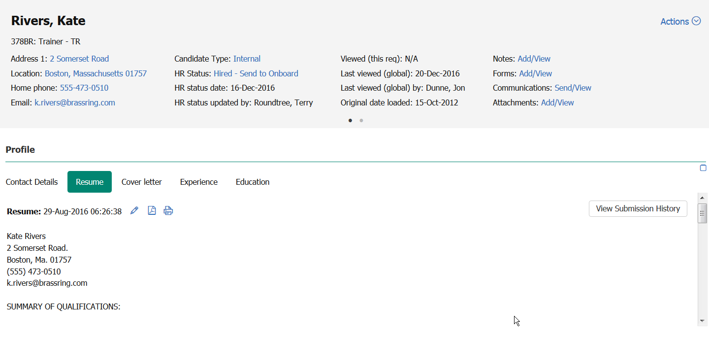

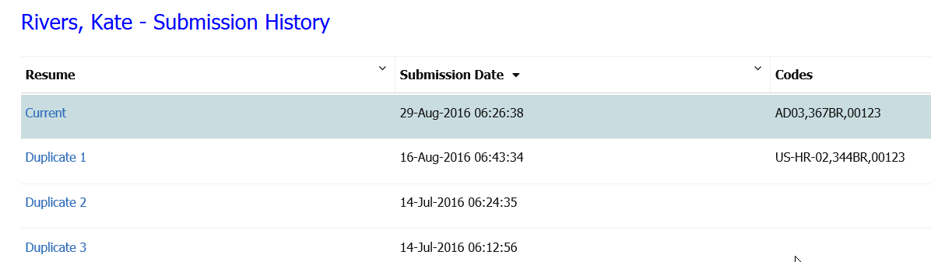
Figure 4- 10: Duplicate resume or CV

- There are 15 duplicate stacking algorithms available. During implementation, your company selected one as the most appropriate.
- When eLinking or forwarding a Talent Record from Search results, a Working folder, My Inbox, or My Candidates, the most recent resume or CV is sent by default unless you opt to select a different duplicate to send.
- While BrassRing displays duplicates from the first up through the 10th duplicate. It allows for any req-specific duplicates to take precedent over any non-req-specific submissions. This means that if the 11th resumes/CV submission was made for a req you are currently working on, that 11th resume or CV would appear as part of the 10 listed within the Talent Record.

Stacking Duplicate Talent Records
The automatic duplicate check that BrassRing runs when resumes or CVs are uploaded into the system is highly accurate. However, there might be an occasion when you come across two talent records that were not stacked for the same candidate. The stack duplicates feature allows you to manually stack all the information (except for one of the two Overview sections) and merges it with the talent record that is selected as the current (i.e., most recently submitted) resume or CV.

- Once you successfully completed the process of manually stacking duplicate candidates, you cannot ‘un-stack’ them.

To Stack Duplicate Talent Records

- From a list of candidates, select the two candidates that are duplicates.
- Click Stack duplicate from the Actions menu. A new window opens with the two overviews for the selected candidates. Refer to Figure 4-11.
- Decide which record should be the current active record. (You might need to view both Talent Records in which case you need to start over.)
- Click Record 1:2 or Record 2:2 to review the two records you are considering stacking.
- Click Keep this candidate to indicate the overview screen you want to retain. This merges all the other two Talent Record’s information, except for the Overview screen you opted not to keep.
- Click OK to confirm that you want to proceed with this action.
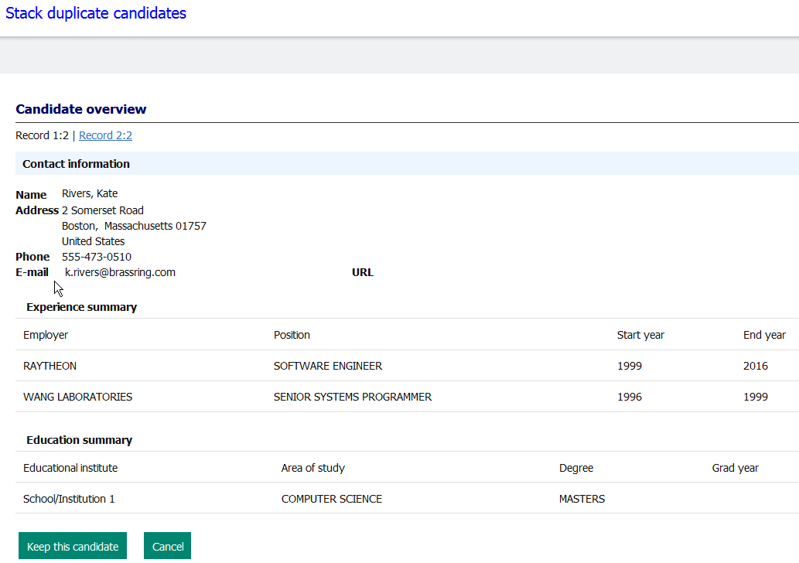
Figure 4-11: Stacking duplicate resumes or CVs

Instafile
Autofile runs every 24 hours, but Instafile works in real-time manner, instantly filing (within seconds) a candidate based on their candidate type to the req folder to which they have applied. Like the Autofile, Instafile is not saved by any one user. Rather it is already turned on and runs for your entire organization. If Instafile identifies candidates who have applied to a specific req, it does not only file the candidates, but also sends an email notification of each candidate filed to that req. Your Signal Labs Talent Talent representative can enable a setting that determines if the names of the candidates or the number of candidates are included in the email.

Instafile accelerates the filing of candidates submitted through Talent Gateways and Agency Manager to your organization’s requisitions, but like any resume or CV loaded into BrassRing, up to two hours might pass before the candidate data being fully searchable.

Candidates in Queue & Referrals in Queue
Available from the Candidates menu, Candidates in queue and Referrals in queue allow you to access resumes or CVs entered by using a Talent Gateway or Add candidate. Refer to Figure 4-12. Resumes or CVs can remain in this holding bin for up to 2 hours, after which time they are indexed and all of their extracted data becomes fully searchable by using Candidates>Search.

- Your organization might have set Instafile to automatically assign one of your starting HR statuses, such as Initial Screen, to candidates filed to the req folder when they apply. This feature can be set to accommodate companies with multiple req templates.
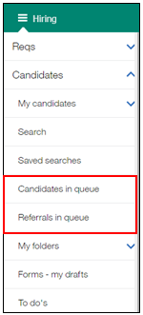
Figure 4-12: Candidates in queue & Referrals in queue

Using Codes to Track Resumes or CVs
Codes are the means in which your organization can track how many responses you received for an ad or job posting, or the number of candidates hired from each of the sources you use. They are stored and maintained within tables found in BrassRing.
Elements of Codes
- Codes facilitate searching, allowing you to search for candidates who, for example, have responded to your specific req.
- When a code attached to a candidate’s record becomes inactivated, it appears with a strikethrough. For example: NHJB.
- Super Users must enter new codes into BrassRing and Workbench Administrator must enter new codes in Workbench before their use in advertising.
- If your company is using Talent Gateways, codes are being captured automatically.
Elements of Codes
There are three standard types of codes:

Code | Description | Example
Job Code | Identifies the Job title | HRM01 for HR Manager
Source code | Identifies where resume or CV specifically came from | MNSTR for Monster.com
Req code | Identifies the req; generated when the req is created | 152BR
In addition to these standard codes, your company might have created other codes for additional tracking purposes. Examples of additional codes are: Business Unit, Division, Recruiter, and School.

The Code String
Placing together multiple codes with a forward slash (delimiter) creates a codes string:

HRM01,MNSTR,152BR

This code string would indicate the candidate is applying for the HR Manager position submitted through Monster.com for requisition number 152BR.

Erase a Candidate or Candidate Application
Erasing a candidate is irreversible. It is not recommended to use this feature unless:
- The candidate requests it.
- Test data is being deleted.
- Your organizations policy dictates it.

Erase a Candidate Application
- Selecting Erase Candidate Application Data erases all data that is related to a specific requisition. This data includes all forms, HR statuses, notes, communication, and any other data related to the application to a specified requisition.
- Erase Candidate Application Data is available only:
  - On Candidate listing, grid, and pane that is accessed by using a specific requisition.
  - In the Actions menu of a candidate Talent Record when the Talent Record is opened from a list of candidates that are accessed by using a specific requisition.
- A warning message is displayed when a user selects Erase Candidate Application Data. When users confirm that they would like to proceed with erasing the application data specific to the requisition, the erase action is taken.

Erase a Candidate:
    - From any list of candidates, select a candidate or multiple candidates.
    - Select Action > Erase Candidate.
    - The Erase Candidate window (Figure 4-13) opens listing the candidates for erasing.
    - If needed, select Erase Talent Gateway profile, to erase the selected candidates Talent Gateway profile.
    - Select Erase.
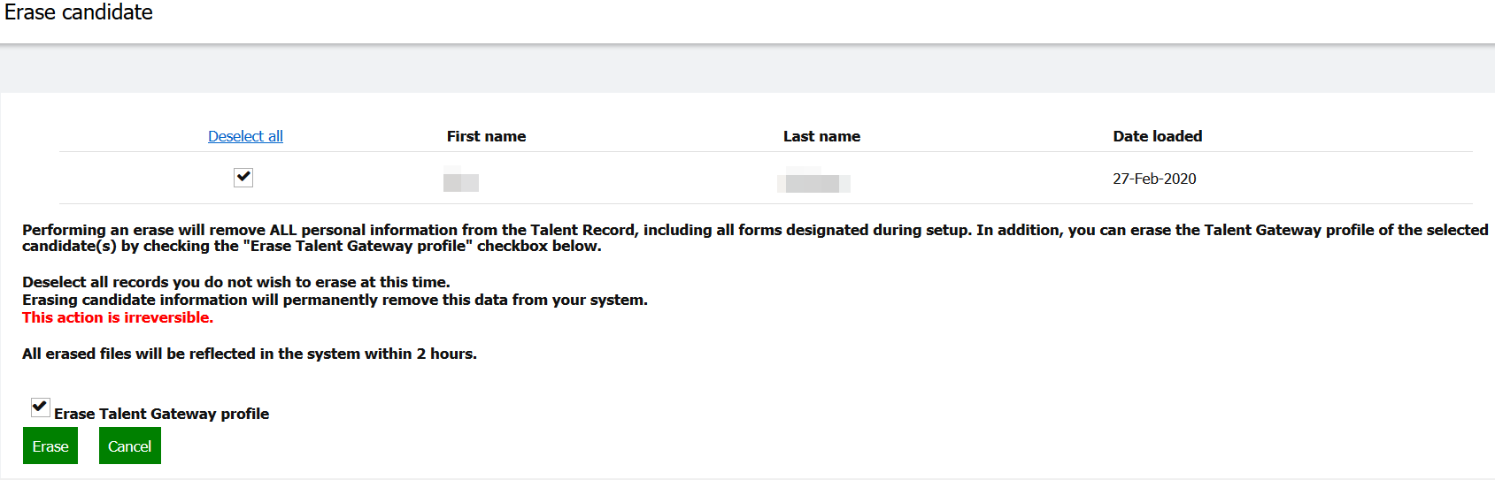
Figure 4-13: Erase Candidate window

Erase Candidate Application Data:
- Select a candidate or multiple candidates on a candidate listing that has been accessed by using a specific requisition, or access a Talent Record from the list of candidates within a specific requisition.
- Select Action > Erase Candidate Application Data.
- A notification displays stating: The erase action taken using this option is irreversible. There is no undo option available after the data is erased.
- Select OK.

Chapter Summary
- Resumes or CVs can be entered into BrassRing by candidates and recruiters.
- Autofiler places resumes or CVs into the req folder to which the candidate applied every 24 hours.
- Instafile places resumes or CVs into the req folder to which the candidate applied within seconds of the resume or CV being submitted.
- Resumes or CVs are entered immediately through a Talent Gateway or Add candidate.
- When BrassRing matches a candidate’s contact information with an existing one, the new resume or CV is appended to the existing candidate file. This causes the previously submitted resume or CV to become a duplicate.
- Signal Labs Talent extracts up to 20 pieces of information from each resume or CV.
- There are three standard types of codes: Source, Job and Req. Your company might capture other codes as well.
- Codes provide the ability to effectively track resumes or CVs.
- Erasing a candidate is irreversible. It is not recommended to use this feature unless the candidate requests it, test data is being deleted, or your organization’s policy dictates it.

Check Your Skills
Answer these True or False Questions:
- Candidates can use Add candidate to submit their resume or CV information.
- Resumes or CVs cannot be entered into BrassRing manually?
- It is best practice to have a new code entered into BrassRing before advertising.
- Candidates should not send cover letters since Signal Labs Talent does not process them.

Answer the following short answer questions:
- What should you do when you receive a resume or CV by using email and you want to get the information into BrassRing immediately?

- What should you do if you want to post a job using an advertising source that is not listed in the Source code list?

Chapter 5: Screening Candidates

Chapter Overview:

Once qualified candidates have been identified for your position, you can then move the candidates through your company’s defined hiring process. Typically, this is performed within the req folder.

The first phase of candidate tracking involves screening the qualified candidates you might have sourced. Screening candidates entails reviewing resumes or CVs, speaking with candidates, and documenting your conversations, all of which BrassRing facilitates.

Objectives:

At the end of this chapter you can:

- View candidates in the req folder
- View resumes or CVs.
- Add a note to a candidate’s Talent Record.
- Initiate the HR status on candidates to track through your organization’s unique hiring process.
- Candidate Tiers.

Overview of Output Grid

To start the screening process, you review your candidates in the req folder, as seen in Figure 5-1. From here you view the resumes or CVs and begin the decision-making process of whether to move the candidates to the next stage (i.e. phone screen, interview, etc.).

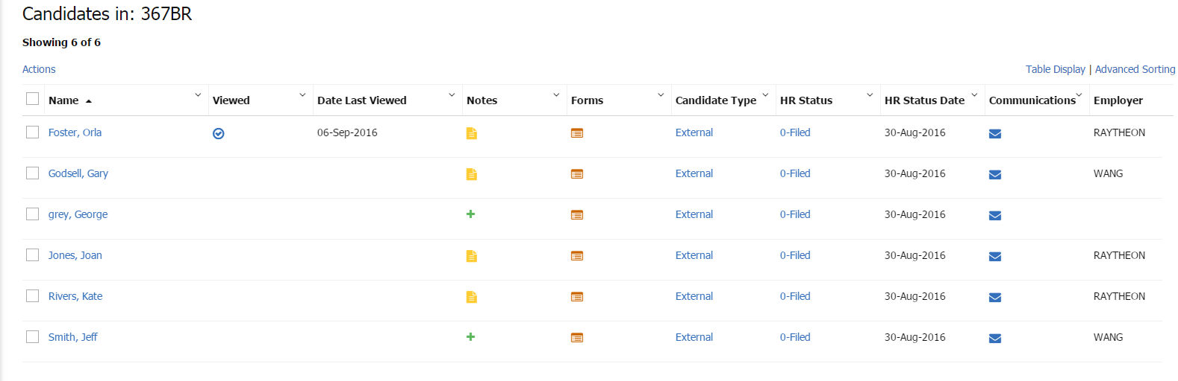
Figure 5- 1: Candidates in Req

Output Grid Management
Column headings that reside in a grid and display candidates (or reqs) are output fields. Your organization opted for certain output fields to appear as defaults in BrassRing.
Output fields are based on the information that is fielded from resumes or CVs, providing you with a quick look at a candidate’s most recent information, such as specific contact, employment or education information.

Elements of Output Fields and the Output Grid
- The candidate’s name, whether you viewed the candidate, if they are an Agency referral (if applicable to your company); Notes, Forms, and HR status icons; most recent Candidate type and Last codes are standard output fields. Resume or CV information (e.g. Position held, Employer, Educational institute) can also display as output fields.
- To move between pages of results, click the wanted numeric group of results from the Show results menu, or use the > - sign at the bottom of the page.
- You can modify the output grid to use only those fields that are most helpful to you. Modification options for the output grid include: dragging and dropping, freeze/unfreezing, resizing, and hiding/showing output fields.
- The req and candidate output grids allow for 3 of your grid selections to be used for multi-sorting-used in succession for sorting columns.
- The Codes field displays the most recent code (e.g. source and job) information for candidates, and is assigned each time a candidate applies through a Talent Gateway. Based on your user type, you might click the hyperlinked string of codes to access a candidate’s code history.
- You can sort the results by clicking any of the column headings once for ascending order (123/abc) and once again for descending order (321/cba).

- You can export candidate and req grids to a Microsoft Excel spreadsheet. The content exported to the Excel spreadsheet depends on the size of the results set:
  - If the results set is 50 rows or fewer, the entire results set is exported to the Excel spreadsheet. You must export each page in a separate action.
- You can select multiple candidates spanning across multiple pages. To keep track of the total number of candidates selected, the number of candidates is displays for you.

To Stack Duplicate Talent Records

The column headings on the search results page can be modified using these steps:

- Select the Table Display icon .
- In the Available Columns list, highlight the fields to add to the output criteria and click to move them to the Selected Columns window. Highlight and click to return them to the Available Columns list.
- To reorder fields within the Selected Columns list, click the field then drag the field to the appropriate position.
- Click Submit.

Additional Output Grid Management Options

In addition to editing output fields, BrassRing offers additional manipulation of candidate and req output grids, supporting: Drag placement, column resizing, hide or show standard columns, and advanced sorting.

- Click the drop-down arrow in the column header and select Pin Left or Pin Right to pin a column all the way to the Left or Right side of the output grid.
- Un-Pin by clicking the drop-down in the column header and selecting Unpin.
- Re-size columns by clicking the column border and sliding the mouse to the right or left. Hide columns by resizing the column small enough that it does not display (similar to MS Excel).
- Re-order columns by clicking the selected column dragging and dropping where wanted (similar to MS Excel).
- Alphabetize the options in a column by clicking the column name. A indicates the column is sorted A-Z and indicates the column is sorted Z-A.

Advanced Sorting

The output grid reveals two buttons: Filters and Advanced Sorting options. These allow you to configure quick filter list options by HR status and Candidate type columns. Sort options allow you to configure multi-sort columns and column sort defaults.

To edit the Sort options:

- From the display of search results, click the Advanced Sorting icon .
- Select up to three different criteria for sorting the output grid display, using the radio button to indicate Ascending (the default) or Descending order.
- Sort by: Select the 1st criterion to sort the output grid by. The column selected for the first sort is applied to the entire output grid.
- Then by: Select the 2nd criterion to sort the output grid by. The column selected here is the second sort applied to the entire output grid.
- Then by: Select the 3rd criterion to sort the output grid by. The column selected here is the third sort applied to the entire output grid.
- Next, choose Apply Sort.

Viewing a Talent Record

To view a Talent Record, click the link of the candidate’s name. Talent Records provide access to all pertinent candidate info: notes, forms, HR Status, eLink history, interview schedules, communication history, and resumes or CVs. (Figure 5-2).

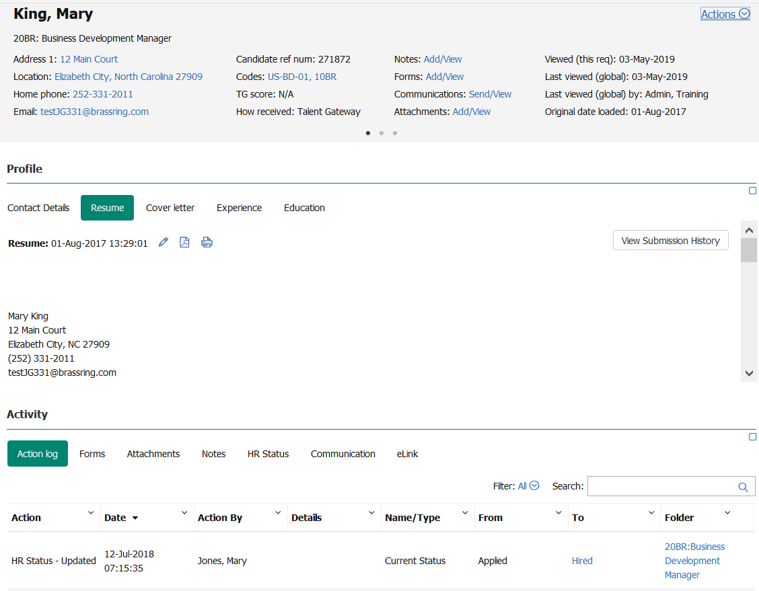
Figure 5- 2: A Talent Record
- Users can filter a Candidate’s Talent Record Action Log by This Folder, My Reqs, or My Actions.

Prepare for Bulk Print

You have the option to print specific areas of a single Talent Record by using Bulk Print:
- From within a Talent Record, go to the Actions menu and select Prepare For Bulk Print. This launches the Prepare for Bulk Print screen.
- Select the checkboxes to indicate which parts of the Talent Record you want to print and click Send.
- The user who initiates the bulk print receives an email with a link to view or print the information.

- If a resume or CV being viewed displays duplicates, and is being viewed within a req folder, any req-specific duplicates (submissions made more than once for the same req) are displayed on the Submission History screen which is accessible by clicking the View Submission History button located in the Profile section of the Talent Record.

Viewing Multiple Resumes or CVs

- From the list of candidates, select all candidates of interest.
- From the Actions menu, click View. BrassRing displays the first candidate’s information. To move from this candidate to one of the other records, click the drop-down arrow next to the candidate’s name of the resume or CV that is currently being viewed. A list of the other selected candidates appear in a drop-down list. (See Figure 5-3).
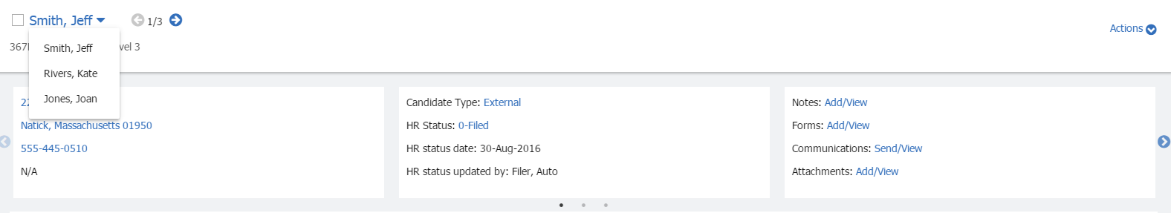
Figure 5- 3: Viewing multiple resumes or CVs

Speed Browse

Speed browse allows the user in BrassRing to review information for multiple candidates side by side. You can change the showing number of candidates to five resumes at once.

- From the list of candidates, select all candidates of interest within a candidates result panel (e.g. Candidates in: 49BR: Administrative Assistant or My Candidates).
- Click Speed Browse in the Actions menu.
- BrassRing displays the first 5 candidates selected.
- You can also take action on these candidates by checking the box next to the candidates’ name and selecting the appropriate option from the Actions menu.
- Forms are viewable in the Forms tab. When candidates with multiple forms are selected, the latest form is opened in Speed Browse.
- If the selected candidate does not have the required form, the candidate is excluded from Speed Browse.
- To easily identify candidates already viewed, candidates who were selected for speed browse in a candidate results grid are marked as viewed in the Viewed column.

Candidate Notes
In BrassRing, document your conversations and email dialogs with candidates, managers and others by adding notes. Notes can also be used to set reminders for future actions you need to take, such as calling a candidate to arrange an interview.

Elements of Notes
- Notes are discoverable and remain with the Talent Record as it travels to various folders and people.
- Notes can be designated as public or private. Notes specified as My notes are private- only you and your Super Users can view these.
- The notes icon appears when candidates have notes attached to their Talent Records.
- You can add a Reminder date to your note. This automatically places a reminder in your To do's (found in the Candidates menu).
- When adding a note to a candidate record from a req folder, that req number appears in the note.

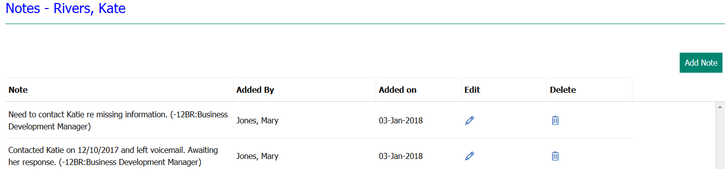
Figure 5- 4: A Candidate Note

Adding Notes
- Click the Note icon, using either the or the .
- Click Add Note. You might type notes from discussions, copy and paste emails, etc. into the message box. See Figure 5-5.
- (Optional step) To add a reminder, click the calendar icon next to the Reminder date field.
- (If available) If you want to be the only one who can see this note, click My note (private).
- Click Save. A confirmation message appears. Click OK.

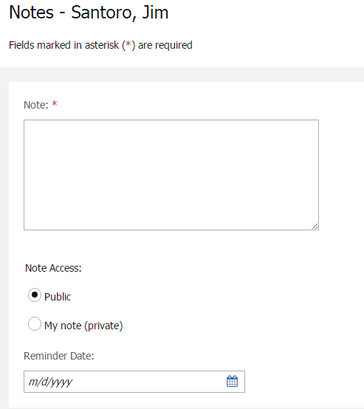
Figure 5- 5: Adding a note
- To gain the most benefit, designate notes as Public. Remember to include only information in the candidate record that is appropriate.
- BrassRing users with the appropriate user privileges can edit or delete Public notes from a candidate’s Talent Record.

To do’s

Your list of To do’s in BrassRing enables you to keep track of tasks you need to accomplish.

To view your To do’s:

- Click Candidates To do’s.
- Click the Notes icon to read the details of the reminder you set.
- After completing the reminder task, click the Mark completed icon. Completed tasks can be accessed later by using the link at the top of the To do’s window (Completed to do’s).

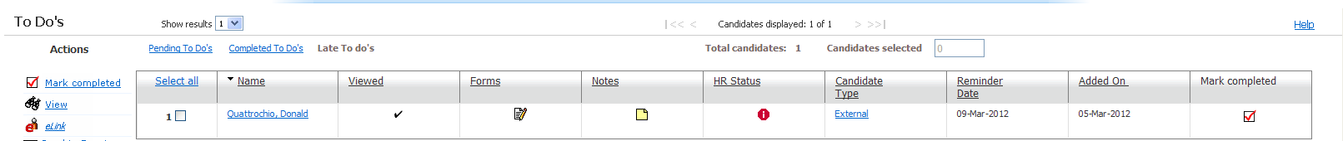
Figure 5- 6: To do’s

Initiating HR Status
The HR status describes where a candidate is in the hiring process. Visible within BrassRing, the HR status is also a significant communication tool upon which reporting metrics are based.
Companies usually identify each step or phase in their process and create an HR status to reflect each one.

Some examples of an initial HR status include:

- Applied
- HR review

HR Status History
The HR Status History is extremely helpful because it allows the user to see the other folders the candidate is residing in, the current HR status the candidate is on in that particular folder, the date the candidate was moved to the HR status, and the user who moved the candidate to that HR status (it also identifies if the system moved the user to the HR status). This information is beneficial if you are interested in pursuing the candidate.

The HR Status History column and its icon in the output grid are significant. If an icon displays in the column, it shows the Req ID for the req, other than the current req, with the most recent status update.

- A Yellow icon indicates that the candidate is assigned to an initial HR Status for the req number displayed in the column.
- A Red icon indicates that the candidate is assigned to an intermediate HR Status (for example passed the initial HR Status such as Phone Screen, Interview Scheduled, etc.) for the req number displayed in the column.
- A gray icon indicates that the candidate is assigned to a final HR Status for the req number displayed in the column.
- By clicking the hyperlinked number, a screen displays identifying the HR Status History for that candidate. Recruiters can also toggle between the Current status and Status history views on this page (Figure 5-8).

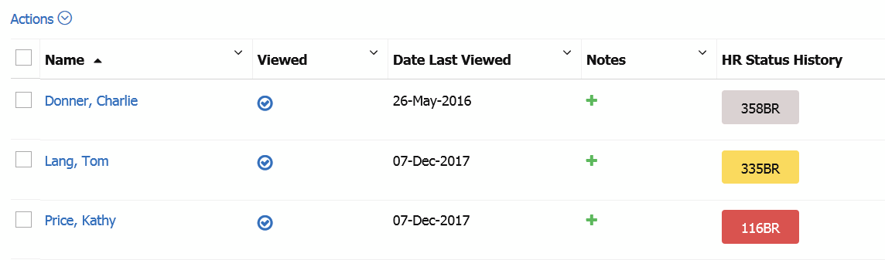
Figure 5- 7: HR Status History column

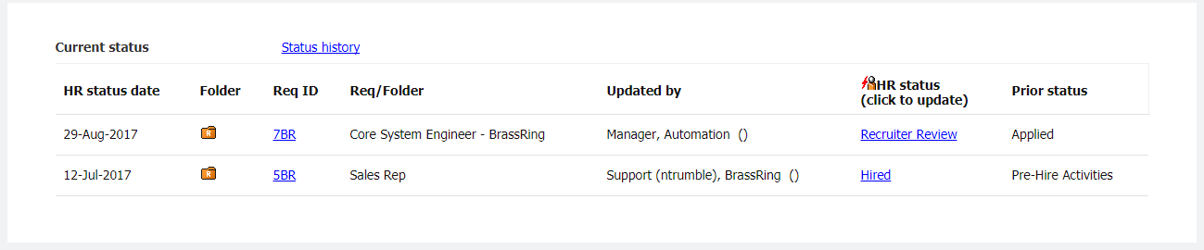
Figure 5- 8: HR Status History Page

- BrassRing displays the HR status in one of two ways: 1) in sequential order, so that you take a candidate through a defined progression of steps; or 2) in a complete list of all statuses, so that you can choose the most appropriate step and move between steps. Most organizations use option 1, as it facilitates more effective reporting on applicant flow.

Elements of HR Status
The following are important considerations regarding HR statuses:

- Designating an HR status is done from within a folder or as a candidate is being filed to a folder.
- The same candidate can move simultaneously through different hiring cycles within different folders, as the candidate might have applied to many jobs.
- Any member of a req or working folder can update the HR status of a candidate filed to that folder.
- It is possible to undo an HR status and go back to the previous HR status.
- If undoing an HR status moves a candidate to an HR status your assigned user type is prevented from seeing, you see the following message: An undo HR status action will not allow you to view this candidate. You can close the message at this point. This prevents you from removing the candidate from your view.
- To view historical status information about a candidate, open the candidate's profile and go to the HR status tab.
- Your company might have associated a BrassRing form with an HR status. For example, when you update a candidate to Phone screen, the Phone screen form might pop-up for you to complete in a new window.
- With the consistent, timely use of HR statuses, accurate reports can be generated.
- If enabled for your user type, when you update the HR status on a candidate, the candidate can be accessed from Candidates>My Candidates.
- Based on your User Type, you can or cannot view candidates assigned to certain HR statuses in req folders.
- Your company might have opted for a feature that states when specific HR statuses are assigned within a req folder, candidates are automatically sent an email message.

Initiating HR Status
To initiate or update the HR status for a candidate:

- From a list of candidates, click the link for the chosen candidate that is under the column HR status. The Update status screen displays the status options for the candidate.
- Click the appropriate HR status.
- Click Save to save the new status and close the screen.
- By clicking Advanced Options you can change the Action date which defaults to the current date, but a past or future date might be assigned. The Action date identifies the day the candidate was moved to the HR Status, it does not physically update the HR Status.
- If available, the field Notify users working with this candidate triggers a mass email to any BrassRing users who, like you, have that same candidate in an active folder of their own.

The new Status, Action date, and Date updated displays in the folder in which the candidate is filed. Refer to Figure 5-8 for an example of updating HR status.

- Your company has determined the HR statuses to be used within your organization. Therefore, if your organization is using multiple req templates, the initial/default HR status of 0-Filed might have been replaced by another option.
- The Action date is the date that the HR status was assigned. This date can be set to a past, present or future date. The day that the HR status is updated is also recorded within BrassRing.

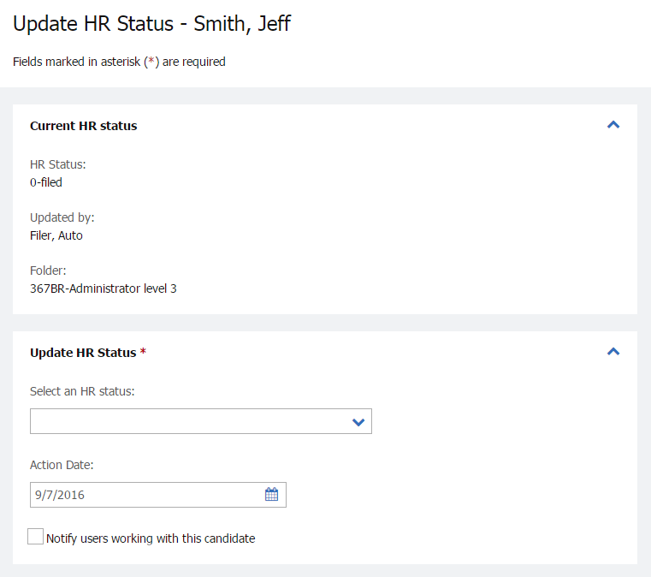
Figure 5- 7: Updating HR status

Update and Add Next
To process a candidate through several status levels at one time, you might use Update and add next. This processes the current update and refreshes the screen so you can immediately select the next HR status. To use update and add next:

- From a list of candidates, click the link for the chosen candidate under the column HR status. The Update status screen displays the status options for the candidate.
- Click Advanced Options.
- The Action Date might be adjusted to display the date the candidate went through/will go through that particular phase of your hiring process.
- If available, the field Notify users working with this candidate triggers a mass email to any BrassRing users who have that same candidate in an active folder of their own.
- Click Update and add next. The screen refreshes and allows you to move the candidate to the next HR status of your choice.
- When you finish assigning the last HR status you wanted to assign, click the Update HR Status button to close the window and return to the candidates listed within your req folder.

- If your organization opted to restrict your ability to view candidates assigned to specific HR statuses, you might still update candidates in a req to that HR status, but upon your browser refreshing, they do not appear in the req folder.

Candidate Tiers
Candidate Tiering allows customers to manage high volumes of candidates within one req folder. Tiering systematically divides up the candidate pool based on certain criteria, for example; proximity, candidate type, or assessment result band. Customers should contact their legal team before putting this process in place.

As candidates apply to a req, the rules determine each candidate’s tier. Users can view and disposition the first tier before seeing and screening candidates in succeeding Tiers. Candidates within the first tier appear in the Req folder until they have been moved into a final non-hire status. At that point, candidates in the next tier appear in the folder for consideration and disposition. This process continues with succeeding configured tiers. Your Workbench Administrator defines the Tiers in Workbench and configures the rules in Rules Automation Manager (RAM) and any exception processing such as changing the visible tiers within a Req folder.

An initiation period, in hours, is also defined for your req templates, and applies to Tiers 2 and succeeding tiers (3, 4, 5 etc.). This initiation period starts when the req is first posted to any Talent Gateway. Only candidates in Tier 1 can be seen during the initiation period. Tiers with order of 2 and succeeding Tiers cannot be seen at all during this initiation period. After the initiation period has elapsed:
- Tier 2 candidates can be seen once all candidates in Tier 1 were assigned to a final non-hire HR Status.
- When candidates no longer remain in Tier 2, candidates in the next Tier are shown. This process of opening new Tiers once no candidate remains in the previous Tier continues, with each succeeding Tier opening only after all candidates have moved out of the previous Tier. As long as one or more candidates remain in a Tier, the next succeeding Tier does not open.
- If a candidate is hired from a certain Tier, then no additional candidates in the succeeding Tiers are shown which means that they are not considered in the candidate pool.
- Users with privileges can update the visible Tiers any time, skipping the order of Tiers defined in the configuration.

- Candidates who have not been assigned a tier appear in the Req folder as “Not Specified.” These candidates are always in the Req folder regardless if the Tier is visible. They do not have to be dispositioned to a final non-hire status for the next tier of candidates to appear. Candidates added manually to a Req folder also have a status of “Not Specified”.

Viewing Candidates in Tiers in Req Folder
Users viewing a Req folder see a list of candidates in Tier that is considered visible at that time and candidates with no specified Tier (null Tier). See Figure 5-8.

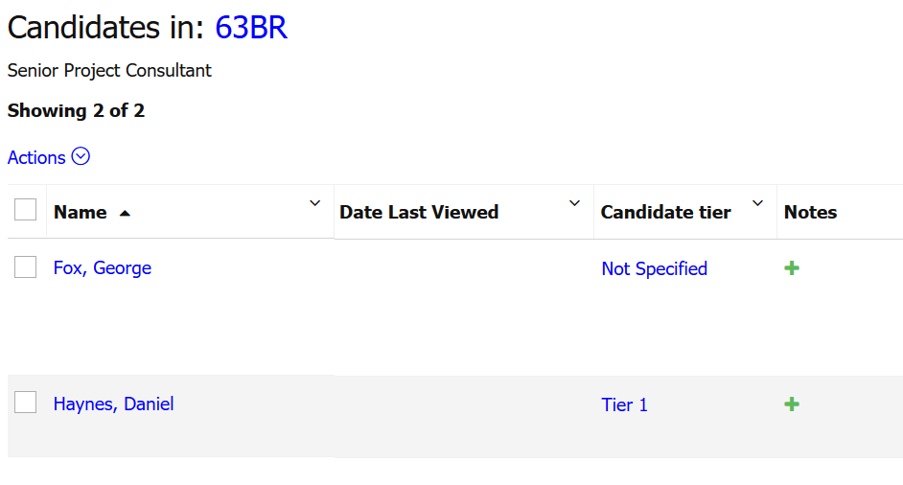
Figure 5- 8: Candidates in Tiers
The visible Tiers cascade such that if Tier 2 is showing, then null tier, Tier 1, and Tier 2 candidates all display. When all candidates in the last visible Tier are assigned to a final non-hire HR status, then the next Tier is automatically visible within the Req folder.

Changing a Candidate’s Tier when Candidate/Tier is Displayed
User types with permission can change a candidate’s tier:
- Click the Tier link in the grid (static text appears for users without permission). The Update candidate Tier page appears.
- Select a new Tier from the list of Tiers active for the req.
- Click Save.

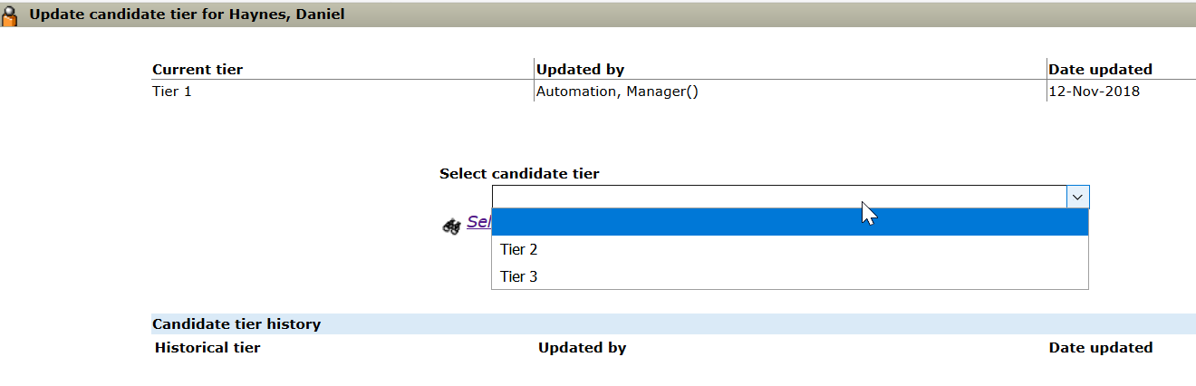
Figure 5- 9: Update Candidate Tier

Changing a Candidate’s Tier when Candidate/Tier is Not Displayed in Req Folder
When a candidate is not visible because his/her Tier is not yet opened, privileged users can update a candidate’s tier from search results:
- Search for the candidate.
- Click the Tier link in the Candidate Tier column for the View Tiers window to display.
- Update the Candidate Tier.

Making Different Tiers Visible for a Req
User types with permission can change the Tier that is visible for a selected req:
- Navigate to any req list and select an open req.
- Select the Edit visible tiers action (Figure 5-10). The Update visible tier screen displays.
- Select one of the active Tiers that is not yet visible and click Save.
- The Update visible tier screen closes, and the new Tier selected becomes the current visible Tier. Candidates in that tier and those in higher-order Tiers appear in the req folder. For example, when Tiers 1 and 2 were visible, selecting Tier 4 also makes Tier 3 visible.

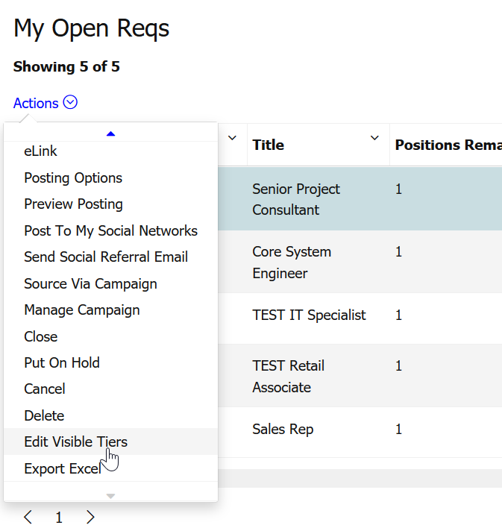
Figure 5- 10: Edit Visible Tiers

Chapter Summary
- The Output fields that display can be changed.
- You can document your conversations and email dialogues by adding notes.
- Notes are discoverable.
- The HR status icon allows the user to see the other folders the candidate is residing in, the current HR status of a candidate in a particular folder, the date the candidate was moved to the HR status and the user who moved them to that HR status (it also identifies if the system moved the user to the HR status).
- The HR status describes where a candidate is in the hiring process.

Check Your Skills
Answer these True or False Questions:
- The check mark appears in a list of candidates after you have viewed the Talent Record.
- The HR Status icon allows you to view the other folders in which the candidate is currently residing.
- When you set a reminder date on a note, a reminder is added to the to-do’s list.
- You can post-date an Action date while updating the HR status.

Complete the following hands-on exercises:
- Access a list of candidates in an open req.
- View the Talent Record of two candidates who are in the open req found in the last step.
- Initiate the HR status for one of the candidates.
- Add a note to the other candidate.

Chapter 6: Tracking Candidates

Chapter Overview:

BrassRing facilitates an efficient, online staffing process and centralizes communication between members of your staffing organization to both hiring managers and candidates. This is a key to helping you move candidates through the hiring pipeline efficiently. Two features that accomplish this are forms and eLinks.

You learned in Chapter 5 about screening candidates; now we look at how to manage the tracking of candidates through your hiring process within BrassRing.

Objectives:

At the end of this chapter you can:

- Access and complete a form.
- eLink a resume or CV along with a form.
- Review and respond to an eLink.
- eLink a blank form by itself to be completed by the recipient.
- Send email and letter correspondence

BrassRing Forms

You can add/complete and view your company’s completed forms within BrassRing. Forms are used to capture and store all types of information related to your hiring process. Examples of forms companies typically use include Phone screen, Interview evaluation, and Offer form. Similar to req forms, candidate forms are available in different language options.

Here is an example of a form:

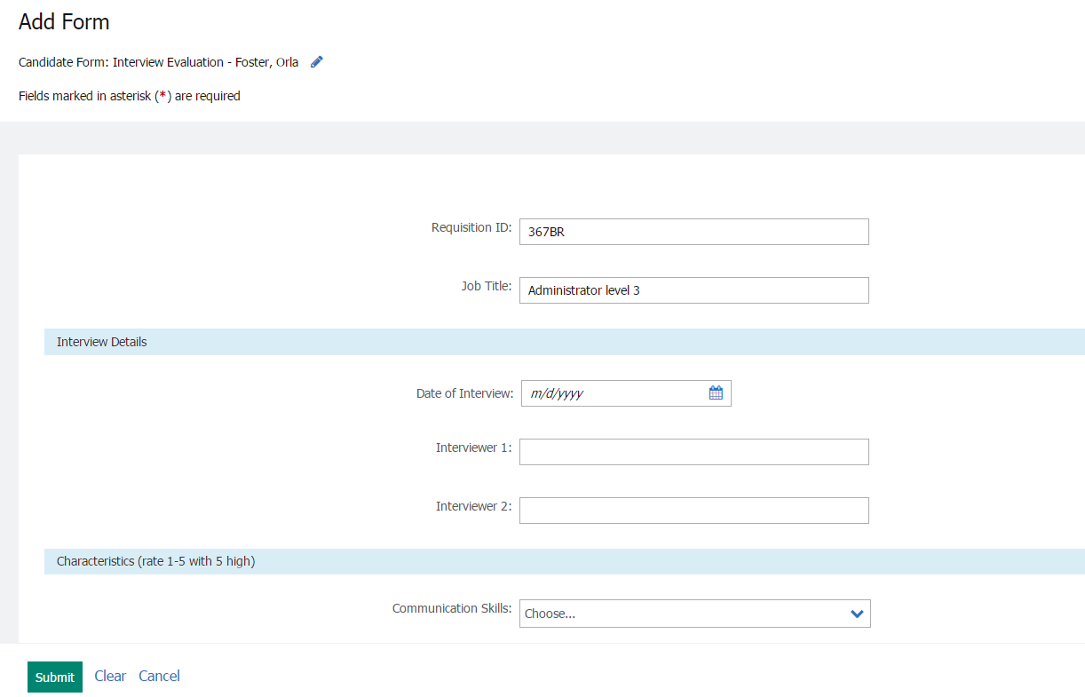
Figure 6- 1: A form

Elements of Forms
- Depending on your user type, you can or cannot view, update and delete certain forms.
- When an asterisk displays adjacent to a field on a form, the field is required.
- There might be some fields on your forms that are encrypted. This means that the information provided on that form is secure. Users with access to view or update a form with encrypted fields can view the decrypted value for the field.
- You can also send a form for someone else to complete. The action is called eLink blank form.
- Candidate form can be sent for approval e.g. Offer form. A communication template can be configured for standard approval emails. When the form is sent for approval, the user can edit the communication to include additional details.

Accessing Forms
Forms can be accessed in a few different ways:
- While viewing a candidate’s Talent Record, by using the Forms tab.
- By clicking the forms icon while viewing a req folder's candidates.
- While viewing candidate search results.
- While viewing an eLink.

Adding Forms
To add a form:
- From a list of candidates, click the forms icon .
- Select the form to add from the drop-down menu.
- Click the button marked Add. See Figure 6-2.
- Complete all required fields (*) and any appropriate optional fields, then click Submit.

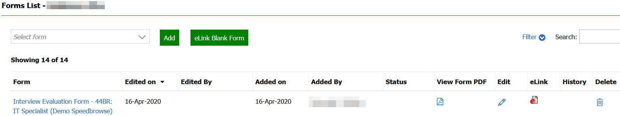
Figure 6- 2: Accessing and adding forms
- The View Forms PDF column is available to users with the appropriate user type privilege. Selecting the PDF icon opens the form as a PDF.
Sending a Blank Forms
You might use elinks to send a blank form to someone to complete, such as to hiring manager to complete an interview form.

To send only a form to be completed (not the form along with the resume or CV):

- From a list of candidates, click the forms icon .
- Select the form to send from the drop-down menu.
- Click eLink blank form. See Figure 6-3.
- Address the eLink as follows:
If receipt is a … | Then
User of BrassRing | Select the name from the System users list.
Not a User of BrassRing | Type the complete email address in the box provided for email address.
- Type a message to the recipient.
- Click Send. A confirmation message appears.

- Completed forms can also be eLinked to be viewed only. At the top of the Send eLink window, use the toggle labeled eLink form to: Select View.
- If applicable, when viewing a list of forms, select the history icon to display a PDF list of versions of the form along with dates and names of users that saved the form.
- Your company might have opted to use eLink Form Approval which allows you to route completed forms for approval. Requests for approval are sent to all recipients simultaneously by using eLink.

eLinking Candidates
Another step in the tracking process facilitated by BrassRing is getting information about screened candidates quickly without having to rely on getting paper documents into the hands of hiring managers for their review and comment. We accomplish this within BrassRing by using eLinks.

What is an eLink?
You can use eLinks to send resumes or CVs and forms to hiring managers by using email. Without logging on to BrassRing, hiring managers might perform actions such as:

- View resumes or CVs sent to them.
- Complete a blank form that was sent to them.
- Review an already completed form that was sent to them.
- Send comments back to the sender by using email.
- Review any file attachments that might have been included, such as the PDF of the candidate’s resume or CV.
- Suggest or update the candidate’s next HR Status.

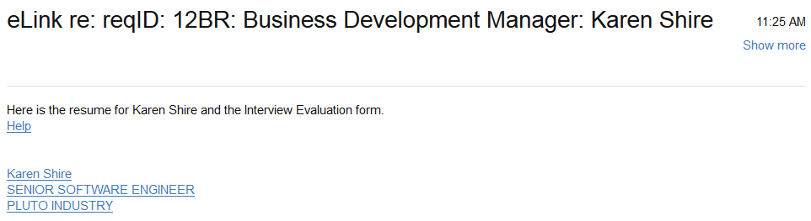
Figure 6- 3: eLink as it appears using email

- Your company might have opted to have eLinks be sent as attachments, rather than embedded in the text of the email, as we see in Figure 6-3.

When the recipient clicks on the link, the eLink launches. See Figure 6-4.

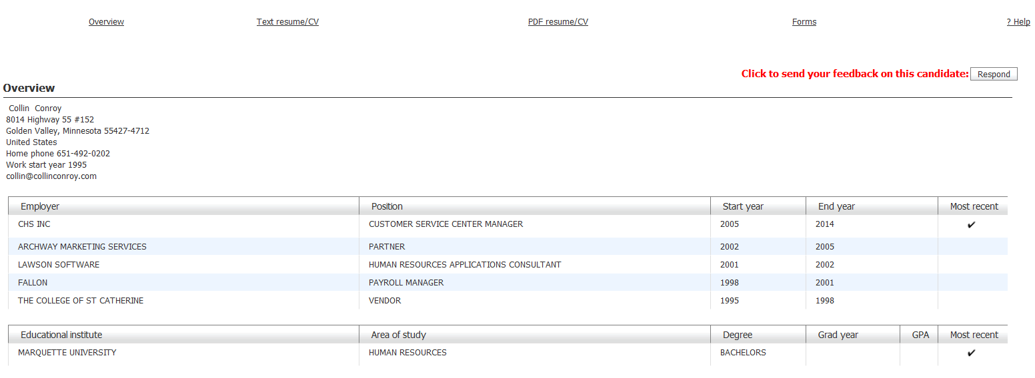
Figure 6-4: The candidate resume or CV eLink

Elements of an eLink
- When eLinking a candidate from within the req folder, the resume or CV (and, if the candidate uploaded their resume or CV when initially applying, the PDF version of that resume or CV) corresponding to the specific req submission is sent by default.
- BrassRing automatically records in eLink history the recipient’s name and the date the eLink was sent, viewed by the recipient and responded to by the recipient.
- The recipient’s response might also be automatically recorded in the eLink history section of the candidate’s Talent Record; if your company has activated this feature.
- The sender of the eLink receives confirmation of receipt email and an email with the recipient’s response to the eLink (once the recipient responds).
- If sent by the BrassRing user, notes are visible based on the User type settings of the recipient (Quick Start User type).

- You can send an eLink while viewing a resume or CV anywhere within BrassRing.
- Both you and the eLink recipient should have the pop-up blocker off to view PDFs.

Sending an eLink
To send an eLink:

- From a list of candidates, select the checkboxes for those candidates you want to send by using eLink.
- Click Send eLink by using the Actions menu.
- Address the eLink as follows:

If receipt is a… | Then
User of BrassRing | Select the name in the system users list.
Not a user of BrassRing | Type the complete email address in the email address field.
- The Subject field contains default information, but it can be changed.
- In the Your message field, you can add a message which is viewed by the eLink recipient of the eLink and located in the body of the email.
- The Forms to complete field include blank forms that must be filled out by the recipient of the eLink. If you include forms to complete, you want to check the field to Notify me when these forms have been submitted. This ensures you are sent a confirmation message by using your email once the forms have been completed and thus returned to BrassRing
- The Forms to view field include is an auto-complete field and includes a list of completed forms that are assigned to each candidate ⎯ the forms are for viewing only, not editing.
- Decide if you want to Include HR status and click that checkbox if you do. This shows the recipient all the folders the candidate you are sending is filed to, what their HR status is within those folders, and which recruiter is assigned to them. If your company is using the feature, the recipients can also update or suggest the next HR statuses of the candidates you are sending.
- If you would like to include Notes, Associated Document sub Forms, or Req Information, put a check mark in the applicable boxes.
- Click Send.

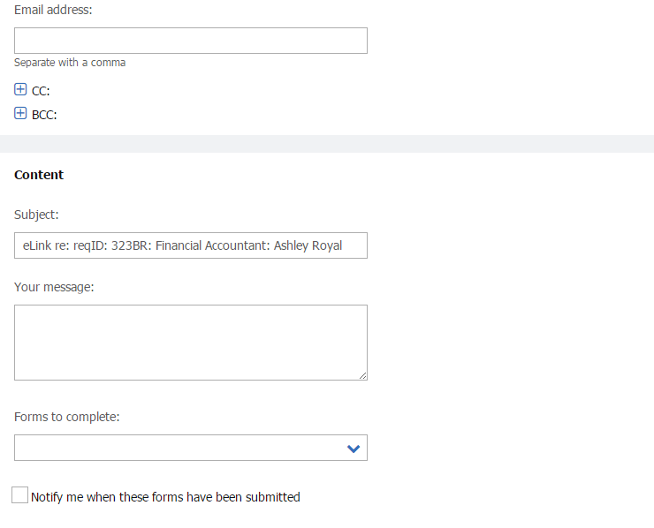
Figure 6- 5: Sending an eLink

- If your company opted to enable the eLink Cc/Bcc feature, then you might copy or blind carbon copy recipients when sending eLinks. Copied recipients receive an email containing a summary of the original eLink details (e.g. who received it, what forms were attached, etc.).
- If an eLink has been sent from search results, My Candidates, the Inbox or Working folders, the most recent resume or CV is sent, unless the sender explicitly selected a different duplicate to send.

Reviewing eLinks
To review and respond to an eLink:

- Open the email message. Click the link composed of the candidate’s name (and any additional information, such as title and employer). This launches the eLink in your web browser.
- Click the Overview, Text resume or CV, PDF resume or CV, Forms, Notes or HR Status tabs to access the information the sender included.
- To complete a blank form or view a completed form, click Forms. Refer to Figure 6-6.
Click the form name to either view or complete the forms sent. When you complete a form, the information is automatically updated in BrassRing.
- When you have finished reviewing the eLink, either close the window as you normally would, or click Respond to send comments back to the sender by using email.

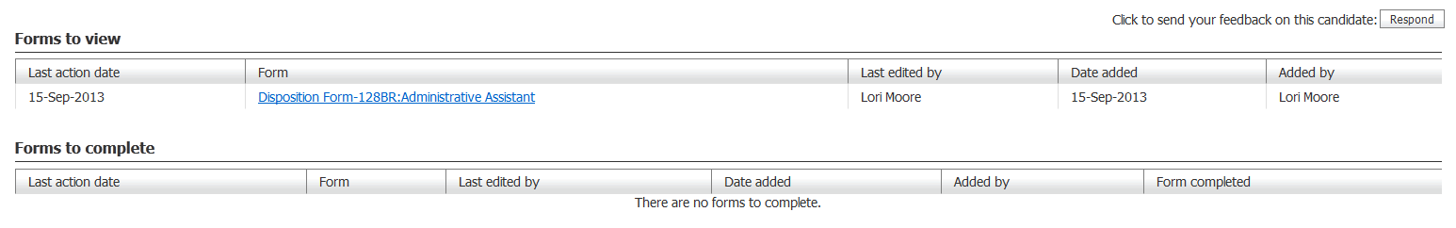
Figure 6- 6: Reviewing the Forms section of an eLink

- If your company opted to enable the PDF to be the default when an eLink recipient opens an eLink, that image would display, as opposed to the text version of the resume or the overview of the resume data. In addition, the PDF only displays where the most recent resume or CV was submitted using the Upload option.
- If an eLink is expired and the user selects it, the user sees the message: We’re sorry; the link to this page is no longer valid.

Responding to eLinks
To respond to an eLink:

- Click the link in your email to open the eLink. Click the button marked Respond located in the top right of the window.
- If available, suggest the next step from the Request drop-down menu. See Figure 6-7. The selection made here does not update the HR status in BrassRing, as this is the recruiter’s role within BrassRing.
- To add a message, type it in the Note text field and, if available and when appropriate, check the Save this text as a note option to add the text as a note in the candidate’s Talent Record.
- Click Send.

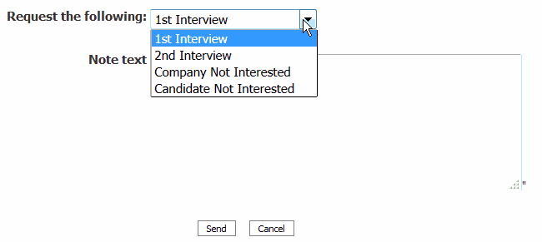
Figure 6-7: Responding to an eLink – replace screen capture

- If an eLink has been sent from search results, My Candidates, the Inbox or Working folders, the most recent resume or CV is sent, unless the sender explicitly selected a different duplicate to send instead.
- When a recipient selects an option in Request the following, the sender receives an email with that information. The candidate’s HR status is not updated.
- Your company might be capturing hiring manager’s comments in the eLink history section of the Talent Record.

Sending Communication
The Communications module provides you with the ability to send correspondence to candidates directly from within BrassRing. You can send an email template, generate and print a letter using MS Word, or submit a letter for batch processing by a colleague or yourself later.

Elements of Communication
The following are important details regarding Communications:

- The email, document and letter templates have been defined by Super Users at your company.
- Blurbs are pieces of frequently used text created by Super Users that can be inserted into an email message.
- BrassRing forms and links to job details posted to a Talent Gateway can be sent as part of the email templates the Super User maintains.
- Email, Documents, and Letters can be sent to up to 200 candidates simultaneously. Each email recipient receives an individual email.
- Letters are created by merging an MS Word™ document with information provided on BrassRing forms and candidate profiles.
- Documents are created with MS Word™ or Text Editor and pull information provided on BrassRing forms and candidate profiles.
- View a candidate’s Correspondence history by clicking the tab marked Communications within a Talent Record.
- You can either generate a letter to print it yourself to send or direct it to a folder for batch processing later.
- Emails can be personalized before they are sent. Letters can be personalized after they are merged into MS Word.
- Documents can be personalized before they are saved to PDF, on a candidate’s Talent Record, and either emailed to a candidate or posted on the Candidate Zone.
- Offer letters can be set by Super Users so that they are visible only to req team members.

Sending a Communication Template
BrassRing allows you to easily send email to candidates by selecting an email template. These templates contain embedded greetings, merge tokens, Talent Gateway job links, forms and attachments for messages you frequently send to candidates, such as a Thank You after interviewing.

To send an email:

- Select a candidate from the list and click Send communication by using the Actions menu.
- Select the appropriate template from the Communication template field and click the button marked Go to the right of the drop-down. Refer to Figure 6-8.
- The email template appears. Confirm and complete the From and Subject lines, and the email’s Message Body text. Use the text editor and spell check options to assist you. Refer to Figure 6-10.
- Select any attachments you might want to upload and include with your email. Any attachments you can upload to the email are available in the Upload attachments from Talent Record field on the bottom right of the email template. Refer to Figure 6-11. Select the attachments you would like to attach and select the Upload button. The selected attachments appear in the box below the upload button.
- To upload multiple attachments as a compressed file. Go to the Upload attachments section of the page and click Select Multiple Attachments. On the Select Files to Upload window, select Browse and go to the directory that contains the files you want to attach. Right-click to open the Select menu, select Send to > Compressed (zipped) folder. The compressed file is saved in the same directory, where you can rename it. Select Open. The file path name is added to the browse field in the Select Files to Upload window. Select Upload. The compressed file is added to the attachments grid.
- Select a Super User-defined Blurb of text or Link to jobs on Talent Gateway to insert into your message.
- Under Candidate and Merge Information, the applicants you selected display. If an email address does not exist on the candidate’s Talent Record you see the default email address of communication-archive@brassring.com. This address automatically adds the communication you are sending to the candidate’s Message Archive section within the Responsive Talent Gateway Candidate Zone.
- Click Preview if you want to review your email before sending.
- Click Send. The Preview and Send buttons are disabled after sending the communication to avoid sending the same communication multiple times.
- Click OK.
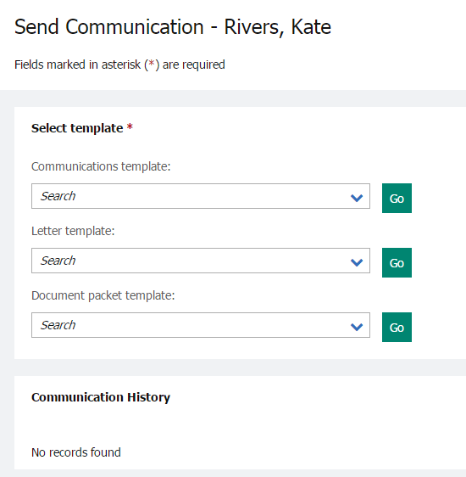
Figure 6-8: Selecting email template

- A candidate’s email address populates only if one was provided by the candidate while filling out their contact information. If no resume was provided, you see communication-archive@brassring.com instead.
- You know a form is included in the email template if the checkbox Notify me when this form is submitted appears.
- Your company might have configured an email communication to be automatically sent, with or without a form, to a candidate once a candidate has been filed to a req folder.
- When a user sends a communication on a requisition that is available in multiple languages, a new page is displayed in which the user can select the language of the communication.

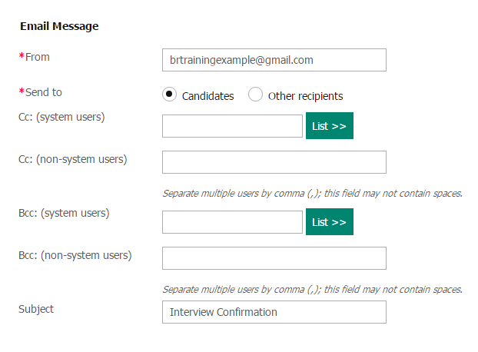
Figure 6- 9: Sending an email

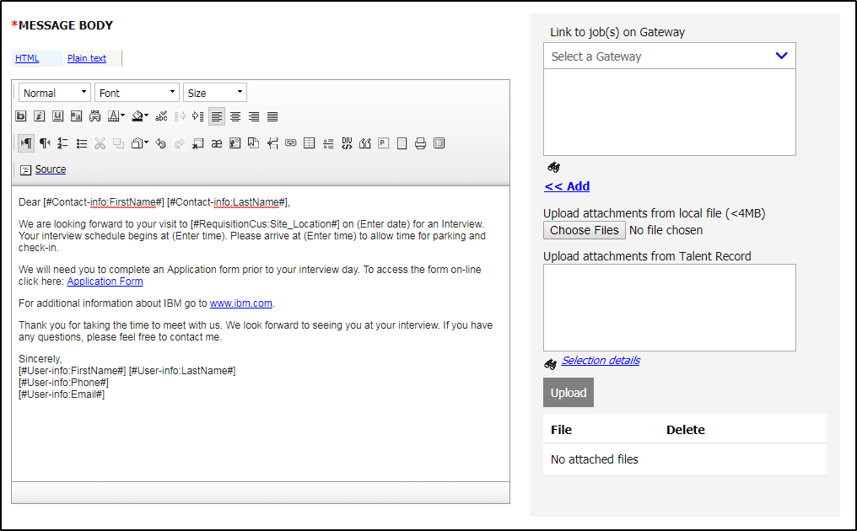
Figure 6- 10: Adding an attachment to an email

When sending an email template to multiple candidates, each candidate receives an individual email and is not copied on the others' correspondence.

- Should you decide not to use an email template when communicating with the candidate, you might select the Send candidate ad hoc email option from the Actions menu to create your own email. A copy of the email is stored on the Candidate Talent Record under the Communication Tab.

Sending a Letter
Sending letters is similar to sending email templates with one exception. With Letters, information entered on BrassRing forms merges with pre-formatted document in MS Word™.

To generate and print a letter to send:

- Select one or more candidates from a list of candidates.
- Click Send communication by using the Actions menu.
- Select the appropriate Letter template. See Figure 6-12.
- Click Go. The Send communication screen appears.
- If there are fields missing that need to merge into MS Word, click link of the number if missing fields, then click the Edit/Add icon. Refer to Figure 6-13.
- Complete the missing fields.
- Click Continue.
- (read the note to the right regarding your pop-up blocker) To print the letter immediately, select Generate Letter now OK. Refer to Figure 6-14 for a preview.

- Contact your Super Users/System Administrators to make comments or suggestions about email or Letter templates.

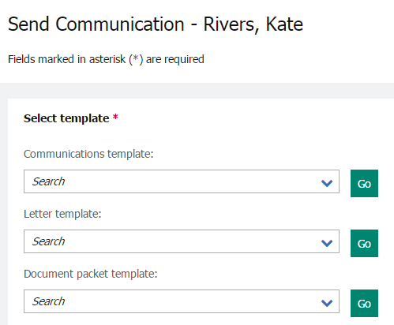
Figure 6- 12: Selecting a letter template

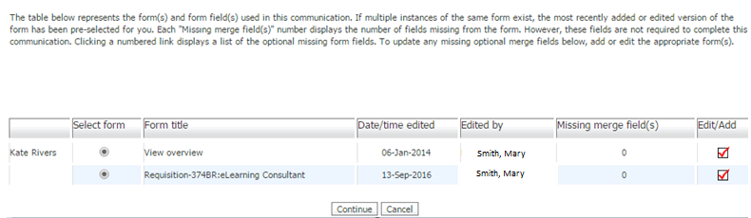
Figure 6- 13: Missing mail merge fields

- If your pop-up blocker is on, it prevents MS Word from launching when you click Generate letter now. To override the pop-up blocker, hold the Ctrl key down until you see MS Word launch and you see the letter appear.
- Should you see a numeric value under the column heading marked Missing merge fields, it means a fields deemed required for the letter to be generated by a Super User is missing. To determine what the field is, click the numeric value under Missing merge fields, then use the Add icon found under Edit/Add to insert the missing value.
- Your organization can elect to restrict access to offer letter attachments to only members of the Req team, meaning: they can see, attach, and send the offer letter as an attachment by using email to the candidate and subsequently view the offer letter on the candidate’s Talent Record. Non-req team members see the attachment as an inactive link.

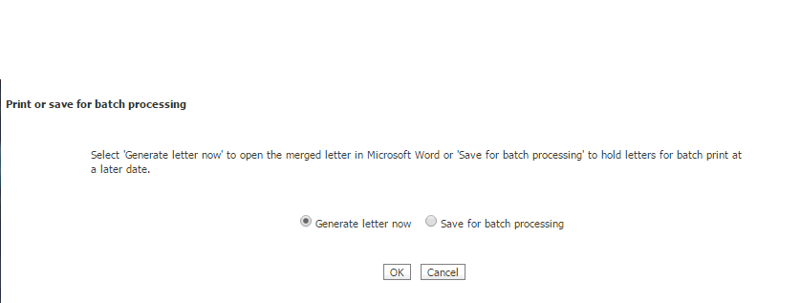
Figure 6- 14: Sending a letter
It is also possible to send a candidate’s Letter for batch processing, using the option Save for batch processing in step 8 on the previous page. With this option, there is usually someone identified in the organization who processes these letters on a regular basis.

- You might also choose to Save for batch processing. Typically, someone is identified within the organization to manage batch processing.
- Navigate to batched letters from the Hiring Navigation icon , click Admin Communications Batch Letters.

Send Communication History
The Send Communication History screen provides you with a list of communication that was sent for a candidate.

To access the Send Communication History Screen (Figure 6-15):

- Select one or more candidates from a list of candidates.
- Click Send communication by using the Actions menu.
- The Send Communication History screen is available at the bottom of the page. You can select the following options to filter the communications:

Candidate – This filter option is selected by default when a BrassRing user views the Send Candidate Communication screen. Communications shown in this filter where sent to the specific candidate that you have accessed.

Other Recipients - This filter option allows the BR user to view communications sent to recipients other than the candidate, such as a communication to the HM to review the candidate's Talent Record.

Event Manager – This filter displays all communications sent from the Event Manager tool to the specific candidate.

All - Displays all communications sent, regardless of who the recipient was.

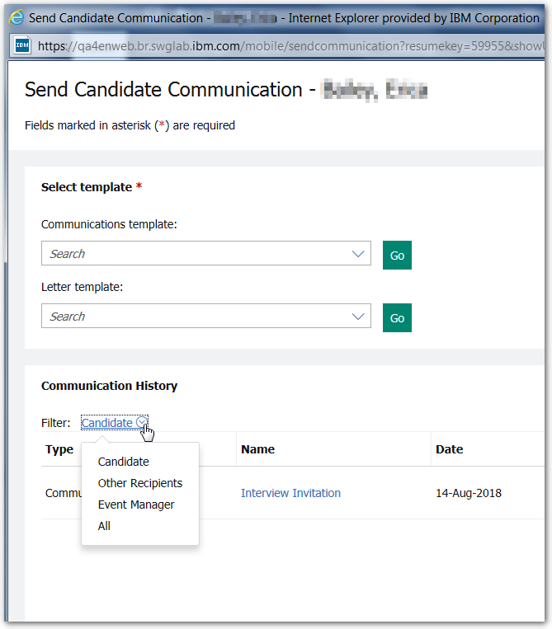
Figure 6- 15: Communication History

Document Template
Document Templates allow users to create a ‘read only’ pdf version of a document. Once the document is created it is stored in the candidate’s Talent Record under the Attachments section. The document can then be attached to an email communication and sent to the candidate, printed off, or posted to the candidate zone.

Create a document for candidate
If your organization has implemented this feature, you can create documents for candidates directly from the Talent Record Actions menu for candidates who are filed to req folders.

- From within a req folder, select the candidate from a list of candidates.
- Click Create Document by using the Actions menu. See Figure 6-16.
- Select a document template from the list and click Go.
- The Create document page displays.
- Enter a unique name for the document in the Document name field. Your administrator might have included a pre-populated document name when creating the template, so this step might not be necessary. This field is required.
- Resolve discrepancies in the Candidate and merge information section, if any. See Figure 6-17.
- Click Preview to see what your document looks like when printed. Click the X to close the preview window.
- Click Save as PDF to create a PDF version of the document. See Figure 6-17.
- Click Close to close the Create document confirmation message window.
- Back on the candidate output grid, click the hyperlinked name of the candidate for whom you created the document to open the candidate's Talent Record.
- Click the Attachments tab to see the document you created that is stored on the attachments grid.
From there you can:
- See information about the document.
- Click the document to view it.
- Select a category for the document.
- Delete the document.

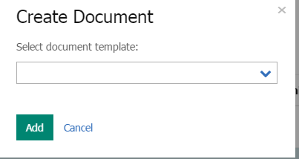
Figure 6- 16: Selecting a document template

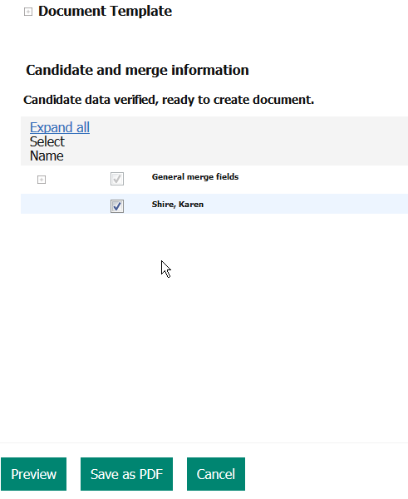
Figure 6- 17: Viewing Candidate Merge Information / Saving a document template as a PDF

Attaching the document to an email template
Once the document is created and saved it is stored as an attachment and available in the candidate’s Talent Record. The document can be attached to an email template and sent to the candidate.
Note: Since the document is a pdf read only file, the candidate cannot edit the document.

To send an email template with the document attached:

Follow steps 1-8 under the section Sending an email template.

Candidate Zone
The candidate zone provides a secure offer process and location where candidates can retrieve, review, and respond to offer documents. The following steps explain the process:

- When an offer letter is ready, the BrassRing user can post the document out to the Candidate Zone and send the candidate an email.
- The designated candidate who receives the email (with an eLink to the secure Candidate Zone), can log in to the Candidate Zone with the same login credentials (username and password) used to apply to the position. If the candidate did not create a profile or did not apply directly through the Talent Gateway, your organization might have elected to allow candidates to log in with other criteria. For example, their email address might be their username and their zip code might be their password.
- The Candidate Zone stores a link to the PDF version of the Offer Letter and to the corresponding response form to record the acceptance or decline of the offer.
- The Candidate Zone can also be used to display candidate forms to the candidate for completion, and other attachments specific to your organization’s hiring process.

Note: Your organization might use an Offer Form that is triggered when a specific HR status is assigned. This form might include fields used as merged fields on the Offer Document.

Posting an Offer Document
To create a document template (Offer), review the previous section entitled Create a document for a candidate for detailed instructions. Once the document template (Offer) is successfully saved, you can immediately post it to the Candidate Zone.

- For the question Want to post this Document and Items to the Candidate Zone, click the Go button. See Figure 6-18.
- On the Post to Candidate Zone screen, select the checkbox for the document template (Offer) you created.
- Optional – you can add a removal date when posting the document template to the Candidate Zone. You can also include additional attachments or candidate forms if necessary.
- Click the Post to Candidate Zone button. See Figure 6-19.
- An alert message appears that asks if you want to continue. Click OK.
- On the Post to Candidate Zone Confirmation page, review the section for: Unsuccessful Candidate Zone Postings and TG Candidate Profile Errors. See Figure 6-20.
- Optional – The Update HR status for successful candidates link allows you to update the HR Status of the candidate.
- Select a communications template to be sent to the candidate and click Go.
- The communication template appears for your review. Make any necessary changes.
- Click Send.
- On the send confirmation page, click OK.

The candidate now receives a notification that the offer was posted on the candidate zone for review and either accept or decline.

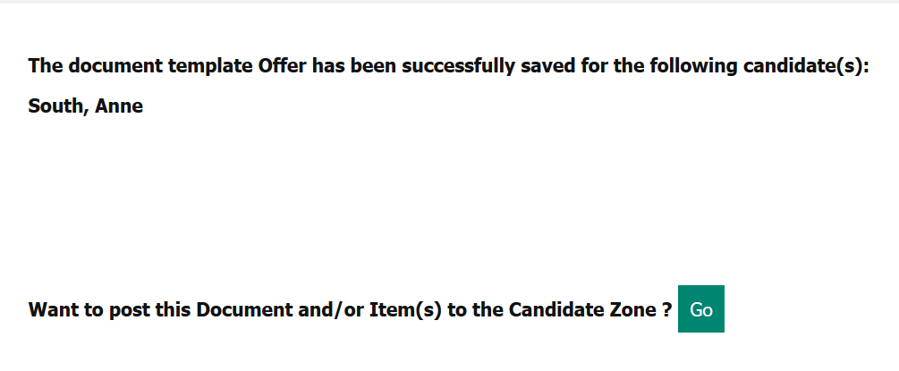
Figure 6- 18: Post this Document and Items to Candidate Zone

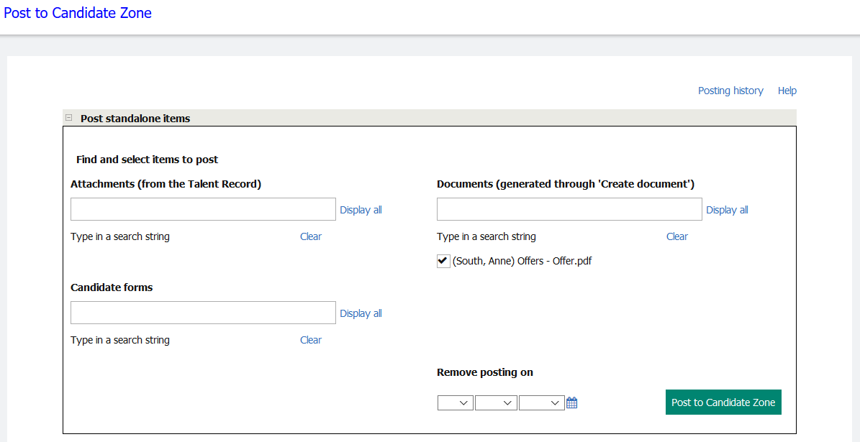
Figure 6- 19: Select items to post

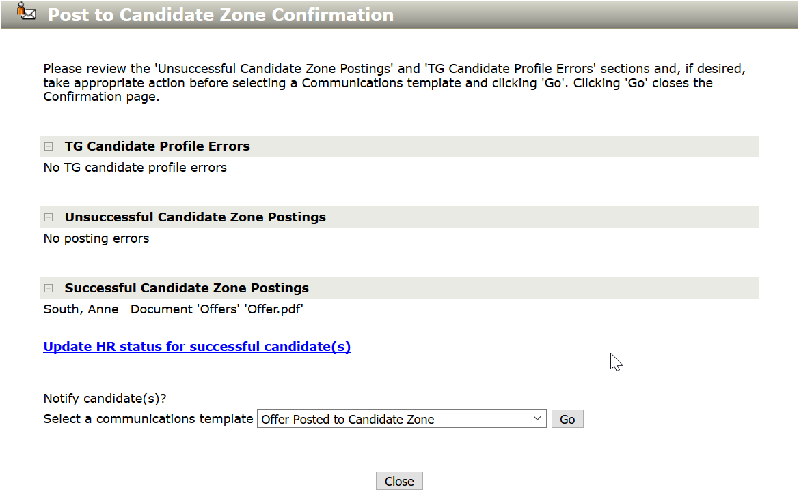
Figure 6- 20: Post to Candidate Zone Confirmation

Posting an Offer Document Packet
The following steps allow you to post the offer document packet to the Candidate Zone:

- Select the checkbox for the candidate who should receive the Offer document
- Click Send Communication in the Actions menu.
- Select the Offer document from the Document Packet Template and click Go.
- Add the name of the document in the Subject field. Your administrator might have included a pre-populated subject when creating the template, so this step might not be necessary.
- Make any changes necessary to the Instructions text.
- From the Upload attachments from Talent Record window, select the Offer Document and click the Add button to move the document to the Selected documents window.
See Figure 6-21.
- Click the Post to Candidate Zone button. See Figure 6-22.
- Once you click the Post to Candidate Zone button, the offer document (which is a PDF file) is posted to the Candidate Zone and available to the candidate.
Note: The Offer document is also available on the Action Log of the Candidate Talent Record.
- If applicable, a screen appears allowing you to send a communication template to the candidate. Select the appropriate communication template to send the candidate.
See Figure 6-23.
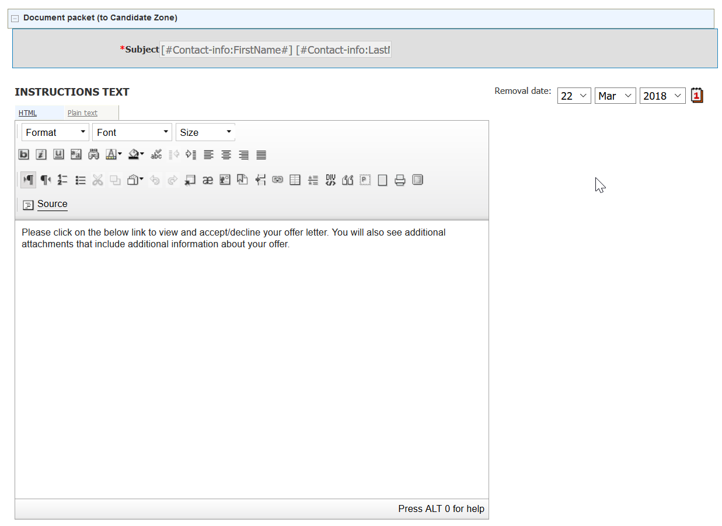
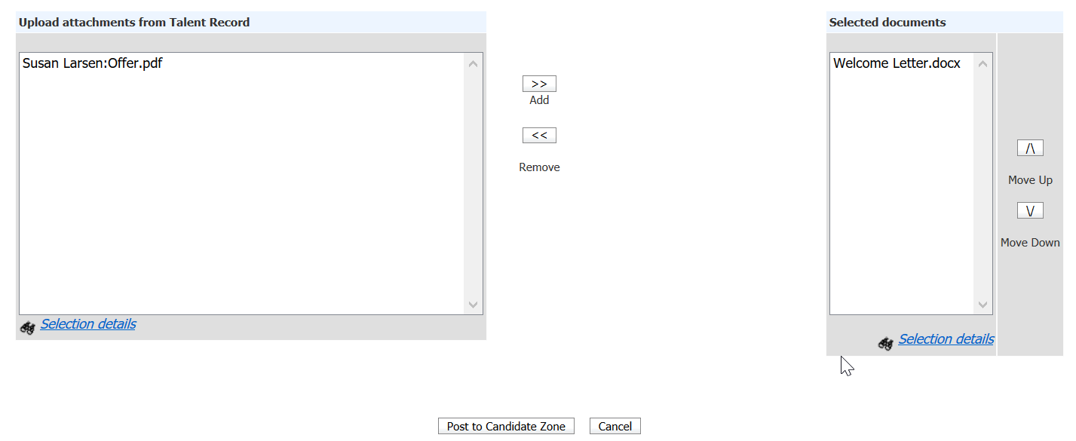
Figure 6- 21: Offer Document from the Document Packet Template

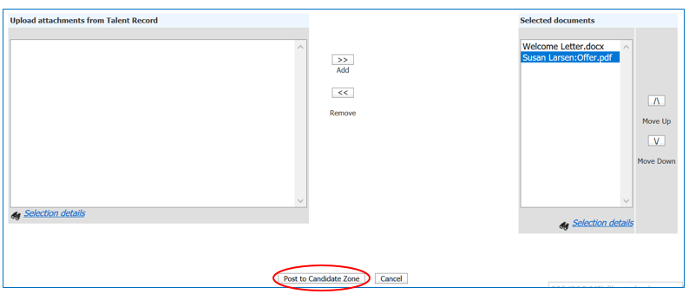
Figure 6- 22: Post the Document to the Candidate Zone

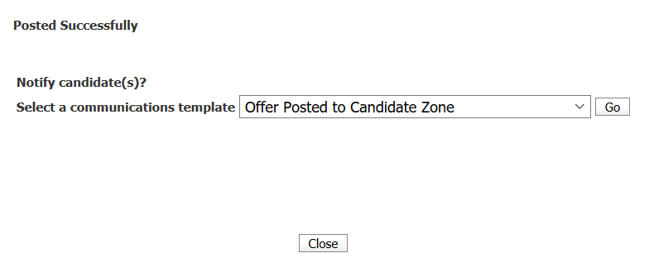
Figure 6- 23: Select Communication Template

Send the Communication to the Candidate

When you are ready to send the Offer email, navigate to the Req folder and select the candidates to whom you are extending the offer and click the Send Communication in the Actions menu.
- Select the email template to be used for the email communication that lets the candidates know about the extended offer and where to access it.
Note: You might want to add the Candidate Zone merge token [#Candidatezone:Candidatezoneurl#] which allows the candidate to click a link in the email to access the offer posted on the candidate zone of the Talent Gateway.
- Once the candidate receives the email, they can either click the link or log-into his/her profile on the Talent Gateway to view and accept or decline the offer. See Figures 6-24 and 6-25.
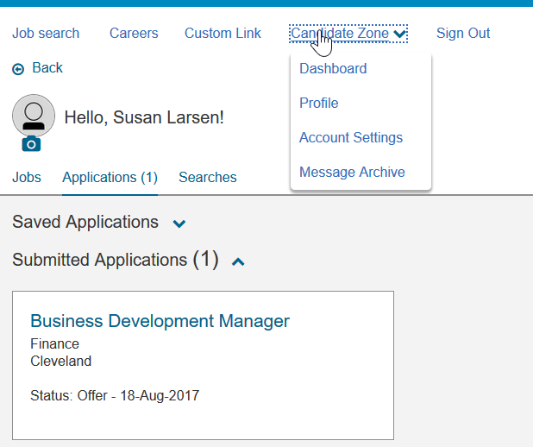
Figure 6- 24: Access the Candidate Zone from the Talent Gateway


Figure 6- 25: View the Offer to either accept of decline

Chapter Summary
- BrassRing forms are used to capture and store all types of information.
- Depending on your user type, you can or cannot add, view, edit and delete forms.
- eLinks allow you to send resumes or CVs and forms to hiring managers by using email.
- The sender of an eLink receives a confirmation email and an email with the recipient's response, if the recipient responds.
- When an eLink is responded to, the sender receives the information by using their email.
- It is possible to eLink a blank form by itself, without the resume or CV.
- Email templates can be sent to multiple candidates at the same time; the email is sent to the candidate as an individual email.
- The history of Communications sent to candidates is readily accessible by accessing the candidate’s Talent Record.

Check Your Skills
Answer these True or False Questions:
- You can send a form by using eLink without the resume or CV.
- A form can automatically pop up when an associated HR status is assigned.
- You can tell if a hiring manager has opened an eLink.
- You can only eLink one resume or CV at a time.

Answer the following short answer questions:
- What information is automatically added to eLink History when sending eLinks? Hint: It is located in the candidate’s Talent Record.

Complete the following hands-on exercises:
- Add a form to a candidate in one of your folders.
- Send an eLink to your own email address.
- Check the eLink history for the candidate you eLinked to confirm the email address.
- File two candidates in a working folder to one of your req folders.

Chapter 7: Closing the Hiring Cycle

Chapter Overview:

To help streamline your workflow, BrassRing can automatically close a req for you and prompt you to complete the applicant tracking for the candidates within the req folder.

There might also be forms for you to complete, such as a disposition form, or other final steps determined by your company’s specific hiring process.

In this chapter we review the steps to close the hiring cycle by updating candidates’ HR statuses and closing the req.

Objectives:

At the end of this chapter you can:

- Take candidates through the hiring cycle.
- Close a req.

Continuing the Hiring Cycle
Companies create HR statuses to indicate where a candidate is in the hiring process. Best practice is to update the HR status for each candidate in a req folder to a final disposition. Basically, this means that you either hired the candidate for the req, or you are no longer interested in the candidate. The HR status should reflect this.

Examples of continuing/intermediate HR statuses include:

- 1st interview
- 2nd interview
- Offer extended
- Background check

Final Disposition
Updating the statuses of your candidates is important for two reasons. By keeping your candidates’ HR statuses up-to-date, others can easily access this information and decide whether to pursue a candidate you are no longer considering. Also, many of the BrassRing reports your organization might run are based on HR status. Keeping this information current is a key to maximizing the usefulness and validity of these reports. Statuses are also used to determine which HR Status Category is shown to a candidate when they are reviewing their job submissions on the Responsive Talent Gateways. Keeping the statuses up-to-date ensures your candidates are informed of where they are in the hiring cycle.

Typical examples of final dispositions companies use include:

- Not Interested – Candidate
- Not Interested – (Company Name)
- Offer Declined
- Offer Accepted
- Hired
Most companies opt to have the Candidate type for a hired candidate automatically change from External to Internal. Once you have extended an offer, and it is accepted by the candidate you are hiring, you should assign a final HR Status to the candidate and close the req.

- To ensure accurate reporting, be sure to update all candidates in req folders to a final status.
- BrassRing shows the most recent date Hired was assigned for employee referral candidates who originally worked for your company, left your company, and were rehired.

Closing a Req
In BrassRing, there are two ways to close a req: automatically with Auto-close, or manually by the user.

Auto-Close
Your company might have decided to have BrassRing help streamline the updating of candidates’ final dispositions and the closing of reqs by using Auto-close. Once all positions have been filled for a req, BrassRing automatically closes the req for you.

However, if all candidates in the req folder are not at a final status, BrassRing prompts you to first disposition those candidates before closing the req.

Keep in mind the following when using Auto-close:

- Your organization might be using more than one final status to trigger BrassRing to Auto-close a req.
- When updating remaining candidates to their final statuses, a Disposition form might appear. Completing it attaches the same form (and the reason for not hiring) to each of the remaining candidates in the req folder. Yet, the reasons for not hiring specific candidates might be different for each.
- To complete Disposition forms independently for each candidate, either add any necessary forms to candidate Talent Records before beginning the Auto-close process, or use the checkboxes to deselect those candidates for whom the HR status and the reason does not apply.
- Auto-close refreshes the page allowing you to update the remaining candidates to a different HR status and add a Disposition form with different reasons for not hiring them. Repeat this process until all candidates are at a final disposition status and have their disposition form associated with them.
- BrassRing prompts you to take each candidate to a final status, skipping any intermediate HR statuses and forms within the hiring process, which might impact reporting.
- If choosing to stop Auto-close to first complete forms, you need to update all other statuses, and close the req manually.
- Once a req is closed, HR status cannot be changed for the candidates in that req folder. To update or change candidate status, you need to re-open the req. This can be done by re-opening the req from your list of closed reqs.
- When a req is closed, it is automatically removed from any Talent Gateways.

- Typically, only Super Users can remove candidates from Req folders.

Closing a Req Yourself
If your company is not using Auto-close, or you need to close a req separately from Auto-close, you can close reqs yourself provided you are designated as req creator, Recruiter, or Req team member.

To close a req yourself:

- From Hiring Navigation icon , click Reqs View My reqs Open.
- Select the req to close.
- Click Close from the Actions list. A new window appears. See Figure 7-1. If you click Yes, BrassRing removes the Talent Gateway postings.

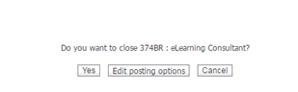
Figure 7- 1: Closing a req

Canceling a Req
Instead of closing a req, it might be more appropriate to cancel a req. For example, if your organization has a change of headcount or the budget for the position is withheld. Canceling a req is a more accurate option in such cases.

To Cancel a Req
- Select the req to cancel.
- Click Cancel from the Actions list. A new window appears. See Figure 7-2. If you click Yes, BrassRing removes the Talent Gateway postings.

Figure 7- 2: Canceling a req

Chapter Summary
- A req can be closed automatically by BrassRing using Auto-close, or manually by the user.
- Best practice is to update all candidates in a req folder to a final status and complete the disposition form.
- Your company might have opted to have a candidate’s Candidate type update to Internal when the candidate is hired.
- Auto-close prompts you to update the HR statuses of all your candidates and then closes the req for you. This removes the postings from your Talent Gateways.

Check Your Skills
Answer these True or False Questions:
- Updating all candidates to a final status helps you build accurate reports.
- It is best to wait until after the req is closed to complete forms for candidates.
- Once a req is closed, it can never be re-opened.

Perform the following hands-on exercises:
- Move one of your candidates through your HR cycle to a status of No Interest. You can cancel out of any forms that might pop-up

- Next, move another candidate through your HR cycle to a hired status. You can cancel out of any forms that might pop-up. If using Auto-close, walk through the process of closing the req.
- Undo the final status for the person you Hired as if that person did not actually show up for the first day of work.
- Close a req manually.

Chapter 8: Getting Organized

Chapter Overview:

Folders in BrassRing are similar to the folders in your desk drawer or the electronic folders in your email program. Earlier, we learned that there are permanent req folders for each job req, allowing you to track candidates through your applicant flow.

You can add a second type of folder, known as working folders, to help organize potential candidates and build talent pipelines when you are sourcing.

Unlike other folders you might use today, BrassRing folders can easily be shared to streamline communications and tracking within your organization.

In this chapter, we focus on organizing your candidates through the use of folders in BrassRing.

Objectives:

At the end of this chapter you can:

- Identify the three different folder types.
- Navigate to your open req folders.
- Add a working folder.
- Inactivate a working folder.
- Edit a working folder.
- Delete a working folder.

Overview of Folders
Have you ever considered that your ideal candidate might have applied to another position at your company, and his/her information is resting in a folder on someone else’s desk?

BrassRing provides you access to your company’s entire candidate pool, using Search, found in the Candidates menu. The folders in BrassRing allow you to set aside a copy of those candidates sourced from the pool that you want to track and organize for your positions.

Benefits of Organizing with Folders
- Req folders provide a permanent place to track candidates for compliance and reporting purposes. Req folders cannot be deleted.
- Working folders are commonly used to build talent pools. They allow you to track past, current and potential candidates. They can be deleted, though any resumes within them remain in BrassRing, and your organization’s candidate pool.
- Team membership with working folders allows you to collaborate on your recruiting efforts across distances and teams within your organization without having to email or print resumes or CVs to share them.

Understanding Folder Types
There are three types of folders in BrassRing:

- Req folders
- Inbox folder
- Working folders

Req Folders
A req folder is automatically created by BrassRing for each req once it hits the Open req stage. You never must manually add a req folder.

There are a few things to know about req folders:
- The req folder includes the name and position title of the req form.
- Candidates might appear in multiple req folders, as they might have applied to multiple positions.
- The tracking of candidates’ HR status through your company’s applicant flow is performed from within req folders.
- Most companies have defined business rules that state when candidates must be tracked to the req folder.
- Candidates within a req folder are typically not removed from them, though they might be copied to another folder.
- Typically, only your Super Users can remove candidates from req folders.
- When a req is closed, the folder can be viewed from the Reqs menu.
To access your open req folders:
- From the Hiring Navigation icon , click Reqs View My Reqs Open. See Figure 8-1.
- The list of open reqs of which you are a member displays.
- Under the Total column click the hyperlinked number to view the folder contents. The New column indicates any new candidates you have not yet screened.
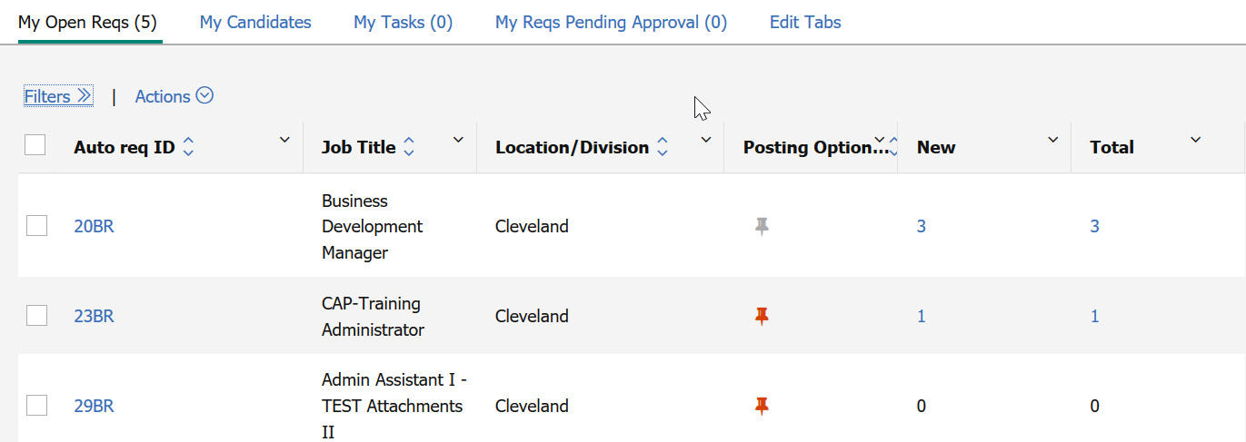
Figure 8- 1: My open reqs
- Filters are available on any requisition tab on the home page.

Inbox Folder
BrassRing users can add working folders whenever they like, as a result, the Inbox is used infrequently. It provides you with a place to file a resume or CV if you have not created a working folder already and simply want to set the resume or CV aside.

The Inbox can also be used to route resumes or CVs to other BrassRing users without having to
email or print them for those recipients.

Working Folders
You add, inactivate, and delete your working folders as needed to organize candidates (build talent pipelines). You can create a working folder to share with others, or for your own personal use.
There are a few things to know about working folders:

- The tracking of candidates’ HR status through your company’s applicant flow is performed only from within req folders, not working folders. However, it is possible to update a candidate’s HR status through a working folder, it is not recommended.
- Once a candidate is filed to a working folder and their status is updated, the candidate cannot be removed without the candidate being moved to a disposition status. (Error that displays: Unable to remove candidates. Candidates with an HR status must be dispositioned to a final status before they can be removed.)
- Only the owner of a working folder can edit, inactivate, or delete it.
- Your list of working folders displays the folder owner’s name and the number of candidates within the folder.
- You can add team members to, or remove them from, a working folder you own.
- You can manually file or move a maximum of 100 candidates to a working folder at one time from candidate search results.

Apply Your Knowledge
When might you move candidates from working folders to req folders?
------------------------------------------------------------------------------------------------
To access your working folders:

- From the Hiring Navigation icon , click Candidates My folders Working.
See Figure 8-2.
- The list of the working folders that you have created and of which you are a team member displays. See Figure 8-3.
- Click the hyperlinked number under Total Candidates to view the folders contents.
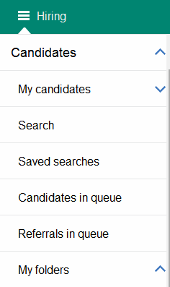
Figure 8- 2: Accessing folders

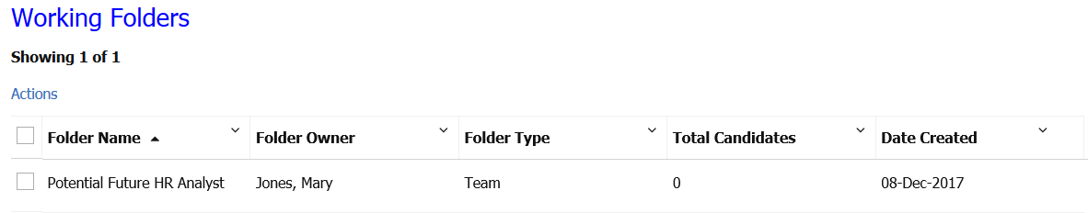
Figure 8- 3: Working folders

Adding Working Folders
To add a working folder:

- From the Hiring Navigation icon , click Candidates My folders Add new.
- Enter the folder name. If the folder is only used by you, proceed to step 5.
- From the Users with access drop-down window, select the appropriate users. You see their names appear as selected users with a check mark.
- Click Submit to save the additional team members.
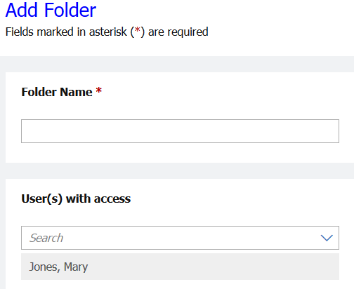
Figure 8- 4: Add a working folder

- Folders are visible to all team members. Be sure to name folders in a manner that everyone understands.
- The option at the bottom of the List window lets you order the list either by first name or last name.
- If you created a working folder, you can add or remove team members. If you are assigned as a member of a folder someone else created, you can remove yourself from that team.

Editing Working Folders
You might edit a working folder’s name or add/remove team members.

To edit a working folder:

- From the Hiring Navigation icon , click Candidates My folders Working.
- Select the Working Folder you would like to edit.
- Click the Actions menu. See Figure 8-5.
- Select Edit.
- Click Save > OK.
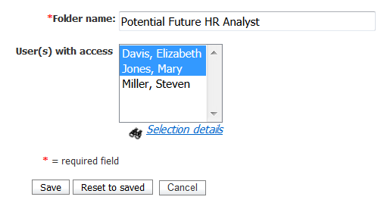
Figure 8- 5: Editing a working folder

Inactivating Folders
Inactivate a working folder to remove it from your active folders list. To inactivate a folder:

- From the Hiring Navigation icon , click Candidates My folders Working.
- Select the folders to inactivate.
- Click the Actions menu.
- Click Deactivate, click OK.

- Consider inactivating a folder when a req is filled yet the folder contains qualified candidates you might want to retrieve at a later time.

To access an inactive folder: From the Hiring menu, click Candidates My folders Inactive. Your inactive working folders displays.

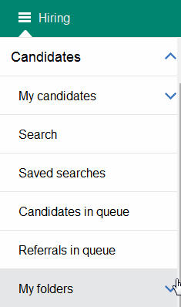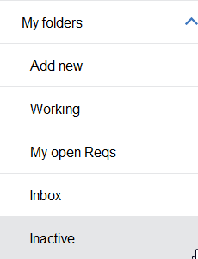
Figure 8- 6: Accessing an inactive folder

Inactivating Folders
You can also choose to delete working folders that you created, though this does not delete the resumes or CVs within it.

Deleting the working folder is only possible if: all candidates in the folder have an HR status of 0-Filed or (if your company allows the tracking of HR statuses within a working folder) the resumes or CVs been assigned a final candidate status such as (company name) not interested.

To delete a working folder:

- From the Hiring Navigation icon , select Candidates My folders Working.
- Click the Actions menu. The Folder delete screen displays a message informing you of any implications of deleting this folder. Refer to Figure 8-7.
- Click OK.

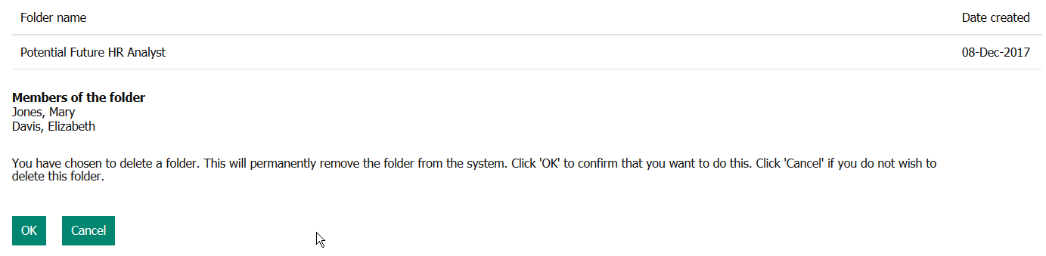
Figure 8- 7: The Folder delete screen

Chapter Summary
- Req folders are created automatically for each req when that req’s lifecycle status is Open.
- In Candidates>Folders>My open reqs, you see all the open reqs to which you have access.
- Working folders can be added to develop talent pools.
- Candidates can be filed to multiple req folders as they might have applied for and thus be considered for multiple positions.
- A working folder’s owner can edit the name and team members for that working folder.
- The owner of a working folder can delete it if all candidates are assigned a 0-Filed status or (if your company allows applicant tracking in a working folder) a final HR status, such as (Company name) not interested.
- Moving a candidate to a folder does not prevent that candidate from being visible to other individuals or being returned in a search.

Check Your Skills
Answer these True or False Questions:
- You have to add your own req folders.
- Candidates can reside in two folders at the same time.
- If a req is deleted, you can no longer access the req folder.

Select the best answers:
- Only the owner of the working folder can:
  - Edit the folder
  - Inactivate the folder
  - Delete the folder
  - All of the above
  - None of the above

- My open reqs…
  - Is a folder that can be deleted.
  - Provides access to all reqs in BrassRing.
  - Provides access to each of your open reqs.
  - All of the above.

Perform these hands-on exercises in BrassRing:
- Add a working folder and title it Sales Prospects.
- Edit the folder and add the person sitting next to you as a member of the team. Remember to pick his/her training username.
- Inactivate the working folder you created in #6. Then reactivate the folder.

Chapter 9: Searching for Candidates

Chapter Overview:

We have learned about the different types of folders available within BrassRing. We now have a better understanding of the value of Working Folders and with our req posted on the Talent Gateways (this was covered in Chapter 3), we are now more organized.

Candidates who apply to a req and are automatically filed to a req folder can be included in searches in BrassRing to identify candidates with the right skills and experience for future jobs, thus allowing for the development of talent pools/pipelines. These resumes can be filed to working folders for future reference.

In this chapter, we learn about searching your BrassRing candidate pool.

Objectives:

At the end of this chapter you can:

- Search for candidates with specific qualifications.
- Use Boolean searching.
- Edit your search page.

Quick Search
The Quick Search functions within BrassRing, allows you to search for reqs based on: job title, a portion of the job title, req number, a portion of the req number, or access a candidate record associated with a specific requisition.

Quick Search is located on the top-right side of the home page of BrassRing and other internal pages.

From the Quick Search feature, select what you would like to search for: Candidates, Reqs or Candidates in Req. Type in the Candidate’s name, Req ID or Job Title based on what you have selected for your search criteria.

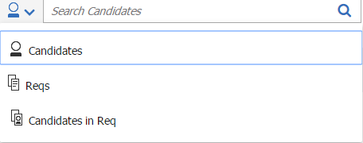
Figure 9- 1: Quick Search

- Candidate Quick Search: You might use the Boolean search terms AND, OR, and NOT when conducting a candidate quick search.
- The Boolean search term of AND is used by default between terms entered into this field if no Boolean search term is used.

- The use of double quotations (“”) is acceptable in this quick search field. Double quotations should be used when users are looking for an exact phrase within a candidate’s resume.

When the result is returned (see Figure 9-2), you can take certain actions on this candidate such as create candidate forms or add notes.

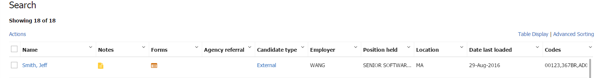
Figure 9- 2: Quick Search Results

In Name Search

When using Quick Search, you have the option to exclusively search by candidate name. Instead of running a search on all candidates with a certain name in their resume (In Resume option), it allows the user to perform a partial or full name search. Entering a name in the quick search field and selecting the Enter key on your keyboard now defaults to the In Name option. See Figure 9-3.

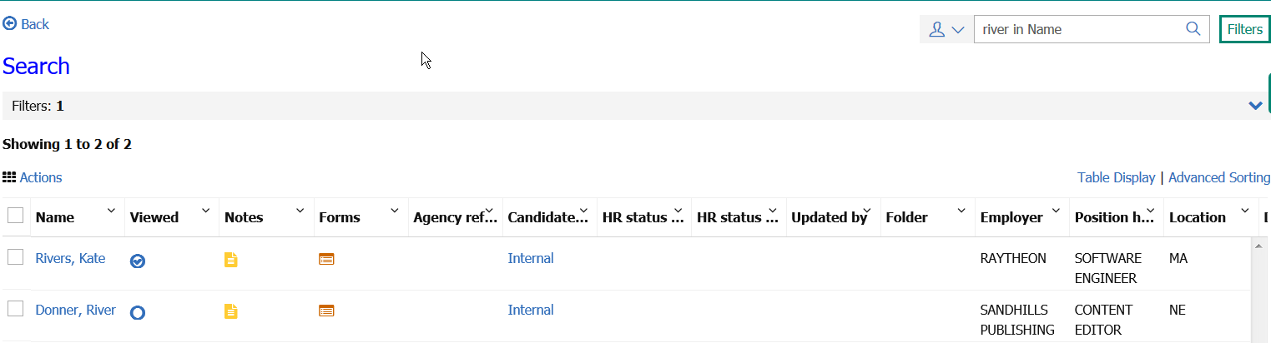
Figure 9- 3: In Name Quick Search

- The In Name Quick Search does not support Boolean searches.
- It also does not display the OFCCP requirements, if enabled.

Overview of Candidate Search Screen
From the Candidates > Search page, you can choose the candidate pool you want to target, build searches to mine those targeted candidate pools, and perform saved searches. See figure 9-4.

Elements of Search
Here is a summary of the search capabilities of BrassRing:

- Candidate pool: When conducting a search in BrassRing, you are searching through resumes or CVs that were sent to your company. When candidates submitted their resumes or CVs through your Talent Gateways, a copy is filed to the req folder, and a copy is placed in the candidate pool.
- Search fields: These allow you to select specific criteria to use, narrowing or broadening your search results.

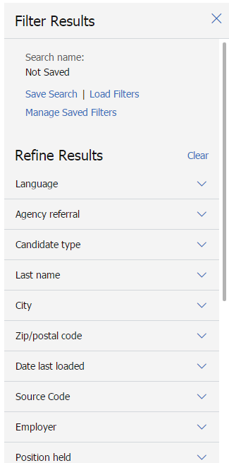
Figure 9- 4: Search page

Elements of Search Fields
Do the searchable fields in Figure 9-4 look familiar? These are some of the fields that we discussed in Chapter 4: Resume or CV Routing and Processing. Recall that the benefit of having information fielded from each resume or CV is that you can search for matches to that piece of information. For instance, enter Director in the Positions held field and you find candidates listing Director as one of the job titles on their resume or CV.

Here is some additional information to keep in mind when searching:

- Searching in BrassRing is neither case-sensitive nor accent-sensitive.
- You can search on fielded information, active or inactive codes, and form fields designated by your company as searchable.
- A candidate’s resume or CV can be searched for specific terms by entering that term into the Quick field followed by in Resume. Example: If you are searching for candidates with experience in analytics, enter in the Quick Search field: analytics. The word string ‘in Resume’ automatically appears next to ‘analytics’.

Running a Search
When running a search, you can search by Candidate types. Candidate types allow you to further filter your searches for targeting specific candidate populations.

Candidate Types
Candidate types provide you with the ability to associate candidates with their appropriate population (e.g. employees versus non-employees). The use of Candidate types also helps manage your company’s employees’ base of skills, enabling quick identification and redeployment of internal talent.

In BrassRing, candidates are categorized into one of four standard candidate types:

- External
- Internal
- Former employee
- Inactive
- Agency (if enabled)
The candidate type is determined by the Talent Gateway the resume or CV is entered into BrassRing. Non-employees are External candidates. Employees are Internal candidates. Automation triggers can also be used to automatically assign the correct candidate type based on specific conditions.

Your user type determines which candidate types you can search. Here is a preview of the Candidate types as they are displayed in Search:

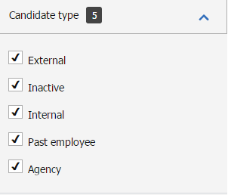
Figure 9- 5: Selecting Candidate types

- Depending on your user type, it might be possible to update a candidate type manually within BrassRing.
- Your company might have opted for additional customized candidate types, for example Referral.

Initiating a Search
As you define your search criteria, BrassRing updates the search results with information entered. Shown in Figure 9-6.

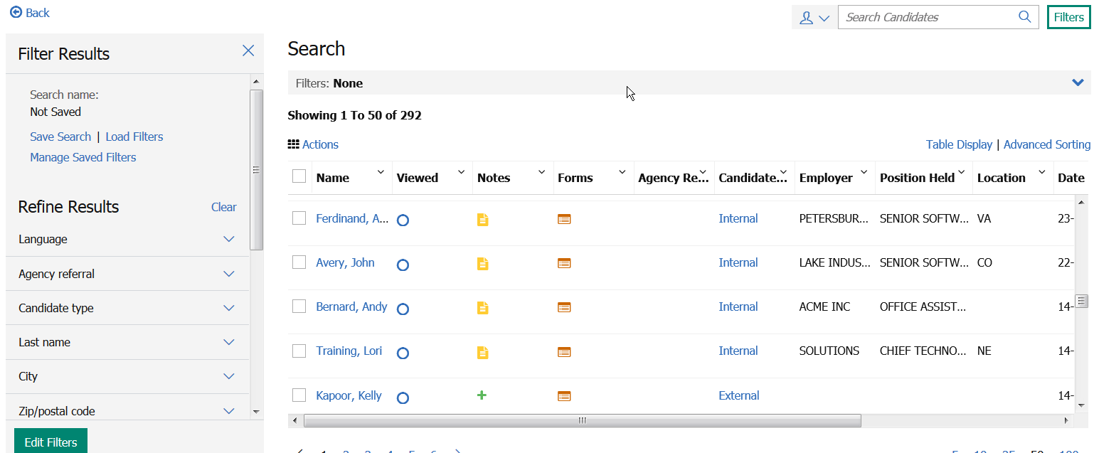
Figure 9- 6: Running a search
The Refine Results section on the left of your Search screen already provides you results for those Search fields with options. Example: When you click the drop-down window for Candidate Type, the list of options shows the number of candidates who have been assigned to the different candidate types in brackets (see Figure 9-7).
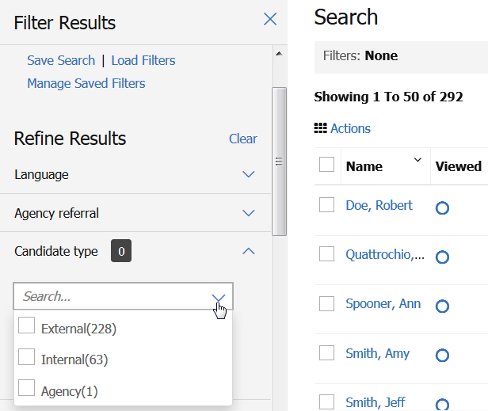
Figure 9- 7: Refine Results

- The filters section displayed on the left allows for continuous access to the search criteria by using the Edit Filter button.
- Filters can display up to 25 options. If the number of options are more than 25, the following message is displayed: Showing first 25 options. Enter more characters to filter further.
- Some filters allow you to search with the terms: contains, ends with, or starts with to narrow down the search results. Example: Employer.

The filters added to a Search appears above the search results output grid. Refer to Figure 9-8. You can remove filters individually by clicking the X next to the filter name or clear all filters by clicking Clear Current Filter.

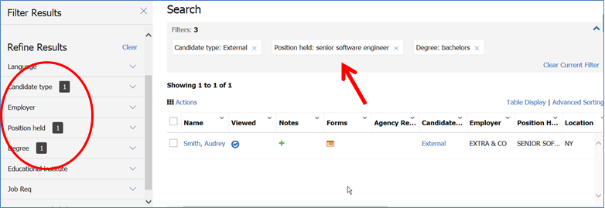
Figure 9- 8: Current Filters

Saving a Search
Searches you frequently perform can be saved which allows you to save the search criteria and run the saved search at a later time.

To save a search:

- From the Hiring Navigation icon , select Candidates > Search.
- Add your search criteria.
- Click the Saved Search button. Enter the name of the Search in the Saved Search window. Refer to Figure 9-9 and 9-10.
- Click the Submit button.

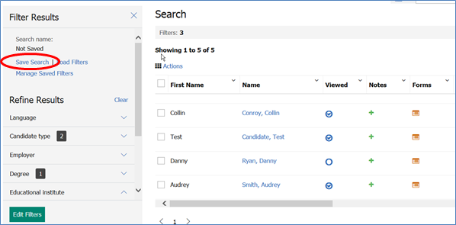
Figure 9- 9: Save Search

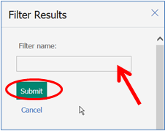
Figure 9- 10: Enter Saved Search Name

Manage Saved Filters
Searches you frequently perform can be saved which allows you to save the search criteria and run the After you saved a search/filter, Managed Saved Filters allows you to rename or delete the Saved Filters.

To access Managed Saved Filters:

- From the Hiring Navigation icon , select Candidates > Search.
- Click Managed Saved Filters from the Filter Results section.
- The Manage Saved Filters screen lists all saved searches/filters. Refer to Figure 9-11.
  - Click the edit icon to Rename the filter/saved search.
  - Click the delete icon to Delete the filter/saved search.
- Click Done.

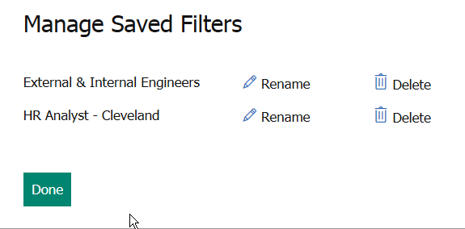
Figure 9- 11: Manage Saved Filters

Edit Filters (Edit Saved Search)
Searches you saved can be edited by adding filters, removing filters, and selecting different filter values.

To edit filters:

- From the Hiring Navigation icon , select Candidates > Search.
- Select Load Filters. The Load Filters screen appears which provides you with a list of all searches you saved.
- Click the radio button for the saved search to edit. Refer to Figure 9-12.
- Click the Done button.
- Once all changes to the filters are made, click the Saved Search, and add a name for the new Saved Search.
- Click the Submit button.

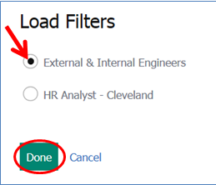
Figure 9- 12: Load Filters: Select Saved Search

Boolean Searching
BrassRing supports searching using Boolean terms to create strings of words and phrases. In BrassRing, there are three basic Boolean terms: AND, OR, and NOT (and NOT is also accepted). Each one has a slightly different role in searching, described below. They are case-sensitive and must be capitalized in a Boolean search. Boolean searches can only be used with Quick Searches.
Using AND
Using AND narrows the number of search results you see. For example, adding to the Quick Search field UNIX AND NT in Resume (where ‘in Resume automatically appears) includes in the search results only resumes or CVs that contain both the words UNIX and NT. If the resume or CV contains only the word ‘UNIX’, it does not consider a match (likewise, if it contains only the word ‘NT’). The resume or CV must contain both words to be included in the search results. Refer to Figure 9-13. AND is the default Boolean operator when using the quick search field.

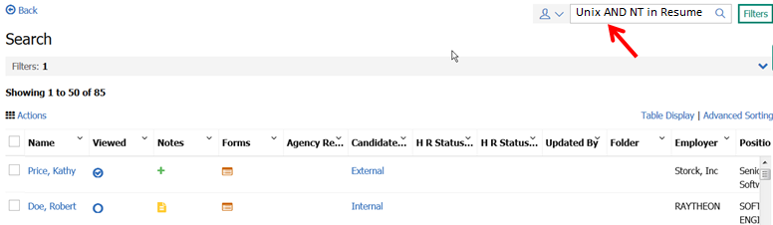
Figure 9- 13: Search Using Boolean Search Term: AND

Using OR
Whereas AND narrows a search, OR broadens it by returning resumes or CVs that have either word you specify. For instance, a Quick Search for UNIX OR NT in Resume returns all the resumes or CVs that contain either the word ‘UNIX’ or those that contain the word ‘NT’. Refer to Figure 9-14.

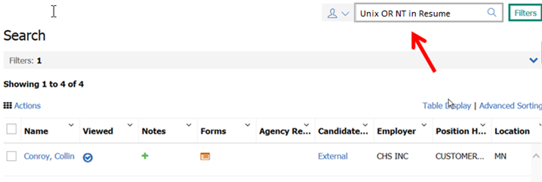
Figure 9- 14: Search Using Boolean Search Term: OR

Using NOT
The third Boolean term is NOT, and it allows you to exclude resumes or CVs with certain words from your Quick Search. Specifying UNIX NOT NT would return all resumes or CVs that contain the word ‘UNIX’ -except those that also contain the word ‘NT’ Refer to Figure 9-15.

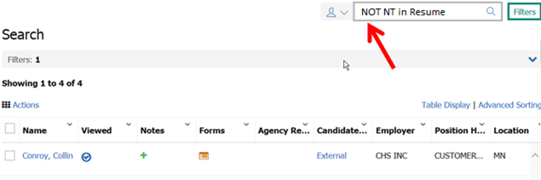
Figure 9- 15: Search Using Boolean Search Term: NOT

- Keep in mind that the more times you use AND, the narrower your search gets, and the fewer resumes or CVs your search results include.
- Be careful when using NOT as you might exclude resumes or CVs you do not intend to exclude.

Filing to Folders
At this point, we have created a working folder, conducted candidate searches and found resumes or CVs. As candidate searching is used primarily to help develop talent pools, most organizations file search results to working folders, not req folders. This is due to the fact that applicant flow is tracked only within req folders.

Filing to Working Folders
Now that you understand how to run searches in BrassRing, you can file candidates into your working folder and begin building your Talent Pipelines.

To file candidates to a working folder from the search results page:

- From the search results page, select the candidates by clicking the check boxes next to their name.
- Click the Actions menu and select File to Folder
- In the Destination section, select the folders to send the candidates to. (Hold the Ctrl key to select more than one folder). Refer to Figure 9-16 for a preview.
- If your process dictates, select an HR status from the Select an initial HR status drop-down window, and an Action date. If you do not select an HR status, the default is 0-Filed. The Action date defaults to today’s date.
- Click File. At this time you can choose to send an eLink of the candidates filed to the working folder by clicking Send eLink or simply click OK to close the confirmation window.

- If you do not select a status when filing to a folder, BrassRing automatically updates your candidate to 0-Filed. This simply means that the candidate has no HR status within your applicant flow (0), and that they are merely Filed to a folder.
- Up to 100 candidates can be filed or moved to a folder at one time.

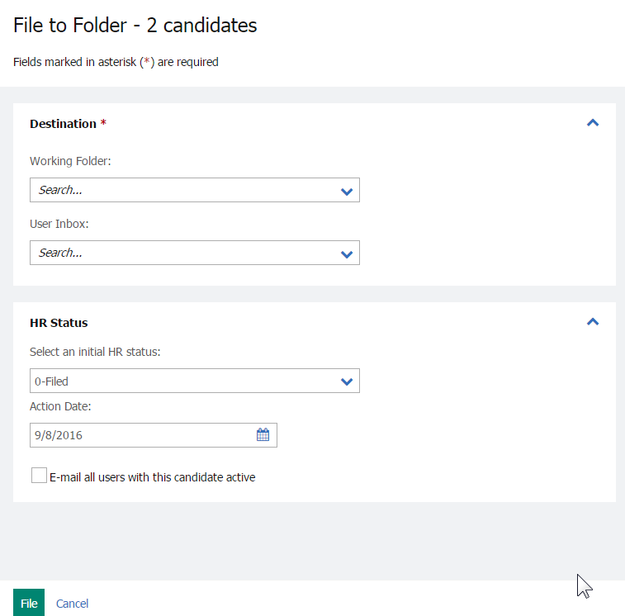
Figure 9-16: Filing to working folders from candidate search results

Filing to Req Folders
Depending on your company’s process, you can file candidates directly to a req folder. This is likely not the case.

- Note: If you manually file a candidate to a req folder, you risk not being compliant, as the candidate you filed might not have expressed interest in the req.

To file candidates to a req from the search results page:

- From a list of candidates, select the candidates to be filed by clicking the check boxes next to their name.
- Click Actions menu and select File to Req.
In the Destination section, select the req folders to send the candidates to. Refer to Figure 9-17 for a preview.
- Select an Initial HR status, and an Action date, if wanted. If you do not select an HR status, the default is 0-Filed or the status your organization has defined for manually filed candidates.
- Decide if you want to email all users who have this candidate active in one of their folders. This sends an email to each person who has that same candidate in a working or req folder they own, letting them know you filed a candidate to a req.
- Click File. If you have tried to file a candidate to a req with no remaining positions, BrassRing lets you know this in a message and the candidate is not filed.

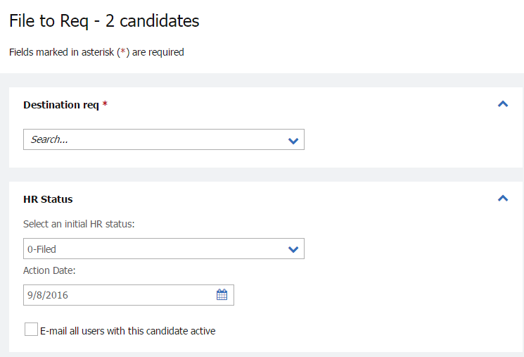
Figure 9-17: Filing to a req folder

Attaching Candidates to Reqs
In the previous section, we discussed how candidates found through a Candidate Search can be filed into a Working Folder. This filing of candidates to a Working Folder is the creation of a Talent Pipeline. A req might open in the near future, but you do not have any promising candidates who have applied for the job. By referring back to your Working Folder, you can attach some of the candidates in the Working Folder to the req folder.

From Working Folder to Req Folder
In an effort to be compliant, best practice is to permit candidates to learn about open jobs and express interest by applying to them through your Talent Gateways. In Chapter 3, we discussed how Talent Gateways allow organizations to ask pre-qualifying questions of their candidates, and to have them complete certain forms while applying. Those individuals whose resumes or CVs have been filed to a working folder can be sent an email communication, alerting them that an open job to which they might be interested has been posted. This would allow them to apply, and thus express interest.

The steps below illustrate the functions which allows resumes or CVs to be moved, or copied, from a working folder to a req folder. It is strongly recommended that you contact your administrator and be certain you are following your designated hiring process and best practices defined by your organization.

To Move or Copy a resume or CV to a req folder from a working folder:

- From a list of candidates, select the candidates to be moved (or copied) from the working folder to the req folder. Click Move/copy to req.
- Select either the Move or Copy option. See Figure 9-18.
- Highlight the Req to which the candidate is filed.
- Select either Move (the candidate is completely removed from the working folder you are in now) or Copy (the candidate remains in both the working folder you are in now, but a copy is made and placed in the req folder).
- Select whether you want to Retain the HR status data in the new req folder. Meaning that if the candidates you are moving to the req have an HR status assigned to them within the folder they are currently in, they retain (and display) that same HR status in the folder they are being placed in. If you select Do not retain any HR status data the candidates appear in the new req folder with a 0-Filed HR status.
- If available, Notify users working with this candidate triggers a mass email to any BrassRing users who, like you, have that same candidate in an active folder of their own.
- Click either the Move or Copy button, depending upon the choice made in Step 2. Click OK.

- Your company might have opted for BrassRing to automatically file, every 24 hours, candidates who directly apply for a specific req to that req folder. This is called Auto-File. Your company might have opted instead to use Instafile. This automatically files candidates immediately to the req folder to which they applied. Check below if either option applies to you.
  - My company uses Auto-File.
  - My company uses Instafile.

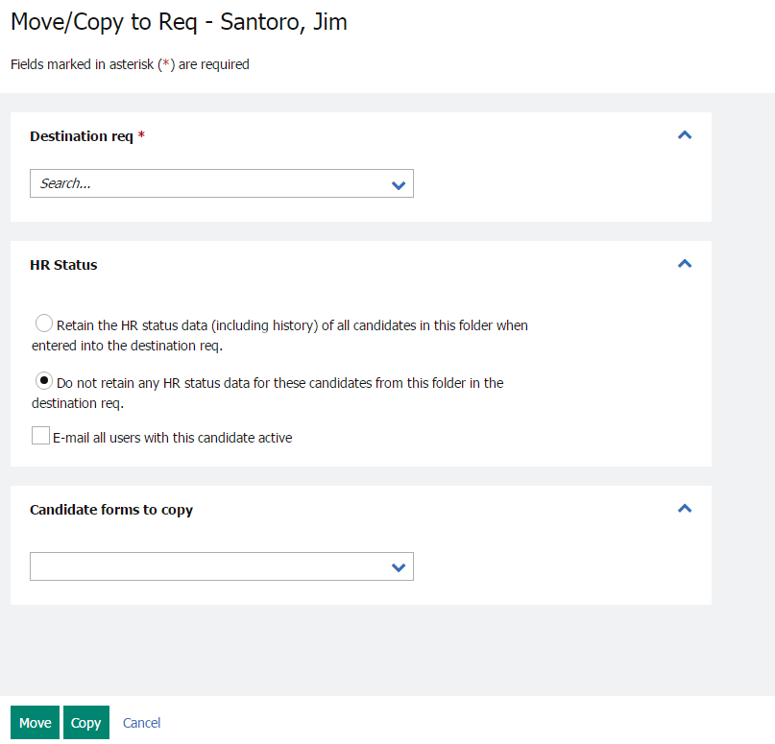
Figure 9-18: Moving or copying candidates from a working folder to req folder

From the req folder, you continue to update the HR statuses for candidates as they progress through the hiring process.

Eventually, someone in your folder is at a hired stage and all other candidates are no longer being considered for the req and are assigned to a final HR Status. The final status might be similar to Company Not Interested or Candidate Not Interested. This was discussed in greater detail in Chapter 7.

- Part of being compliant is that candidates express interest in a particular job. It is because of this that such a process would state that ideal candidates filed to a working folder who were sourced need to be contacted. This lets them know to go online and apply for particular jobs.

Chapter Summary
- You can search on fielded information, codes, and fields from forms designated as searchable.
- Quick Search supports the use of Boolean searching.
- Using AND narrows searches, OR broadens searches, and NOT excludes resumes or CVs from searches.
- Candidate types allow you to filter your search for a specific candidate population.

Check Your Skills
Answer these True or False Questions:
- You can use Boolean searching in the Quick Search field.
- Using Boolean search term AND narrows your search.
- Using Boolean search term OR broadens your search.
- Searching in BrassRing is case-sensitive.
- Managed Saved Filters allows you to rename or delete your saved filter/search.
- You click Save search to change search fields.
- You can search for resumes or CVs entered through Talent Gateways as soon as they are submitted.

Perform these hands-on exercises in BrassRing:
- Run a search for your typical candidate traits.
- Remove two search fields and add three new ones.

Appendix A: Standard Reports

Appendix Overview:
BrassRing Standard reports are designed to help you accurately track and report on talent relationship activities and reduce cost-per-hire and time-per-hire.

These reports streamline the reporting process while providing you with robust, usable data.

Objectives:
At the end of this appendix you can:

- Identify standard report options available in BrassRing
- Run a standard report

BrassRing Standard Reports
BrassRing Standard reports are always selected from the Reports menu page. Access to data collected through specific reports is based on both your user type and the organizational group to which you are assigned, both of which are maintained by your Super User.

The Reports menu page provides descriptions for each report and allows you to specify a reporting preference.

To access the Reports menu page:

From the Hiring Navigation icon , click Reports Standard Reports. Then select an individual report from the drop-down menu.

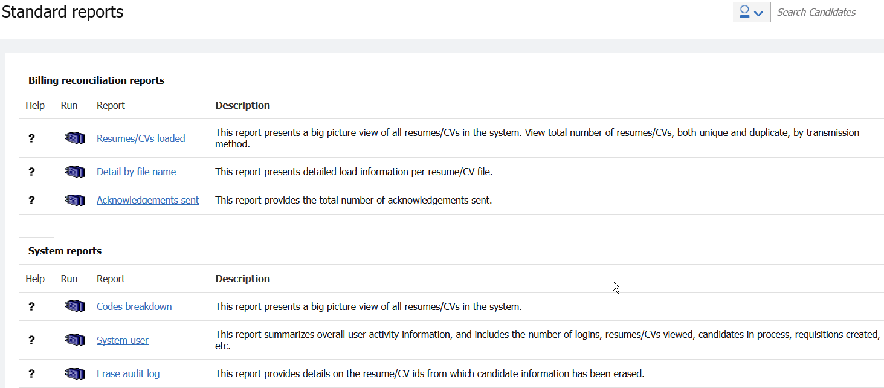
Figure A- 1: BrassRing Standard reports page

- Your company might have also opted to configure the Diversity Breakdown Report which is formatted to be printed for submission to EEOC.

Categories of BrassRing Standard Reports
This appendix covers only the types of BrassRing Standard reports that most typical users can access. These reports fall into the categories of:

- Hire/Req reports
- TRM dashboard reports

The Data Insight tool (DIT) is a reports option which is detailed by using an online, self-study course on the BrassRing Support Community > Resources: Signal Labs Talent Knowledge Center (Product Documentation and Training eLessons) > BrassRing eLearning Videos: Data Insight Tool (DIT) eLearning.

Elements of BrassRing Standard Reports
Keep the following considerations in mind as you access BrassRing Standard reports:

- The Reporting database is replicated daily in the early morning. Therefore, Standard Report results most likely reflect the previous day's data. The Data Insight Tool is replicated three times per day (12:00 am, 8:00 am, and 4:00 pm EST). Depending on when you run the report, results might not reflect the previous 8 hours of activity within the system.
- All of the reports have the same look, feel, and functions.
- Filter options enable you to select the specific information you want displayed in your report. Filter options are available for all BrassRing Standard reports.
- BrassRing Standard reports display in a browser window with the report results displayed in the frame of the format that you select for output.
- If you do not have privileges to view a particular req field-derived output field, the data in that output column is replaced with the * character, and the associated sorting/grouping options in Adobe Acrobat are removed.
- If you can see only My reqs in BrassRing, as opposed to All reqs, then your reports pull data taken only from your reqs.
- If you only see certain candidate types (Internal, External, Past Employee, Agency, etc.) when searching for candidates, then reports you run that include candidate data based on candidate type likewise only provides access to those candidate types.

Running BrassRing Standard Reports
To view a BrassRing Standard report:

- From the Hiring Navigation icon , click Reports Standard reports.
- Click the Name of the report you would like to run.
- Select the filters to apply to the report and an output format.
- Run the report.
- When you receive the report results, use the Sorting and Grouping options on the left side menu within Adobe Acrobat to display the results.
Here is an example of typical filter options:
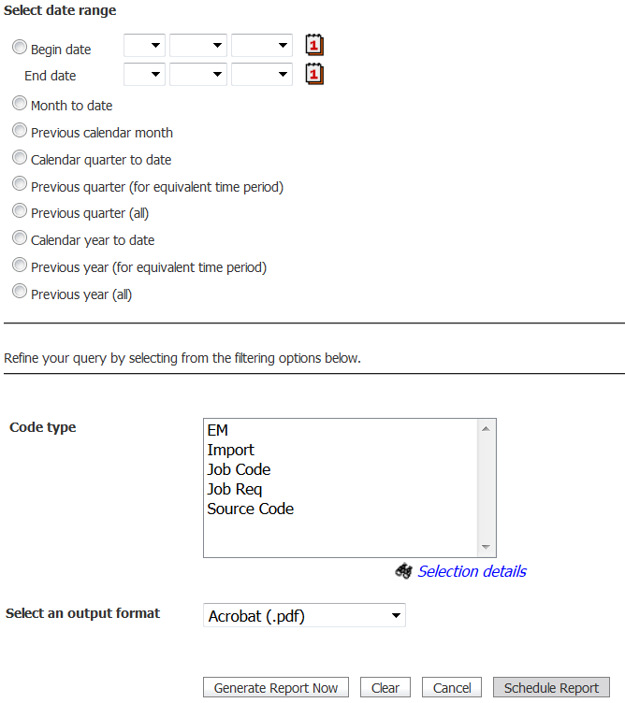
Figure A- 2: Report filter options

- To schedule a report, follow the same steps for running a report except click Schedule report button and then define the frequency, recurrence and the distribution list for the report.
- Your organization has made many decisions regarding the data that is used to both run, and display in results of, the following reports: HR Action Activity, New Hire, Open req activity, Req status summary, Diversity hires, and Time to Fill.
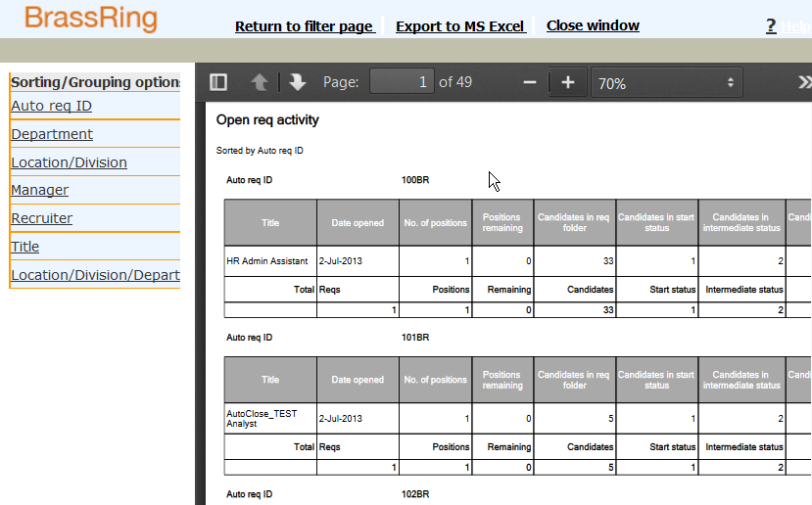
Figure A- 3: Sorting and grouping options

Hire/Req Report
Hire/Req reports display information about the status of hires and reqs.

Hire/Req reports include:

- New hire report
- Open req activity report
- Req status summary report
- Req history report
- Cost per hire report

- Click Help in the top toolbar for more information about the specifics of the report you’ve run.
- You find descriptions for all Standard reports in BrassRing using the online help for each, noted with a bold question mark on the left side of the Standard reports page.

Open Req Activity Report
This report provides information on any req with open status as of the date specified (cumulative total). Information can be sorted and grouped by location, department, manager, etc., and viewed as a text report or pie chart.

Uses of the Open req activity report include:

- Monitor and analyze open req activity as of a specific date. For example, monitor and analyze by recruiter, by location or by department.
- Identify trends and bottlenecks within the hiring process.

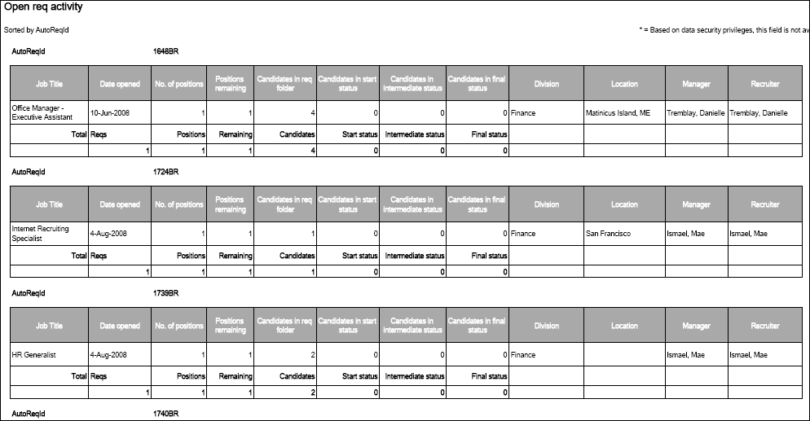
Figure A- 4: Open req activity report

- When users select Current as the date range filter for Open Req Activity, the report returns data for all reqs in the open status as of the last reporting server refresh, which takes place every 24 hours (12AM and 3AM ET (GMT/UTC-5 hours). In the report output, the column “As of <current date>” is populated with Today’s date in the report output.

TRM Dashboard Reports (Talent Relationship Management)
TRM dashboard reports provide key metrics to help drive budget and resource allocation decisions and act as a guide for promoting change within your organization. Typically, these reports are intended for use by HR executives.

The types of TRM dashboard reports available include:

- Diversity hires report
- Source yield report
- Talent pipeline report
- eLink responsiveness report
- Time to fill report
- Req aging report

Talent Pipeline Report
This report provides a global view of all HR statuses in the system as of one day prior. It is designed as a pipeline report, so only those candidates considered to be either beginning (e.g., Phone Screen, 1st Interview) or mid-cycle (e.g., 2nd Interview, Offer Made) in the HR cycle are included. Note that candidates moved to a final status are no longer considered to be in the pipeline and therefore are not included in this report. Information can be viewed in a text format or as a bar chart.

Uses of the Talent pipeline report include:

- Analyze overall hiring process flow.
- Analyze hiring process flow per recruiter, manager, department, location, etc.

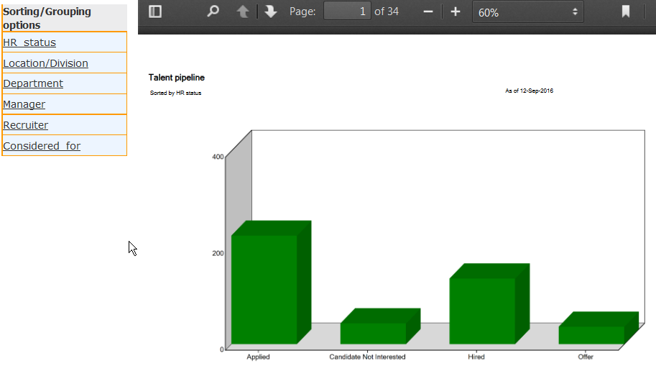
Figure A- 5: Page 1 of a Talent pipeline report

Reports Queue
You can administer all scheduled reports from the Reports Queue.
You can also track progress and download the reports generated from the Reports queue in the Reports Module of BrassRing.
If the report has been generated, a link to download the report is available from the Reports queue.
All reports are delivered by using email to the requester in the format selected on the filter page. Users who have the ability to run a report have the ability to request report delivery. Users with authorized access to the Reports queue can see all reports that have been generated over the last 14 days, and can download and review those reports from this location.
Reports in the Reports queue is of one of the following statuses:
  - Scheduled
  - Running
  - Suspended
  - Completed
  - Failed
Once at the status of completed, the report can be downloaded from the Reports queue.
To suspend and restart a report
- Navigate to the Hiring Navigation icon , click Reports Reports queue.
- The Reports queue window pops up.
- By default, you are viewing your reports. If you want to view all reports, click the All reports link at the top of the screen.
- Select the radio button of the report you want to suspend, and click either Suspend scheduled report or Restart scheduled report in the Actions menu on the left of the screen.
- The report’s status changes to the option you selected in #4.

To remove a scheduled report
- Navigate to the Hiring Navigation icon , click Reports Reports queue.
- The Reports queue window pops up.
- By default, you are viewing your reports. If you want to view all reports, click the All reports link at the top of the screen.
- Select the radio button of the report you want to remove, and click the Remove scheduled report link in the Actions menu.
- A popup window asks if you are sure you want to remove the report. To confirm the removal, click the OK button.
- The report is removed from the queue.
To edit a scheduled report's schedule
- Navigate to the Hiring Navigation icon , click Reports Reports queue.
- The Reports queue window pops up.
- By default, you are viewing your reports. If you want to view all reports, click the All reports link at the top of the screen.
- Select the radio button of the scheduled report whose schedule you want to edit, and click the Edit report schedule link in the Actions menu.
- The report's scheduled information appears in a popup window. Make any wanted changes to the schedule and click Save.
Voided status for reports in the Reports queue
Reports in the Reports queue can have a status of Voided. A report schedule is voided when a standard report filter field that is set to a specific value (not All) is replaced by a customized filter field, rendering the filter criteria for the scheduled report invalid.
You can view details of the voided schedule for up to fourteen days following the report configuration change and then it is deleted from the queue. You cannot edit report schedules with a status of Voided. You must create a new report schedule using the replacement custom report filters.

Chapter Summary
- All BrassRing Standard reports follow the same basic procedure to execute.
- To display information about hires or reqs, run a Hire/Req report.
- The Talent pipeline report shows the details of candidates in your company's pipeline.
- The Data Insight tool is a reports option which is detailed by using an online, self-study course on the BrassRing Support Community > Resources: Brassring Knowledge Center (Product Documentation and Training eLessons) > BrassRing eLearning Videos: Data Insight Tool (DIT) eLearning.

Appendix B: Scheduling Interviews

Appendix Overview:

BrassRing facilitates interview scheduling with hiring managers. All interviews are tracked in the candidate's Talent Record within BrassRing.

Objectives:
At the end of this appendix you can:
- Send an Interview request.
- Send email and letter correspondence.

Scheduling Interviews
Scheduling, an optional module within BrassRing that your company might have opted to use as part of your hiring process, assists you with scheduling interviews and communicating with hiring managers about them.

Elements of Scheduling
The following are considerations regarding Scheduling:

- Interview requests are intended to be sent internally, by using email, using eLink technology.
- Because BrassRing is a web-based product, there is no full integration with your company’s email program. However, clients might choose to implement the Outlook plug-in to perform some interview scheduling actions from within BrassRing.
- Once an interview request has been confirmed, interview schedules can be sent by using email to candidates and interviewers.
- BrassRing tracks the time it takes to schedule interviews.
- The statuses for Interview Requests are called: Pending, Accepted, Declined, Cancelled, and Expired.
- Send interview request allows you to see if the potential interviewer is willing to accept the scheduling of an interview.
- Schedule interview means the interview details have been arranged offline, and allows the recipient to download the interview date and time into Microsoft Outlook (only). The scheduler cannot see the Outlook calendar and thus the potential interviewer’s availability from within BrassRing.
- You cannot schedule an interview within two hours of the time you're creating the interview request.

Sending an Interview Request

To send an Interview request:

- From a list of candidates, click the candidate’s name to open the Talent Record.
- Once the Talent Record appears, click the Actions button in the Talent Record. From the menu that appears click Send Interview Request or Schedule interview.
The Send interview request form appears.
- To address the email, select a user from the To: (system users) field or complete the To: (non-system users) field.
- Enter the details for your request.
- Click Send.

From the confirmation screen that appears, click OK if you are finished, or Next if you have another interview to schedule. Refer to Figure C-2 for a preview of an Interview request.

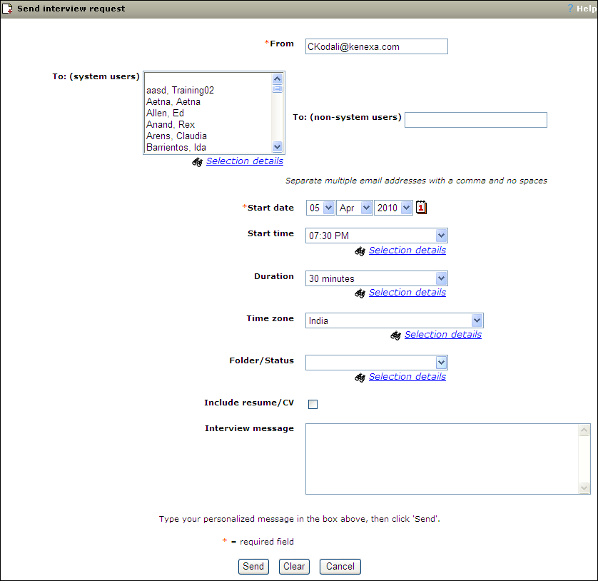
Figure C-1: Sending an Interview request

- Interview requests can only be addressed to one person per request.

Responding to Interview Requests

Interviewers receive the Interview requests in their email inboxes. Interviewers have the option of accepting or declining interview requests.

To respond to an Interview request:

- Open the email message, view the details of the interview and the resume or CV, if included.
- Click the Accept/Decline link in the email.
- Enter a reply message, if applicable.
- Click either Accept interview or Decline interview.
- The action is confirmed and you have the opportunity to view your calendar, if wanted.

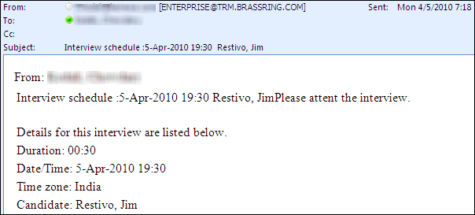
Figure C-2: Interview request
When an interviewer responds to an Interview request, an email is sent to the requester, including the
Reply message, and the status of the Interview request is updated in BrassRing.

- The Reply message is sent to the requester and is not recorded in BrassRing, it is sent back to the Sender’s email In-box

Checking Interview Schedules

You can go into BrassRing anytime and check on interview schedule for your active candidates, both confirmed appointments and requested. You can also check the Master schedule.

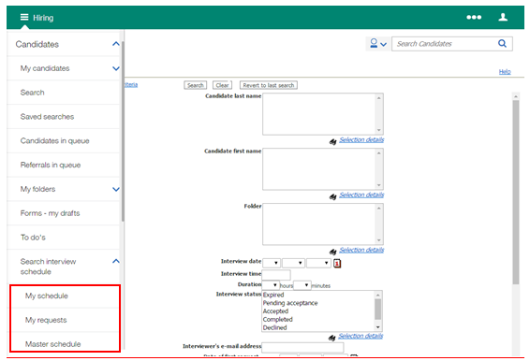
Figure C-3: Checking Interview Schedules

To check your requested interview schedule:

From Hiring Navigation icon , click Candidates, then select Search interview schedule, then select My schedule.

To check your confirmed interview schedule:

From Hiring Navigation icon , click Candidates, then select Search interview schedule, then select My requests.

To check your master interview schedule:

From Hiring Navigation icon , click Candidates, then select Search interview schedule, then select Master schedule.

Appendix C: Managing Talent Comparison Profiles

Appendix Overview:

A means of reviewing the upper slate of candidates you are considering is to run a Talent Comparison Summary. This allows you to compare information on up to five candidates in your folder. You can save criteria for up to 25 Talent comparison profiles, which you run at any time moving forward.

Objectives:
At the end of this appendix you can:
- Run a Talent Comparison Summary.
- Add a Talent Comparison Profile.

Talent Comparison Summary

Run a Talent Comparison Summary
To run a Talent Comparison Summary:

    - From with a folder, select a minimum of two candidates to run the talent comparison summary.
    - Select Talent Comparison from the Actions menu. This launches the Talent comparison profile administration window.
    - Click the Run link for the Talent comparison summary you want to run.
    - The Talent Comparison Summary appears.
    - Select elink report to share the summary with system users or non-system users (if applicable).
    - Select Export to MS Excel to save the report on your computer.

Adding a Talent Comparison Profile
To run a Talent Comparison summary, a Talent Comparison Profile must first be added.

To add a Talent Comparison Profile:

- From with a folder, select a minimum of two candidates.
- Select Talent Comparison from the Actions menu. This launches the Talent comparison profile administration window.
- Click Add new by using the Actions menu. This launches the Add talent comparison profile window.
- In the Profile name field, enter a unique name for the profile.
- Select up to ten fields in the Available fields list and click the Add >> button to move them to the Selected fields list. To select more than one field at once, press down the Ctrl key while selecting each field.
- In the Selected fields list, use the up and down arrows to change the order of selected fields. The order in which fields appear in the box is the order in which they appear in the report output.
- Click Save and run to both save the profile and run the Talent comparison summary report now, using this profile. The data displays in a separate window. Click Save if you want to save the profile but not run it. The Talent comparison profile admin grid lists your newly-saved profile. See Figure D-1.

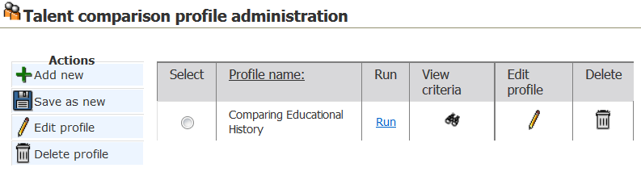
Figure D- 1: Talent comparison profile page

- From the Actions menu>Talent comparison, the Talent comparison profile administration page, allows you to add, save as new, edit and delete your profiles.
- You might use Save as new to facilitate the creation of new Talent Comparison Summary profiles. Similar to saving a req as new, this action allows you to copy all the data from an existing profile, but can make any updates you like. Navigate to the Actions menu within a folder>Talent comparison profile administration>Save as new.
- Your company selected those form fields that you have available as comparison criteria within the Available fields list.

Check Your Skills Answer Key

Chapter 1
Getting Started
- F
- F
- D

Chapter 2
Managing Reqs
- F
- F
- D
- E

Chapter 3
Talent Gateways
- T
- F
- T
- D
- E

Chapter 4
Resume or CV Routing & Processing
- F
- F
- T
- F
- You might either email the resume or CV to your dedicated email address, enter it through Add candidate, Add contact in BrassRing, or enter it through a Gateway if your company has them and if this is in alignment with your company’s process.
- Contact your Super User/System Administrator or other designated person, so they can create a source code for you.

Chapter 5
Screening Candidates
- T
- T
- T
- T

Chapter 6
Tracking Applicants
- T
- T
- T
- F
- The date the eLink was sent, the sender of the eLink & the recipient of the eLink.

Chapter 7
Closing the Hiring Cycle
- T
- F
- F

Chapter 8
Getting Organized
- F
- T
- F
- D
- C

Chapter 9
Searching for Candidates
- T
- T
- T
- F
- T
- F
- F

