


Signal Labs Talent BrassRing

TG Profile Import Technical Specifications API Guide
The information contained in this document is the property of Signal Labs Talent Inc. Except as specifically authorized in writing by Signal Labs Talent Inc, the holder of this document shall: (1) keep all information contained herein confidential and shall protect same in whole or in part from disclosure and dissemination to all third parties and, (2) use same for operating and maintenance purposes only.

Version: 1.0.0
Date: January 06, 2022

Table of Contents
Chapter 1: Introduction 1
1.1 What are BrassRing’s XML Integration APIs 1
1.2 Purpose 1
1.3 Audience 1
Chapter 2: BrassRing’s Talent Gateway Profile Integration APIs 2
2.1 Overview 2
2.2 Communication Methodology 2
2.3 Rules for the Internal Talent Gateway Profile Integration 3
2.4 BrassRing Talent Gateway Profile Snapshot 3
2.5 Employee Referral Gateway Profile Snapshot 5
2.6 TG Profile Tag Definitions (Summary) 6
Chapter 3: Schemas 18
3.1 Sample XML Request 18
3.1.1 TG Profile with complete profile data 18
3.1.2 TG Profile with complete profile data and Candidate forms 18
3.1.3 TG Profile with minimum information 18
3.2 Sample JSON Request 18
3.2.1 TG Profile with complete profile data 18
3.2.2 TG Profile with complete profile data and Candidate forms 19
3.2.3 TG Profile with minimum information 19
3.3 Sample XML Response (Success) 19
3.4 Sample JSON Response (Success) 19
3.5 Sample XML Response (Failure) 19
3.6 Sample JSON Response (Failure) 20
3.7 Handling special characters in XML requests 20
3.8 Handling special characters in JSON requests 21
Chapter 4: Envelope Processing 21
4.1 Sender 21
4.2 Recipient 22
4.3 TransactInfo 22
4.4 Packet 22
4.5 Payload 22
Chapter 5: Security 23
5.1 Standard Implementation Security 23
5.1.1 Message Integrity 23
5.1.2 Transport Layer Security (TLS) 23
5.1.3 IP restrictions 23
5.2 Optional Security Features 23
5.2.1 Message Layer Encryption/Security (MLS) 23
5.2.2 2-Way SSL / Certificate Based Authentication 24
Chapter 6: Integration API URLs 25
6.1 Message Router Addresses 25
Chapter 7: API Error Messages 26

- Introduction
  - What are BrassRing’s Integration APIs
BrassRing XML integrations feature flexible, secure, real-time integrations by sending XML/JSON over the Internet using web services or HTTP Posts. XML formats used in BrassRing XML/JSON integrations are based on HR-XML/JSON Consortium guidelines.

The BrassRing XML/JSON integration offerings allow BrassRing to work with the customers to configure multi-level, robust integration relationships between BrassRing and any systems that can send and receive XML/JSON. Examples of these systems include HRIS systems such as SAP/Oracle/PeopleSoft, etc., and systems that perform HR related services like background checks, assessments or compensation analysis.

The customer can choose to send data through either a web service or HTTP post. BrassRing handles the exchange of XML/JSON requests and responses using its own messaging software. The customer builds their own messaging system to exchange XML web service messages or HTTP post with BrassRing.
  - Purpose
The purpose of this document is as follows:
To present high-level architecture and design of BrassRing APIs and how BrassRing implements Internal Talent Gateway Profile integration to meet its customers’ needs for automated Foundation data management.
To describe suggested high-level workflow processes that can be supported between BrassRing and any external, third-party system that can send and receive XML requests and responses.
To describe the steps required to implement Internal Talent Gateway Profile integration.
  - Audience
Client Decision Makers, HRIS Implementation Teams, Internal IT Teams, Systems Integrators and Support Teams.
BrassRing Engineering Services Team, Support Team, and Technical Services Group.

- BrassRing’s Talent Gateway Profile Integration APIs
  - Overview
Talent Gateway Profile (Internal Gateway or Employee Referral Gateway) integration is used in parallel with Internal Talent Gateway Single Sign-On solution. This integration cannot be used stand alone and client must be SSO enabled on the Talent Gateways to be able to use it.

TG Profile XML/JSON integrations, allows profile information to be pre-populated when an employee single signs-on to the Talent Gateways.

Note that implementing Internal TG profile integration is not mandatory for a client who implements an internal TG SSO project. If a client chooses not to implement TG profile integration with their Internal TG SSO implementation, their Internal Talent Gateway profile page will appear blank to the employee and the employee is expected to complete the profile upon landing on the Internal Talent Gateway or the Employee Referral Gateway.

Employee data can be pre-populated on Internal Talent Gateway from an external system. Employee information is any data that applies to a candidate, such as the name, address, previous employers, education, skills, or status that is maintained in a client’s HRIS.

A client can build the integration in such a way as to automatically send employee profile information to the Internal Talent Gateway from the client’s HRIS system. The Candidate fields to be transferred are chosen by the client at integration set-up time and recorded in the XML_Integrations_Data_Mapping_Document.doc.

The API allows you do the below:
Uses industry standard web services interface
Ability to pre-populate new or update existing internal candidates in the Talent Gateway to be used in parallel with Internal TG SSO.
Ability to manage information such as mailing address, employment history, education history, employee Id (Global Id) etc.
Ability to pre-populate/update information on pre-configuration forms in the BrassRing application.
Ability to add Text Resume and Cover letter
  - Communication Methodology
Connection to the BrassRing Internal Talent Gateway system is accomplished via Web Services as a data transfer vehicle.

The above mechanism is synchronous meaning all transactions are real-time with a request-response messaging and no message queuing.

The XML/JSON format is depicted in Section 3.

Client can choose to batch transactions or send data to BrassRing in real-time.
BrassRing will always process transactions in real-time regardless of whether they were batched or not by the client.
  - Rules for the Internal Talent Gateway Profile Integration
Below are a few rules to consider when looking into the use of the TG Profile Import Integration:
The XML/JSON schema cannot be customized (see sample XML/JSON below). The Candidate fields to be sent in the integration can however be chosen depending on a Client’s mapping requirements. Field requirements are outlined in the Data Mapping sections.
Talent Gateway profile Import XML/JSON files are processed real time via Web Services.
The TG Import API processes only one Candidate XML/JSON data per transaction. Bundle/group TG import data is not allowed in the same XML/JSON.
The TG system allows 5 work experience history records and 3 education history records on a Candidate profile.
Client’s HRIS or external system should wait for a success/failure response from the current transaction before sending the next transaction. It is best practice to put in a sleep time of a few seconds before sending the next transaction.
The SsoId tag in the integration is the unique identifier that determines whether the transaction is an Insert versus an Update. The value in the SsoId tag is the same value that is sent in the actual SSO process.
Send delta loads only. Full/destructive loads are not recommended.
  - BrassRing Talent Gateway Profile Snapshot
Below is a screen print of the profile page in the Internal Talent Gateways for your reference.
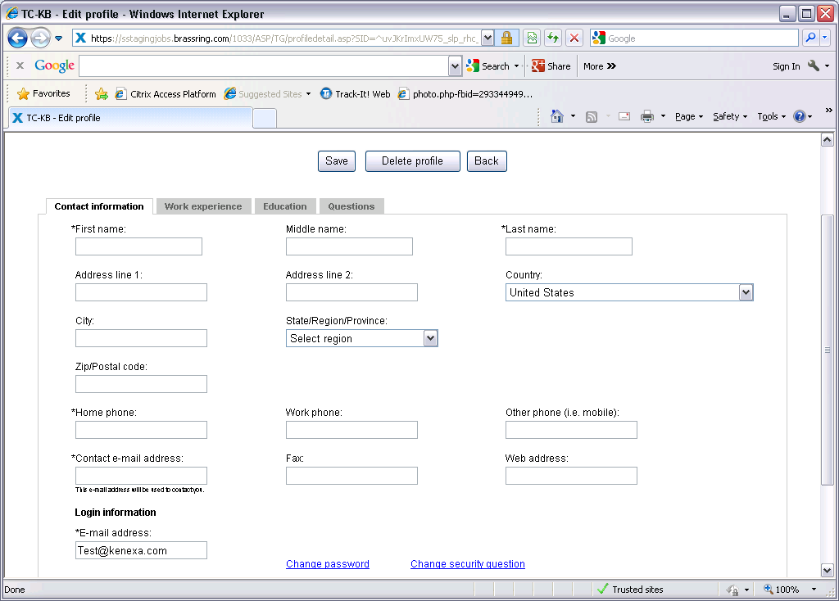

Below is the screen print of the Experience and Education screen in Internal Talent gateway for your reference. Talent Gateways allows a maximum of 5 work experiences and 3 education records.
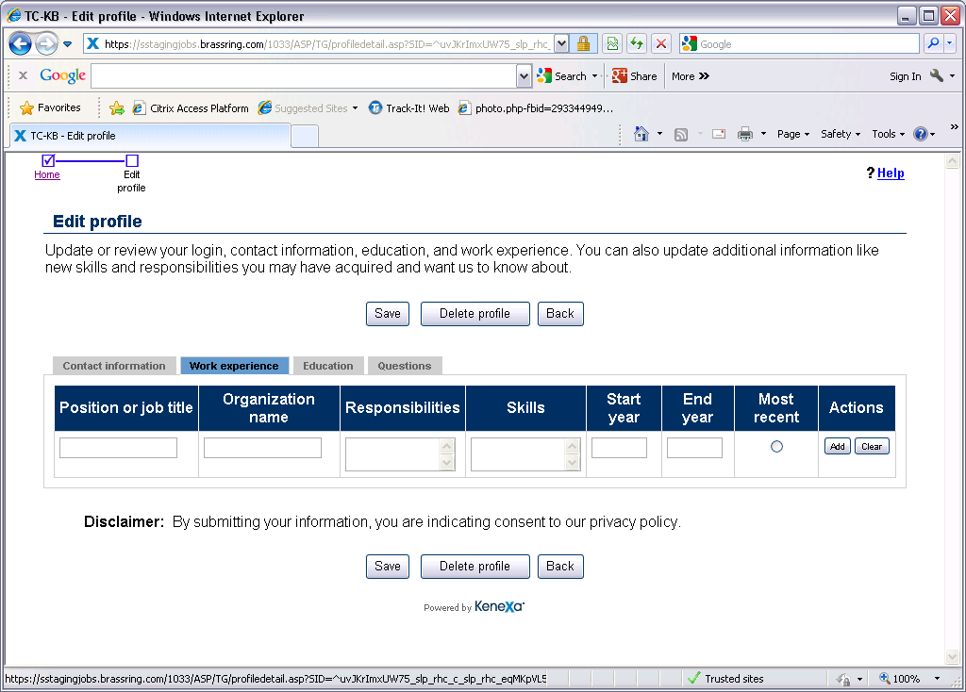

Talent Gateways allows a maximum of 3 education records to be present on the profile.
Education profile screen shot below.

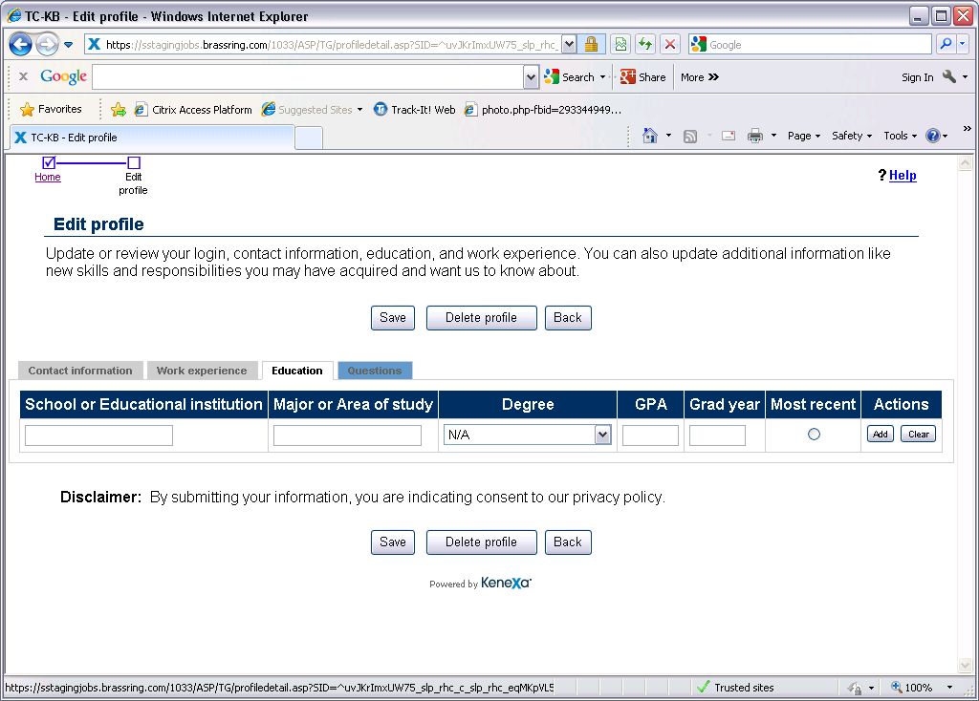
  - Employee Referral Gateway Profile Snapshot
The Employee Referral Gateway does not have all the fields as seen in the Internal Talent Gateway. However, the fields such as the ones shown below are pre-populated by the integration such as the First Name, Last Name and the Email address of the referring employee. Note that pre-population only works when Single-Sign-On is enabled.

Below is a screen print of the profile page in the Employee Referral Gateways for your reference.
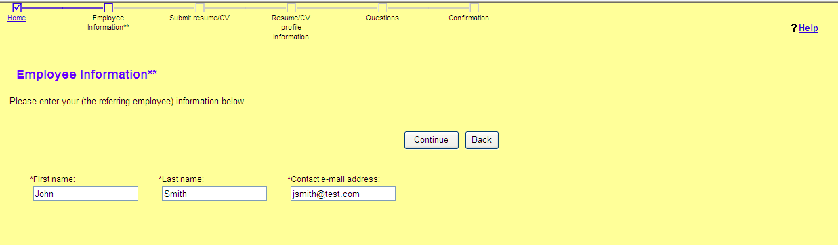

  - TG Profile Tag Definitions (Summary)
Field Name | Format |  | Length |  | BrassRing Notes and XML Tag/JSON Keys
Unit tag Attribute UnitProcessor | Varchar |  | NA |  | Required: Must be hard coded to TGProfileImport  XML: <Unit UnitProcessor=”TGProfileImport”>  JSON: "Unit": {  "UnitProcessor": "TGProfileImport"  }
Language | Varchar |  | NA |  | Required: This value must be hard coded to en-US.  XML: <CandidateProfile xml:lang=”en-US”>  JSON: "CandidateProfile": {  "lang": "en-US"  }
CANDIDATE PERSONAL PROFILE INFORMATION BELOW:
Candidate First Name | Varchar |  | 100 |  | Required: Candidate’s First Name  //CandidateProfile/PersonalData/PersonName/GivenName
Candidate Middle Name | Varchar |  | 20 |  | Optional: Candidate’s Middle Name  //CandidateProfile/PersonalData/PersonName/MiddleName
Candidate Last Name | Varchar |  | 100 |  | Required: Candidate’s Last Name  //CandidateProfile/PersonalData/PersonName/FamilyName
CANDIDATE CONTACT INFORMATION BELOW:
Contact Method
Use | Varchar |  | 8 |  | Required – Value = personal  //CandidateProfile/PersonalData/ContactMethod/ContactMethod/Use
Location | Varchar |  | 10 |  | Required – Value = Home  //CandidateProfile/PersonalData/ContactMethod/Location
Home Phone | Varchar |  | 25 |  | Candidate’s home phone/primary phone number. Format of the phone number is free text and does not require specific formatting.  //CandidateProfile/PersonalData/ContactMethod/Telephone/FormattedNumber
Fax Number | Varchar |  | 25 |  | Optional: Candidate’s fax number. Format of the fax number is free text.  //CandidateProfile/PersonalData/ContactMethod/Fax/FormattedNumber
Email Address | Varchar |  | 200 |  | Required if Home Phone is missing. Candidate’s email address.  //CandidateProfile/PersonalData/ContactMethod/InternetEmailAddress
Home Page | Varchar |  | 100 |  | Optional: Candidate’s home page URL if provided  //CandidateProfile/PersonalData/ContactMethod/InternetWebAddress
Address 1 | Varchar |  | 50 |  | Optional: Candidate’s address Line 1  //CandidateProfile/PersonalData/../PostalAddress/DeliveryAddress/AddressLine
Address 2 | Varchar |  | 50 |  | Optional: Candidate’s address Line 2  //CandidateProfile/PersonalData/../PostalAddress/DeliveryAddress/AddressLine
City | Varchar |  | 45 |  | Optional: Candidate’s city  //CandidateProfile/PersonalData/ContactMethod/PostalAddress/Municipality
State | Varchar |  | 100 |  | Optional: Candidate’s State  //CandidateProfile/PersonalData/ContactMethod/PostalAddress/Region
Zip | Varchar |  | 10 |  | Optional: Candidate’s Zip or postal code  //CandidateProfile/PersonalData/ContactMethod/PostalAddress/PostalCode
Country | Varchar |  | 40 |  | Required: Candidate’s country of residence. If Country information is not available, send “ZZ” which is a code for “No country”.  //CandidateProfile/PersonalData/ContactMethod/PostalAddress/CountryCode
CANDIDATE CONTACT INFORMATION BELOW:
Contact Method
Use | Varchar |  | 8 |  | Required – Value = personal  //CandidateProfile/PersonalData/ContactMethod/ContactMethod/Use
Location | Varchar |  | 10 |  | Required – Value = onPerson  //CandidateProfile/PersonalData/ContactMethod/Location
Mobile | Varchar |  | 25 |  | Contains one attribute: smsEnabled=”true”  //CandidateProfile/PersonalData/ContactMethod/Mobile/FormattedNumber
CANDIDATE CONTACT INFORMATION BELOW:
Contact Method
Use | Varchar |  | 8 |  | Hard coded value = business  //CandidateProfile/PersonalData/ContactMethod/Use
Location | Varchar |  | 10 |  | Hard coded value = office  //CandidateProfile/PersonalData/ContactMethod/Location
Telephone (Work) | Varchar |  | 25 |  | Candidate’s work phone number. Free text and does not require specific formatting.  //CandidateProfile/PersonalData/ContactMethod/Telephone/FormattedNumber
Fax | Varchar |  | 25 |  | Optional. The value should not have any space character at all otherwise the read-only / read-write flag will not work properly. Leaving this value empty is Ok.  //CandidateProfile/PersonalData/ContactMethod/Fax/FormattedNumber
CANDIDATE EXPERIENCE (UPTO 5 MAXIMUM EMPLOYMENT HISTORY CAN BE PASSED)
All tags required if sending experience.
Employer Name | Varchar |  | 60 |  | Please refer to Section 2.4 of the document. Candidate’s company name.  //CandidateProfile/EmploymentHistory/EmployerOrg/EmployerOrgName
Position or Job Title | Varchar |  | 60 |  | Candidate’s job title  //CandidateProfile/EmploymentHistory/../PositionHistory/OrgName/Title
OrganizationName | Varchar |  |  |  | OrganizationName is required for HR-XML but will not be used for TG.  //CandidateProfile/EmploymentHistory/..PositionHistory/OrgName/OrganizationName
Description | Varchar |  |  |  | Populates Responsibilities on the Experience tab in the TG and will be found on the Resume Tab in BrassRing. There is no character limit on this field, however, the more characters that are sent the longer the Experience page will be to navigate on the TG. Infinite suggests sending 4000 characters or less.  //CandidateProfile/EmploymentHistory/EmployerOrg/PositionHistory/Description
Start Year | Integer |  | 6 |  | Candidate’s start year at the job. This is a year only field. Data must be sent as 1998, 2001, etc.  //CandidateProfile/EmploymentHistory/EmployerOrg/PositionHistory/StartDate/Year
End Year | Integer |  | 6 |  | Candidate’s end year at the job. This is a year only field. Data must be sent as 1998, 2001, etc.  //CandidateProfile/EmploymentHistory/EmployerOrg/PositionHistory/EndDate/Year
CANDIDATE EDUCATION (UP TO 3 MAXIMUM EDUCATION HISTORY CAN BE PASSED)
All tags required if sending education.
SchoolOrInstitution | Varchar |  | 100 |  | SchoolType is not used by TG but required for HR-XML, therefore type can always = "university". Optional. Leaving this value empty is Ok.  //CandidateProfile/EducationHistory/SchoolOrInstitution/School/SchoolName
School Name | Varchar |  | 100 |  | Optional. Leaving this value empty is Ok.  //CandidateProfile/EducationHistory/SchoolOrInstitution/SchoolName
Degree | Varchar |  |  |  | Contains one attribute degreeType. degreeType must match BrassRing list for US English TG, other language TGs are free text boxes. Example degreeType="Masters"  //CandidateProfile/EducationHistory/SchoolOrInstitution/Degree
Degree Name | Varchar |  | 50 |  | Optional. Leaving this value empty is Ok  //CandidateProfile/EducationHistory/SchoolOrInstitution/Degree/DegreeName
Major or Area of Study | Varchar |  | 80 |  | Optional. Leaving this value empty is Ok  //CandidateProfile/EducationHistory/SchoolOrInstitution/Degree/degreeType
Grad Year | Integer |  | 6 |  | Optional. Leaving this value empty is Ok  //CandidateProfile/EducationHistory/SchoolOrInstitution/Degree/DegreeDate/Year
Measure |  |  |  |  | Contains one attribute measureType. The value is hard coded. measureType="numeric". Attribute measuretype is not used by TG, only required for HR-XML.  //CandidateProfile/EducationHistory/…/Degree/DegreeMeasure/MeasureSystem
MeasureSystem | Varchar |  | 3 |  | MeasureSystem will always be GPA for US English, not applicable for other languages and node can be removed.  //CandidateProfile/EducationHistory/Degree/DegreeMeasure/Measure/MeasureSystem
GPA | Float |  | 15 |  | Optional. Leaving this value empty is Ok.  //CandidateProfile/EducationHistory/…/DegreeMeasure/MeasureValue/NumericValue
USER AREA INFORMATION
SsoId |  | Varchar |  | 50 |  | REQUIRED: SSO ID is the value that represents the identifier used during single sign-on. This is the same as the SAML SSO ID on the internal talent gateway. This ID is used to determine an insert versus an update.  //UserArea/SsoNodes/SsoId
CandidateStackingField |  | Varchar |  | 50 |  | OPTIONAL – This value is typically the Employee ID from the client’s system  //UserArea/SharedCandidateID/CandidateStackingField
TextResume |  | Varchar |  | 6000 |  | OPTIONAL – This is the Resume of the employee  XML:  <Resume>  <NonXMLResume>  <TextResume>This is the text resume</TextResume>  </NonXMLResume>  </Resume>  JSON: "Resume": {  "NonXMLResume": {  "TextResume": "This is the text resume"  }  }
Forms |  |  |  |  |  | OPTIONAL – This section can be used to pass custom form information that is saved on a BrassRing candidate form. Fieldtypes supported include: date, single-select, multi-select, radio, checkbox, ssn, email, text, text area, numeric. These form fields must be configured to appear on the TG/GQ and can have a displaymode of readonly, hidden or readwrite.  readonly – Only the integration has the ability to maintain the information and prevents the TG user to make any updates sent via the integration  readwrite – The integration inserts the values the first time and subsequently allows the TG user to make changes, modify and maintain the information going forward.  hidden – This integration maintains this information and is not shown to the applicant. The values will be passed into BrassRing upon submission of application.  XML:  <Forms>  <Form formtypeid="70" formname="Talent-Gateway">  <FormInput fieldid="7785" fieldlabel="Employment Status" displaymode="readonly"><![CDATA[Response]]></FormInput>  <FormInput fieldid="7787" fieldlabel ="Application Date" displaymode="readonly"><![CDATA[Response]]></FormInput>  <FormInput fieldid="7788" fieldlabel ="Eligibility" displaymode="readonly"><![CDATA[Response]]></FormInput>  <FormInput fieldid="7789" fieldlabel ="Comments" displaymode="readonly"><![CDATA[Response]]></FormInput>  </Form>  </Forms>  JSON:  {  "Forms": {  "Form": {  "FormInput": [  {  "fieldid": "7785",  "fieldlabel": "Employment Status",  "displaymode": "readonly",  "value": ""  },  {  "fieldid": "7787",  "fieldlabel": "Application Date",  "displaymode": "readonly",  "value": ""  },  {  "fieldid": "7788",  "fieldlabel": "Eligibility",  "displaymode": "readonly",  "value": ""  },  {  "fieldid": "7789",  "fieldlabel": "Comments",  "displaymode": "readonly",  "value": ""  }  ],  "formtypeid": "70",  "formname": "Talent-Gateway"  }  }  }

ACCESS MODIFIERS INFORMATION
ccessModifiers | Varchar |  | OPTIONAL –If not included all profile, education and experience section will be set up with readwrite setting. Possible values are:  readwrite – The integration inserts the values the first time and subsequently allows the TG user to make changes, modify and maintain the information going forward.  readonly – Only the integration has the ability to maintain the information and prevents the TG user to make any updates sent via the integration  hidden – This attribute is not allowed for any of the standard fields in this section.  Impact of Access Modifiers on Resume Extraction: If any extractable fields are submitted via TG Profile Import as readonly, the TG will NOT extract resume data when a new resume is loaded regardless of the TG Resume Extract setting.  XML:  <AccessModifiers RemoveAllFields="No">  <ProfileField fieldlabel="GivenName" displaymode="readwrite"/>  <ProfileField fieldlabel="FamilyName" displaymode="readonly"/>  <ProfileField fieldlabel="MiddleName" displaymode="readwrite"/>  <ProfileField fieldlabel="AddressLine1" displaymode="readonly"/>  <ProfileField fieldlabel="AddressLine2" displaymode="readwrite"/>  <ProfileField fieldlabel="CountryCode" displaymode="readonly"/>  <ProfileField fieldlabel="Municipality" displaymode="readwrite"/>  <ProfileField fieldlabel="Region" displaymode="readonly"/>  <ProfileField fieldlabel="PostalCode" displaymode="readwrite"/>  <ProfileField fieldlabel="HomePhone" displaymode="readonly"/>  <ProfileField fieldlabel="WorkPhone" displaymode="readwrite"/>  <ProfileField fieldlabel="OtherPhone" displaymode="readonly"/>  <ProfileField fieldlabel="InternetEmailAddress" displaymode="readwrite"/>  <ProfileField fieldlabel="Fax" displaymode="readonly"/>  <ProfileField fieldlabel="InternetWebAddress" displaymode="readwrite"/>  <ProfileField fieldlabel="Education" displaymode="readonly"/>  <ProfileField fieldlabel="Experience" displaymode="readwrite"/>  <ProfileField fieldlabel="Resume" displaymode="readwrite"/>  <ProfileField fieldlabel="CandidateStackingField" displaymode="hidden"/>  </AccessModifiers>  JSON:  {  "AccessModifiers": {  "ProfileField": [  {  "fieldlabel": "GivenName",  "displaymode": "readwrite"  },  {  "fieldlabel": "FamilyName",  "displaymode": "readonly"  },  {  "fieldlabel": "MiddleName",  "displaymode": "readwrite"  },  {  "fieldlabel": "AddressLine1",  "displaymode": "readonly"  },  {  "fieldlabel": "AddressLine2",  "displaymode": "readwrite"  },  {  "fieldlabel": "CountryCode",  "displaymode": "readonly"  },  {  "fieldlabel": "Municipality",  "displaymode": "readwrite"  },  {  "fieldlabel": "Region",  "displaymode": "readonly"  },  {  "fieldlabel": "PostalCode",  "displaymode": "readwrite"  },  {  "fieldlabel": "HomePhone",  "displaymode": "readonly"  },  {  "fieldlabel": "WorkPhone",  "displaymode": "readwrite"  },  {  "fieldlabel": "OtherPhone",  "displaymode": "readonly"  },  {  "fieldlabel": "InternetEmailAddress",  "displaymode": "readwrite"  },  {  "fieldlabel": "Fax",  "displaymode": "readonly"  },  {  "fieldlabel": "InternetWebAddress",  "displaymode": "readwrite"  },  {  "fieldlabel": "Education",  "displaymode": "readonly"  },  {  "fieldlabel": "Experience",  "displaymode": "readwrite"  },  {  "fieldlabel": "Resume",  "displaymode": "readwrite"  },  {  "fieldlabel": "CandidateStackingField",  "displaymode": "hidden"  }  ],  "RemoveAllFields": "No"  }  }

- Schemas
  - Sample XML Request
    - TG Profile with complete profile data
The below sample shows how to send the complete TG profile data including Basic profile information, experience, education, resume text, client employee id data and all access modifiers

    - TG Profile with complete profile data and Candidate forms
The below sample shows how to send the complete TG profile data including Basic profile information, experience, education, resume text, client employee id data and all access modifiers
In addition, the example also explains how Candidate forms can be included.

Note in the example that the Form payload, the “formtypeid” and “FormInput name” values are environment specific and values for Staging and Production environments are different and will be provided at the time of implementation.

    - TG Profile with minimum information
The below sample shows how to send minimum information in the TG profile by way of passing the Client’s employee id
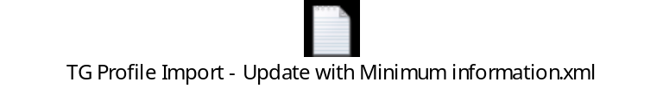
  - Sample JSON Request
    - TG Profile with complete profile data
The below sample shows how to send the complete TG profile data including Basic profile information, experience, education, resume text, client employee id data and all access modifiers.



    - TG Profile with complete profile data and Candidate forms
The below sample shows how to send the complete TG profile data including Basic profile information, experience, education, resume text, client employee id data and all access modifiers
In addition, the example also explains how Candidate forms can be included.

Note in the example that the Form payload, the “formtypeid” and “FormInput name” values are environment specific and values for Staging and Production environments are different and will be provided at the time of implementation.
    - TG Profile with minimum information
The below sample shows how to send minimum information in the TG profile by way of passing the Client’s employee id


  - Sample XML Response (Success)
The below is a sample Response for a successful transaction. A successful transaction is represented by a code 200 in the response.

  - Sample JSON Response (Success)
The below is a sample Response for a successful transaction. A successful transaction is represented by a code 200 in the response.
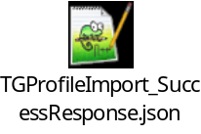
  - Sample XML Response (Failure)
The below is a sample Response for an unsuccessful transaction. A failed transaction is represented by a code 405 in the response.


  - Sample JSON Response (Failure)
The below is a sample Response for an unsuccessful transaction. A failed transaction is represented by a code 405 in the response.

  - Handling special characters in XML requests
There are several special characters that are either not allowed or not recommended for use within XML transmissions within text nodes, even within the CDATA section. These characters are: < (less than), > (greater than), & (ampersand), '(apostrophe) and "(quotation mark). In cases where these options appear within a text node within the XML, these characters must be escaped in order for the import to work without error.

The following table describes how special characters should be escaped in XML. Apostrophes, quotation marks and greater than signs are legal, but BrassRing recommends replacing them with the corresponding escape sequences, as well.

Special Characters | Escaped Character
< (less than) | &lt;
> (greater than) | &gt;
& (ampersand) | &amp;
' (apostrophe) | &apos;
" (quotation mark) | &quot;

Below are additional special characters that are not allowed in the Code values.

Other Special Characters | Denotation
; | semi colon
" | double quotes/single quotes
! | Exclamation
~ | Tilde
@ | Apple
# | Hash
= | equal to
+ | Add
? | question mark
, | Comma
> < | greater than / less than
% | Percent
| | Pipe
[ ] | square brackets
{} | curly braces

The above special characters are not allowed to be used in the XML. Special characters such as above conflict with non-XML integrations and can be mistaken or conflict with delimiters in some integrations.

  - Handling special characters in JSON requests
Escaping of special characters

The FOR JSON clause escapes special characters in the JSON output with \, as shown in the following table. This escaping occurs both in the names of properties and in their values.

Special Character | Escaped output
Quotation mark (“) | \”
Backslash (\) | \\
Slash (/) | \/
Backspace | \b
Form feed | \f
New line | \n
Carriage return | \r
Horizontal tab | \t

- Envelope Processing
The top level Envelope contains two attributes, version and encoding.
Version attribute identifies the version of the envelope. The only valid value at this time is “01.00”.
Encoding attribute identifies XML encoding and is optional. It can be set to “UTF-8” or “UTF-16”. The recommended setting is “UTF-16”.

The Envelope also has four top-level mandatory elements (Sender, Recipient, TransactInfo and Packet). These elements are described in detail below.
  - Sender
The values below will be provided at the time of implementation.
Employee Id: Sent in the Id tag for envelopes coming into BrassRing. This acts as the identification of the user who sends the data.
Client Id : Sent in the Credential tag.
  - Recipient
The URL of the recipient is passed in the Id tag. This helps to identify whether the data has been sent to the correct recipient destination.
  - TransactInfo
An identifier for the transaction should be included in the TransactId. This identifies the envelope transaction and not any of the constituent data, since there could be multiple documents within one envelope. The combination of the client Id, TransactId and PacketId creates a globally unique identifier for each packet.

A timestamp can be added in the optional TimeStamp. This date format should conform to ISO standard 8601 (i.e. “2000-10-09T14:14:11Z”)

transactType should be set to “data”. This attribute helps provide the envelope parser with a heads up on what to expect in the payloads.
  - Packet
The Packet contains the payload and metadata about the payload. The Payload element contains the actual XML and the PacketInfo element contains the metadata about the packet.
PacketInfo contains the following elements:
packetType This attribute describes the content of the packet. A packetType of data is the default.
PacketId: This element uniquely identifies the contents of the payload. PacketId is 1 unless suggested otherwise
Action: This optional element contains the transaction code – SET
Manifest: This is a mandatory element that identifies the contents of the payload. This field must be set to the value provided during implementation and should not be changed.
  - Payload
The Payload element contains one HR-XML document inside a CDATA section. This approach allows the payload to be parsed separately from the envelope and avoids any interdependency between envelope and contents when validating envelope documents.

Note: the Payload XML should not have any additional CDATA section within it as in nested CDATA sections.

- Security
Several security protocols and measures have been implemented to ensure security on the data transmission, message integrity, and message confidentiality. These mechanisms can be used to accommodate a wide variety of security models and encryption technologies.
  - Standard Implementation Security
    - Message Integrity
Message integrity is ensured on the XML data. Unique credentials within the XML act as authentication information for a transaction to be consumed. These credentials in the Id, Credential and Manifest nodes act as unique value for a given implementation.
    - Transport Layer Security (TLS)
Transport Layer Security (TLS) and its predecessor, Secure Sockets Layer (SSL), are cryptographic protocols that provide communication security over the Internet. TLS and SSL encrypt the segments of network connections above the Transport Layer, using asymmetric cryptography for key exchange, symmetric encryption for privacy, and message authentication codes for message integrity.

BrassRing integration API URLs (web service and HTTP Post URLs) are HTTPS-enabled and utilize 128 bit encryption over SSL when exchanging and transmitting information over the Internet. This is a mandatory encryption of the data that is enforced.
    - IP restrictions
To add another layer to security and protection, IP restrictions can also be enforced. At the time of implementation, IP addresses from Staging and Production environments can be provided that can be white-listed on an external firewall on the customer’s network. These IP addresses are provided on request.
  - Optional Security Features
    - Message Layer Encryption/Security (MLS)
In additional to the above security protocols, message layer encryption is also available on the payload data.

Message layer encryption is facilitated using RSA encryption on the XML. Both Java and Microsoft .NET development environments support APIs for RSA encryption. BrassRing uses 1024-bit RSA encryption key pairs along with a public key generated by the client to implement functions to encrypt, sign, decrypt and authenticate data.

Adding MLS adds to the cost and timeline of the project and as this is not part of standard implementations.

    - 2-Way SSL / Certificate Based Authentication
Additionally, client certificate authentications or 2-way SSL or mutual SSL authentication is also available to enforce additional security around the integrations. The method of data exchange is accomplished with the use of certificates that confirm the source of the data before processing the information. SSL Session negotiated by Handshake Protocol via a X.509 public key Certificate of Peer.

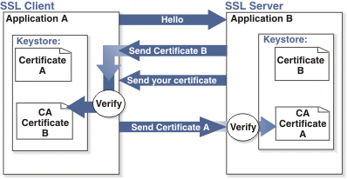

Adding 2-way SSL adds to the cost and timeline to the project as this is not part of Standard implementations.

Note: 2-way SSL is currently not available to clients on the China data-center.

- Integration API URLs
  - Message Router Addresses
Web service URLs you need to invoke to send transactional data to BrassRing TG. These URLs below apply to the US data-center only. Europe and China end point URLs are provided during time of implementation on such integrations.

Staging Environment
Web Service
URL - https://stagingimport.brassring.com/WebRouter/WebRouter.asmx
WSDL - https://stagingimport.brassring.com/WebRouter/WebRouter.asmx?wsdl

Production Environment
Web Service
URL - https://import.brassring.com/WebRouter/WebRouter.asmx
WSDL - https://import.brassring.com/WebRouter/WebRouter.asmx?wsdl

- API Error Messages
Below is a list of error messages that you may encounter when using the TG Import integration. We have also included an explanation in order to assist you with troubleshooting.
Code | Error Description | Reasoning
401 | ValidateAccess: - Access not setup for Sender – DSDSDS | Value in the Sender tag is incorrect
401 | Credential value is invalid | Value in the Credential tag in incorrect
405 | All units are processed with failure codes  Error: Missing Element/Values | Mandatory SSO ID field and value missing
405 | Invalid value in XML  The candidate record was not created or updated. The data entered for the Candidate stacking field is incorrect. | Stacking Field length does not match the length defined.
405 | The candidate record was not created or updated.  A value in the email field or a value in the homephone field is required. | Required field is missing data
405 | The underlying connection was closed:  Could not establish secure channel for SSL/TLS | Unexpected error perhaps due to time-out. Resend transaction again
405 | Timeout expired. The timeout period elapsed prior to completion of the operation or the server is not responding. | Service down. Retry message
405 | Forms Processing Error : Unexpected system error occured. [ Violation of PRIMARY KEY constraint 'PK__#1E91D13__5DFCD433207A19AA'. Cannot insert duplicate key in object 'dbo.@CandidateForms'. The duplicate key value is (1466, 0). | Invalid Form Field ID
405 | Invalid xml. XML Validation Error (The element 'PositionHistory' in namespace 'http://ns.hr-xml.org/2007-04-15' has invalid child element 'StartDate' in namespace 'http://ns.hr-xml.org/2007-04-15'. List of possible elements expected: 'OrgInfo, OrgIndustry, OrgSize, Description' in namespace 'http://ns.hr-xml.org/2007-04-15'. ) | Missing Description Tag in Experience section.

NOTE: This list is not all inclusive but contains the errors that are most encountered.

