


Signal Labs Talent BrassRing

Job Code Default Data (JCDD) Import Technical Specifications API Guide

The information contained in this document is the property of Signal Labs Talent Inc. Except as specifically authorized in writing by Signal Labs Talent Inc, the holder of this document shall: (1) keep all information contained herein confidential and shall protect same in whole or in part from disclosure and dissemination to all third parties and, (2) use same for operating and maintenance purposes only.

Version: 1.0.0
Date: January 06, 2022
Table of Contents
Chapter 1: Introduction 1
1.1 What are BrassRing’s XML Integration APIs 1
1.2 Purpose 1
1.3 Audience 1
Chapter 2: BrassRing’s JCDD Integration APIs 2
2.1 Overview 2
2.2 Communication Methodology 2
2.3 Rules for the Job Code Default Data Integration 3
2.4 JCDD Snapshot in BrassRing 4
2.5 JCDD Tag Definitions (Summary) 5
2.6 JCDD Tag Definitions – Detailed Descriptions 6
2.6.1 Required Fields (Mandatory) 6
2.6.2 Optional Fields 7
2.6.3 Special Attributes 20
Chapter 3: Schemas 20
3.1 Sample XML Request 20
3.2 Sample JSON Request 21
3.3 Sample XML Response (Success) 23
3.4 Sample JSON Response (Success) 23
3.5 Sample XML Response (Failure) 25
3.6 Sample JSON Response (Failure) 25
3.7 Handling special characters in XML requests 27
3.8 Special Characters in JSON Requests 28
Chapter 4: Envelope Processing 29
4.1 Sender 29
4.2 Recipient 29
4.3 TransactInfo 29
4.4 Packet 29
4.5 Payload 29
Chapter 5: Security 31
5.1 Standard Implementation Security 31
5.1.1 Message Integrity 31
5.1.2 Transport Layer Security (TLS) 31
5.1.3 IP restrictions 31
5.2 Optional Security Features 31
5.2.1 Message Layer Encryption/Security (MLS) 31
5.2.2 2-Way SSL / Certificate Based Authentication 32
Chapter 6: Integration API URLs 33
6.1 Message Router Addresses 33
Chapter 7: API Error Messages 34

- Introduction
- What are BrassRing’s Integration APIs
BrassRing XML/JSON integrations feature flexible, secure, real-time integrations by sending XML/JSON over the Internet using web services or HTTP Posts. XML/JSON formats used in BrassRing XML/JSON integrations are based on HR-XML Consortium guidelines.

The BrassRing XML/JSON integrations offering allows BrassRing to work with the customers to configure multi-level, robust integration relationships between BrassRing and any systems that can send and receive XM/JSON L. Examples of these systems include HRIS systems such as SAP/Oracle/PeopleSoft, etc., and systems that perform HR related services like background checks, assessments or compensation analysis.

The customer can choose to send data through either a web service or HTTP post. BrassRing handles the exchange of XML requests and responses using its own messaging software. The customer builds their own messaging system to exchange XML/JSON web service messages or HTTP post with BrassRing.
- Purpose
The purpose of this document is as follows:
- To present high-level architecture and design of BrassRing APIs and how BrassRing implements JCDD Import integrations to meet its customers’ needs for automated data management.
- To describe suggested high-level workflow processes that can be supported between BrassRing and any external, third-party system that can send and receive XML/JSON requests and responses.
- To describe the steps required to implement JCDD integration.
- Audience
- Client Decision Makers, HRIS Implementation Teams, Internal IT Teams, Systems Integrators and Support Teams.
- BrassRing Engineering Services Team, Support Team, and Technical Services Group.

- BrassRing’s JCDD Integration APIs
- Overview
Job Code Default Data (JCDD) can be imported into BrassRing from an external system. JCDD functionality allows you to associate a set of default values to a Job Code. This is especially useful when Requisitions (jobs) are created in the system where a Recruiter/Hiring Manager chooses a Job code and all pre-determined fields in the Requisition get auto-populated based on the code selected.

The JCDD fields on the Requisition that need to be defaulted are chosen by the client at integration set-up time and recorded in the XML_Integrations_Data_Mapping_Document.doc.
- Communication Methodology
Connection to the BrassRing system is accomplished via 2 mechanisms using XML/JSON as a data transfer vehicle.
- HTTP Post
- Web services
Both the above mechanisms are synchronous meaning all transactions are real-time with a request-response messaging and no message queuing.

The XML/JSON format is depicted in Section 3.

Clients can choose to batch transactions or send data to BrassRing in real-time.

BrassRing will always process transactions in real-time regardless of whether they were batched or not by the client.

- Rules for the Job Code Default Data Integration
Below are a few rules to consider when looking into the use of the Job Code Default Data Integrations:
- The JCDD API processes only one Job Code at a time, meaning one XML/JSON for each Job code. Bundle/group Job Code Default Data is not allowed in the same XML/JSON.
- The purpose for JCDD is to pre-populate standard and custom fields on a Req template. This functionality simplifies the process of creation of a Requisition for recruiters or hiring managers as fields can be pre-populated. Not all fields on the Req template should be/ can be mapped to JCDD integrations. Details of client’s specific fields and what can/cannot be mapped to the integration should be outlined and captured within XML/JSON data mapping template.
- JCDD cannot lock the populated defaulted field. If certain fields should be locked for certain users so they won’t be able to change the information, please coordinate with your BrassRing Support Team to lock the field from being modified.
- The XML/JSON schema cannot be customized (see sample XML/JSON below). The JCDD fields to be sent in the integration can however be added depending on a client’s Req template.
- JCDD XML/JSON files are processed real-time via HTTP Post or Web Services.
- Client’s HRIS or external systems should wait for a success/failure response before sending the next transaction.
- JCDD API works on the Requisition template level. For example if a given client has 3 Requisition templates “Confidential Requisition”, “Contractor” and “Employee Requisition Form” and JCDD should create a JCDD for all 3 templates, then the client can send the one JCDD XML/JSON to populate all 3 Req templates. Mapping can also be adjusted on specific Req templates. For example, in the case above, if client wants JCDD to work on only one of the Req templates, e.g., “Confidential Requisition,” then that can be done as well. Such details must be outlined and captured in the data mapping document.
- In some cases, a given client might have multiple Req templates that are significantly different in structure, for example “Full time employee Req” and “CoOp/Temp Req”. If structures of Req templates are significantly different, the recommendation is to set up 2 different JCDD integrations to populate these 2 completely different Req templates. Such details have to be captured and outlined in data mapping document.
- Field requirements are outlined in the Data Mapping sections.
- Select fields (such as single-select, multi-select, check-box, radio button fields) mapped to the integration by default accept the defined description for that field in BrassRing. This setting can be adjusted on a field-by-field level to accept the code instead. If a given client is using more than one language, the recommendation is to adjust the settings to accept code. Code will remain the same for all translated values, whereas descriptions could vary from language to language.
- Special characters in the XML/JSON must be escaped. See Section 3.4
- Send delta loads only. Full/destructive loads are not recommended.

- JCDD Snapshot in BrassRing
Below are screen prints of the Job Code and Requisition screens for your reference.
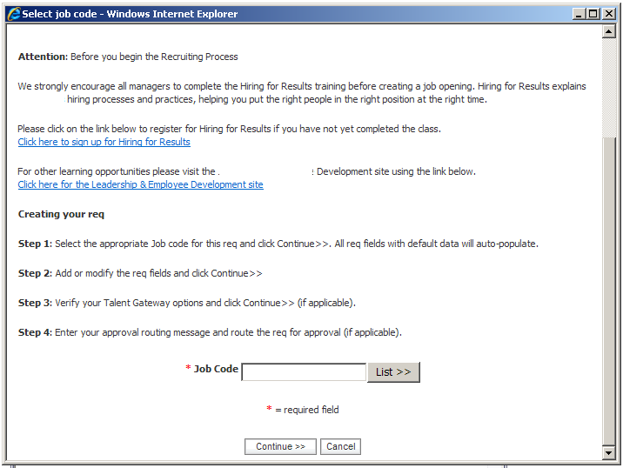
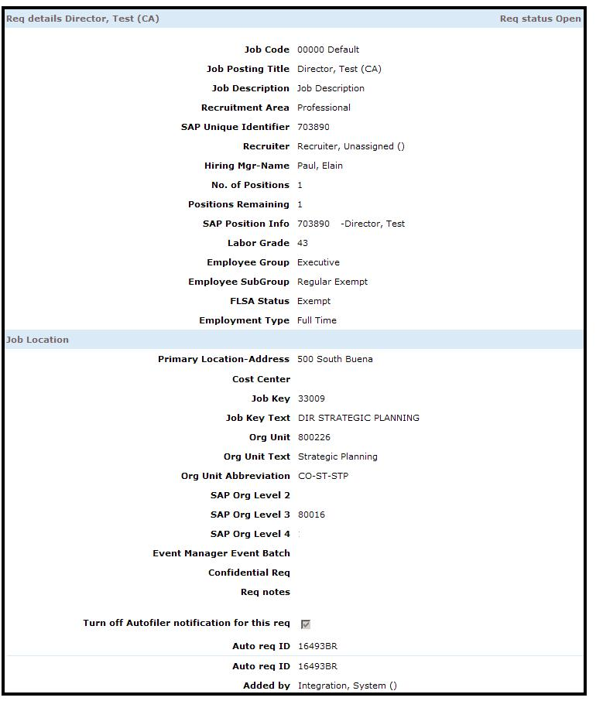

- JCDD Tag Definitions (Summary)
Line # | Field Name | Field Type | Format | Length | XML Tag/JSON Key | BrassRing Notes
Mandatory Fields
1 | Job Code (Position Number) | NA | Varchar | 35 | JOBCODE | Used as a record key identifier
2 | Job Code Description (Position Title) | NA | Varchar | 70 | JOBCODEDESC | Usually the same as Job Title
3 | Status | NA | Varchar | 1 | JOBCODESTATUS | Must be either A= active or I=Inactive
Optional Fields (examples below)
4 | Department | Standard | Varchar | 255 | DEPARTMENT | The XML/JSON tags names for additional fields will be provided later after the client  identifies the fields required for the JCDD integration in the data mapping document
5 | Location / Division | Standard | Varchar | 255 | LOCATION
6 | Recruiter Name | Standard | Varchar | 255 | RECRUITER
7 | Manager Name | Standard | Varchar | 255 | MANAGER
Custom Fields (examples below)
8 | FLSA | Custom | Varchar | 255
9 | EEO | Custom | Varchar | 255
10 | Job Function | Custom | Varchar | 255
11 | Job Sub-Function | Custom | Varchar | 255
12 | Personnel Sub Area | Custom | Varchar | 255
13 | Cost Center | Custom | Varchar | 255

- JCDD Tag Definitions – Detailed Descriptions
XML tags//JSON Keys for Job Code Default Data can be categorized as below.
- Mandatory tags for insert: JOBCODE, JOBCODEDESC, JOBCODESTATUS
- Minimum mandatory tags for update: JOBCODE, JOBCODEDESC, JOBCODESTATUS
- The following tags are BrassRing standard tags. They are not mandatory and a client can choose to use them as long as they exist on the Req templates. These tags should be finalized in data mapping document for a given client.
- DEPARTMENT, LOCATION, RECRUITER, MANAGER are a couple of examples.
- Additional optional custom tags: Client’s specific custom field/tags. A couple of good examples for common client custom tags will be, FLSA, EEO, JOB_FUNCTION, JOB_SUB_FUNCTION.
- Required Fields (Mandatory)
- JOBCODE (1)
This tag identifies the Unique Job Code on the Client’s system
XML Tag/JSON Key | Tag Required? | Value Required? | Format | Length
JOBCODE | Yes | Yes, required for both insert and update | Varchar
_Rules:
- This tag plays the unique identifier for determining the inserting or updating an existing Job Code record. This tag and its value must be present for all submissions. If the value of JOBCODE is present in BrassRing system, an update will be applied to the existing record. If the value JOBCODE is not present in BrassRing system, a brand new Job code will be created.
- JOBCODE value contains Client’s unique identifier for a Job Code.

- JOBCODEDESC (2)
This tag identifies the Job Description
XML Tag/JSON Key | Tag Required? | Value Required? | Format | Length
JOBCODEDESC | Yes | Yes, required for both insert and update | Varchar
_Rules:
- Tag and value are both required.

- STATUS (3)
This tag identifies the Status of a Job Code.
XML Tag/JSON Key | Tag Required? | Value Required? | Format | Length
JOBCODESTATUS | Yes | Yes, required for both insert and update | Varchar
_Rules:
- Tag and value are both required.
- Values:
  - A (Active)
  - I (Inactive)
- For reporting purposes, Job Codes do not get deleted. Instead they can become inactivated with JOBCODESTATUS of “I”. Inactivating a job code, will make the job code no longer appear on the Job Code drop down.

- Optional Fields
- “Select” Field types (i.e. single-select, multi-select, check-box, radio button)
This rule applies to Select type custom and standard questions
XML Tag/JSON Key | Tag Required? | Value Required? | Format | Length
CUSTOM_SELECT/  STANDARD_SELECT | No | No | Varchar
Rules:
- Value passed for a select question must be the description defined for that field by default.
- On field-by-field level, this setting can be adjusted to accept the code. This is highly recommended for multi-language integration Clients.
- If Select question is a type of multi-select and multiple options should be passed and defaulted, that tag should repeated with appropriate defined values. For example:
XML:
<BUSINESSLOCATION>Boston</BUSINESSLOCATION>
<BUSINESSLOCATION>Miami</BUSINESSLOCATION>
JSON:
"BUSINESSLOCATION": "Boston"
"BUSINESSLOCATION": "Miami"
- Text Area field types
This rule applies to Text Area fields
XML Tag/JSON Key | Tag Required? | Value Required? | Format | Length
CUSTOM_TEXTAREA | No | No | Varchar
Rules:
- Maximum allowed length for a Text Area type is 4000 chars.

- MANAGER and RECRUITER
These tags represent the Hiring Manager and the Recruiter on the Requisition.
XML Tag/JSON Key | Tag Required? | Value Required? | Format | Length
MANAGER  RECRUITER | Optional | Yes, required for both insert and update | Varchar | 255
Rules:
- Acceptable formats are:
  - Employee ID stored in BrassRing’s user table
  - First Name <space> Last Name (for example John Smith)
  - Please note, some Clients might have a setting called User differentiator turned “On”. In such cases the format should be First Name <space> Last Name (differentiator) (for example, John Smith (123456))

- Approval Routing
These tags represent the approval routing section on the Requisition.
XML Tag/JSON Key | Tag Required? | Value Required? | Format | Length
APPROVERS  APPROVALGROUP | Optional | Yes, required for both insert and update | Varchar | 255
Rules:
- Acceptable formats are:
  - Employee ID stored in BrassRing’s user table
  - First Name <space> Last Name (for example John Smith)
  - Please note, some Clients might have a setting called User differentiator turned “On”. In such cases the format should be First Name <space> Last Name (differentiator) (for example, John Smith (123456))
  - Bypass
  - Non-System User Email

XML:
<APPROVERS type="standard">
<APPROVALGROUP name="Non-System User Approval Group">
<NONSYSTEMEMAIL>first.last@kenexa.com</NONSYSTEMEMAIL>
</APPROVALGROUP>
<APPROVALGROUP name="Bypass Approval Group" action='bypass'>
</APPROVALGROUP>
<APPROVALGROUP name="Employee Name Approval Group 3">
<EMPNAME>Max Payne (MP123456)</EMPNAME>
</APPROVALGROUP>
<APPROVALGROUP name="EmployeeID Approval Group">
<EMPLOYEEID>MP123456</EMPLOYEEID>
</APPROVALGROUP>
</APPROVERS>

JSON:
{
"APPROVERS": {
"APPROVALGROUP": [
{
"NONSYSTEMEMAIL": "first.last@kenexa.com",
"name": "Non-System User Approval Group"
},
{
"name": "Bypass Approval Group",
"action": "bypass"
},
{
"EMPNAME": "Max Payne (MP123456)",
"name": "Employee Name Approval Group 3"
},
{
"EMPLOYEEID": "MP123456",
"name": "EmployeeID Approval Group"
}
],
"type": "standard"
}
}

- TEAM / REQ TEAM
This tag represents the Req Team for the Requisition
XML Tag/JSON Key | Tag Required? | Value Required? | Format | Length
TEAM | No | No | Varchar | 7500
Rules:
- Req team can be passed and populated via JCDD import integration.
- A given Req can be assigned to more than one Req team person.
- Req team can be passed in format of employee ID. Using employee ID is highly recommended for Clients who do use EmployeeId in the User setup (since employee ID is optional). Example below illustrates how multiple Req team members can be included using employee ID.
XML
<TEAM action=”replace”>
<EMPLOYEEID>3057559</EMPLOYEEID>
<EMPLOYEEID>3057560</EMPLOYEEID>
<EMPLOYEEID>3057561</EMPLOYEEID>
<EMPLOYEEID>3057562</EMPLOYEEID>
</TEAM>

JSON
{
"TEAM": {
"EMPLOYEEID": [
"3057559",
"3057560",
"3057561",
"3057562"
],
"action": "replace"
}
}

- Req team can be passed in format of Employee name. Using Employee Name is recommended for clients who do not use EmployeeId . Example below illustrates how multiple Req team members can be included using Employee name.
XML
<TEAM action=”replace”>
<EMPNAME>John Smith</EMPNAME>
<EMPNAME>Mandy Cooper</EMPNAME>
<EMPNAME>Liz Johnson</EMPNAME>
</TEAM>

JSON
{
"TEAM": {
"EMPNAME": [
"John Smith",
"Mandy Cooper",
"Liz Johnson"
],
"action": "replace"
}
}

- Please note, if User differentiator setting is on and a Client decides to send EMPLOYEENAME, then the User differentiator chosen should be passed as well. In this example, the EmployeeID was the user differentiator selected. See example below:

XML
<TEAM action=”replace”>
<EMPNAME>John Smith (3057559)</EMPNAME>
<EMPNAME>Mandy Cooper (3057560)</EMPNAME>
<EMPNAME>Liz Johnson (3057561)</EMPNAME>
<EMPNAME>Niki Anderson (3057562)</EMPNAME>
</TEAM>

JSON
{
"TEAM": {
"EMPNAME": [
"John Smith (3057559)",
"Mandy Cooper (3057560)",
"Liz Johnson (3057561)",
"Niki Anderson (3057562)"
],
"action": "replace"
}
}

Below are the other actions tags that can be used.
- This tag should be used to delete the current Req Team and replace it with the values sent. Use if the client always sends the entire Req Team.

XML
<TEAM action="replace">
<EMPNAME>employeeName</EMPNAME>
<EMPLOYEEID>3057559</EMPLOYEEID>
</TEAM>

JSON
{
"TEAM": {
"EMPNAME": "employeeName",
"EMPLOYEEID": "3057559",
"action": "replace"
}
}

- This tag should be used to remove certain members from the Req Team. NOTE: You will get an error if you try to remove all members without replacing them.
XML:
<TEAM>
<remove>
<EMPNAME>employeeName</EMPNAME>
<EMPLOYEEID>3057559</EMPLOYEEID>
</remove>
</TEAM>

JSON:
{
"TEAM": {
"remove": {
"EMPNAME": "employeeName",
"EMPLOYEEID": "3057559"
}
}
}

- This tag should be used to add members to the current Req Team.
XML:
<TEAM>
<add>
<EMPNAME>employeeName</EMPNAME>
<EMPLOYEEID>3057559</EMPLOYEEID>
</add>
</TEAM>
JSON:
{
"TEAM": {
"add": {
"EMPNAME": "employeeName",
"EMPLOYEEID": "3057559"
}
}
}
- This tag can be used to add and remove members from the Req Team. This could be used to remove all and add new instead of the replace tag above but all values would have to be sent.
XML:
<TEAM>
<remove>
<EMPNAME>employeeName</EMPNAME>
<EMPLOYEEID>3057559</EMPLOYEEID>
</remove>
<add>
<EMPNAME>employeeName</EMPNAME>
<EMPLOYEEID>3057559</EMPLOYEEID>
</add>
</TEAM>

JSON:
{
"TEAM": {
"remove": {
"EMPNAME": "employeeName",
"EMPLOYEEID": "3057559"
},
"add": {
"EMPNAME": "employeeName",
"EMPLOYEEID": "3057559"
}
}
}

- JOBOO fields (9)
This tag and its attributes are used to populate posting information of a Req on the Talent Gateways. Please note that not all posting options/selections are available through integration.
XML Tag/JSON Key | Tag Required? | Value Required? | Format | Length
JOBOO | No | No | Multi nodes
Rules:
- A given Req can be posted to one or many Talent gateways. Below is an example of posting a Req to multiple gateways.
XML:
<JOBOO>
<SITE ID="123" NAME="CLIENT Careers" DAYSTILLPOSTING="0" POSTINGDAYS="365" QUESTIONSIDS="12345,98765" GQNAME="External Application" ASSESSMENTBATCH="Batch1" MINSCORE="5" MINASSESSMENTSCORE="10" MINREQUIREDSCORE="15" PASSHRSTATUS="Applied" FAILHRSTATUS="Company Not Interested" STATUS="A"/>
<SITE ID="456" NAME="CLIENT Internal Opportunities" DAYSTILLPOSTING="0" POSTINGDAYS="365" QUESTIONSIDS="12345,98765" GQNAME="Internal Application" ASSESSMENTBATCH="Batch3" MINSCORE="5" MINASSESSMENTSCORE="10" MINREQUIREDSCORE="15" PASSHRSTATUS="Applied" FAILHRSTATUS="Company Not Interested" STATUS="A" />
<!-- ... etc ... -->
</JOBOO>

JSON:
{
"JOBOO": {
"SITE": [
{
"ID": "123",
"NAME": "CLIENT Careers",
"DAYSTILLPOSTING": "0",
"POSTINGDAYS": "365",
"QUESTIONSIDS": "12345,98765",
"GQNAME": "External Application",
"ASSESSMENTBATCH": "Batch1",
"MINSCORE": "5",
"MINASSESSMENTSCORE": "10",
"MINREQUIREDSCORE": "15",
"PASSHRSTATUS": "Applied",
"FAILHRSTATUS": "Company Not Interested",
"STATUS": "A"
},
{
"ID": "456",
"NAME": "CLIENT Internal Opportunities",
"DAYSTILLPOSTING": "0",
"POSTINGDAYS": "365",
"QUESTIONSIDS": "12345,98765",
"GQNAME": "Internal Application",
"ASSESSMENTBATCH": "Batch3",
"MINSCORE": "5",
"MINASSESSMENTSCORE": "10",
"MINREQUIREDSCORE": "15",
"PASSHRSTATUS": "Applied",
"FAILHRSTATUS": "Company Not Interested",
"STATUS": "A"
}
]
}
}

- Additionally question scoring can be added using the tags below in place of the ones above.
XML:
<JOBOO>
<SITE ID="123" NAME=" CLIENT Careers " DAYSTILLPOSTING="0" POSTINGDAYS="365" GQNAME="External Application" ASSESSMENTBATCH="Batch1" STATUS="A" MINSCORE="5" MINASSESSMENTSCORE="10" MINREQUIREDSCORE="15" PASSHRSTATUS="Applied" FAILHRSTATUS="Company Not Interested">
<QUESTIONS>
<Question ID="12345" requiredscore="10"/>
<Question ID="98765" requiredscore="10"/>
<!-- ... etc ... -->
</QUESTIONS>
</SITE>
<!-- ... etc ... -->
</JOBOO>
JSON:
{
"JOBOO": {
"SITE": {
"QUESTIONS": {
"Question": [
{
"ID": "12345",
"requiredscore": "10"
},
{
"ID": "98765",
"requiredscore": "10"
}
]
},
"ID": "123",
"NAME": " CLIENT Careers ",
"DAYSTILLPOSTING": "0",
"POSTINGDAYS": "365",
"GQNAME": "External Application",
"ASSESSMENTBATCH": "Batch1",
"STATUS": "A",
"MINSCORE": "5",
"MINASSESSMENTSCORE": "10",
"MINREQUIREDSCORE": "15",
"PASSHRSTATUS": "Applied",
"FAILHRSTATUS": "Company Not Interested"
}
}
}

Below is a screen print of the BrassRing Posting Options page along with a description of each tag that is associated to this page.
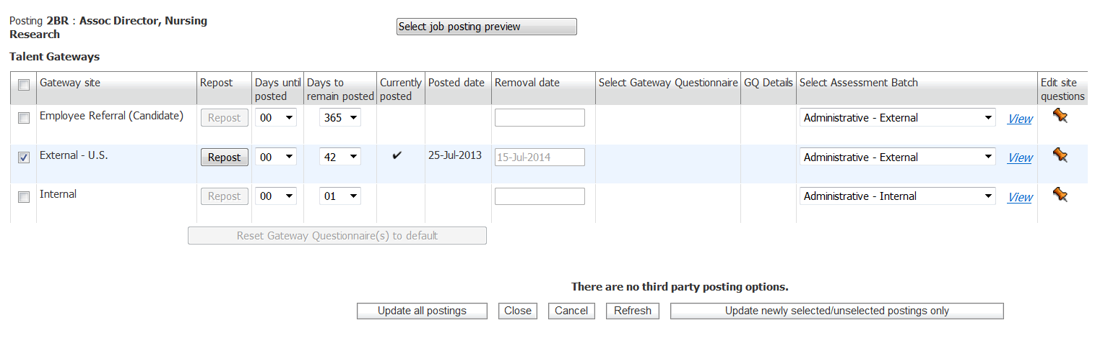
5
4
3
2
1
6

XML Tag//JSON Key | Description
1 - SITEID | SITE ID is mandatory and is the unique identifier for a given Talent Gateway. This number will vary between staging and production. If a new Gateway is created, a new Site ID will have to be added. Site IDs can be found in Workbench under Tools > Talent Gateways.
1 - NAME | NAME is mandatory and is the display name of a given Talent Gateway. This value is generally the same between staging and production. If a new Gateway is created, a new name will have to be added. Name can be found in Workbench under Tools > Talent Gateways.
2 - GQNAME | Gateway Questionnaire name. This value is generally the same between staging and production. If a GQ is revised or created, the name will have to be added in the XM/JSON L. GQ Name can be found in Workbench under Tools > Gateway Questionnaires.
3 - ASSESSMENTBATCH | Name of the Assessment Batch associated to the posting. This is a query-select field in BrassRing that requires you to send Description (i.e. the name as you see it in Workbench/BrassRing).
3 - DAYSTILLPOSTING | This value indicates the date in which the Req should be posted on the gateway. A value of 0 indicates that it should be posted right away.
4 - POSTINGDAYS | This value sets the number of days a given Req should remain active on a given gateway.
5 - STATUS | Status can be either “A” (Active/Posted/Checked) or “I” (Inactive/Not Posted/Unchecked).
_

Below is a screen print of the Edit Site Questions page along with a description of each tag that is associated to this page.
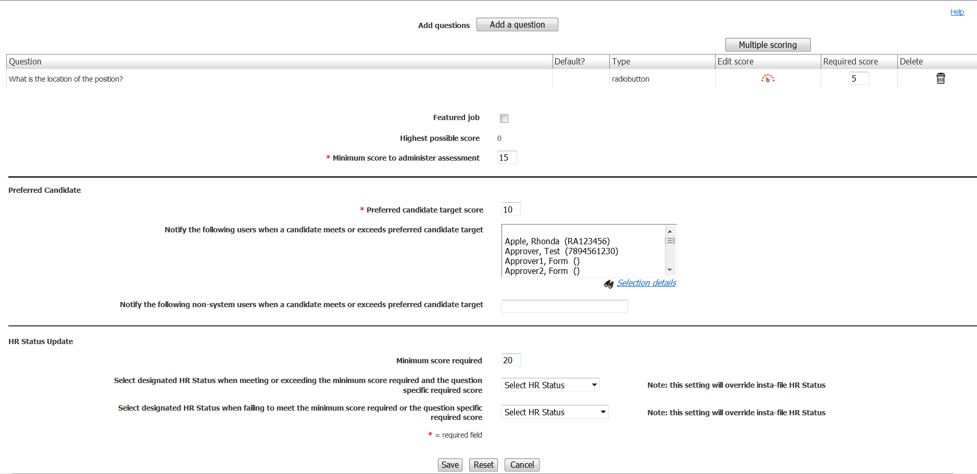
7
6
5
3
4
2
1

XML Tag/JSON Key | Description
1 - QUESTIONIDS | Adds questions to the posting. Please note that if values are provided, they wipe out the default questions associated to the specific gateway so please make sure to include the IDs for all the questions you want the candidate to answer.
2 - requiredscore | Required scores can be entered for any QUESTIONIDS that contain options for the candidate to choose from. This feature aid in screening candidates.
3 - MINSCORE | The target score is the threshold to define candidates who will be automatically routed to the designated users. A target score of "0" will assure that every candidate who applies for the position will be sent to the designated individuals. (An account setting may default this to the highest score possible).
4 – MINASSESSMENTSCORE | For use with scoring assessments. Accounts using the "Always launch assessments" setting will ignore this value.
5 - MINREQUIREDSCORE | For use when updating a candidate’s HR Status based on score.
6 - PASSHRSTATUS | For use when updating a candidate’s HR Status based on score. Must be a Start Status.
7 - FAILHRSTATUS | For use when updating a candidate’s HR Status based on score. Must be a Final Status.
_

- Special Attributes
- Job Code Default Data can also support multiple languages. Language is handled via an attribute. If a Job Code must default for multiple languages, that job code must be submitted multiple times to BrassRing with appropriate language attributes. Language attributes accepts 2-letter ISO format. BrassRing has a standard, static list of languages and their corresponding ISO formats. Client and PSE engineering should understand all the languages that will be used for a Client to ensure all possible attribute values are exchanged.
XML:
<CLIENTNAME_POSITIONDATA language="EN" AutoFilerNotification="No">

JSON:
"POSITIONDATA": {
"language": "EN",
"AutoFilerNotification": "No"
}

- Mandatory job code description cannot be supported in more than one language. This means Job description should only be sent in Client’s default language. Language attribute should only be used for defaulting select questions and populating translated values in text fields and text areas.
- In case of Select questions (single-select, multi-select, radio….), in order for defaults for a given language to work as expected, JCDD data for that given language should be sent. Recommendation is to adjust such fields to accept code instead of description on field-by-field level since codes will remain the same for all languages.
- JCDD can also support selecting and deselecting auto-filer notification. Auto-filer notification can be handled via AutoFilerNotification attribute. This attribute can only accept 2 following values:
  - Yes (to uncheck/unselect auto filer notification check box)
  - No (to check/select auto filer notification check box)

XML:
<CLIENTNAME_POSITIONDATA language="EN" AutoFilerNotification="No">

JSON:
"POSITIONDATA": {

"language": "EN",

"AutoFilerNotification": "No"

}
- Schemas
- Sample XML Request
Below is a sample JCDD XML file. The items highlighted in yellow are required to be sent within the Payload. You can only send 1 JCDD data in a single XML.

<?xml version="1.0"?>
<Envelope version="01.00">
<Sender>
<Id>INTEGRATIONID</Id>
<Credential>CLIENTID</Credential>
</Sender>
<Recipient>
<Id/>
</Recipient>
<TransactInfo transactType="data">
<TransactId>15747</TransactId>
<TimeStamp>2006-02-28 09:22:10AM</TimeStamp>
</TransactInfo>
<Packet>
<PacketInfo packetType="data">
<PacketId>1</PacketId>
<Action>SET</Action>
<Manifest>CLIENT_POSITIONDATA</Manifest>
</PacketInfo>
<Payload><![CDATA[<?xml version="1.0"?>
<POSITIONDATA AutoFilerNotification="No">
<JOBCODE>01122</JOBCODE>
<JOBCODEDESC>ANALYST-CNTRCT MGT-II-NONC-SLR</JOBCODEDESC>
<JOBCODESTATUS>A</JOBCODESTATUS>
<HOURLY_MINIMUM>$24.88</HOURLY_MINIMUM>
<JOBTITLE>ANALYST-CONTRACT MGMT-II</JOBTITLE>
<UNION_POSITION>Yes</UNION_POSITION>
<PAY_RANGE>18S</PAY_RANGE>
<EEO_CATEGORY></EEO_CATEGORY>
<UNION_NAME></UNION_NAME>
<SALARIED_HOURLY>Salaried</SALARIED_HOURLY>
<POSITIONCODE>002473: ANALYST-CONTRACT MGMT-II</POSITIONCODE>
<COST_CENTER></COST_CENTER>
<DEPARTMENT></DEPARTMENT>
<GL_LOCATION></GL_LOCATION>
<TEAM>
<EMPLOYEEID>3057559</EMPLOYEEID>
<EMPLOYEEID>3057560</EMPLOYEEID>
<EMPLOYEEID>3057561</EMPLOYEEID>
<EMPLOYEEID>3057562</EMPLOYEEID>
</TEAM>
</POSITIONDATA>]]></Payload>
</Packet>
</Envelope>

- Sample JSON Request
{
"Envelope":
{
"Packet":
{
"PacketInfo":
{
"Action": "SET",
"Manifest": "CLIENT_POSITIONDATA",
"PacketId": "1",
"packetType": "data"
},
"Payload":
{
"POSITIONDATA":
{
"AutoFilerNotification": "No",
"ENCCHECKBOX1": "",
"ENCDATE": "",
"JOBCODE": "01122",
"JOBCODEDESC": "ANALYST-CNTRCT MGT-II-NONC-SLR",
"JOBCODESTATUS": "A",
"language": "EN"
}
}
},
"Recipient":
{
"Id": ""
},
"Sender":
{
"Credential": "CLIENTID",
"Id": "INTEGRATIONID"
},
"TransactInfo":
{
"TimeStamp": "2023-01-07 07:27 AM",
"TransactId": "15747",
"transactType": "data"
},
"version": "01.00"
}
}

- Sample XML Response (Success)
Below is a sample success response XML file.

<?xml version="1.0" encoding="utf-8"?>
<Envelope version="01.00">
<Sender>
<Id>INTEGRATIONID</Id>
<Credential>CLIENTID</Credential>
</Sender>
<Recipient>
<Id/>
</Recipient>
<TransactInfo transactType="response">
<TransactId>005056BD2B8A</TransactId>
<TimeStamp>2012-05-30 03:34:55</TimeStamp>
<Status>
<Code>200</Code>
<ShortDescription>Success</ShortDescription>
<LongDescription>POSITIONDATA Data transfer was a success</LongDescription>
</Status>
</TransactInfo>
<Packet>
<PacketInfo packetType="response">
<PacketId>1</PacketId>
<Action>SET</Action>
<Manifest>CLIENT_POSITIONDATA</Manifest>
<Status>
<Code>200</Code>
<ShortDescription>Success</ShortDescription>
<LongDescription>POSITION Data transfer was a success</LongDescription>
</Status>
</PacketInfo>
<Payload/>
</Packet>
</Envelope>
- Sample JSON Response (Success)
{
"Envelope": {
"Sender": {
"Id": "INTEGRATIONID",
"Credential": "CLIENTID"
},
"Recipient": {
"Id": ""
},
"TransactInfo": {
"TransactId": "005056BD2B8A",
"TimeStamp": "2012-05-30 03:34:55",
"Status": {
"Code": "200",
"ShortDescription": "Success",
"LongDescription": "POSITIONDATA Data transfer was a success"
},
"transactType": "response"
},
"Packet": {
"PacketInfo": {
"PacketId": "1",
"Action": "SET",
"Manifest": "CLIENT_POSITIONDATA",
"Status": {
"Code": "200",
"ShortDescription": "Success",
"LongDescription": "POSITION Data transfer was a success"
},
"packetType": "response"
},
"Payload": ""
},
"version": "01.00"
}
}

- Sample XML Response (Failure)
Below is a sample failure response XML file.

<?xml version="1.0" encoding="utf-8"?>
<Envelope version="01.00" />
<Sender>
<Id>INTEGRATIONID</Id>
<Credential> CLIENTID</Credential>
</Sender>
<Recipient>
<Id/>
</Recipient>
<TransactInfo transactType="response">
<TransactId>005056BD2B8A</TransactId>
<TimeStamp>2012-05-30 03:34:55</TimeStamp>
<Status>
<Code>405</Code>
<ShortDescription>Failure</ShortDescription>
<LongDescription>POSITIONDATA Data transfer was not successful</LongDescription>
</Status>
</TransactInfo>
<Packet>
<PacketInfo packetType="response">
<PacketId>1</PacketId>
<Action>SET</Action>
<Manifest>CLIENT_POSITIONDATA</Manifest>
<Status>
<Code>405</Code>
<ShortDescription>Invalid option specified</ShortDescription>
<LongDescription>Validate Standard Question : Question - 8351 has an invalid option USA</LongDescription>
</Status>
</PacketInfo>
<Payload/>
</Packet>
</Envelope>

- Sample JSON Response (Failure)
{
"Envelope": {
"Sender": {
"Id": "INTEGRATIONID",
"Credential": "CLIENTID"
},
"Recipient": {
"Id": ""
},
"TransactInfo": {
"TransactId": "005056BD2B8A",
"TimeStamp": "2012-05-30 03:34:55",
"Status": {
"Code": "405",
"ShortDescription": "Failure",
"LongDescription": "POSITIONDATA Data transfer was not successful"
},
"transactType": "response"
},
"Packet": {
"PacketInfo": {
"PacketId": "1",
"Action": "SET",
"Manifest": "CLIENT_POSITIONDATA",
"Status": {
"Code": "405",
"ShortDescription": "Invalid option specified",
"LongDescription": "Validate Standard Question : Question - 8351 has an invalid option USA"
},
"packetType": "response"
},
"Payload": ""
},
"version": "01.00"
}
}

- Handling special characters in XML requests
There are several special characters that are either not allowed or not recommended for use within XML transmissions within text nodes, even within the CDATA section. These characters are: < (less than), > (greater than), & (ampersand), '(apostrophe) and "(quotation mark). In cases where these options appear within a text node within the XML, these characters must be escaped in order for the import to work without error.

The following table describes how special characters should be escaped in XML. Apostrophes, quotation marks and greater than signs are legal, but BrassRing recommends replacing them with the corresponding escape sequences, as well.

Special Characters | Escaped Character
< (less than) | &lt;
> (greater than) | &gt;
& (ampersand) | &amp;
' (apostrophe) | &apos;
" (quotation mark) | &quot;

Below are additional special characters that are not allowed in the Code values.

Other Special Characters | Denotation
; | semi colon
" | double quotes/single quotes
! | exclamation
~ | tilda
@ | apple
# | hash
= | equal to
+ | add
? | question mark
, | comma
> < | greater than / less than
% | percent
| | pipe
[ ] | square brackets
{} | curly braces

The above special characters are not allowed to be used in the Code values. Special characters such as above conflict with non-XML integrations and can be mistaken or conflict with delimiters in some integrations.
- Special Characters in JSON Requests
Escaping of special characters

The FOR JSON clause escapes special characters in the JSON output with \, as shown in the following table. This escaping occurs both in the names of properties and in their values.

Special Character | Escaped output
Quotation mark (“) | \”
Backslash (\) | \\
Slash (/) | \/
Backspace | \b
Form feed | \f
New line | \n
Carriage return | \r
Horizontal tab | \t

- Envelope Processing
The top level Envelope contains two attributes, version and encoding.
- Version attribute identifies the version of the envelope. The only valid value at this time is “01.00”.
- Encoding attribute identifies XML encoding and is optional. It can be set to “UTF-8” or “UTF-16”. The recommended setting is “UTF-16”.

The Envelope also has four top-level mandatory elements (Sender, Recipient, TransactInfo and Packet). These elements are described in detail below.
- Sender
The values below will be provided at the time of implementation.
- Employee Id: Sent in the Id tag for envelopes coming into BrassRing. This acts as the identification of the user who sends the XML/JSON data.
- Client Id : Sent in the Credential tag.
- Recipient
The URL of the recipient is passed in the Id tag. This helps to identify whether the data has been sent to the correct recipient destination.
- TransactInfo
An identifier for the transaction should be included in the TransactId. This identifies the envelope transaction and not any of the constituent data, since there could be multiple documents within one envelope. The combination of the client Id, TransactId and PacketId creates a globally unique identifier for each packet.

A timestamp can be added in the optional TimeStamp. This date format should conform to ISO standard 8601 (i.e. “2000-10-09T14:14:11Z”)

transactType should be set to “data”. This attribute helps provide the envelope parser with a heads up on what to expect in the payloads.
- Packet
The Packet contains the payload and metadata about the payload. The Payload element contains the actual XML and the PacketInfo element contains the metadata about the packet.

PacketInfo contains the following elements:
- packetType This attribute describes the content of the packet. A packetType of data is the default.
- PacketId: This element uniquely identifies the contents of the payload. PacketId is 1 unless suggested otherwise
- Action: This optional element contains the transaction code – SET
- Manifest: This is a mandatory element that identifies the contents of the payload. This field must be set to the value provided during implementation and should not be changed.
- Payload
The Payload element contains one HR-XML document inside a CDATA section. This approach allows the payload to be parsed separately from the envelope and avoids any interdependency between envelope and contents when validating envelope documents.

Note: the Payload XML should not have any additional CDATA section within it as in nested CDATA sections.

- Security
Several security protocols and measures have been implemented to ensure security on the data transmission, message integrity, and message confidentiality. These mechanisms can be used to accommodate a wide variety of security models and encryption technologies.
- Standard Implementation Security
- Message Integrity
Message integrity is ensured on the XML data. Unique credentials within the XML act as authentication information for a transaction to be consumed. These credentials in the Id, Credential and Manifest nodes act as unique value for a given implementation.
- Transport Layer Security (TLS)
Transport Layer Security (TLS) and its predecessor, Secure Sockets Layer (SSL), are cryptographic protocols that provide communication security over the Internet. TLS and SSL encrypt the segments of network connections above the Transport Layer, using asymmetric cryptography for key exchange, symmetric encryption for privacy, and message authentication codes for message integrity.

BrassRing integration API URLs (web service and HTTP Post URLs) are HTTPS-enabled and utilize 128 bit encryption over SSL when exchanging and transmitting information over the Internet. This is a mandatory encryption of the data that is enforced.
- IP restrictions
To add another layer to security and protection, IP restrictions can also be enforced. At the time of implementation, IP addresses from Staging and Production environments can be provided that can be white-listed on an external firewall on the customer’s network. These IP addresses are provided on request.
- Optional Security Features
- Message Layer Encryption/Security (MLS)
In additional to the above security protocols, message layer encryption is also available on the payload data.

Message layer encryption is facilitated using RSA encryption on the XML. Both Java and Microsoft .NET development environments support APIs for RSA encryption. BrassRing uses 1024-bit RSA encryption key pairs along with a public key generated by the client to implement functions to encrypt, sign, decrypt and authenticate data.

Adding MLS adds to the cost and timeline of the project and as this is not part of standard implementations.

- 2-Way SSL / Certificate Based Authentication
Additionally, client certificate authentications or 2-way SSL or mutual SSL authentication is also available to enforce additional security around the integrations. The method of data exchange is accomplished with the use of certificates that confirm the source of the data before processing the information. SSL Session negotiated by Handshake Protocol via a X.509 public key Certificate of Peer.

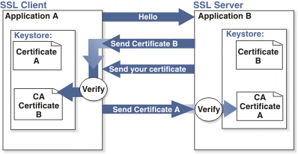

Adding 2-way SSL adds to the cost and timeline to the project as this is not part of Standard implementations.

Note: 2-way SSL is currently not available to clients on the China data-center.

- Integration API URLs
- Message Router Addresses
Web service URLs you need to invoke to send transactional data to BrassRing. These URLs below apply to the US data-center only. Europe and China end point URLs are provided during time of implementation on such integrations.

Staging Environment
Web Service
URL - https://staging.brassring.com/HRISprocessor9/DispatchMessage.asmx
WSDL - https://staging.brassring.com/HRISprocessor9/DispatchMessage.asmx?wsdl

HTTP Post
URL - https://staging.brassring.com/jetstream/500/presentation/template/asp/HRISIntegration/msgdispatch.asp

Production Environment
Web Service
URL - https://trm.brassring.com/HRISprocessor9/DispatchMessage.asmx
WSDL - https://trm.brassring.com/HRISprocessor9/DispatchMessage.asmx?wsdl

HTTP Post
URL - https://trm.brassring.com/jetstream/500/presentation/template/asp/HRISIntegration/msgdispatch.asp

- API Error Messages
Below is a list of error messages that you may encounter when using the Job Code Default Data integration. We have also included an explanation in order to assist you with troubleshooting.

Code | Error Description | Reasoning
401 | ValidateAccess: - Access not setup for Sender – DSDSDS | Value in the Sender tag is incorrect
401 | Credential value is invalid | Value in the Credential tag in incorrect
405 | getProfileInfo: - Inactive subscription | Value in the Manifest tag is incorrect
405 | Data must be present in JobTitle to create a requisition | JobTitle is required
405 | Validate Custom Question : Question ID/FIELDNAME has an invalid option | Invalid Option Specified.
405 | Invalid FormTypeID | Invalid form name or missing form name translation

NOTE: This list is not all inclusive but contains the errors that are most encountered.

