

The information contained in this document is the property of Signal Labs Talent Inc. Except as specifically authorized in writing by Signal Labs Talent Inc, the holder of this document shall: (1) keep all information contained herein confidential and shall protect same in whole or in part from disclosure and dissemination to all third parties and, (2) use same for operating and maintenance purposes only.
Version: 1.0.0
Date: December 23, 2021

Signal Labs Talent BrassRing

HR Status Update Technical Specifications API Guide

Chapter 1: Introduction 3
1.1 What are BrassRing’s Integration APIs 3
1.2 Purpose 3
1.3 Audience 3
Chapter 2: BrassRing’s HR Status Update Integration APIs 4
2.1 Overview 4
2.2 Communication Methodology 4
2.3 Rules for the HR Status Update Integration 4
2.4 HR Status Snapshot (BrassRing) 5
2.4.1 Candidate Grid 5
2.4.2 Candidate Record 5
2.4.3 Current HR Status 6
2.4.4 HR Status History 6
2.4.5 HR Status Update 6
2.5 HR Status Update Tag Definitions 6
2.5.1 Candidate Identifier Attributes 7
2.5.2 reqid 7
2.5.3 Action Date 8
2.5.4 Language and HR Status 8
Chapter 3: Schemas 9
3.1 Sample XML Request 9
3.2 Sample JSON Request 9
3.3 Sample XML Response (Success) 11
3.4 Sample JSON Response (Success) 11
3.5 Sample XML Response (Failure) 13
3.6 Sample JSON Response (Failure) 14
3.7 Handling special characters in XML requests 16
3.8 Special Characters in JSON Requests 17
Chapter 4: Envelope Processing 17
4.1 Sender 17
4.2 Recipient 17
4.3 TransactInfo 17
4.4 Packet 18
4.5 Payload 18
Chapter 5: Security 19
5.1 Standard Implementation Security 19
5.1.1 Message Integrity 19
5.1.2 Transport Layer Security (TLS) 19
5.1.3 IP restrictions 19
5.2 Optional Security Features 19
5.2.1 Message Layer Encryption/Security (MLS) 19
5.2.2 2-Way SSL / Certificate Based Authentication 20
Chapter 6: Integration API URLs 21
6.1 Message Router Addresses 21
Chapter 7: API Error Messages 22

- Introduction
- What are BrassRing’s Integration APIs
BrassRing XML/JSON integrations feature flexible, secure, real-time integrations by sending XML/JSON over the Internet using web services or HTTP Posts. XML/JSON formats used in BrassRing integrations are based on HR-XML Consortium guidelines.

The BrassRing XML/JSON integrations offering allows BrassRing to work with the customers to configure multi-level, robust integration relationships between BrassRing and any systems that can send and receive XML/JSON. Examples of these systems include HRIS systems such as SAP/Oracle/PeopleSoft, etc., and systems that perform HR related services like background checks, assessments, or compensation analysis.

The customer can choose to send data through either a web service or HTTP post. BrassRing handles the exchange of XML/JSON requests and responses using its own messaging software. The customer builds their own messaging system to exchange XML/JSON web service messages or HTTP post with BrassRing.
- Purpose
The purpose of this document is as follows:
- To present high-level architecture and design of BrassRing APIs and how BrassRing implements HR Status Update integrations to meet its customers’ needs for automated data management.
- To describe suggested high-level workflow processes that can be supported between BrassRing and any external, third-party system that can send and receive XML/JSON requests and responses.
- To describe the steps required to implement the HR Status Update integration.
- Audience
- Client Decision Makers, HRIS Implementation Teams, Internal IT Teams, Systems Integrators and Support Teams.
- BrassRing Engineering Services Team, Support Team, and Technical Services Group.

- BrassRing’s HR Status Update Integration APIs
- Overview
Candidate HR status information can be imported from an external system to BrassRing. In BrassRing, candidate status defines at which step a candidate is in the hiring process. This integration service is intended to update the HR Status of candidate(s). The integration can be used by client HRIS systems or 3rd party vendors that wish to integrate with BrassRing.

The integration service will follow tracking logic rules that are set up in BrassRing with respect to start, intermediate and final HR Statuses.

The service does not support “Undo” HR Status or final HR Status updates such as “Hired” that will either Auto-Close a requisition or Count Down positions on a requisition.
- Communication Methodology
Connection to the BrassRing Internal Talent Gateway system is accomplished via Web Services as a data transfer vehicle.

The above mechanism is synchronous, meaning all transactions are real-time with a request-response messaging and no message queuing.

The XML/JSON format is depicted in Section 3.

Client can choose to batch transactions or send data to BrassRing in real-time.

BrassRing will always process transactions in real-time regardless of whether they were batched or not by the client.
- Rules for the HR Status Update Integration
The HR Status Update integration automates sending of HR Status updates from an external system to a candidate record in BrassRing.

Below are a few rules to consider when looking into the use of the HR Status Update Integration:
- The XML/JSON schema cannot be customized (see sample XML/JSON below).
- HR Status Update XML/JSON files are processed real-time via Web Services.
- Customer’s HRIS or external system should wait for a success/failure response before sending the next transaction in a sequential manner.
- Field requirements are outlined in the Data Mapping sections.
- The Updated By value cannot be set through the import and will always appear in BrassRing as Integration, System.
- The HR Status Update XML/JSON cannot be used to file a candidate to a Req, only update an HR Status for a candidate in a Req in which they are already filed.
- HR Statuses can only be updated on Open Requisitions.
- Send delta loads only. Full/destructive loads are not recommended.
- HR Status Snapshot (BrassRing)
Below are screen prints of the HR Status sections of the Candidate Record in BrassRing for your reference.
- Candidate Grid
The Candidate Grid can display current HR Status information for all candidates in the folder. Please note that the grid is configurable by user so it may look slightly different than below. Please see your Signal Labs Talent Representative to learn how to update configuration of this page.
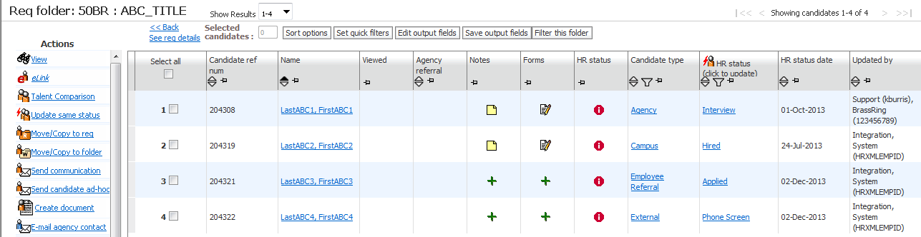
- Candidate Record
The Candidate Record will display HR Status actions for the selected candidate in the Action Log. Also, if configured, you may see current HR Status details on the candidate ribbon.
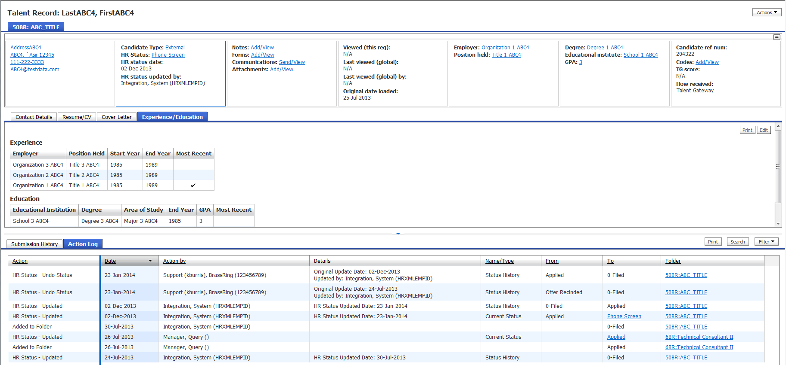

- Current HR Status
The Current HR Status page will display the selected candidates current HR Status for all Reqs in which they are filed.
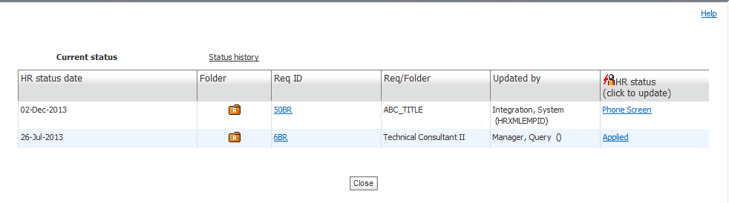
- HR Status History
The Status History page will display the selected candidates HR Status History for all Reqs for which they are filed.
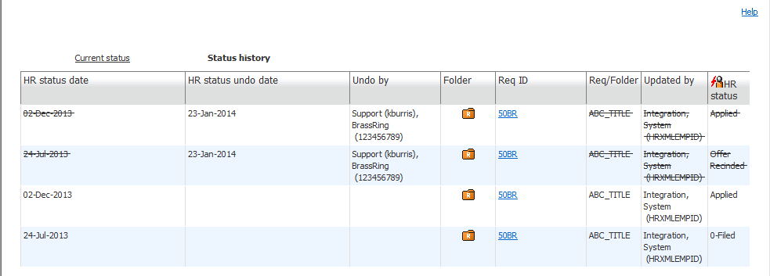
- HR Status Update
The HR Status Update page is where users can update the candidate’s current HR Status.
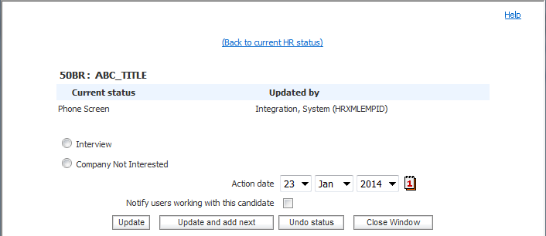

- HR Status Update Tag Definitions
XML/JSON tags for the HR Status Update integration are categorized below.

- Candidate Identifier Attributes
These attributes are used to determine the candidate the HR Status Update is associated to.
XML Tag/JSON Keys | Tag Required? | Value Required? | Format | Length
resumekey | See rules below | See rules below. | Numeric | 15
firstname | See rules below | See rules below. | Varchar | 100
lastname | See rules below | See rules below. | Varchar | 100
email | See rules below | See rules below. | Varchar | 200
phone | See rules below | See rules below. | Varchar | 25
bruid | See rules below | See rules below. | Numeric | 15
Rules:
- If resumeKey value is passed then no other candidate information is required (i.e. firstname, lastname, email and phone is not necessary.
- If resumeKey value is not available, then firstname, lastname and (email or phone) value must be sent.
- bruid is an internal representation of the Candidate ID in BrassRing. It is unlikely that an external system would be able to reference this value.

- reqid
The Req Number in which the Candidate and HR Status are associated to.
XML Tag/JSON Keys | Tag Required? | Value Required? | Format | Length
reqid | Yes | Yes | Varchar
Rules:
- If Client Setting “Req Trigger” is set to Auto send the AutoReqID (i.e. 1234BR).
- If Client Setting “Req Trigger” is set to Optional send the Optional Req ID.
- HR Status will not update on a Req that is On Hold or Cancelled.

- Action Date
The date in associated to the HR Status Update Action.
XML Tag/JSON Keys | Tag Required? | Value Required? | Format | Length
actiondate | Yes | No | MM-DD-YYYY | 10
Rules:
- If no value sent, the action date will default to the date the import was submitted.

- Language and HR Status
This attribute is used to determine the “Action” to be performed
XML Tag/JSON Keys | Tag Required? | Value Required? | Format | Length
language | No | No | Varchar | 2
HR Status | Yes | Yes | Varchar | 255
Rules:
- Language is a 2 letter ISO code (i.e. EN, FR, etc.).
- The integration will follow the tracking logic rules that are set up in BrassRing with respect to start, intermediate and final HR Status. Integration will error if tracking logic is not followed.
- BrassRing integrations do not support “Undo” HR Status or final HR Status updates such as “Hired” that will either Auto-Close a requisition or Count Down positions on a requisition.

- Schemas
- Sample XML Request
Below is a sample HR Status Update XML file for your reference.

<?xml version="1.0" encoding="UTF-8"?>
<Envelope version="01.00" xmlns:xsi="http://www.w3.org/2001/XMLSchema-instance">
<Sender>
<Id>BrassRing to provide</Id>
<Credential>BrassRing to provide</Credential>
</Sender>
<Recipient>
<Id/>
</Recipient>
<TransactInfo transactType=”data”>
<TransactId>3368</TransactId>
<TimeStamp>2014-01-24 12:07 PM</TimeStamp>
</TransactInfo>
<Packet>
<PacketInfo packetType=”data”>
<PacketId>1</PacketId>
<Action>INSERT</Action>
<Manifest>Brassring to provide</Manifest>
</PacketInfo>
<Payload><![CDATA[<?xml version=”1.0” encoding=”UTF-8”?>
<UpdateStatus>
<Candidate firstname=”” lastname=”” email=”” phone=”” resumekey=”204308” bruid=””>
<status reqid=”50BR” actiondate=”01-24-2014” language=”en”>Offer Extended</status>
</Candidate>
</UpdateStatus>]]></Payload>
</Packet>
</Envelope>
- Sample JSON Request
{
"Envelope": {
"Packet": {
"PacketInfo": {
"Action": "INSERT",
"Manifest": "BrassRing to provide",
"PacketId": "1",
"packetType": "data"
},
"Payload": {
"UpdateStatus": {
"Candidate": {
"bruid": "",
"email": "",
"firstname": "",
"lastname": "",
"phone": "",
"resumekey": "204308",
"status": [
{
"actiondate": "04-06-2006",
"language": "en",
"reqid": "50BR",
"value": "Phone Screen"
},
{
"actiondate": "04-06-2006",
"language": "en",
"reqid": "50BR",
"value": "First Interview"
}
]
}
}
}
},
"Recipient": {
"Id": null
},
"Sender": {
"Credential": "BrassRing to provide",
"Id": "BrassRing to provide"
},
"TransactInfo": {
"TimeStamp": "2023-04-14 02:24 AM",
"TransactId": "3368",
"transactType": "data"
},
"version": "01.00"
}
}

- Sample XML Response (Success)
Below is a sample success response XML file.
<?xml version=”1.0” encoding=”utf-8”?>
<Envelope version=”01.00” xmlns:xsi=”http://www.w3.org/2001/XMLSchema-instance”>
<Sender>
<Id>BrassRing to provide</Id>
<Credential>BrassRing to provide</Credential>
<remoteIP>216.52.51.250</remoteIP>
</Sender>
<Recipient>
<Id/>
</Recipient>
<TransactInfo transactType=”response”>
<TransactId>3368</TransactId>
<TimeStamp>2013-02-25 17:53 PM</TimeStamp>
<Status>
<Code>200</Code>
<ShortDescription>Success</ShortDescription>
<LongDescription>STATUSUPDATE Data transfer was a success</LongDescription>
</Status>
</TransactInfo>
<Packet>
<PacketInfo packetType=”response”>
<PacketId>1</PacketId>
<Action>INSERT</Action>
<Manifest>BrassRing to provide</Manifest>
<Status>
<Code>200</Code>
<ShortDescription>Success</ShortDescription>
<LongDescription>Candidate HRStatus was successfully updated</LongDescription>
</Status>
</PacketInfo>
<Payload><![CDATA[<UpdateStatus>
<Candidate resumekey=”204308”>
<status language=”EN” reqid=”50BR” actiondate=”12-02-2013”>Offer Extended</status>
</Candidate>
<Status>
<Code>200</Code>
<ShortDescription>Success</ShortDescription>
<LongDescription>Candidate HRStatus was successfully updated</LongDescription>
</Status>
</UpdateStatus>
]]></Payload>
</Packet>
</Envelope>
- Sample JSON Response (Success)
Below is a sample success response JSON file.
{
"Envelope": {
"Sender": {
"Credential": "BrassRing to provide",
"remoteIP": [
"",
"xxx.xx.xx.xx"
],
"Id": "NO IMPORT"
},
"Packet": {
"PacketInfo": {
"packetType": "response",
"Status": {
"LongDescription": "Candidate HRStatus was successfully updated",
"Code": "200",
"ShortDescription": "Success"
},
"Action": "INSERT",
"Manifest": "BrassRing to provide",
"PacketId": "1"
},
"Payload": {
"UpdateStatus": {
"Candidate": {
"resumekey": "12345",
"firstname": "",
"phone": "",
"bruid": "",
"email": "",
"lastname": "",
"status": {
"language": "gb",
"actiondate": "05-09-2023",
"content": "Default Final",
"reqid": "123BR"
}
},
"Status": {
"LongDescription": "Candidate HRStatus was successfully updated",
"Code": "200",
"ShortDescription": "Success"
}
}
}
},
"Recipient": {
"Id": null
},
"version": "01.00",
"TransactInfo": {
"Status": {
"LongDescription": "STATUSUPDATE Data transfer was a success",
"Code": "200",
"ShortDescription": "Success"
},
"TransactId": "3368",
"transactType": "response",
"TimeStamp": "2023-05-04 08:16 AM"
}
}
}

- Sample XML Response (Failure)
Below is a sample failure response XML file.
<?xml version=”1.0” encoding=”utf-8”?>
<Envelope version=”01.00” xmlns:xsi=”http://www.w3.org/2001/XMLSchema-instance”>
<Sender>
<Id> BrassRing to provide </Id>
<Credential> BrassRing to provide </Credential>
<remoteIP>216.52.51.250</remoteIP>
</Sender>
<Recipient>
<Id/>
</Recipient>
<TransactInfo transactType=”response”>
<TransactId>3368</TransactId>
<TimeStamp>2013-02-25 17:53 PM</TimeStamp>
<Status>
<Code>405</Code>
<ShortDescription>Failure</ShortDescription>
<LongDescription>STATUSUPDATE Data transfer was not successful</LongDescription>
</Status>
</TransactInfo>
<Packet>
<PacketInfo packetType=”response”>
<PacketId>1</PacketId>
<Action>INSERT</Action>
<Manifest> BrassRing to provide</Manifest>
<Status>
<Code>405</Code>
<ShortDescription>HRStatus update failed</ShortDescription>
<LongDescription>Candidate HRStatus was not updated</LongDescription>
</Status>
</PacketInfo>
<Payload><![CDATA[<Root><Payload><![CDATA[<UpdateStatus>
<Candidate resumekey=”204308”>
<status language=”EN” reqid=”50BR” actiondate=”12-02-2013”>Offer Extended</status>
</Candidate>
<Status>
<Code>405</Code>
<ShortDescription>Process Status : Invalid HR status order specified. 69032 to 69032</ShortDescription>
<LongDescription>
<Candidate resumekey=”204308”>
<FailureReason>The candidate record was not created or updated. Invalid HR status order specified. Statuses must be imported in an order consistent with the configured tracking logic steps.</FailureReason>
</Candidate>
</LongDescription>
</Status>
</UpdateStatus>]]</Payload></Root>]]></Payload>
</Packet>
</Envelope>

- Sample JSON Response (Failure)
Below is a sample failure response JSON file.
{
"Envelope": {
"Sender": {
"Id": "BrassRing to provide",
"Credential": "BrassRing to provide",
"remoteIP": "216.52.51.250"
},
"Recipient": {
"Id": ""
},
"TransactInfo": {
"TransactId": "3368",
"TimeStamp": "2013-02-25 17:53 PM",
"Status": {
"Code": "405",
"ShortDescription": "Failure",
"LongDescription": "STATUSUPDATE Data transfer was not successful"
},
"transactType": "response"
},
"Packet": {
"PacketInfo": {
"PacketId": "1",
"Action": "INSERT",
"Manifest": "BrassRing to provide",
"Status": {
"Code": "405",
"ShortDescription": "HRStatus update failed",
"LongDescription": "Candidate HRStatus was not updated"
},
"packetType": "response"
},
"Payload": {
"UpdateStatus": {
"Candidate": {
"status": {
"language": "EN",
"reqid": "50BR",
"actiondate": "12-02-2013",
"text": "Offer Extended"
},
"resumekey": "204308"
},
"Status": {
"Code": "405",
"ShortDescription": "Process Status : Invalid HR status order specified. 69032 to 69032",
"LongDescription": {
"Candidate": {
"resumekey": "12345",
"firstname": "",
"phone": "",
"FailureReason": {
"StatusUpdate": {
"Description": "The candidate record was not created or updated. Invalid HR status order specified. Statuses must be imported in an order consistent with the configured tracking logic steps.",
"Code": "Failed"
}
},
"bruid": "",
"email": "",
"lastname": ""
}
}
}
}
}
},
"version": "01.00"
}
}

- Handling special characters in XML requests
There are several special characters that are either not allowed or not recommended for use within XML transmissions within text nodes, even within the CDATA section. These characters are: < (less than), > (greater than), & (ampersand), ‘(apostrophe) and “(quotation mark). In cases where these options appear within a text node within the XML, these characters must be escaped in order for the import to work without error.

The following table describes how special characters should be escaped in XML. Apostrophes, quotation marks and greater than signs are legal, but BrassRing recommends replacing them with the corresponding escape sequences, as well.

Special Characters | Escaped Character
< (less than) | &lt;
> (greater than) | &gt;
& (ampersand) | &amp;
‘ (apostrophe) | &apos;
“ (quotation mark) | &quot;

Below are additional special characters that are not allowed in the Code values.

Other Special Characters | Denotation
; | semi colon
“ | double quotes/single quotes
! | exclamation
~ | tilda
@ | apple
# | hash
= | equal to
+ | add
? | question mark
, | comma
> < | greater than / less than
% | percent
| | pipe
[ ] | square brackets
{} | curly braces

The above special characters are not allowed to be used in the Code values. Special characters such as above conflict with non-XML integrations and can be mistaken or conflict with delimiters in some integrations.

- Special Characters in JSON Requests
Escaping of special characters

The FOR JSON clause escapes special characters in the JSON output with \, as shown in the following table. This escaping occurs both in the names of properties and in their values.

Special Character | Escaped output
Quotation mark (“) | \”
Backslash (\) | \\
Slash (/) | \/
Backspace | \b
Form feed | \f
New line | \n
Carriage return | \r
Horizontal tab | \t

- Envelope Processing
The top level Envelope contains two attributes, version and encoding.
- Version attribute identifies the version of the envelope. The only valid value at this time is “01.00”.
- Encoding attribute identifies XML encoding and is optional. It can be set to “UTF-8” or “UTF-16”. The recommended setting is “UTF-16”.

The Envelope also has four top-level mandatory elements (Sender, Recipient, TransactInfo and Packet). These elements are described in detail below.
- Sender
The values below will be provided at the time of implementation.
- Employee Id: Sent in the Id tag for envelopes coming into BrassRing. This acts as the identification of the user who sends the XML data.
- Client Id : Sent in the Credential tag.
- Recipient
The URL of the recipient is passed in the Id tag. This helps to identify whether the data has been sent to the correct recipient destination.
- TransactInfo
An identifier for the transaction should be included in the TransactId. This identifies the envelope transaction and not any of the constituent data, since there could be multiple documents within one envelope. The combination of the client Id, TransactId and PacketId creates a globally unique identifier for each packet.

A timestamp can be added in the optional TimeStamp. This date format should conform to ISO standard 8601 (i.e. “2000-10-09T14:14:11Z”)

transactType should be set to “data”. This attribute helps provide the envelope parser with a heads up on what to expect in the payloads.
- Packet
The Packet contains the payload and metadata about the payload. The Payload element contains the actual XML/JSON and the PacketInfo element contains the metadata about the packet.

PacketInfo contains the following elements:
- packetType This attribute describes the content of the packet. A packetType of data is the default.
- PacketId: This element uniquely identifies the contents of the payload. PacketId is 1 unless suggested otherwise
- Action: This optional element contains the transaction code – SET
- Manifest: This is a mandatory element that identifies the contents of the payload. This field must be set to the value provided during implementation and should not be changed.
- Payload
The Payload element contains one HR-XML document inside a CDATA section. This approach allows the payload to be parsed separately from the envelope and avoids any interdependency between envelope and contents when validating envelope documents.

Note: the Payload XML should not have any additional CDATA section within it as in nested CDATA sections.

- Security
Several security protocols and measures have been implemented to ensure security on the data transmission, message integrity, and message confidentiality. These mechanisms can be used to accommodate a wide variety of security models and encryption technologies.
- Standard Implementation Security
- Message Integrity
Message integrity is ensured on the XML data. Unique credentials within the XML act as authentication information for a transaction to be consumed. These credentials in the Id, Credential and Manifest nodes act as unique value for a given implementation.
- Transport Layer Security (TLS)
Transport Layer Security (TLS) and its predecessor, Secure Sockets Layer (SSL), are cryptographic protocols that provide communication security over the Internet. TLS and SSL encrypt the segments of network connections above the Transport Layer, using asymmetric cryptography for key exchange, symmetric encryption for privacy, and message authentication codes for message integrity.

BrassRing integration API URLs (web service and HTTP Post URLs) are HTTPS-enabled and utilize 128 bit encryption over SSL when exchanging and transmitting information over the Internet. This is a mandatory encryption of the data that is enforced.
- IP restrictions
To add another layer to security and protection, IP restrictions can also be enforced. At the time of implementation, IP addresses from Staging and Production environments can be provided that can be white-listed on an external firewall on the customer’s network. These IP addresses are provided on request.
- Optional Security Features
- Message Layer Encryption/Security (MLS)
In additional to the above security protocols, message layer encryption is also available on the payload data.

Message layer encryption is facilitated using RSA encryption on the XML. Both Java and Microsoft .NET development environments support APIs for RSA encryption. BrassRing uses 1024-bit RSA encryption key pairs along with a public key generated by the client to implement functions to encrypt, sign, decrypt and authenticate data.

Adding MLS adds to the cost and timeline of the project and as this is not part of standard implementations.

- 2-Way SSL / Certificate Based Authentication
Additionally, client certificate authentications or 2-way SSL or mutual SSL authentication is also available to enforce additional security around the integrations. The method of data exchange is accomplished with the use of certificates that confirm the source of the data before processing the information. SSL Session negotiated by Handshake Protocol via a X.509 public key Certificate of Peer.

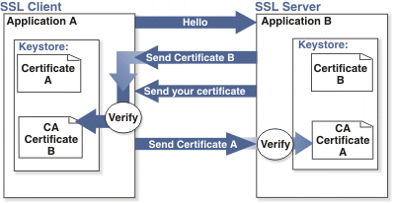

Adding 2-way SSL adds to the cost and timeline to the project as this is not part of Standard implementations.

Note: 2-way SSL is currently not available to clients on the China data-center.

- Integration API URLs
- Message Router Addresses
Web service URLs you need to invoke to send transactional data to BrassRing. These URLs below apply to the US data-center only. Europe and China end-point URLs are provided during time of implementation on such integrations.

Staging Environment
Web Service
URL - https://staging.brassring.com/HRISStatus/HRISStatus.asmx
WSDL – https://staging.brassring.com/HRISStatus/HRISStatus.asmx?WSDL

Production Environment
Web Service
URL - https://trm.brassring.com/HRISprocessor9/DispatchMessage.asmx
WSDL – https://trm.brassring.com/HRISprocessor9/DispatchMessage.asmx?wsdl

- API Error Messages
Below is a list of error messages that you may encounter when using the HR Status Update integration. Please refer to the explanation below in order to assist you with troubleshooting.

Code | Error Description | Reasoning
401 | ValidateAccess: - Access not setup for Sender – DSDSDS | Value in the Sender tag is incorrect
401 | Credential value is invalid | Value in the Credential tag in incorrect
405 | getProfileInfo: - Inactive subscription | Value in the Manifest tag is incorrect
405 | Process Status : Invalid HR status order specified. 69032 to 69030 | Statuses must be imported in an order consistent with the configured tracking logic steps.
405 | Error Processing Profile fields | Missing candidate identifier (i.e. Name, resumekey,etc.)
405 | ValidateResumekey : Invalid Resumekey | Candidate could not be found based on resumekey provided.
405 | Reqid is blank, folderid is 0 and folderdescription is blank or invalid | No ReqID Provided
405 | Process Status : Input ReqId, FolderId or FolderDescription yielded an Invalid folderID | Req could not be found based on the ReqID provided.
405 | Process Status : Invalid Actiondate | Incorrect Date format (MM_DD_YYYY).
405 | Candidate not Filed to Requisition | Candidate must already be filed to a req in order to be updated.
405 | The candidate record was not created or updated. A req folder with a valid req status is required. | Req is not in an Open status.
405 | Timeout expired. The timeout period elapsed prior to completion of the operation or the server is not responding. | Service down. Retry message

NOTE: This list is not all inclusive but contains the errors that are most encountered.

