


Signal Labs Talent BrassRing

Form Import Technical Specifications API Guide

Version: 1.0.0
Date: December 23, 2021
The information contained in this document is the property of Signal Labs Solutions. Except as specifically authorized in writing by Signal Labs Solutions, the holder of this document shall: (1) keep all information contained herein confidential and shall protect same in whole or in part from disclosure and dissemination to all third parties and, (2) use same for operating and maintenance purposes only.
Table of Contents
Chapter 1: Introduction 3
1.1 What are BrassRing’s XML Integration APIs 3
1.2 Purpose 3
1.3 Audience 3
Chapter 2: BrassRing’s Form Import Integration APIs 4
2.1 Overview 4
2.2 Communication Methodology 4
2.3 Rules for the Form Import Integration 4
2.4 Form Data Snapshot (BrassRing) 5
2.4.1 Candidate Talent Record 5
2.4.2 Forms Page 5
2.4.3 Background Check Results Form with Results 5
2.5 Form Tag Definitions 5
2.5.1 formTypeId and formName attributes 6
2.5.2 FormInput name and title attributes 6
2.5.3 action attribute 7
2.5.4 Language attribute 7
2.5.5 “Select” Field types (i.e. single-select, multi-select, check-box, radio button) 8
2.5.6 Date field types 8
2.5.7 “Parameterized” attributes 9
Chapter 3: XML Schemas 10
3.1 Sample XML Request 10
3.2 Sample JSON Request 10
3.3 Sample XML Response (Success) 13
3.4 Sample JSON Response (Success) 13
3.5 Sample XML Response (Failure) 15
3.6 Sample JSON Response (Failure) 15
3.7 Handling special characters in XML requests 16
3.8 Special Characters in JSON Requests 17
Chapter 4: Envelope Processing 18
4.1 Sender 18
4.2 Recipient 18
4.3 TransactInfo 18
4.4 Packet 18
4.5 Payload 19
Chapter 5: Security 20
5.1 Standard Implementation Security 20
5.1.1 Message Integrity 20
5.1.2 Transport Layer Security (TLS) 20
5.1.3 IP restrictions 20
5.2 Optional Security Features 20
5.2.1 Message Layer Encryption/Security (MLS) 20
5.2.2 2-Way SSL / Certificate Based Authentication 21
Chapter 6: Integration API URLs 22
6.1 Message Router Addresses 22
Chapter 7: API Error Messages 23

- Introduction
- What are BrassRing’s XML Integration APIs
BrassRing XML integrations feature flexible, secure, real-time integrations by sending XML over the Internet using web services or HTTP Posts. XML formats used in BrassRing XML integrations are based on HR-XML Consortium guidelines.

The BrassRing XML integrations offering allows BrassRing to work with the customers to configure multi-level, robust integration relationships between BrassRing and any systems that can send and receive XML. Examples of these systems include HRIS systems such as SAP/Oracle/PeopleSoft, etc., and systems that perform HR related services like background checks, assessments or compensation analysis.

The customer can choose to send data through either a web service or HTTP post. BrassRing handles the exchange of XML requests and responses using its own messaging software. The customer builds their own messaging system to exchange XML web service messages or HTTP post with BrassRing.
- Purpose
The purpose of this document is as follows:
- To present high-level architecture and design of BrassRing APIs and how BrassRing implements Form Import integrations to meet its customers’ needs for automated Foundation data management.
- To describe suggested high-level workflow processes that can be supported between BrassRing and any external, third-party system that can send and receive XML requests and responses.
- To describe the steps required to implement Form Import integration.
- Audience
- Client Decision Makers, HRIS Implementation Teams, Internal IT Teams, Systems Integrators and Support Teams.
- BrassRing Engineering Services Team, Support Team, and Technical Services Group.

- BrassRing’s Form Import Integration APIs
- Overview
Form data is data that directly corresponds to a pre-existing Candidate form within the Client’s BrassRing configuration site. Candidate Form data is referred to as form fields that store candidate specific data on custom forms, for example, Offer form, New Hire form, EEO form, Assessment forms, etc.

Background check vendors, assessment vendors and client’s HRIS system can utilize this integration to send background check results, assessment results and any candidate related form information such as EEO information, Rehire information, etc. to a pre-configured candidate form in BrassRing.

Form Import integration is used extensively in bi-directional integrations where candidate data is exported from BrassRing and results needs to be sent back in BrassRing.
- Communication Methodology
Connection to the BrassRing system is accomplished via two mechanisms using XML as a data transfer vehicle.
- HTTP Post
- Web services

Both the above mechanisms are synchronous, meaning all transactions are real-time with a request-response messaging and no message queuing.

The XML format is depicted in Section 3.

Client can choose to batch transactions or send data to BrassRing in real-time.

BrassRing will always process transactions in real-time regardless of whether they were batched or not by the client.
- Rules for the Form Import Integration
The Form import integration automates sending of form/result information from an external system to a candidate form in BrassRing.

Below are a few rules to consider when looking into the use of the Form Import Integration:
- The XML schema cannot be customized (see sample XML below).
- Form Import XML files are processed real-time via HTTP Post or Web Services.
- Each XML should contain 1 Form per transaction. Customer’s HRIS or external system should wait for a success/failure response before sending the next transaction in a sequential manner.
- Field requirements are outlined in the Data Mapping sections.
- In the Form import XML, the “formTypeId” and “FormInput name” values are environment specific and are different in Staging and Production. These values are provided at the time of integration implementation. See sample XML in section 3.
- Send delta loads only. Full/destructive loads are not recommended.

- Form Data Snapshot (BrassRing)
Below is a screen print of the Candidate Form management screen in BrassRing for your reference.
- Candidate Talent Record
This is how you can find a list of forms associated to a candidate.
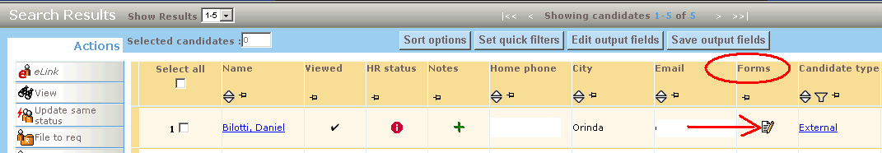
- Forms Page
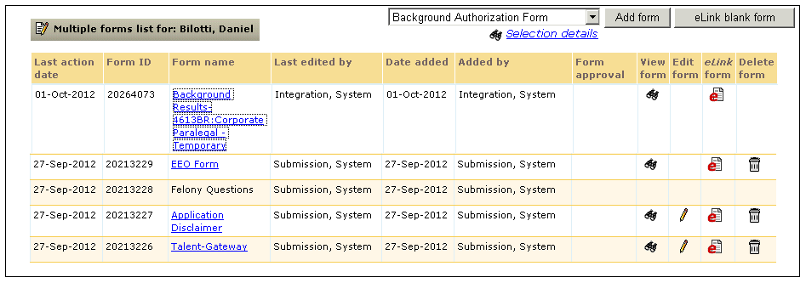
- Background Check Results Form with Results
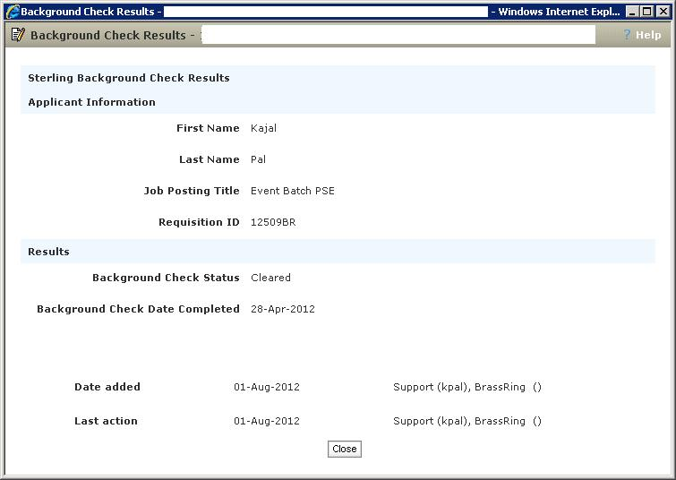
- Form Tag Definitions
XML tags for Form Imports can be categorized as below.

- formTypeId and formName attributes
The formTypeId value determines the Candidate form in BrassRing and the formName is the title of the Form.
XML Tag | Tag Required? | Value Required? | Format | Length
formTypeId | Yes | Yes, required for both insert and update | Numeric | 10
formName | Yes | Yes, required for both insert and update | Varchar | 255
Rules:
- The “formTypeId” attribute is required and is used to determine the form where the results/form data would reside.
- The “formTypeId” value is environment specific and is different for Staging and Production

- FormInput name and title attributes
The name attribute is the field
XML Tag | Tag Required? | Value Required? | Format | Length
FormInput name | Yes | Yes, required for both insert and update | Numeric | 10
Title | Yes | Yes, required for both insert and update | Varchar | 255
Rules:
- The “name” attribute is required and is used to determine the field where a particular data would reside.
- The “name” value is environment specific and is different for Staging and Production
Limitations:
- Form Import XML does not support importing data into a Manager or Recruiter auto-fill fields.
- Form Import XML does not support importing validated data into a Single-Select field whose options are pulling from the Manager or Recruiter user fields. Whatever value is sent is what will be seen on the form. If the form is subsequently edited by a user in BrassRing, the value sent in the XML will disappear and a valid selection will have to be made by the user.
- Form Import XML does support importing data into auto-fill fields (with the exception of Manager and Recruiter). If the auto-fill is a select list, send Code in the XML not description.

- action attribute
This attribute is used to determine the “Action” to be performed
XML Tag | Tag Required? | Value Required? | Format | Length
action | Yes | Yes, required for both insert and update | Varchar | 40
Rules:
- There are 3 possible values for the “action” attribute.
  - Insert – This will create a new form
  - update – This will delete the existing form and create a new instance of the form with the data that is sent in the XML
  - UpdateIndividual – This action will update the existing form with only the fields that is sent in the XML. If no existing is present then it will create a new form.
- Recommended action attribute is the “UpdateIndividual” action attribute.

- Language attribute
This attribute is used to determine the “Action” to be performed
XML Tag | Tag Required? | Value Required? | Format | Length
language | No | No | Varchar | 2
Rules:
- 2 letter ISO code value should be passed. (i.e. EN, FR, etc.)

- “Select” Field types (i.e. single-select, multi-select, check-box, radio button)
This rule applies to Select Type Custom questions
XML Tag | Tag Required? | Value Required? | Format | Length
FormInput | No | No | Varchar
Rules:
- Value passed for a select question must be the Code defined for that field.
- If Select question is a type of multi-select and multiple options should be passed and defaulted, that tag should repeated with appropriate defined values. For example:

<FormInput fieldid="12345" title="Please indicate which languages you speak " >English</FormInput>
<FormInput fieldid="12345" title="Please indicate which languages you speak " >Dutch</FormInput>

- Date field types
This rule applies to Custom Date Type fields
XML Tag | Tag Required? | Value Required? | Format | Length
FormInput | No | No | YYYY-MM-DD
Rules:
- The only acceptable format is YYYY-MM-DD.
<FormInput fieldid="12346" title="Start Date" >2016-12-20</FormInput>

- “Parameterized” attributes
These attributes are used to determine the candidate on whom the form result should be associated to.
XML Tag | Tag Required? | Value Required? | Format | Length
resumeKey | No |  | Numeric | 15
autoreq | No |  | Varchar | 15
FirstName | No |  | Varchar | 100
LastName | No |  | Varchar | 100
email | No |  | Varchar | 200
homePhone | No |  | Varchar | 25
formId | No |  | Numeric | 15
brUID | No |  | Numeric | 15
OrderID | No |  | Numeric | 15
Rules:
- If resumeKey value is passed then no other candidate information is required like the FirstName, LastName, email and homePhone is not necessary.
- If the Candidate form in BrassRing where the results are being sent is a “per Req” form, then the Req number must be sent as well. The Req number is sent in the “autoreq” attribute (i.e. 100BR, 23443BR).
- If resumeKey value is not available, then FirstName, LastName and (email or homePhone) value must be sent. The API utilizes these values to determine an existing candidate in the system.
- formId is the Form identifier for the Candidate form if the form already exists in the system. If formId value is passed then none of the parameterized attributes are required to be sent since the formId value knows exactly what BrassRing form it must update.
- brUID is an internal representation of the Candidate ID in BrassRing. It is unlikely that an external system would be able to reference this value.
- OrderID is the assessment Order ID used mainly for assessments like SHL.
- All tags in the Form header are required even if they are blank.
<form formTypeId="XXXX" formName="EEO_FORM" action="UPDATE" FirstName="First" LastName="Last" homePhone="111-111-1111" email="" resumeKey="" language="EN">

- XML Schemas
- Sample XML Request
Below is a sample Form XML file for your reference.
<?xml version=”1.0”?>
<Envelope version=”01.00”>
<Sender>
<Id>INTEGRATIONID</Id>
<Credential>CLIENTID</Credential>
</Sender>
<Recipient>
<Id/>
</Recipient>
<TransactInfo transactType=”data”>
<TransactId>TRANSACTIONID</TransactId>
<TimeStamp>2006-02-28 09:22:10AM</TimeStamp>
<!–date-time value for troubleshooting and tracking
</TransactInfo>
<Packet>
<PacketInfo packetType=”data”>
<PacketId>1</PacketId>
<Action>SET</Action>
<Manifest>CLIENTNAME_FORMNAME</Manifest>
<!–Manifest is configured for a client at the time of integration. Provided by BrassRing
</PacketInfo>
<!–The PayLoad information below is for a given Form.
The information below will be different depending on the Form.
The ID values are generally different in Staging and Production

<Payload><![CDATA[<?xml version=”1.0”?>
<form formTypeId=”100” formName=”Background Results” action=”UpdateIndividual” resumeKey=”3904697” autoreq=”4613BR” FirstName=”” LastName=”” email=”” homePhone=”” language=”EN”>
<FormInput name=”34566” title=”First”>Jane</FormInput>
<FormInput name=”34567” title=”Last Name”>Doe</FormInput>
<FormInput name=”34568” title=”Middle”/>
<FormInput name=”34569” title=”Social Security Number”>000-01-1348</FormInput>
<FormInput name=”34570” title=”Criminal Check Status”>Completed</FormInput>
<FormInput name=”34571” title=”Adjudication Status”>Pass</FormInput>
<FormInput name=”34572” title=”Education Check Status”>Completed</FormInput>
<FormInput name=”34573” title=”Detailed Report”>&lt;a href=”https://www.background.com/JSP/ViewReport?e=n2u8”&gt;https://www.accuratebackground.com/JSP/ViewReport?e=n2u8&lt;/a&gt;</FormInput>
</form>]]></Payload>
</Packet>
</Envelope>

- Sample JSON Request
{
"Envelope": {
"Sender": {
"Id": "INTEGRATIONID",
"Credential": "CLIENTID"
},
"Recipient": {
"Id": ""
},
"TransactInfo": {
"TransactId": "TRANSACTIONID",
"TimeStamp": "2006-02-28 09:22:10AM",
"transactType": "data"
},
"Packet": {
"PacketInfo": {
"PacketId": "1",
"Action": "SET",
"Manifest": "CLIENTNAME_FORMNAME",
"packetType": "data"
},
"Payload": {
"form": {
"FormInput": [
{
"name": "34566",
"title": "First",
"value": "Jane"
},
{
"name": "34567",
"title": "Last Name",
"value": "Doe"
},
{
"name": "34568",
"title": "Middle"
},
{
"name": "34569",
"title": "Social Security Number",
"value": "000-01-1348"
},
{
"name": "34570",
"title": "Criminal Check Status",
"value": "Completed"
},
{
"name": "34571",
"title": "Adjudication Status",
"value": "Pass"
},
{
"name": "34572",
"title": "Education Check Status",
"value": "Completed"
},
{
"name": "34573",
"title": "Detailed Report",
"value": "<a href=\"https://www.background.com/JSP/ViewReport?e=n2u8\">https://www.accuratebackground.com/JSP/ViewReport?e=n2u8</a>"
}
],
"formTypeId": "100",
"formName": "Background Results",
"action": "UpdateIndividual",
"resumeKey": "3904697",
"autoreq": "4613BR",
"FirstName": "",
"LastName": "",
"email": "",
"homePhone": "",
"language": "EN"
}
}
},
"version": "01.00"
}
}

- Sample XML Response (Success)
Below is a sample success response XML file.
<?xml version=”1.0” encoding=”utf-8”?>
<Envelope version=”01.00”>
<Sender>
<Id>INTEGRATIONID</Id>
<Credential>CLIENTID</Credential>
</Sender>
<Recipient>
<Id/>
</Recipient>
<TransactInfo transactType=”response”>
<TransactId>TRANSACTIONID</TransactId>
<TimeStamp>10/01/2012 02:18:06 PM PDT</TimeStamp>
<Status>
<Code>200</Code>
<ShortDescription>Success</ShortDescription>
<LongDescription>FORM Data transfer was a success</LongDescription>
</Status>
</TransactInfo>
<Packet>
<PacketInfo packetType=”response”>
<PacketId>1</PacketId>
<Action>SET</Action>
<Manifest>CLIENTNAME_FORMNAME</Manifest>
<Status>
<Code>200</Code>
<ShortDescription>3904697</ShortDescription>
<LongDescription>FORM Data transfer was a success</LongDescription>
</Status>
</PacketInfo>
<Payload/>
</Packet>
</Envelope>

- Sample JSON Response (Success)
{
"Envelope": {
"Sender": {
"Id": "INTEGRATIONID",
"Credential": "CLIENTID"
},
"Recipient": {
"Id": ""
},
"TransactInfo": {
"TransactId": "TRANSACTIONID",
"TimeStamp": "10/01/2012 02:18:06 PM PDT",
"Status": {
"Code": "200",
"ShortDescription": "Success",
"LongDescription": "FORM Data transfer was a success"
},
"transactType": "response"
},
"Packet": {
"PacketInfo": {
"PacketId": "1",
"Action": "SET",
"Manifest": "CLIENTNAME_FORMNAME",
"Status": {
"Code": "200",
"ShortDescription": "3904697",
"LongDescription": "FORM Data transfer was a success"
},
"packetType": "response"
},
"Payload": ""
},
"version": "01.00"
}
}

- Sample XML Response (Failure)
Below is a sample failure response XML file.
<?xml version=”1.0” encoding=”utf-8”?>
<Envelope version=”01.00”>
<Sender>
<Id>INTEGRATIONID</Id>
<Credential>CLIENTID</Credential>
</Sender>
<Recipient>
<Id/>
</Recipient>
<TransactInfo transactType=”response”>
<TransactId>TRANSACTIONID</TransactId>
<TimeStamp>10/01/2012 08:18:05 PM PDT</TimeStamp>
<Status>
<Code>405</Code>
<ShortDescription>Failure</ShortDescription>
<LongDescription>FORM Data transfer was not successful</LongDescription>
</Status>
</TransactInfo>
<Packet>
<PacketInfo packetType=”response”>
<PacketId>1</PacketId>
<Action>SET</Action>
<Manifest>CLIENTNAME_FORMNAME</Manifest>
<Status>
<Code>405</Code>
<ShortDescription>ResumKey 2546200 was not found for Req passed</ShortDescription>
<LongDescription>Candidate is not filed to the Req folder identified.</LongDescription>
</Status>
</PacketInfo>
<Payload/>
</Packet>
</Envelope>

- Sample JSON Response (Failure)
{
"Envelope": {
"Sender": {
"Id": "INTEGRATIONID",
"Credential": "CLIENTID"
},
"Recipient": {
"Id": ""
},
"TransactInfo": {
"TransactId": "TRANSACTIONID",
"TimeStamp": "10/01/2012 08:18:05 PM PDT",
"Status": {
"Code": "405",
"ShortDescription": "Failure",
"LongDescription": "FORM Data transfer was not successful"
},
"transactType": "response"
},
"Packet": {
"PacketInfo": {
"PacketId": "1",
"Action": "SET",
"Manifest": "CLIENTNAME_FORMNAME",
"Status": {
"Code": "405",
"ShortDescription": "ResumKey 2546200 was not found for Req passed",
"LongDescription": "Candidate is not filed to the Req folder identified."
},
"packetType": "response"
},
"Payload": ""
},
"version": "01.00"
}
}

- Handling special characters in XML requests
There are several special characters that are either not allowed or not recommended for use within XML transmissions within text nodes, even within the CDATA section. These characters are: < (less than), > (greater than), & (ampersand), ‘(apostrophe) and “(quotation mark). In cases where these options appear within a text node within the XML, these characters must be escaped in order for the import to work without error.

The following table describes how special characters should be escaped in XML. Apostrophes, quotation marks and greater than signs are legal, but BrassRing recommends replacing them with the corresponding escape sequences, as well.

Special Characters | Escaped Character
< (less than) | &lt;
> (greater than) | &gt;
& (ampersand) | &amp;
‘ (apostrophe) | &apos;
“ (quotation mark) | &quot;

Below are additional special characters that are not allowed in the Code values.

Other Special Characters | Denotation
; | semi colon
“ | double quotes/single quotes
! | exclamation
~ | tilda
@ | apple
# | hash
= | equal to
+ | add
? | question mark
, | comma
> < | greater than / less than
% | percent
| | pipe
[ ] | square brackets
{} | curly braces

The above special characters are not allowed to be used in the Code values. Special characters such as above conflict with non-XML integrations and can be mistaken or conflict with delimiters in some integrations.

- Special Characters in JSON Requests

Escaping of special characters

The FOR JSON clause escapes special characters in the JSON output with \, as shown in the following table. This escaping occurs both in the names of properties and in their values.

Special Character | Escaped output
Quotation mark (“) | \”
Backslash (\) | \\
Slash (/) | \/
Backspace | \b
Form feed | \f
New line | \n
Carriage return | \r
Horizontal tab | \t

- Envelope Processing
The top level Envelope contains two attributes, version and encoding.
- Version attribute identifies the version of the envelope. The only valid value at this time is “01.00”.
- Encoding attribute identifies XML encoding and is optional. It can be set to “UTF-8” or “UTF-16”. The recommended setting is “UTF-16”.

The Envelope also has four top-level mandatory elements (Sender, Recipient, TransactInfo and Packet). These elements are described in detail below.
- Sender
The values below will be provided at the time of implementation.
- Employee Id: Sent in the Id tag for envelopes coming into BrassRing. This acts as the identification of the user who sends the XML data.
- Client Id : Sent in the Credential tag.
- Recipient
The URL of the recipient is passed in the Id tag. This helps to identify whether the data has been sent to the correct recipient destination.
- TransactInfo
An identifier for the transaction should be included in the TransactId. This identifies the envelope transaction and not any of the constituent data, since there could be multiple documents within one envelope. The combination of the client Id, TransactId and PacketId creates a globally unique identifier for each packet.

A timestamp can be added in the optional TimeStamp. This date format should conform to ISO standard 8601 (i.e. “2000-10-09T14:14:11Z”)

transactType should be set to “data”. This attribute helps provide the envelope parser with a heads up on what to expect in the payloads.
- Packet
The Packet contains the payload and metadata about the payload. The Payload element contains the actual XML and the PacketInfo element contains the metadata about the packet.

PacketInfo contains the following elements:
- packetType This attribute describes the content of the packet. A packetType of data is the default.
- PacketId: This element uniquely identifies the contents of the payload. PacketId is 1 unless suggested otherwise
- Action: This optional element contains the transaction code – SET
- Manifest: This is a mandatory element that identifies the contents of the payload. This field must be set to the value provided during implementation and should not be changed.
- Payload
The Payload element contains one HR-XML document inside a CDATA section. This approach allows the payload to be parsed separately from the envelope and avoids any interdependency between envelope and contents when validating envelope documents.

Note: the Payload XML should not have any additional CDATA section within it as in nested CDATA sections.

- Security
Several security protocols and measures have been implemented to ensure security on the data transmission, message integrity, and message confidentiality. These mechanisms can be used to accommodate a wide variety of security models and encryption technologies.
- Standard Implementation Security
- Message Integrity
Message integrity is ensured on the XML data. Unique credentials within the XML act as authentication information for a transaction to be consumed. These credentials in the Id, Credential and Manifest nodes act as unique value for a given implementation.
- Transport Layer Security (TLS)
Transport Layer Security (TLS) and its predecessor, Secure Sockets Layer (SSL), are cryptographic protocols that provide communication security over the Internet. TLS and SSL encrypt the segments of network connections above the Transport Layer, using asymmetric cryptography for key exchange, symmetric encryption for privacy, and message authentication codes for message integrity.

BrassRing integration API URLs (web service and HTTP Post URLs) are HTTPS-enabled and utilize 128 bit encryption over SSL when exchanging and transmitting information over the Internet. This is a mandatory encryption of the data that is enforced.
- IP restrictions
To add another layer to security and protection, IP restrictions can also be enforced. At the time of implementation, IP addresses from Staging and Production environments can be provided that can be white-listed on an external firewall on the customer’s network. These IP addresses are provided on request.
- Optional Security Features
- Message Layer Encryption/Security (MLS)
In additional to the above security protocols, message layer encryption is also available on the payload data.

Message layer encryption is facilitated using RSA encryption on the XML. Both Java and Microsoft .NET development environments support APIs for RSA encryption. BrassRing uses 1024-bit RSA encryption key pairs along with a public key generated by the client to implement functions to encrypt, sign, decrypt and authenticate data.

Adding MLS adds to the cost and timeline of the project and as this is not part of standard implementations.

- 2-Way SSL / Certificate Based Authentication
Additionally, client certificate authentications or 2-way SSL or mutual SSL authentication is also available to enforce additional security around the integrations. The method of data exchange is accomplished with the use of certificates that confirm the source of the data before processing the information. SSL Session negotiated by Handshake Protocol via a X.509 public key Certificate of Peer.

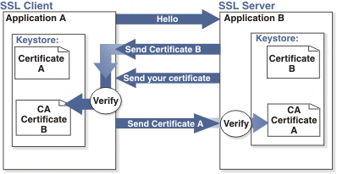

Adding 2-way SSL adds to the cost and timeline to the project as this is not part of Standard implementations.

Note: 2-way SSL is currently not available to clients on the China data-center.

- Integration API URLs
- Message Router Addresses
Web service URLs you need to invoke to send transactional data to BrassRing. These URLs below apply to the US data-center only. Europe and China end-point URLs are provided during time of implementation on such integrations.

Staging Environment
Web Service
URL - https://staging.brassring.com/HRISprocessor9/DispatchMessage.asmx
WSDL – https://staging.brassring.com/HRISprocessor9/DispatchMessage.asmx?wsdl

HTTP Post
URL – https://staging.brassring.com/jetstream/500/presentation/template/asp/HRISIntegration/msgdispatch.asp

Production Environment
Web Service
URL - https://trm.brassring.com/HRISprocessor9/DispatchMessage.asmx
WSDL – https://trm.brassring.com/HRISprocessor9/DispatchMessage.asmx?wsdl

HTTP Post
URL – https://trm.brassring.com/jetstream/500/presentation/template/asp/HRISIntegration/msgdispatch.asp

- API Error Messages
Below is a list of error messages that you may encounter when using the Form Import integration. Please refer to the explanation below in order to assist you with troubleshooting.

Code | Error Description | Reasoning
401 | ValidateAccess: - Access not setup for Sender – DSDSDS | Value in the Sender tag is incorrect
401 | Credential value is invalid | Value in the Credential tag in incorrect
405 | getProfileInfo: - Inactive subscription | Value in the Manifest tag is incorrect
405 | Required tag Code does not have any data in the XML. Code could not be uploaded. | Code is missing. It is a required field
405 | Candidate is not filed to the Req folder identified | The Candidate does not exist in the Req that was specified in the XML
405 | Either the FormTypeID passed is not defined for this client or the formtype is not translated | The value passed in the formTypeId attribute is incorrect.
405 | The QuestionID: 477 was not found for this form | The value passed in the “FormInput name” attribute is incorrect.
405 | Timeout expired. The timeout period elapsed prior to completion of the operation or the server is not responding. | Service down. Retry message

NOTE: This list is not all inclusive but contains the errors that are most encountered.

