

The information contained in this document is the property of Signal Labs Talent Inc. Except as specifically authorized in writing by Signal Labs Talent Inc, the holder of this document shall: (1) keep all information contained herein confidential and shall protect same in whole or in part from disclosure and dissemination to all third parties and, (2) use same for operating and maintenance purposes only.

Signal Labs Talent BrassRing

Candidate Field Association (CFA) Import Technical Specifications API Guide

Version: 1.0.0
Date: December 23, 2021
Table of Contents
Chapter 1: Introduction 3
1.1 What are BrassRing’s Integration APIs 3
1.2 Purpose 3
1.3 Audience 3
Chapter 2: BrassRing’s Candidate Field Association Integration APIs 4
2.1 Overview 4
2.2 Communication Methodology 4
2.3 Rules for CFA Import Integration 4
2.4 General Rules for CFA 5
2.5 Parent and Child Relationships 6
2.5.1 Parents with Multiple Children 6
2.5.2 Multiple Selections in Parent Fields 6
2.5.3 Circular Associations 6
2.5.4 Hidden Fields 7
2.5.5 Languages 7
2.5.6 Inactive Options 7
2.6 Adding and Editing Options 7
2.6.1 Valid Parent Field Types 7
2.6.2 Valid Child Field Types 8
2.7 Planning Field Associations 9
2.7.1 Field Placement 9
2.7.2 Country and State/Province Fields 9
2.8 User Experience 9
2.9 Adding Field Associations (Workbench Configuration) 10
2.10 Field Association Import Workflow 11
2.10.1 Displaying the Import Report in Workbench 13
Chapter 3: Schemas 14
3.1 Sample XML Request (Select Field Type Parent) 14
3.2 Sample JSON Request (Select Field Type Parent) 15
3.3 Sample XML Request (Autofill Field Type Parent) 16
3.4 Sample JSON Request (Autofill Field Type Parent) 17
3.5 Processing the XML Request 18
3.6 Special Characters in XML Requests 18
3.7 Special Characters in JSON Requests 20
3.8 Payload Node 21
3.9 Adding Field Associations 22
3.10 Removing Field Associations 22
3.10.1 Delete Associations between a Child Field and a Parent Option 23
3.10.2 Delete Associations between a Child Option and a Parent Option 24
Chapter 4: Envelope Processing 25
4.1 Sender 25
4.2 Recipient 25
4.3 TransactInfo 25
4.4 Packet 25
4.5 Payload 26
Chapter 5: Security 26
5.1 Standard Implementation Security 26
5.1.1 Message Integrity 26
5.1.2 Transport Layer Security (TLS) 26
5.1.3 IP restrictions 26
5.2 Optional Security Features 26
5.2.1 Message Layer Encryption/Security (MLS) 26
5.2.2 2-Way SSL / Certificate Based Authentication 27
Chapter 6: Integration API URLs 28
6.1 Message Router Addresses 28
Chapter 7: API Error Handling 29
7.1 Analyzing Failed Requests 29
7.2 HTTP Status Codes 29
7.3 Asynchronous Error Conditions and Messages 30
7.3.1 Completed Successfully (Without Error) 30
7.3.2 Import Failed 30
7.3.3 Completed with Errors 31
7.4 API Error Messages 31
7.5 Sample Workbench > Task Manager > Excel Errors 32

- Introduction
- What are BrassRing’s Integration APIs
BrassRing XML/JSON integrations feature flexible, secure, real-time integrations by sending XML/JSON over the Internet using web services or HTTP Posts. XM/JSON L formats used in BrassRing XML/JSON integrations are based on HR-XML/JSON Consortium guidelines.

The BrassRing XM/JSON L integrations offering allows BrassRing to work with the customers to configure multi-level, robust integration relationships between BrassRing and any systems that can send and receive XML/JSON. Examples of these systems include HRIS systems such as SAP/Oracle/PeopleSoft, etc., and systems that perform HR related services like background checks, assessments or compensation analysis.

The customer can choose to send and receive data through either a web service or HTTP post. BrassRing handles the exchange of XML/JSON requests and responses using its own messaging software. The customer builds their own messaging system to exchange XML/JSON web service messages or HTTP post with BrassRing.
- Purpose
The purpose of this document is as follows:
- To present a high-level architecture and design of BrassRing APIs and how BrassRing implements CFA Import integrations to meet its Customer’s needs for automated CFA management.
- To describe suggested high-level workflow processes that can be supported between BrassRing and any external, third-party system that can send and receive XML requests and responses.
- To describe the steps required to implement CFA integration.
- Audience
- Client Decision Makers, HRIS Implementation Teams, Internal IT Teams, Systems Integrators and Support Teams.
- BrassRing Engineering Services Team, Support Team, and Technical Services Group.

- BrassRing’s Candidate Field Association Integration APIs
- Overview
The Candidate Field Association import API is a BrassRing XML/JSON integration that allows you to create, update or delete field associations in the system.

Field association allows the selection of an option in a parent field to determine the options that are available in one or more subsequent child fields on a candidate form. CFA relationships can be configured in one of two ways in the system.
- Manually using Workbench by Certified Workbench administrators
- Automatically via CFA Import Integrations using BrassRing APIs

The rest of the document is focused on Option 2 in the list above.
- Communication Methodology
Connection to the BrassRing system is accomplished via two mechanisms using XML/JSON as a data transfer vehicle.
- HTTP Post
- Web services

When you send a field association import feed, BrassRing returns a synchronous response that specifies whether or not the request has been received. Because of the level of validation that needs to occur for this type of import, BrassRing handles the actual processing of the import through an off-line, asynchronous process. Once the off-line process finishes importing field associations, BrassRing sends a message to an email address containing the results.

The XML/JSON format is depicted in Section 3.
- Rules for CFA Import Integration
- Workbench configuration required to set fields as Parent/Child.
- The manifest is fixed as ASYNCXML (<Manifest>ASYNCXML</Manifest>).
- The node <association></association> is not set, this can be just about anything.
- The first packet must contain all nodes being passed in the session. The system uses the first node to determine what nodes to look at in following nodes so that if a field is omitted in the first node it is ignored thereafter.
- The system will ignore duplicate data elements within each packet. In the case of
XML:
<COMPANY>LHC</COMPANY>
<COMPANY>123</COMPANY>
the <COMPANY>123</COMPANY> tag will be ignored.
JSON:
"COMPANY": [
"LHC",
"123"
]
The 123 in quotes will be ignored.
- Case matters.
- When you are going to change child defaults, especially for single select or radio button fields, be sure to place the old default option (being switched to No) BEFORE the new default option (being switched to Yes) in the XML/JSON.
- Autofill parent fields are not supported in the Mapping Tool.

Note: Initial import of field association data must be completed via Workbench import. Changes can then be sent via XML/JSON.

- General Rules for CFA
- A child field can have only one parent, but a parent can have multiple children.
- If the total number of options exceeds 200 options, but the field association filters the list down to less than 200, the child field is STILL presented as a scaled select.
- If the parent or child field is hidden on a Req template, no filtering will occur.
- When updates are sent, historical data will not be impacted.
- Field level configuration within Workbench to designate Parent and Child fields.
- Autofill fields are supported for parents only. When an Autofill field is a parent, all the child field values are derived based on the autofilled parent value.

Field Associations are supported in:
Candidate forms (accessed in BrassRing) | Document subsidiary forms  - Add via Talent Gateway  - Edit via BrassRing
eLinked forms | Agency Manager  - Agency contact questions  - Candidate questions  - Candidate – attached forms
Basic Talent Gateways  - Default questions  - Attached form fields | Employee Referral  - Referring employee questions for non-GQ flow  - Referring employee – attached form(s)  - Referred Candidate Questions  - Referred Candidate attached form(s)
Talent Gateways  - Default and job-specific questions (when both parent & child included)  - Job specific questions  - Attached forms | Gateway Questionnaires (JSQ widget ONLY)
Event Manager forms

- Parent and Child Relationships
Each field association has a parent field and one or more child fields. Parent fields control the selections available in each of the child fields on a form. In the following illustration, Location is the parent and Department is the child. Each selection in the Location field causes a different subset of departments to be available in the Department field.

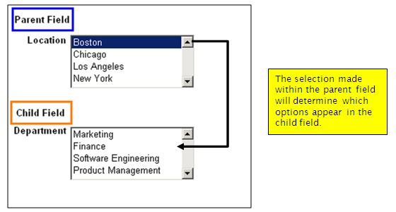
- Parents with Multiple Children
A parent field can have one or more child fields, but a child field can have only one parent field. For example, Location can be the parent field for Department and Division. However, if Location is the parent field to Department, Location is the only field that can control the options displayed in the Department field; the Division field cannot also control the options displayed in Department (Note: You can make this association work by making Location the parent of Division, and Division the parent of Department).

Additionally, a child field cannot be the parent of a sibling field – that is, it cannot be the parent of another field controlled by its own parent. For example, if Country is the parent of both the State and City fields, a selection in the State field will have no impact on the list of options available in the City list. The correct way to build this association is to make Country the parent of State and make State the parent of City.
- Multiple Selections in Parent Fields
If the parent field is a multi-select field and a user selects more than one option in the parent, the child will be populated with a combination of all options associated with all parent selections. For example, suppose Country is the parent field and City is the child field. When a user selects both USA and UK in the Country field, the City list displays only US and UK cities instead of all cities for all countries.
- Circular Associations
Circular field associations are not supported. For example, if Department is a parent to Location and Location is a parent to Business Group, Business Group cannot be the parent to Department.
- Hidden Fields
Hidden fields cannot effectively function as either parent or child fields in a field association. If a parent field is hidden on a specific form, field associations have no effect on any of its child fields. That is, hidden parent fields have no control over the options available in their child fields.

- Languages
Field associations are valid for all languages for the parent and child fields.

Parent options must be translated in Workbench, just like any other field option. Child fields with option lists automatically inherit the parent’s language selection. If you do not translate a child option into a specific language in Workbench, that option does not appear when the filtered list is displayed in that language.

When importing a child text field value, it needs to be localized into each language via the import. For instance, if a child text value is only uploaded in English, when adding or editing the form in French, the field association would not populate anything in the child field because a French text translation was not supplied in the upload.
- Inactive Options
The status of an option in a child field does not impact field association. BrassRing allows you to associate an inactive child field option with an active parent field option. When an option is selected in the parent, associated options do not appear in the child field if they are inactive, but do appear once they are activated.
- Adding and Editing Options
If a selected option in a parent field is changed, even if child is a non-editable field, the child option list is also changed. When new options are added to a parent field, field associations must be configured for each new option; otherwise child fields will show ALL options.
- Valid Parent Field Types
Parent fields can control the selection(s) presented to the user in a subsequent field or fields.

Parent Field Types | Field Types that cannot be a Parent
- Single Select  - Radio buttons  - Multi-select  - Checkboxes  - Option source = Maintain Custom List  - Autofill (with source of):  - Single Select  - Radio button | - Field types that don’t have options:  - Date  - Text  - Text area  - Label  - Grid  - SSN  - Email  - Numeric  - Autofill (with source of):  - Multi-select  - Checkbox  - Option source = Pull options from existing list other than = ‘Options from other form fields’
- Valid Child Field Types
In child fields, the data (or options) presented depend upon a selection made in another field, the parent field. A child field has only one parent. Child fields can initially contain a full option list, but, based on the parent option selected, only a sub-set of the full list of options may appear.

Child field types: | Excluded field types:
- Radio  - Single-Select  - Checkbox  - Multi-select  - Text box  - Text area  - Numeric  - Email  - Query-select  - Pull from list | - Date  - Label  - Grid  - SSN  - Autofill

A child list can be affected by a parent field in several ways. The child list can show:
- A full list of options
- A full list of options with a default option selected
- A full list of options with multiple defaults selected (if multi-select field)
- A subset of options
- A subset of options with a default option selected
- A subset of options with multiple defaults selected (if multi-select field)
- A single value
- A single value with the option defaulted
Child fields can be a parent to other field(s) on form, but not to a sibling field. For example, if “Country” is the parent field of both the “State” and “City” child fields, a selection in “State” will have no impact on the “City” list of options.

For child fields with multi-value parents:
- If the parent is multi-select or checkbox, the child field cannot be a numeric, text box, text area or email type.
- These child field types do not support multiple options being displayed.
- If multiple parent options are selected, the child will be populated with a combination of ALL options associated with ALL parent selections.

- Planning Field Associations
This section provides some guidelines for planning field associations. Before you begin creating requisitions and forms that contain field associations, take a few minutes to read this section. Implementing these practices will streamline the creation of field associations and reduce errors when you import them.
- Field Placement
Whenever possible, place a parent field above all its child fields on the form. If a child field appears above a parent field, users might make selections in the child field before making a selection in its parent field. When a selection is eventually made in the parent field, the selection the user already made in the child field is lost and the user is not notified of the change.
- Country and State/Province Fields
To create a field association between country, state/province, and city fields, create custom Country and State/Province fields for the form. This is necessary because the options for the standard BrassRing country and state/province fields cannot be edited.
- User Experience
Configuration of field association does not affect look or feel of form or fields. Before you select a parent option, the child field shows the full list of values.

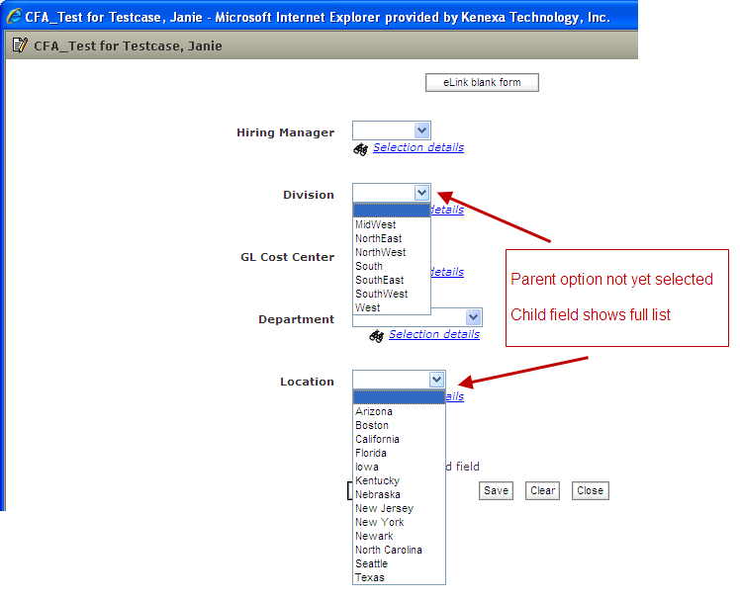

Once an option is selected in a ‘Parent’ field, the system displays “Please wait…” and temporarily disables the form during the database call to get the appropriate list of values for child fields. Database call time is dependent on amount of data being retrieved.
When the data is retrieved, the system displays a check mark for a few seconds beside all child fields that have been filtered or defaulted as a result of the ‘parent’ selection. Child field option lists are also filtered/defaulted.

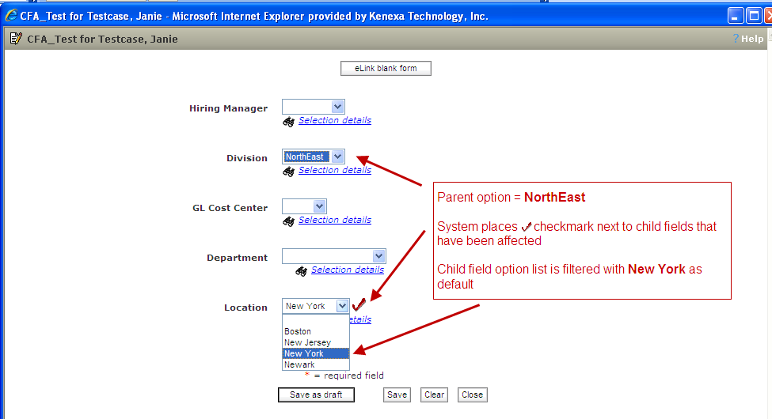

- Adding Field Associations (Workbench Configuration)
For configuration of CFA, you should coordinate with the BrassRing Support Team for the initial import of your field associations. You can maintain field associations for fields via XML after they are set up.

Workbench > Tools > Forms > Candidate Forms > Administer form fields [for selected form] > Add | Edit field > Define field attributes

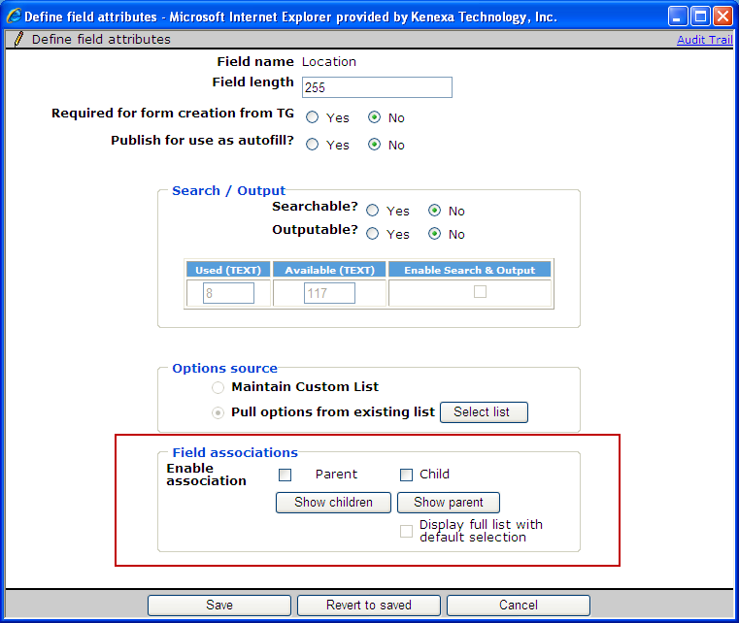

The Parent checkbox is disabled and grey for any field type that can’t be a parent; similarly with the Child checkbox.

The ‘Show children’ button only shows the children that have been uploaded with field association values for that parent, and likewise for the ‘Show parent’ button.

The ‘Display full list with default selection’ checkbox allows you to set a default for a full list of child options without having to UPLOAD the full list of child options. You only need to upload the option or options that you’d like to have defaulted.

A new Export field association action on the Administer form fields page allow you to export the child associations for each parent candidate form field
- Field Association Import Workflow
When you send a field association import feed, BrassRing returns a synchronous response that specifies whether or not the request has been received. Because of the level of validation that needs to occur for this type of import, BrassRing handles the actual processing of the import through an off-line, asynchronous process. Once the off-line process finishes importing field associations, BrassRing sends a message to an email address containing the results.

The email message tells you whether or not the import was successful and prompts you to review the import report in Workbench > Task Manager. The report details the import activity (Success, Partial Success, Error, or Failure).

The following illustration shows the XML field association workflow in detail:

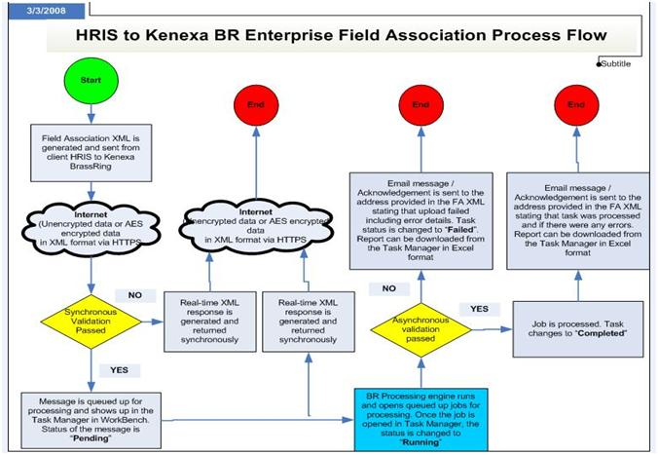
- Displaying the Import Report in Workbench
Below are the steps you will want to follow to display the field association import report
- Log into BrassRing Workbench and go to Tools > Task Manager
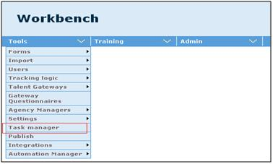
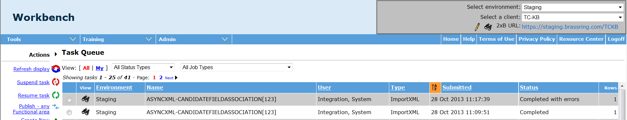
- Workbench displays the Task Queue window.

Tasks can appear in the following statuses:
- Pending (Waiting to be picked up for processing)
- Running (Currently being processed)
- Completed (Successfully processed)
- Completed with errors (Successfully processed)
- Failed (Could not be successfully processed)

To view the report for a completed or failed task, click the binoculars icon to download the report in Microsoft Excel Workbook (.XSL) format.

- Schemas
Use the Field Association XML/JSON schema to create XML/JSON requests that add, edit, or remove field associations. Like all BrassRing XML/JSON Integration schemas, the field association XML/JSON schema conforms to the HR-XML/JSON Provisional Envelope schema. A single XML/JSON request can accommodate multiple parent updates; you don’t have to submit a separate file per parent field.

Use the Field Association JSON to create JSON requests that add, edit, or remove field associations.
Like all BrassRing JSON Integration schemas, the field association JSON conforms to the HR-XML Provisional Envelope schema.
A single JSON request can accommodate multiple parent updates; you don’t have to submit a separate file per parent field.

NOTE : XML or JSON selection depends on property values selected while configuring the project on the Mapping Tool.
- Sample XML Request (Select Field Type Parent)
<?xml version="1.0"?>
<Envelope>
<Sender>
<Id>BrassRing will provide</Id>
<Credential>BrassRing will provide</Credential>
<Email>email_to_send_results@email.com</Email>
</Sender>
<TransactInfo>
<TransactId>123</TransactId>
</TransactInfo>
<Packet>
<PacketInfo packetType="data">
<PacketId>1</PacketId>
<Action>SET</Action>
<Manifest>ASYNCXML</Manifest>
</PacketInfo>
<Payload><![CDATA[<?xml version="1.0" encoding="UTF-8"?>
<CANDIDATEFIELDASSOCIATION form= "Form Name" dbfieldname= "Field Name" type = "Candidate">
<association>
<Import_Action>Update</Import_Action>
<Parent_Option_Code>test</Parent_Option_Code>
<Child_Type>Candidate</Child_Type>
<Child_Question>BoundByConfidential</Child_Question>
<Child_Option>Yes</Child_Option>
<Default_Selection>Yes</Default_Selection>
<Child_Text.en></Child_Text.en>
</association>
<association>
<Import_Action>Update</Import_Action>
<Parent_Option_Code>1212</Parent_Option_Code>
<Child_Type>Candidate</Child_Type>
<Child_Question>BoundByConfidential</Child_Question>
<Child_Option>No</Child_Option>
<Default_Selection>No</Default_Selection>
<Child_Text.en></Child_Text.en>
</association>
<association>
<Import_Action>Update</Import_Action>
<Parent_Option_Code>test</Parent_Option_Code>
<Child_Type>Candidate</Child_Type>
<Child_Question>ReferralName</Child_Question>
<Child_Option></Child_Option>
<Default_Selection>Yes</Default_Selection>
<Child_Text.en>This is a TEST1</Child_Text.en>
</association>
</CANDIDATEFIELDASSOCIATION>]]></Payload>
</Packet>
</Envelope>

- Sample JSON Request (Select Field Type Parent)
{
"Envelope": {
"Sender": {
"Id": "BrassRing will provide",
"Credential": "BrassRing will provide",
"Email": "email_to_send_results@email.com"
},
"TransactInfo": {
"TransactId": "123"
},
"Packet": {
"PacketInfo": {
"PacketId": "1",
"Action": "SET",
"Manifest": "ASYNCXML",
"packetType": "data"
},
"Payload": {
"CANDIDATEFIELDASSOCIATION": {
"association": [
{
"Import_Action": "Update",
"Parent_Option_Code": "test",
"Child_Type": "Candidate",
"Child_Question": "BoundByConfidential",
"Child_Option": "Yes",
"Default_Selection": "Yes",
"Child_Text.en": ""
},
{
"Import_Action": "Update",
"Parent_Option_Code": "1212",
"Child_Type": "Candidate",
"Child_Question": "BoundByConfidential",
"Child_Option": "No",
"Default_Selection": "No",
"Child_Text.en": ""
},
{
"Import_Action": "Update",
"Parent_Option_Code": "test",
"Child_Type": "Candidate",
"Child_Question": "ReferralName",
"Child_Option": "",
"Default_Selection": "Yes",
"Child_Text.en": "This is a TEST1"
}
],
"form": "Form Name",
"dbfieldname": "Field Name",
"type": "Candidate"
},
"AssociationName": "KENEXAGENERATEDMANIFESTNAME",
}
}
}
}

- Sample XML Request (Autofill Field Type Parent)
The Mapping Tool does not currently support autofill parent fields but they are supported via CFA XML. Below is a sample XML that can be used for development. Update the items highlighted in yellow for your particular CFA.
<?xml version="1.0"?>
<Envelope>
<Sender>
<Id>BrassRing will provide</Id>
<Credential>BrassRing will provide</Credential>
<Email>email_to_send_results@email.com</Email>
</Sender>
<TransactInfo>
<TransactId>123</TransactId>
</TransactInfo>
<Packet>
<PacketInfo packetType="data">
<PacketId>1</PacketId>
<Action>SET</Action>
<Manifest>ASYNCXML</Manifest>
</PacketInfo>
<Payload><![CDATA[<?xml version="1.0" encoding="UTF-8"?>
<CANDIDATEFIELDASSOCIATION form= "Form Name" dbfieldname= "Field Name" type = "Candidate">
<association>
<Import_Action>Update</Import_Action>
<Parent_Option>test</Parent_Option>
<Child_Type>Candidate</Child_Type>
<Child_Question>BoundByConfidential</Child_Question>
<Child_Option>Yes</Child_Option>
<Default_Selection>Yes</Default_Selection>
<Child_Text.en></Child_Text.en>
</association>
<association>
<Import_Action>Update</Import_Action>
<Parent_Option>1212</Parent_Option>
<Child_Type>Candidate</Child_Type>
<Child_Question>BoundByConfidential</Child_Question>
<Child_Option>No</Child_Option>
<Default_Selection>No</Default_Selection>
<Child_Text.en></Child_Text.en>
</association>
<association>
<Import_Action>Update</Import_Action>
<Parent_Option>test</Parent_Option>
<Child_Type>Candidate</Child_Type>
<Child_Question>ReferralName</Child_Question>
<Child_Option></Child_Option>
<Default_Selection>Yes</Default_Selection>
<Child_Text.en>This is a TEST1</Child_Text.en>
</association>
</CANDIDATEFIELDASSOCIATION>]]></Payload>
</Packet>
</Envelope>

- Sample JSON Request (Autofill Field Type Parent)
{
"Envelope": {
"Sender": {
"Id": "BrassRing will provide",
"Credential": "BrassRing will provide",
"Email": "email_to_send_results@email.com"
},
"TransactInfo": {
"TransactId": "123"
},
"Packet": {
"PacketInfo": {
"PacketId": "1",
"Action": "SET",
"Manifest": "ASYNCXML",
"packetType": "data"
},
"Payload": {
"CANDIDATEFIELDASSOCIATION": {
"association": [
{
"Import_Action": "Update",
"Parent_Option": "test",
"Child_Type": "Candidate",
"Child_Question": "BoundByConfidential",
"Child_Option": "Yes",
"Default_Selection": "Yes",
"Child_Text.en": ""
},
{
"Import_Action": "Update",
"Parent_Option": "1212",
"Child_Type": "Candidate",
"Child_Question": "BoundByConfidential",
"Child_Option": "No",
"Default_Selection": "No",
"Child_Text.en": ""
},
{
"Import_Action": "Update",
"Parent_Option": "test",
"Child_Type": "Candidate",
"Child_Question": "ReferralName",
"Child_Option": "",
"Default_Selection": "Yes",
"Child_Text.en": "This is a TEST1"
}
],
"form": "Form Name",
"dbfieldname": "Field Name",
"type": "Candidate"
}
}
}
}
}

- Processing the XML Request
Field Association Import requests can include multiple <Parent> nodes. BrassRing processes the nodes in the XML request in a linear “first-come, first-served” order. This means that if the message includes a <ParentValue> node to add a new association and also includes a subsequent <RemoveAssociation> node, it is possible that the newly added association will be removed. For this reason, if you send an import request that both adds and removes associations, place <RemoveAssociation> nodes ahead of any <ParentValue> nodes.
- Special Characters in XML Requests
There are several special characters that are either not allowed or not recommended for use within XML transmissions within text nodes, even within the CDATA section. These characters are: < (less than), > (greater than), & (ampersand), '(apostrophe) and "(quotation mark). In cases where these options appear within a text node within the XML, these characters must be escaped in order for the import to work without error.

Incorrect (Unescaped)
XML :
<association>
<Import_Action>Update</Import_Action>
<Parent_Option_Code>test</Parent_Option_Code>
<Child_Type>Candidate</Child_Type>
<Child_Question>BoundByConfidential</Child_Question>
<Child_Option>Finance & Accounting</Child_Option>
<Default_Selection>Yes</Default_Selection>
<Child_Text.en></Child_Text.en>
</association>

JSON:
{
"association": {
"Import_Action": "Update",
"Parent_Option_Code": "test",
"Child_Type": "Candidate",
"Child_Question": "BoundByConfidential",
"Child_Option": "Finance"Accounting",
"Default_Selection": "Yes",
"Child_Text.en": ""
}
}

Correct (Escaped)
XML:
<association>
<Import_Action>Update</Import_Action>
<Parent_Option_Code>test</Parent_Option_Code>
<Child_Type>Candidate</Child_Type>
<Child_Question>BoundByConfidential</Child_Question>
<Child_Option>Finance &amp Accounting</Child_Option>
<Default_Selection>Yes</Default_Selection>
<Child_Text.en></Child_Text.en>
</association>

JSON:
{
"association": {
"Import_Action": "Update",
"Parent_Option_Code": "test",
"Child_Type": "Candidate",
"Child_Question": "BoundByConfidential",
"Child_Option": "Finance\"Accounting",
"Default_Selection": "Yes",
"Child_Text.en": ""
}
}

The following table describes how special characters should be escaped in XML. Note that only the characters "<" and "&" are strictly illegal in XML. Apostrophes, quotation marks and greater than signs are legal, but BrassRing recommends replacing them with the corresponding escape sequences, as well.

Special Characters | Escaped Character
< (less than) | &lt;
> (greater than) | &gt;
& (ampersand) | &amp;
' (apostrophe) | &apos;
" (quotation mark) | &quot;

Below are additional special characters that are not allowed in the Code values.

Other Special Characters | Denotation |  | Other Special Characters | Denotation
; | semi colon |  | + | add
" | double quotes/single quotes |  | ? | question mark
! | exclamation |  | > < | greater than / less than
~ | tilda |  | % | percent
@ | apple |  | | | pipe
# | hash |  | [ ] | square brackets
= | equal to |  | {} | curly braces

These additional special characters cannot be escaped in the XML and are prohibited to be used in the Code values as per the BrassRing design. Special characters such as above conflict with non-XML integrations and can be mistaken or conflict with delimiters in other integrations.
- Special Characters in JSON Requests
Escaping of special characters

The FOR JSON clause escapes special characters in the JSON output with \, as shown in the following table. This escaping occurs both in the names of properties and in their values.

Special Character | Escaped output
Quotation mark (“) | \”
Backslash (\) | \\
Slash (/) | \/
Backspace | \b
Form feed | \f
New line | \n
Carriage return | \r
Horizontal tab | \t

- Payload Node
The details of the field association are contained in the <Payload> node. The tag names are highlighted in yellow and the description of the value is described in the chart below.
XML:
<Payload><![CDATA[<?xml version="1.0" encoding="UTF-8"?>
<CANDIDATEFIELDASSOCIATION form= "Form Name" dbfieldname= "Field Name" type = "Candidate">
<association>
<Import_Action>Update</Import_Action>
<Parent_Option_Code>test</Parent_Option_Code>
<Child_Type>Candidate</Child_Type>
<Child_Question>BoundByConfidential</Child_Question>
<Child_Option>Yes</Child_Option>
<Default_Selection>Yes</Default_Selection>
<Child_Text.en></Child_Text.en>
</association>
<association>
<Import_Action>Update</Import_Action>
<Parent_Option_Code>1212</Parent_Option_Code>
<Child_Type>Candidate</Child_Type>
<Child_Question>BoundByConfidential</Child_Question>
<Child_Option>No</Child_Option>
<Default_Selection>No</Default_Selection>
<Child_Text.en></Child_Text.en>
</association>
</CANDIDATEFIELDASSOCIATION>]]></Payload>
JSON:
{
"Payload": {
"CANDIDATEFIELDASSOCIATION": {
"association": [
{
"Import_Action": "Update",
"Parent_Option_Code": "test",
"Child_Type": "Candidate",
"Child_Question": "BoundByConfidential",
"Child_Option": "Yes",
"Default_Selection": "Yes",
"Child_Text.en": ""
},
{
"Import_Action": "Update",
"Parent_Option_Code": "1212",
"Child_Type": "Candidate",
"Child_Question": "BoundByConfidential",
"Child_Option": "No",
"Default_Selection": "No",
"Child_Text.en": ""
}
],
"form": "Form Name",
"dbfieldname": "Field Name",
"type": "Candidate"
},
"AssociationName": "KENEXAGENERATEDMANIFESTNAME",
}
}

Tag Name | Description/Notes | Valid Values | Requirement
Form Name | Candidate Form Name |  | Required
dbfieldname | Parent Database Field Name |  | Required
Import_Action | Will default to Update | Update or Delete | Not Required
Parent_Option | Code for parent option |  | Required
Child_Type | Will default to Candidate | Candidate | Required
Child_Question | Database Field Name of the Child Question |  | Required
Child_Option | Can be either option Code or Description. Please Note: This ‘flexibility’ can cause issues if the same value exists for both codes and descriptions for several options within the options list. |  | Not Required
Default_Selection | Setting that tells the system if the option sent is to be displayed to the user by default. If changing a default selection, the old default option needs to be switched to No before the new default option can be imported. | Yes or No | Not Required
Child_Text | Only populate when the Child field is Text, Text Area or Numeric. One association is required per language. |  | Not Required
- Adding Field Associations
Below are recommended and suggested practice for sending CFA data.
- If you have multiple child updates to be performed, the suggested way is to send all the child updates for the parent in a single XML transmission instead of sending one child and one parent in a transmission. Processing one transmission is faster and easier than processing multiple transmissions especially when number of child updates is in the thousands. Field association XMLs can also process multiple parents of the same parent type and their children in a single XML.
- Also, as a recommended practice, we advise not to send more than 10,000 child options in total in a single XML or transmission.

- Removing Field Associations
This section describes the XML requests that remove field associations.
- Delete Associations between a Child Field and a Parent Option
In the following example, the <Child> element’s fieldname and type attributes are populated with values that specify which child fields to disassociate with the parent option. Associations between the specified parent option and any children not included in the XML request are unaffected by this request. This action affects both text-based child fields and child fields that contain option lists. The <Option> node is not required for this example because all associated child options are removed.
XML:
<association>
<Import_Action>Delete</Import_Action>
<Parent_Option_Code>test</Parent_Option_Code>
<Child_Type>Candidate</Child_Type>
<Child_Question>BoundByConfidential</Child_Question>
<Child_Option></Child_Option>
<Default_Selection></Default_Selection>
<Child_Text.en></Child_Text.en>
</association>

JSON:
{
"association": {
"Import_Action": "Delete",
"Parent_Option_Code": "test",
"Child_Type": "Candidate",
"Child_Question": "BoundByConfidential",
"Child_Option": "",
"Default_Selection": "",
"Child_Text.en": ""
}
}

- Delete Associations between a Child Option and a Parent Option
In the following example, the <Child> element’s fieldname and type attributes are populated with values that specify which child fields to disassociate with the parent option. The <Option> node specifies which child options to disassociate.
Associations between the specified parent option and any child options not included in the XML request are unaffected by this request. This action affects only child fields that contain option lists.
XML:
<association>
<Import_Action>Delete</Import_Action>
<Parent_Option_Code>test</Parent_Option_Code>
<Child_Type>Candidate</Child_Type>
<Child_Question>BoundByConfidential</Child_Question>
<Child_Option>Yes</Child_Option>
<Default_Selection>Yes</Default_Selection>
<Child_Text.en></Child_Text.en>
</association>
JSON:
{
"association": {
"Import_Action": "Delete",
"Parent_Option_Code": "test",
"Child_Type": "Candidate",
"Child_Question": "BoundByConfidential",
"Child_Option": "Yes",
"Default_Selection": "Yes",
"Child_Text.en": ""
}
}

- Envelope Processing
The top level Envelope contains two attributes, version and encoding.
- Version attribute identifies the version of the envelope. The only valid value at this time is “01.00”.
- Encoding attribute identifies XML encoding and is optional. It can be set to “UTF-8” or “UTF-16”. The recommended setting is “UTF-16”.

The Envelope also has four top-level mandatory elements (Sender, Recipient, TransactInfo and Packet). These elements are described in detail below.
- Sender
The values below will be provided at the time of implementation.
- Employee Id: Sent in the Id tag for envelopes coming into BrassRing. This acts as the identification of the user who sends the XML data.
- Client Id : Sent in the Credential tag.
- Recipient
The URL of the recipient is passed in the Id tag. This helps to identify whether the data has been sent to the correct recipient destination.
- TransactInfo
An identifier for the transaction should be included in the TransactId. This identifies the envelope transaction and not any of the constituent data, since there could be multiple documents within one envelope. The combination of the client Id, TransactId and PacketId creates a globally unique identifier for each packet.

A timestamp can be added in the optional TimeStamp. This date format should conform to ISO standard 8601 (i.e. “2000-10-09T14:14:11Z”)

transactType should be set to “data”. This attribute helps provide the envelope parser with a heads up on what to expect in the payloads.
- Packet
The Packet contains the payload and metadata about the payload. The Payload element contains the actual XML and the PacketInfo element contains the metadata about the packet.

PacketInfo contains the following elements:
- packetType This attribute describes the content of the packet. A packetType of data is the default.
- PacketId: This element uniquely identifies the contents of the payload. PacketId is 1 unless suggested otherwise
- Action: This optional element contains the transaction code – SET
- Manifest: This is a mandatory element that identifies the contents of the payload. This field must be set to the value provided during implementation and should not be changed.
- Payload
The Payload element contains one HR-XML document inside a CDATA section. This approach allows the payload to be parsed separately from the envelope and avoids any interdependency between envelope and contents when validating envelope documents.

Note: the Payload XML should not have any additional CDATA section within it as in nested CDATA sections.

- Security
Several security protocols and measures have been implemented to ensure security on the data transmission, message integrity, and message confidentiality. These mechanisms can be used to accommodate a wide variety of security models and encryption technologies.
- Standard Implementation Security
- Message Integrity
Message integrity is ensured on the XML data. Unique credentials within the XML act as authentication information for a transaction to be consumed. These credentials in the Id, Credential and Manifest nodes act as unique value for a given implementation.
- Transport Layer Security (TLS)
Transport Layer Security (TLS) and its predecessor, Secure Sockets Layer (SSL), are cryptographic protocols that provide communication security over the Internet. TLS and SSL encrypt the segments of network connections above the Transport Layer, using asymmetric cryptography for key exchange, symmetric encryption for privacy, and message authentication codes for message integrity.

BrassRing integration API URLs (web service and HTTP Post URLs) are HTTPS-enabled and utilize 128 bit encryption over SSL when exchanging and transmitting information over the Internet. This is a mandatory encryption of the data that is enforced.
- IP restrictions
To add another layer to security and protection, IP restrictions can also be enforced. At the time of implementation, IP addresses from Staging and Production environments can be provided that can be white-listed on an external firewall on the customer’s network. These IP addresses are provided on request.
- Optional Security Features
- Message Layer Encryption/Security (MLS)
In additional to the above security protocols, message layer encryption is also available on the payload data.

Message layer encryption is facilitated using RSA encryption on the XML. Both Java and Microsoft .NET development environments support APIs for RSA encryption. BrassRing uses 1024-bit RSA encryption key pairs along with a public key generated by the client to implement functions to encrypt, sign, decrypt and authenticate data. Adding MLS adds to the cost and timeline of the project and as this is not part of standard implementations.

- 2-Way SSL / Certificate Based Authentication
Additionally, client certificate authentications or 2-way SSL or mutual SSL authentication is also available to enforce additional security around the integrations. The method of data exchange is accomplished with the use of certificates that confirm the source of the data before processing the information. SSL Session negotiated by Handshake Protocol via a X.509 public key Certificate of Peer.

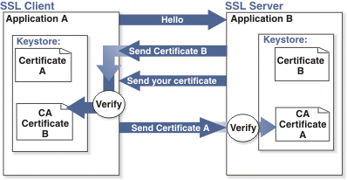

Adding 2-way SSL adds to the cost and timeline to the project as this is not part of Standard implementations.

Note: 2-way SSL is currently not available to clients on the China data-center.

- Integration API URLs
- Message Router Addresses
Web service URLs you need to invoke to send transactional data to BrassRing. These URLs below apply to the US data-center only. Europe and China end-point URLs are provided during time of implementation on such integrations.

Staging Environment
Web Service
URL - https://staging.brassring.com/HRISprocessor9/DispatchMessage.asmx
WSDL - https://staging.brassring.com/HRISprocessor9/DispatchMessage.asmx?wsdl

HTTP Post
URL - https://staging.brassring.com/jetstream/500/presentation/template/asp/HRISIntegration/msgdispatch.asp

Production Environment
Web Service
URL - https://trm.brassring.com/HRISprocessor9/DispatchMessage.asmx
WSDL - https://trm.brassring.com/HRISprocessor9/DispatchMessage.asmx?wsdl

HTTP Post
URL - https://trm.brassring.com/jetstream/500/presentation/template/asp/HRISIntegration/msgdispatch.asp

- API Error Handling
Real-time (synchronous) XML responses must be sent for all inbound and outbound transactions.

For all inbound transactions (imports), BrassRing provides a synchronous XML response within the same transaction. If the response XML contains CDATA sections in the payload, the <Payload> node is encrypted to protect sensitive information.

It is your responsibility to log the XML responses and re-attempt the transmission if the initial request was not successful.

Additionally, for Field Associations Imports, BrassRing processes the message offline and sends asynchronous responses to an e-mail address or URL that the client specifies.
- Analyzing Failed Requests
If an error is detected during validation of an integration XML request, the entire message is rejected and a failure response is returned synchronously. Information in a failure response’s <Status> node helps diagnose problems.

The following elements are children of the <Status> element:
- The <Code> element contains the HTTP status code associated with the outcome of the request.
- The <ShortDescription> element contains a string that briefly describes why the request failed.
- The <LongDescription> element contains a string that describes in detail why the request failed.
- HTTP Status Codes
All synchronous responses sent by BrassRing in an XML integration – both success responses and failure responses – include one of the following HTTP status codes:

HTTP Status Code | Description
200 | The request sent by the client was successful.
401 | Access was denied because of a security or authentication problem. This type of error might occur while BrassRing and the client are setting up the integration in a test environment.
405 | All failures related to anything other than security and authentication. When the <Code> for a failure response is 405, check the detailed error message in <LongDescription> to see if the error is the result of:  - A permanent condition that must be fixed before the request can be resubmitted. For example, the request did not include the authenticated user’s email address.  - A transient condition for which retrying the request is appropriate. For example, there was a system problem like a database timeout.

- Asynchronous Error Conditions and Messages
This section describes the messages BrassRing sends via email and displays in Workbench reports when asynchronous processing of the import is complete. The first part of this section describes errors contained in email messages and shows several sample email messages. The second part describes each individual error message you might see in the .Excel report you download from Workbench.
The Task Name, which is displayed in the response email and in Workbench > Task Manager is a combination of the Manifest Name and the Task ID and displays as: Manifest Name [Task ID: xxx].
- Completed Successfully (Without Error)
From: BrassRing TaskManager [mailto:TaskManager@brassring.com]
Sent: Friday, September 22, 2006 4:51 PM
To: Robert P. Foley
Subject: import task has completed successfully
Task Name: | MY MANIFEST NAME [Task ID: My Task ID]
Environment: | PRODUCTION
Client Name: | ABC COMPANY
Submitted On: | Friday, September 22, 2006 4:50:40 PM
Started On: | Friday, September 22, 2006 4:50:43 PM
Finished On: | Friday, September 22, 2006 4:50:44 PM
Total Rows Processed: | 2
Updates: | 2
Use Task Manager to view the results.
This message was e-mailed from a send-only account. Please do not reply. If problems persist, please contact your assigned BrassRing support representative.
- Import Failed
From: Brassring Task Manager [mailto:TaskManager@brassring.com]
Sent: Friday, September 22, 2006 4:23 PM
To: Robert P. Foley
Subject: import task has failed
Importance: High
Task Name: | MY MANIFEST NAME [Task ID: My Task ID]
Environment: | PRODUCTION
Client Name: | ABC COMPANY
Submitted On: | Friday, September 22, 2006 4:22:58 PM
Error Message: | Invalid internal XML in ‘Association_Data’
This message was e-mailed from a send-only account. Please do not reply. If problems persist, please contact your assigned BrassRing support representative.

- Completed with Errors
From: BrassRing TaskManager [mailto:TaskManager@brassring.com]
Sent: Friday, September 22, 2006 9:02 AM
To: Robert P. Foley
Subject: import task has completed with errors
Task Name: | Users [Task ID: My Task ID]
Environment: | Dev3
Client Name: | ABC COMPANY
Submitted On: | Friday, September 22, 2006 9:01:31 AM
Started On: | Friday, September 22, 2006 9:01:31 AM
Finished On: | Friday, September 22, 2006 9:01:41 AM
Total Rows Processed: | 1
Errors: | 1
Use Task Manager to view the results.
This message was e-mailed from a send-only account. Please do not reply. If problems persist, please contact your assigned BrassRing support representative.

- API Error Messages
Below is a list of error messages that you may encounter when using the CFA Import integration in the email you receive. These email messages all contain the subject line IMPORT TASK HAS FAILED and are sent to an email address that the client provided to BrassRing. We have also included an explanation in order to assist you with troubleshooting.

Code | Error Description | Reasoning
401 | ValidateAccess: - Access not setup for Sender – DSDSDS | Value in the Sender tag is incorrect
401 | Credential value is invalid | Value in the Credential tag in incorrect
405 | Can’t find association data | The XML document does not contain a <Payload> node
405 | Invalid internal XML in ‘Association_Data’ | The text inside the [[CData]] section in the XML file is not properly formatted XML.
405 | ClientID not provided | The XML document does not contain a <Credential> node
405 | ClientID doesn’t match | The ID provided in the <Credential> node does not match the current client ID
405 | Email address not provided | The XML document does not contain an <Email> node
405 | Parent question is not specified | The XML document does not contain a <Parent> node inside the <Association_Data> node
405 | <language ISO letter> is not a client language | The value specified by the <languages> node inside the <Association_Data> node either is not the correct client language or is simply incorrect
405 | Parent question name is not specified | The <Parent> node does not contain a valid fieldname attribute
405 | Parent question type is not specified | The <Parent> node does not contain a valid type attribute
405 | Child question cannot have option and text value in the same time | The XML document includes a <ChildValue> node that contains both <Option> and <TextValue> nodes. A <ChildValue> node can contain only one or the other
405 | Child question must contain either text value or option | The XML document includes a <ChildValue> node that does not contain either an <Option> or <TextValue> node. One or the other is required for each <ChildValue> node

- Sample Workbench > Task Manager > Excel Errors
The following sections describe errors that might appear in the Workbench report you can download when an import is complete.
Error Description | Reasoning
<ID> required | <ID> is a required node
<ID> Invalid | The value passed in the <ID> node is not a valid client ID
<Credential> required | <Credential> is a required node
<Credential> required | The value passed in the <Credential> node is not a valid userID
<Manifest> required | <Manifest> is a required node
<Email> required | <Email> is a required node
<Manifest> Invalid | The value passed in the <Manifest> node is not a valid manifest name for your Company
<Code> required | <Code> is a required node
<DefaultSelection> invalid | The value passed in the <DefaultSelection> node is not = “Yes” or “No”
<ImportAction> invalid | The value passed in the <ImportAction> node does not = “Update” or “Delete”
ParentQuestion required | Parent <Code> is a required node
<ImportAction> required | <ImportAction> is a required node
ParentType required | Parent Type is a required node
ParentType invalid | Parent Type node does not = “Standard” or “Custom”
ParentOption required | Parent <Code> is a required node
ParentOption exceeds max length | Parent <Code> node cannot exceed 50 characters
ChildQuestion invalid | Child Fieldname does not currently exist in 2x BrassRing
ChildQuestion required | Child fieldname is a required node
ChildQuestion exceeds max length | Child fieldname node cannot exceed 30 characters
ChildType required | Child Type is a required node
ChildType invalid | Child Type node does not = “Standard” or “Custom”.
ChildOption required | Child <Option> is a required node. “Child option can be empty only for Delete action.”
ChildOption invalid | Child <Option> does not currently exist in 2x BrassRing
ChildOption not allowed | Child <Option> does not support text field
ChildOption exceeds max length | Child <Option> cannot exceed 255 characters
DefaultSelection invalid | <DefaultSelection> node does not = “Yes” or “No”
ChildText exceeds max length | <TextValue Language="EN"> node exceeds 4000 characters
Multi-select may not be parent to text-based child | The parent field cannot be a multi-select or checkbox type with a child that is numeric, text box, text area or email type field. The following error message is returned in such cases: “[Field name] is a multi-select field. Multi-select field types may not be parents to fields which do not contain option list.”
Invalid child field type | Child field cannot be a Date, Label, Grid, SSN or Autofill field type, nor can it be Job code, Approval Routing or Add type. The following error message is returned in such cases: “[Field name] may not be used as a child field.”
Invalid default option | Only one default value is allowed on single-select and radio button field types. If the child field is a single-select or radio button field type, and more than one (1) default selection is specified for a specific parent, return the following error message: “Multiple default selections are not allowed for single-select [or radio] question.” (The error text should be updated based on the child field type.)
Multiple parents | A child cannot have more than one parent. The following error message is returned in such cases: “Child field is already associated to another Req field [field name]. A child field cannot have more than one (1) parent.”
Circular relationships | Field A is a parent to Field B, Field B is a parent to Field C, a field association cannot be imported where Field C is a parent to Field A. The following error message is returned in such cases: “Circular field relationships cannot be supported. Parent field is related to child field through an existing field association: ([PATH: Field A; Field B]).”
Field type cannot be changed | The field imported has already been configured as an association
Key group required | If either the Cypher or XML encrypt option has been selected and a key group is not selected, return the following error message: “A Key group must be selected.”
Encrypt option required | If either the Cypher or XML encrypt option has been selected and at least one (1) encrypt option has not been selected, return the following error message: “At least one (1) “Encrypt” option must be selected.”
Field [or Option] inactivation | Within Workbench, when taking the Inactivate or Delete action against a field or option that is used within a field association, return a warning message at the top of the screen (per existing WB functionality); “Before deleting/inactivating this field [option] you should review the following issues:” A grid will be presented with a hyperlink labeled “Field Associations” in the left column and the applicable associations listed in the right column. Format for the right column = Child of [parent field name] or Parent of [child field name]. Clicking on the Field associations hyperlink will display the following message: “This field [option] is used in a field association. If you inactivate/delete it, the associations listed will be removed.”
Unable to locate field with on a form or template with a database name of CFA Test Form and a database field name of SS_Test1 | The Form or Field Name sent is invalid. Please make sure to send Database Name.
Primary key has not been mapped to an import column. | Make sure to use the correct Parent field tag for the parent field type you have mapped (Select = <Parent_Option_Code> and Autofill = <Parent_Option>.
NOTE: This list is not all inclusive but contains the errors that are most encountered.

