

The information contained in this document is the property of Signal Labs Talent Inc. Except as specifically authorized in writing by Signal Labs Talent Inc, the holder of this document shall: (1) keep all information contained herein confidential and shall protect same in whole or in part from disclosure and dissemination to all third parties and, (2) use same for operating and maintenance purposes only.
Version: 1.0.1
Date: June 15, 2023

Signal Labs Talent BrassRing

Candidate Export Technical Specifications API Guide

Table of Contents
Chapter 1: Introduction 3
1.1 What are BrassRing’s Integration APIs 3
1.2 Purpose 3
1.3 Audience 3
Chapter 2: BrassRing’s Candidate Export Integration APIs 4
2.1 Overview 4
2.2 Communication Methodology 4
2.3 Rules for the Candidate Export Integration 5
2.4 Candidate Export Snapshot 5
2.4.1 Figure 1: Trigger Page 5
2.4.2 Figure 2: Success Page 6
2.4.3 Figure 3: Form Import 6
2.5 Candidate XML Definitions (Data-mapping) 7
2.5.1 Mandatory Fields 7
2.5.2 Custom Fields defined by Customer (examples below) 7
2.6 Candidate Tag Definitions – Detailed Descriptions 8
2.6.1 Mandatory Fields 8
Chapter 3: XML Schemas 9
3.1 Sample XML Export Request (Candidate data only) 9
3.2 Sample JSON Export Request (Candidate data only) 10
3.3 Sample XML export Request (Candidate data and Requisition data) 11
3.4 Sample JSON export Request (Candidate data and Requisition data) 12
3.5 Sample Synch XML Response (Success) 13
3.5.1 Example 1: Standard Response XML 14
3.5.2 Example 1: Standard Response JSON 14
3.5.3 Example 2: Redirect Response XML 16
3.5.4 Example 2: Redirect Response JSON 16
3.6 Sample XML Response (Failure) 18
3.7 Sample JSON Response (Failure) 18
Chapter 4: Envelope Processing 20
4.1 Sender 20
4.2 Recipient 20
4.3 TransactInfo 20
4.4 Packet 20
4.5 Payload 21
Chapter 5: Security 22
5.1 Standard Implementation Security 22
5.1.1 Transport Layer Security (TLS) 22
5.1.2 IP restrictions 22
5.2 Optional Security Features 22
5.2.1 Message Layer Encryption/Security (MLS) 22
5.2.2 2-Way SSL / Certificate Based Authentication 23
5.2.3 Basic Authentication 23
Chapter 6: API Error Messages 24

- Introduction
- What are BrassRing’s Integration APIs
BrassRing XML/JSON integrations feature flexible, secure, real-time integrations by sending XML/JSON over the Internet using web services or HTTP Posts. XML/JSON formats used in BrassRing XML /JSON integrations are based on HR-XML Consortium guidelines.

The BrassRing XML/JSON integrations offering allows BrassRing to work with the customers to configure multi-level, robust integration relationships between BrassRing and any systems that can send and receive XML/JSON. Examples of these systems include HRIS systems such as SAP/Oracle/PeopleSoft, etc., and systems that perform HR related services like background checks, assessments or compensation analysis.

The customer can choose to receive data through either a web service or HTTP post. BrassRing handles the exchange of XML/JSON requests and responses using its own messaging software. The customer builds their own messaging system to exchange XML/JSON web service messages or HTTP post with BrassRing.

Note: Web Service exports require special PSE configuration. Self-Service exports configured in the Mapping Tool only support HTTP Post.
- Purpose
The purpose of this document is as follows:
- To present a high-level architecture and design of BrassRing APIs and how BrassRing implements Candidate export integrations to meet its customer’s needs to candidate data exchange.
- To describe suggested high-level workflow processes that can be supported between BrassRing and any external, third-party system that can send and receive XML/JSON requests and responses.
- To describe the steps required to implement Candidate/New Hire Export integration.
- Audience
- Client Decision Makers, HRIS Implementation Teams, Internal IT Teams, Systems Integrators and Support Teams.
- BrassRing Engineering Services Team, Support Team, and Technical Services Group.

- BrassRing’s Candidate Export Integration APIs
- Overview
Candidate export Integrations from BrassRing to an external system (Customer or a third-party vendor) is referred in many ways namely:
- New Hire export
- Candidate export for Assessments
- Candidate export for Background check

Candidate data is any data that applies to a candidate such as name, address, etc. and any information that resides on a candidate or Req form in the BrassRing system.

These integrations are triggered real-time in BrassRing meaning Recruiters initiate the export by moving a candidate to a configured triggering HR Status which initiates the transaction of the data across. For example, a customer may wish to export candidate data each time a Recruiter moves a candidate to an “Offer Accepted” or “Initiate Background Check” HR Status.

This integration can be implemented as a one-way integration or a two-way integration.

Unidirectional or One-way integration – Candidate data flows one way from BrassRing to external system

Bidirectional or Two-way integration – Candidate data flows one way from BrassRing to external system and information such as assessment results, background check results or any candidate form data are sent from external system to BrassRing which then get attached to the candidate in BrassRing on a candidate form. Please refer to the BrassRing Form Import Technical Specifications API.docx documentation on details of bringing back results into BrassRing.

The data required to be transacted is defined in the data mapping document process.
- Communication Methodology
Connection to the BrassRing system is accomplished via 2 mechanisms using XML/JSON as a data transfer vehicle.
- HTTP Post
- Web services

Both the above mechanisms are synchronous meaning all transactions are real-time with a request-response messaging and no message queuing.

The XML/JSON format is depicted in Section 3.

Note: Web Service exports require special PSE configuration. Self-Service exports configured in the Mapping Tool only support HTTP Post.

- Rules for the Candidate Export Integration
Below are a few rules to consider when looking into the use of the Integration:
- The XML/JSON schema will be provided by BrassRing and cannot be customized (see sample XML/JSON below).
- Transactions are processed real-time via HTTPS Post or Web Services.
- Field requirements (outlined in the Data Mapping sections).

Note: Web Service exports require special PSE configuration. Self-Service exports configured in the Mapping Tool only support HTTP Post.
- Candidate Export Snapshot
Recruiters in the system trigger the export. Below is a screen print of the HR Status screen for your reference.
- Figure 1: Trigger Page
Triggering page and page displayed to the Recruiter when the export is unsuccessful.
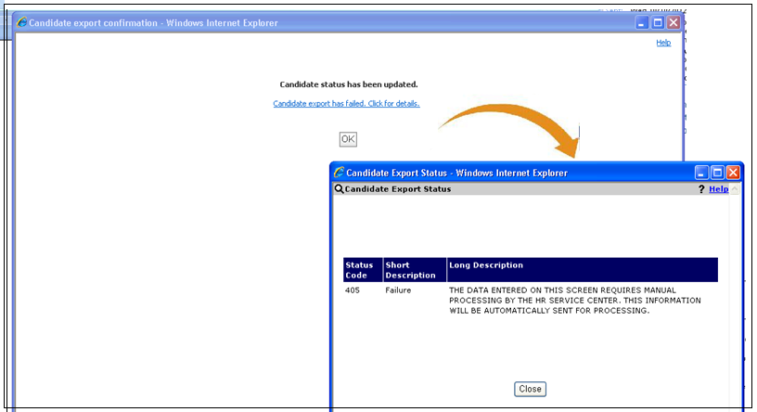

- Figure 2: Success Page
Page displayed to the Recruiter when the export is successful.
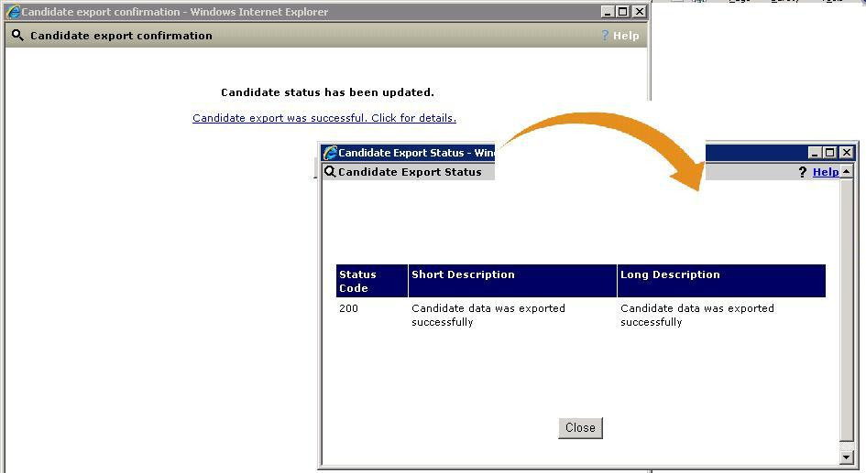
- Figure 3: Form Import
Candidate results screen (in case of bi-directional integrations) . This is the screenshot of the Form when Form results are sent back as part of the Form Import (ILOAD) integrations.
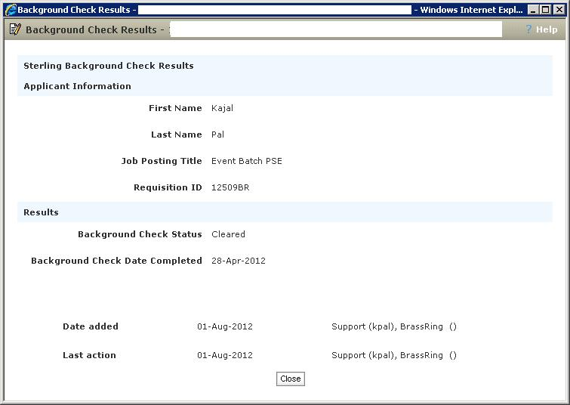

- Candidate XML Definitions (Data-mapping)
- Mandatory Fields
Field Name | Format | Field Length | Form Name | XML Tag/JSON Keys
CANDIDATEID | Integer | 15 | This is the unique identifier of the Candidate in the BrassRing system | CANDIDATEID
REQUISITIONNUMBER | Varchar | 30 | This is the Client Req number also referred as the Optional Req Number. The value will be blank if client does not use it | REQUISITIONNUMBER
BRREQNUMBER | Varchar | 30 | This is the unique identifier of the Job in BrassRing. It is always a value that ends with “BR”, for example 100 BR, 3423BR, etc. | BRREQNUMBER
JOBCODE | Varchar | 35 | This is the standard job code associated with the Job | JOBCODE
STATUS | Varchar | 50 | This is the HR Status value that triggered the candidate/new hire integration | STATUS
- Custom Fields defined by Customer (examples below)
Field Name | Format | Field Length | Form Name | XML Tag/JSON Keys
Start Date | Varchar | 255 | Offer Form | XML/JSON tags for Custom fields are provided after data mapping requirements are provided for the integration
Employee ID | Varchar | 50 | Offer Form
Race | Varchar | 255 | EEO Form
Gender | Varchar | 255 | EEO Form
Recruiter | Varchar | 255 | Requisition Form
Job title | Varchar | 255 | Requisition Form
Department | Varchar | 100 | Requisition Form

- Candidate Tag Definitions – Detailed Descriptions
- Mandatory Fields
- CANDIDATEID
The value in this tag contains the candidate’s unique number in BrassRing
XML Tag/JSON Keys | Tag Present? | Value Present? | Format | Length
CANDIDATEID | Yes | Yes | Integer | 15

- REQUISITIONNUMBER
The value in this tag contains the customer’s Req Number also referred as the Optional Req number in BrassRing
XML Tag/JSON Keys | Tag Present? | Value Present? | Format | Length
REQUISITIONNUMER | Yes | Optional | Varchar | 30
_
- BRREQNUMBER
The value in this tag contains the BrassRing generated Req number. This value is unique in BrassRing and always in “BR”. (i.e. 100BR).
XML Tag/JSON Keys | Tag Present? | Value Present? | Format | Length
BRREQNUMBER | Yes | Yes | Varchar | 30
_
- JOBCODE
The value in this tag contains the job code value association with the Requisition.
XML Tag/JSON Keys | Tag Present? | Value Present? | Format | Length
JOBOCDE | Yes | Optional | Varchar | 35
_
- STATUS
The value in this tag contains the HR Status name that triggered the export.
XML Tag/JSON Keys | Tag Present? | Value Present? | Format | Length
STATUS | Yes | Yes | Varchar | 50
_

- XML Schemas
- Sample XML Export Request (Candidate data only)
Below is a sample Candidate XML file. The items highlighted in yellow are mandatory fields that are exported. Other fields are listed as an example and driven by the data mapping document requirements on the fields to be exported. Candidate data only represents all information that resides on Candidate forms in BrassRing.

<?xml version="1.0" encoding="UTF-8"?>
<Envelope version="01.00">
<Sender>
<!—The Id tag will always be included. It will hold the employee ID of the BrassRing user who is initiating the request. If the user has no employee ID, the Id tag will be exported with no value. -->
<Id/>
<Credential>BrassRing will provide</Credential>
</Sender>
<Recipient>
<Id/>
</Recipient>
<TransactInfo transactType="data">
<TransactId>HSCAND636096</TransactId>
<TimeStamp>2/28/2011 5:34:34 PM</TimeStamp>
</TransactInfo>
<Packet>
<PacketInfo packetType="data">
<PacketId>1</PacketId>
<Action>SET</Action>
<Manifest>MANIFEST_NAME</Manifest>
</PacketInfo>
<Payload><![CDATA[<?xml version="1.0"?>
<CANDIDATE>
<CANDIDATEID>984577</CANDIDATEID>
<REQUISITIONNUMBER/>
<BRREQNUMBER>100BR</BRREQNUMBER>
<JOBCODE>09845145447</JOBCODE>
<STATUS>03-Offer Accepted</STATUS>
<CANDIDATEFIRSTNAME></CANDIDATEFIRSTNAME>
<CANDIDATELASTNAME></CANDIDATELASTNAME>
<DATEOFBIRTH>1977-02-15</DATEOFBIRTH>
<BIRTHPLACE>Boston</BIRTHPLACE>
<COUNTRYOFBIRTH>USA</COUNTRYOFBIRTH>
<GENDER>M</GENDER>
<MARITALSTATUS>Single</MARITALSTATUS>
<NATIONALITY>American</NATIONALITY>
<LANGUAGENAME>EN</LANGUAGENAME>
<ACTION_REASON>Addition</ACTION_REASON>
<ADDITIONAL_COMPENSATION>0</ADDITIONAL_COMPENSATION>
<ADDRESS1>4719 Fetteressa Drive</ADDRESS1>
<ADDRESS2>none</ADDRESS2>
<BASE_SALARY_FREQUENCY>H</BASE_SALARY_FREQUENCY>
<SALARY_GRADE>OL6</SALARY_GRADE>
<SIGN_ON_BONUS_AMOUNT>0</SIGN_ON_BONUS_AMOUNT>
<ETHNIC_GROUP>White</ETHNIC_GROUP>
<HIRE_DT>2012-04-23</HIRE_DT>
</CANDIDATE>
]]></Payload>
</Packet>
</Envelope>

- Sample JSON Export Request (Candidate data only)
{
"Envelope": {
"Sender": {
"Id": "",
"Credential": "BrassRing will provide"
},
"Recipient": {
"Id": ""
},
"TransactInfo": {
"TransactId": "HSCAND636096",
"TimeStamp": "2/28/2011 5:34:34 PM",
"transactType": "data"
},
"Packet": {
"PacketInfo": {
"PacketId": "1",
"Action": "SET",
"Manifest": "MANIFEST_NAME",
"packetType": "data"
},
"Payload": {
"CANDIDATE": {
"CANDIDATEID": "984577",
"REQUISITIONNUMBER": "",
"BRREQNUMBER": "100BR",
"JOBCODE": "09845145447",
"STATUS": "03-Offer Accepted",
"CANDIDATEFIRSTNAME": "",
"CANDIDATELASTNAME": "",
"DATEOFBIRTH": "1977-02-15",
"BIRTHPLACE": "Boston",
"COUNTRYOFBIRTH": "USA",
"GENDER": "M",
"MARITALSTATUS": "Single",
"NATIONALITY": "American",
"LANGUAGENAME": "EN",
"ACTION_REASON": "Addition",
"ADDITIONAL_COMPENSATION": "0",
"ADDRESS1": "4719 Fetteressa Drive",
"ADDRESS2": "none",
"BASE_SALARY_FREQUENCY": "H",
"SALARY_GRADE": "OL6",
"SIGN_ON_BONUS_AMOUNT": "0",
"ETHNIC_GROUP": "White",
"HIRE_DT": "2012-04-23"
}
}
},
"version": "01.00"
}
}

- Sample XML export Request (Candidate data and Requisition data)
Below is a sample Candidate XML file. The items highlighted in yellow are mandatory fields that are exported. Other fields are listed as an example and driven by the data mapping document requirements on the fields to be exported. Candidate data only represents all information that resides on Candidate forms in BrassRing. Requisition data represents information that reside on the Requisition forms in BrassRing and appears in a second Packet node in the XML.

<?xml version="1.0" encoding="UTF-8"?>
<Envelope version="01.00">
<Sender>
<Id>BrassRing will provide</Id>
<Credential>BrassRing will provide</Credential>
</Sender>
<Recipient>
<Id/>
</Recipient>
<TransactInfo transactType="data">
<TransactId>HSCAND636096</TransactId>
<TimeStamp>2/28/2011 5:34:34 PM</TimeStamp>
</TransactInfo>
<Packet>
<PacketInfo packetType="data">
<PacketId>1</PacketId>
<Action>SET</Action>
<Manifest>MANIFEST_NAME</Manifest>
</PacketInfo>
<Payload><![CDATA[<?xml version="1.0"?>
<CANDIDATE>
<CANDIDATEID>984577</CANDIDATEID>
<REQUISITIONNUMBER/>
<BRREQNUMBER>100BR</BRREQNUMBER>
<JOBCODE>09845145447</JOBCODE>
<STATUS>03-Offer Accepted</STATUS>
<CANDIDATEFIRSTNAME></CANDIDATEFIRSTNAME>
<CANDIDATELASTNAME></CANDIDATELASTNAME>
<DATEOFBIRTH>1977-02-15</DATEOFBIRTH>
<BIRTHPLACE>Boston</BIRTHPLACE>
<COUNTRYOFBIRTH>USA</COUNTRYOFBIRTH>
<GENDER>M</GENDER>
<MARITALSTATUS>Single</MARITALSTATUS>
<NATIONALITY>American</NATIONALITY>
<LANGUAGENAME>EN</LANGUAGENAME>
</CANDIDATE>
]]></Payload>
</Packet>
<Packet>
<PacketInfo packetType="data">
<PacketId>2</PacketId>
<Action>SET</Action>
<Manifest>MANIFEST_NAME</Manifest>
</PacketInfo>
<Payload><![CDATA[<REQUISITION>
<JOBCODE>09845145447</JOBCODE>
<SAPPOSITION>Manager of Operations</SAPPOSITION>
<COMPANYCODE>IBM</COMPANYCODE>
<JOBKEY>RD-54123</JOBKEY>
<ORGUNIT>Hosting</ORGUNIT>
<PERSONNELAREA>PA_784</PERSONNELAREA>
<EMPLOYEEGROUP>Permanent</EMPLOYEEGROUP>
<EMPLOYEESUBGROUP>Labor</EMPLOYEESUBGROUP>
<BUSINESSAREA>Talent Management</BUSINESSAREA>
</REQUISITION> ]]></Payload>
</Packet>
</Envelope>

- Sample JSON export Request (Candidate data and Requisition data)
{
"Envelope": {
"Sender": {
"Id": "BrassRing will provide",
"Credential": "BrassRing will provide"
},
"Recipient": {
"Id": ""
},
"TransactInfo": {
"TransactId": "HSCAND636096",
"TimeStamp": "2/28/2011 5:34:34 PM",
"transactType": "data"
},
"Packet": [
{
"PacketInfo": {
"PacketId": "1",
"Action": "SET",
"Manifest": "MANIFEST_NAME",
"packetType": "data"
},
"Payload": {
"CANDIDATE": {
"CANDIDATEID": "984577",
"REQUISITIONNUMBER": "",
"BRREQNUMBER": "100BR",
"JOBCODE": "09845145447",
"STATUS": "03-Offer Accepted",
"CANDIDATEFIRSTNAME": "",
"CANDIDATELASTNAME": "",
"DATEOFBIRTH": "1977-02-15",
"BIRTHPLACE": "Boston",
"COUNTRYOFBIRTH": "USA",
"GENDER": "M",
"MARITALSTATUS": "Single",
"NATIONALITY": "American",
"LANGUAGENAME": "EN"
}
}
},
{
"PacketInfo": {
"PacketId": "2",
"Action": "SET",
"Manifest": "MANIFEST_NAME",
"packetType": "data"
},
"Payload": {
"REQUISITION": {
"JOBCODE": "09845145447",
"SAPPOSITION": "Manager of Operations",
"COMPANYCODE": "IBM",
"JOBKEY": "RD-54123",
"ORGUNIT": "Hosting",
"PERSONNELAREA": "PA_784",
"EMPLOYEEGROUP": "Permanent",
"EMPLOYEESUBGROUP": "Labor",
"BUSINESSAREA": "Talent Management"
}
}
}
],
"version": "01.00"
}
}

- Sample Synch XML Response (Success)
Below is a sample synchronous success Response XML that must be sent back by the client’s URL on the Request. Code value of 200 indicates that the transaction was successfully received by the Client’s URL.

The synchronous response can be sent in 1 of 2 ways.
- Example 1: Standard Response XML
Below is how 90% of our client have implemented. It the standard response that acknowledges receipt of the XML and a successful message is displayed on the screen to the user who triggered the export.

<?xml version="1.0" encoding="UTF-8"?>
<Envelope version="01.00">
<Sender>
<Id>BrassRing will provide</Id>
<Credential>BrassRing will provide</Credential>
</Sender>
<Packet>
<PacketInfo packetType="response">
<PacketId>1</PacketId>
<Action>SET</Action>
<Manifest>MANIFEST_NAME</Manifest>
<Status>
<Code>200</Code>
<ShortDescription>Candidate data was exported successfully</ShortDescription>
<LongDescription>Candidate data was exported successfully</LongDescription>
</Status>
</PacketInfo>
<Payload/>
</Packet>
<Recipient>
<Id/>
</Recipient>
<TransactInfo transactType="response">
<TransactId>11082520</TransactId>
<TimeStamp>11/23/2009 08:54:28 AM PST</TimeStamp>
<Status>
<Code>200</Code>
<ShortDescription>Candidate data was exported successfully</ShortDescription>
<LongDescription>Candidate data was exported successfully</LongDescription>
</Status>
</TransactInfo>
</Envelope>

- Example 1: Standard Response JSON
{
"Envelope": {
"Sender": {
"Id": "BrassRing will provide",
"Credential": "BrassRing will provide"
},
"Packet": {
"PacketInfo": {
"PacketId": "1",
"Action": "SET",
"Manifest": "MANIFEST_NAME",
"Status": {
"Code": "200",
"ShortDescription": "Candidate data was exported successfully",
"LongDescription": "Candidate data was exported successfully"
},
"packetType": "response"
},
"Payload": ""
},
"Recipient": {
"Id": ""
},
"TransactInfo": {
"TransactId": "11082520",
"TimeStamp": "11/23/2009 08:54:28 AM PST",
"Status": {
"Code": "200",
"ShortDescription": "Candidate data was exported successfully",
"LongDescription": "Candidate data was exported successfully"
},
"transactType": "response"
},
"version": "01.00"
}
}

- Example 2: Redirect Response XML
The below example adds an additional tag called RedirectURL. Including this tag with a valid URL in the Response will automatically redirect the user to the designated URL provided upon a successful transaction. You may choose such an option when you require the user to be automatically redirected into some other system upon a successful transaction of the candidate data from BrassRing. An example of such a scenario would be to redirect the user to an external on-boarding system after data transfer for the candidate data was successful.

<?xml version="1.0" encoding="UTF-8"?>
<Envelope version="01.00">
<Sender>
<Id>BrassRing will provide</Id>
<Credential>BrassRing will provide</Credential>
</Sender>
<Recipient>
<Id>3054485</Id>
</Recipient>
<TransactInfo transactType="response">
<TransactId>2193791</TransactId>
<TimeStamp>11/10/2011 12:25:22 PM</TimeStamp>
<Status>
<Code>200</Code>
<ShortDescription>Success</ShortDescription>
<LongDescription>Candidate data transfer was successful</LongDescription>
<RedirectURL>https://mydomain.com/showmessage.aspx?token=634e9e5ed8749c19</RedirectURL>
</Status>
</TransactInfo>
<Packet>
<PacketInfo packetType="response">
<PacketId>1</PacketId>
<Action>SET</Action>
<Manifest>DGTALX_CANDIDATE_EXPORT</Manifest>
<Status>
<Code>200</Code>
<ShortDescription>Success</ShortDescription>
<LongDescription>Candidate data transfer was successful</LongDescription>
<RedirectURL>https://mydomain.com/showmessage.aspx?token=634e9e5ed8749c19</RedirectURL>
</Status>
</PacketInfo>
<Payload/>
</Packet>
</Envelope>

- Example 2: Redirect Response JSON
{
"Envelope": {
"Sender": {
"Id": "BrassRing will provide",
"Credential": "BrassRing will provide"
},
"Recipient": {
"Id": "3054485"
},
"TransactInfo": {
"TransactId": "2193791",
"TimeStamp": "11/10/2011 12:25:22 PM",
"Status": {
"Code": "200",
"ShortDescription": "Success",
"LongDescription": "Candidate data transfer was successful",
"RedirectURL": "https://mydomain.com/showmessage.aspx?token=634e9e5ed8749c19"
},
"transactType": "response"
},
"Packet": {
"PacketInfo": {
"PacketId": "1",
"Action": "SET",
"Manifest": "DGTALX_CANDIDATE_EXPORT",
"Status": {
"Code": "200",
"ShortDescription": "Success",
"LongDescription": "Candidate data transfer was successful",
"RedirectURL": "https://mydomain.com/showmessage.aspx?token=634e9e5ed8749c19"
},
"packetType": "response"
},
"Payload": ""
},
"version": "01.00"
}
}

- Sample XML Response (Failure)
Below is a sample synchronous failure Response XML that must be sent back on the Request in the event an error is encountered. Code value of 405 indicates that the transaction was unsuccessfully processed by the Client’s URL.

<?xml version="1.0" encoding="UTF-8"?>
<Envelope version="01.00">
<Sender>
<Id>BrassRing will provide</Id>
<Credential>BrassRing will provide</Credential>
</Sender>
<Packet>
<PacketInfo packetType="response">
<PacketId>1</PacketId>
<Action>SET</Action>
<Manifest>MANIFEST_NAME</Manifest>
<Status>
<Code>405</Code>
<ShortDescription>Background Request Submission Not Successful</ShortDescription>
<LongDescription>Missing Required: Applicant Region., Missing Required: Applicant SSN, Missing Required: Applicant Date of Birth., Missing Required: Conviction Question. </LongDescription>
</Status>
</PacketInfo>
<Payload/>
</Packet>
<Recipient>
<Id/>
</Recipient>
<TransactInfo transactType="response">
<TransactId/>
<TimeStamp>11/23/2009 03:54:19 PM PST</TimeStamp>
<Status>
<Code>405</Code>
<ShortDescription>Background Request Submission Not Successful</ShortDescription>
<LongDescription>Missing Required: Applicant Region., Missing Required: Applicant SSN, Missing Required: Applicant Date of Birth., Missing Required: Conviction Question. </LongDescription>
</Status>
</TransactInfo>
</Envelope>

- Sample JSON Response (Failure)
{
"Envelope": {
"Sender": {
"Id": "BrassRing will provide",
"Credential": "BrassRing will provide"
},
"Packet": {
"PacketInfo": {
"PacketId": "1",
"Action": "SET",
"Manifest": "MANIFEST_NAME",
"Status": {
"Code": "405",
"ShortDescription": "Background Request Submission Not Successful",
"LongDescription": "Missing Required: Applicant Region., Missing Required: Applicant SSN, Missing Required: Applicant Date of Birth., Missing Required: Conviction Question."
},
"packetType": "response"
},
"Payload": ""
},
"Recipient": {
"Id": ""
},
"TransactInfo": {
"TransactId": "",
"TimeStamp": "11/23/2009 03:54:19 PM PST",
"Status": {
"Code": "405",
"ShortDescription": "Background Request Submission Not Successful",
"LongDescription": "Missing Required: Applicant Region., Missing Required: Applicant SSN, Missing Required: Applicant Date of Birth., Missing Required: Conviction Question."
},
"transactType": "response"
},
"version": "01.00"
}
}

- Envelope Processing
The top level Envelope contains two attributes, version and encoding.
- Version attribute identifies the version of the envelope. The only valid value at this time is “01.00”.
- Encoding attribute identifies XML encoding and is optional. It can be set to “UTF-8” or “UTF-16”. The recommended setting is “UTF-16”.

The Envelope also has four top-level mandatory elements (Sender, Recipient, TransactInfo and Packet). These elements are described in detail below.
- Sender
The values below will be provided at the time of implementation.
Employee Id: The Id tag will always be included. It will hold the employee ID of the BrassRing user who is initiating the request. If the user has no employee ID, the Id tag will be exported with no value
- Client Id : Sent in the Credential tag.
- Recipient
The URL of the recipient is passed in the Id tag. This helps to identify whether the data has been sent to the correct recipient destination.
- TransactInfo
An identifier for the transaction should be included in the TransactId. This identifies the envelope transaction and not any of the constituent data, since there could be multiple documents within one envelope. The combination of the client Id, TransactId and PacketId creates a globally unique identifier for each packet.

A timestamp can be added in the optional TimeStamp. This date format should conform to ISO standard 8601 (i.e. “2000-10-09T14:14:11Z”)

transactType should be set to “data”. This attribute helps provide the envelope parser with a heads up on what to expect in the payloads.
- Packet
The Packet contains the payload and metadata about the payload. The Payload element contains the actual XML and the PacketInfo element contains the metadata about the packet.

PacketInfo contains the following elements:
- packetType This attribute describes the content of the packet. A packetType of data, the default.
- PacketId: This element uniquely identifies the contents of the payload. PacketId is 1 unless suggested otherwise
- Action: This optional element contains the transaction code – SET
- Manifest: This is a mandatory element that identifies the contents of the payload. This field must be set to the value provided during implementation and should not be changed.
- Payload
The Payload element contains one HR-XML document inside a CDATA section. This approach allows the payload to be parsed separately from the envelope and avoids any interdependency between envelope and contents when validating envelope documents.

- Security
Several security protocols and measures have been implemented to ensure security on the data transmission, message integrity, and message confidentiality. These mechanisms can be used to accommodate a wide variety of security models and encryption technologies.
- Standard Implementation Security
- Transport Layer Security (TLS)
Transport Layer Security (TLS) and its predecessor, Secure Sockets Layer (SSL), are cryptographic protocols that provide communication security over the Internet. TLS and SSL encrypt the segments of network connections above the Transport Layer, using asymmetric cryptography for key exchange, symmetric encryption for privacy, and message authentication codes for message integrity.

BrassRing integration API URLs (web service and HTTP Post URLs) are HTTPS-enabled and utilize 128 bit encryption over SSL when exchanging and transmitting information over the Internet. This is a mandatory encryption of the data that is enforced.
- IP restrictions
To add another layer to security and protection, IP restrictions can also be enforced. At the time of implementation, IP addresses from Staging and Production environments can be provided that can be white-listed on an external firewall on the customer’s network. These IP addresses are provided on request.
- Optional Security Features
- Message Layer Encryption/Security (MLS)
In additional to the above security protocols, message layer encryption is also available on the payload data.

Message layer encryption is facilitated using RSA encryption on the XML. Both Java and Microsoft .NET development environments support APIs for RSA encryption. BrassRing uses 1024-bit RSA encryption key pairs along with a public key generated by the client to implement functions to encrypt, sign, decrypt and authenticate data.

Adding MLS adds to the cost and timeline of the project as this is not part of standard implementations.

- 2-Way SSL / Certificate Based Authentication
Additionally, client certificate authentications or 2-way SSL or mutual SSL authentication is also available to enforce additional security around the integrations. The method of data exchange is accomplished with the use of certificates that confirm the source of the data before processing the information. SSL Session negotiated by Handshake Protocol via a X.509 public key Certificate of Peer.

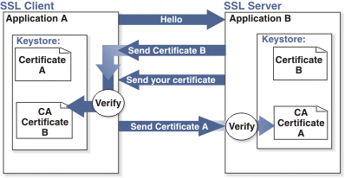

Adding 2-way SSL adds to the cost and timeline to the project as this is not part of Standard implementations.

Note: 2-way SSL is currently not available to clients on the China data-center.
- Basic Authentication
In the context of an HTTP transaction, basic access authentication is a method for a HTTP Post URL to provide a user name and password when making a request. When the user agent wants to send the server authentication credentials it will make use of the Authorization.

This username and password will be used for authentication while sending data over to the client. Upon successful validation of the credentials, we will transfer the candidate export data to the client.

Username and password be encoded in base 64 for transmission.

Note: Basic Authentication is not the same as Web service authentication (WSA). Basic authentication applies on HTTP Post URLs whereas WSA applies on web services. BrassRing infrastructure on candidate export integrations does not currently support WSA.

- API Error Messages
Below is a list of error messages that you may encounter when using the Candidate export integration. Please refer to the explanation below in order to assist you with troubleshooting.

Code | Error Description | Reasoning
401 | ValidateAccess: - Access not setup for Sender – DSDSDS | Value in the Sender tag is incorrect
401 | Credential value is invalid | Value in the Credential tag in incorrect
405 | getProfileInfo: - Inactive subscription | Value in the Manifest tag is incorrect
405 | Error While trying to post :The remote server returned an error: (405) Method Not Allowed | The customer’s HTTP URL or the web service URL is not available or not responding
405 | ***Custom error messages can be sent in the client’s Response that can be displayed to the end user | ***

NOTE: This list is not all inclusive but contains the errors that are most encountered.

