


Integration with Signal Labs Talent Assessments:
Configuration Guide
Last Updated: February 2018
The information contained in this document is the property of Signal Labs Talent Inc. Except as specifically authorized in writing by Signal Labs Talent Inc, the holder of this document shall: (1) keep all information contained herein confidential and shall protect same in whole or in part from disclosure and dissemination to all third parties and, (2) use same for operating and maintenance purposes only.

Configuration Steps

Client Settings
Workbench > Edit pencil icon (Client Settings)
Please note: Client Settings can only be enabled by Signal Labs Talent team members. Should you want any client setting enabled, please reach out to your Signal Labs Talent representative.

Enable the “IntegrationAssessment” client setting by selecting the vendor the client has chosen to integrate with.
- If Previsor is selected, the other vendor options will be disabled.
- If either Searchable KAS or 2x Assess are selected then Previsor will be disabled.
- Dual integration of Searchable KAS and 2x Assess is now supported, both vendors may be selected at the same time! If electing dual integration, the clients list of assessments will display both their Assess and Searchable KAS assessments simultaneously with an appended token indicating which vendor the assessment is associated with.

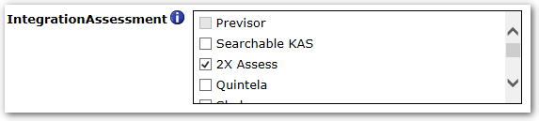

When the client setting is saved, several new items are automatically added to the client’s system:
- Custom requisition fields
- Candidate assessment results form
- Several new user type privileges
- Additional WB and BrassRing screens.

The identical additions are made, regardless of whether 2x Assess, Searchable KAS or both are selected. There will only be a single instance of forms, fields, privileges etc regardless of how many vendors are selected.

Enable the “Power user edit access” setting. This setting allows any Power Users for the client account to be able to configure Assessments in Workbench without the help of a Signal Labs Talent member. (This excludes Banding configuration. A Signal Labs Talent team member will still have to complete any banding configuration required.)


Enable the “Integration tab enabled” setting. This will cause the assessment status to be displayed in the action log.


The “IntegrationAssessment Considered for/Result” setting is normally set to Display Hyperlink if using the Signal Labs Talent assessment product.



The “IntegrationAssessment link expiration (1 – 365)” setting allows you to enter the number of days the assessment link should be actionable for the candidate. Most clients require candidates to take the assessment(s) within a certain timeframe, after which, they will be disqualified. This setting will cause the link to expire so the candidate does not have access to the assessment after the allotted timeframe. NOTE: this pertains to the BrassRing generated link only (via email or the pending assessment page), if the candidate copies/saves the link from 2xA or KAS, the expiration will not carry through.

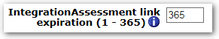

Configure Assessment Vendor
WB > Tools > Integrations > Assessments > Configure Assessment Vendor

Several pieces of information need to be entered into the Configure Assessment Vendor screen, these are detailed below. Additionally, KAS/2xA must be configured separately for the client by the respective service teams, including defining which assessments the client has contracted for.

For KAS: Please contact your client’s assessment consultant or assessment client support for the “Partner client ID” and “KAS ATS ID”. Once the Assessment Vendor has been configured, the assessment list will automatically be created via an overnight synchronization process. Assessments do not need to be manually entered, and should not be unless otherwise instructed.

For 2xA: Please contact your client’s assessment consultant or assessment client support for the “Partner client ID” and “KAS ATS ID”.
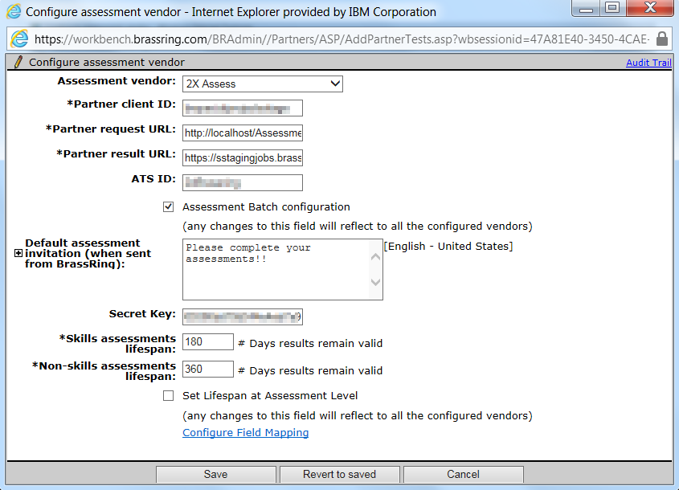

- Assessment vendor: This is a drop-down which enables toggling from one vendor configuration details to the next. Please make sure to Save prior to switching vendors!
- Partner client ID: To be provided by KAS/2xA contact. This is case sensitive!
- Partner request URL:
  - Staging: https://staging.proveit.com/KPIATS/WebServices/WebServiceKAS.asmx
  - Production*: http://www.proveit.com/KPIATS/WebServices/WebServiceKAS.asmx
* https: may also be used for production, either http or https will work
- Partner request URL:
  - All environments : http://localhost/AssessmentOrder/XmlTransformer.aspx?t=2XA

- 3rd Party Vendor Partner request URL:
  - Aon Hewitt: http://localhost/AssessmentOrder/XmlTransformer.aspx?t=Hewitt
  - Quintela Group: http://localhost/AssessmentOrder/XmlTransformer.aspx?t=Quintela
  - Shaker: http://localhost/AssessmentOrder/XmlTransformer.aspx?t=Shaker
  - APT: http://localhost/AssessmentOrder/XmlTransformer.aspx?t=APT
  - CEB/SHL-UK: http://localhost/AssessmentOrder/xmltransformer.aspx?t=CEB/SHIL
  - CEB/SHL-China: http://localhost/AssessmentOrder/xmltransformer.aspx?t=CEBSHLChina
  - People Answers: http://localhost/AssessmentOrder/xmltransformer.aspx?t=Infor-PeopleAnswers
  - BHI: http://localhost/AssessmentOrder/xmltransformer.aspx?t=BHI
  - Assess Systems: http://localhost/AssessmentOrder/xmltransformer.aspx?t=Assess-System
  - Chemistry Group: http://localhost/AssessmentOrder/xmltransformer.aspx?t=ChemistryGroup
  - Talent Plus: http://localhost/AssessmentOrder/xmltransformer.aspx?t=TalentPlus

- Available Partners can be found here: https://cdn.us.document360.io/4bb62c4c-9973-48ec-ab93-23d4b1755503/Images/Documentation/BrassRing_Platform_Common_Services_V.pdf

- KAS Partner results URL:
- Staging : https://staging.brassring.com/HRISprocessor9/MsgDispatchService.asmx
- Production: https://trm.brassring.com/HRISprocessor9/MsgDispatchService.asmx

- Assess and 3rd Party Vendor results URL:
  - US-staging: https://sstagingjobs.brassring.com/AssessmentOrder/XmlTransformer.aspx?t=2XACB
  - US-production: https://sjobs.brassring.com/AssessmentOrder/xmltransformer.aspx?t=2XACB
  - EU-staging: https://stagingkrb-jobs.brassring.com/AssessmentOrder/XmlTransformer.aspx?t=2XACB
  - EU-production: https://krb-jobs.brassring.com/AssessmentOrder/XmlTransformer.aspx?t=2XACB

- ATS ID: To be provided by KAS/2xA contact. The default for KAS is “KRB2” when no custom KAS code is required. The default for 2xA is “2xBrassring”. ATS ID for all 3rd party vendors should be “BrassRing” by default.
- Assessment Batch configuration: To create assessment batches, this must be checked. If enabled for one vendor it will automatically persist for all vendors. Assessment batches are used when complex delivery rules are required, as discussed below. Once checked, additional custom Req fields, configuration options and user privileges are available.
- Default Assessment Invitation Text: Text entered here is used to pre-populate emails sent via Run/Retake Assessment.
- Skills Assessment Lifespan: The value entered here determines how long a Skills assessment results are valid for. If the results on file for a candidate exceed the assessment’s lifespan, the candidate will be asked to complete a fresh test the next time the assessment is requested of them.
- Behavioral Assessment Lifespan: The value entered here determines how long Behavioral assessment results are valid for. If the results on file for a candidate exceed the assessments lifespan, the candidate will be asked to complete a fresh test the next time the assessment is requested of them.
- Set Lifespan at Assessment Level: Check this box if the client requires lifespan to be defined at the assessment level. This also enables functionality to have lifespan based on the candidate’s assessment score: for example, if a candidate passes an assessment, they will not be required to take it again for 2 years, if they fail, they’ll be able to try again in 6 months. Best practice is to work with the assessment consultant to determine whether this functionality is required. If enabled for one vendor, this will persist for all other vendors.
- Configure Field Mapping: EEO data will be sent to KAS if mapping is completed. This is not required for Assess. Clicking this link will open the following window. Select the appropriate candidate form for each of the demographic items and map the options to each of the fields. Custom fields may also be configured for KAS, please work with the KAS team if there is a need to send custom fields.
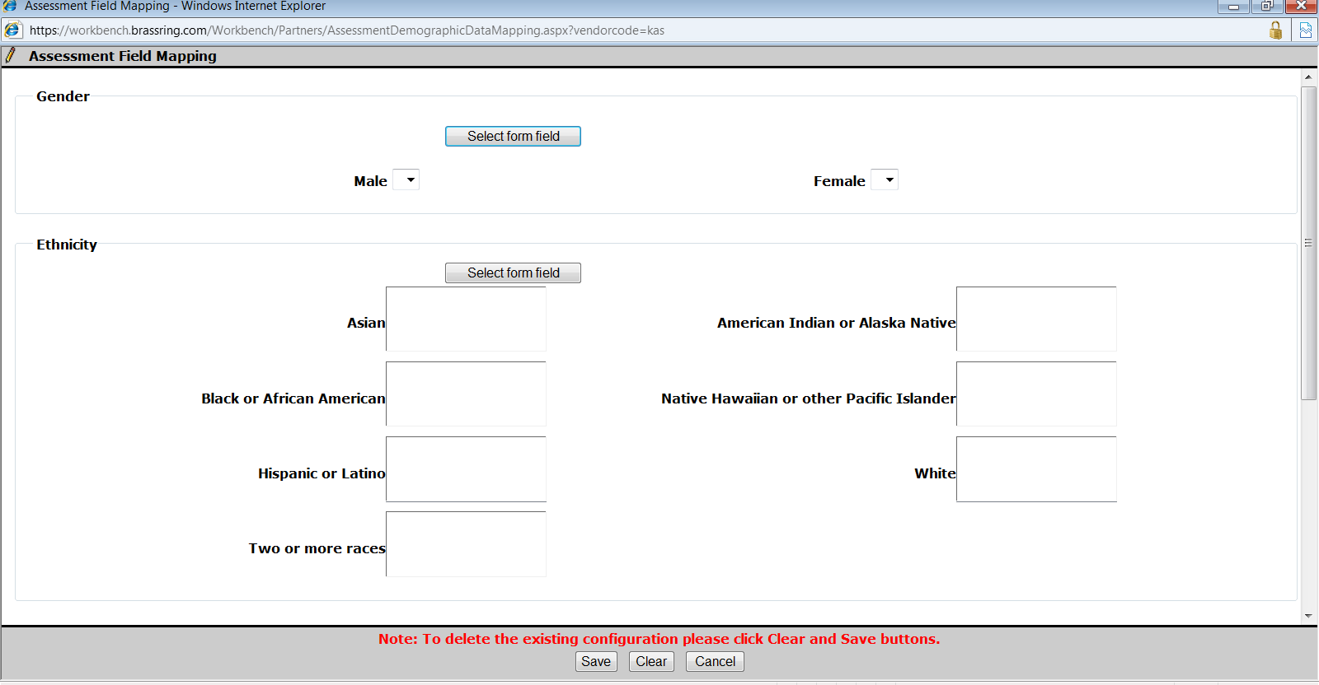
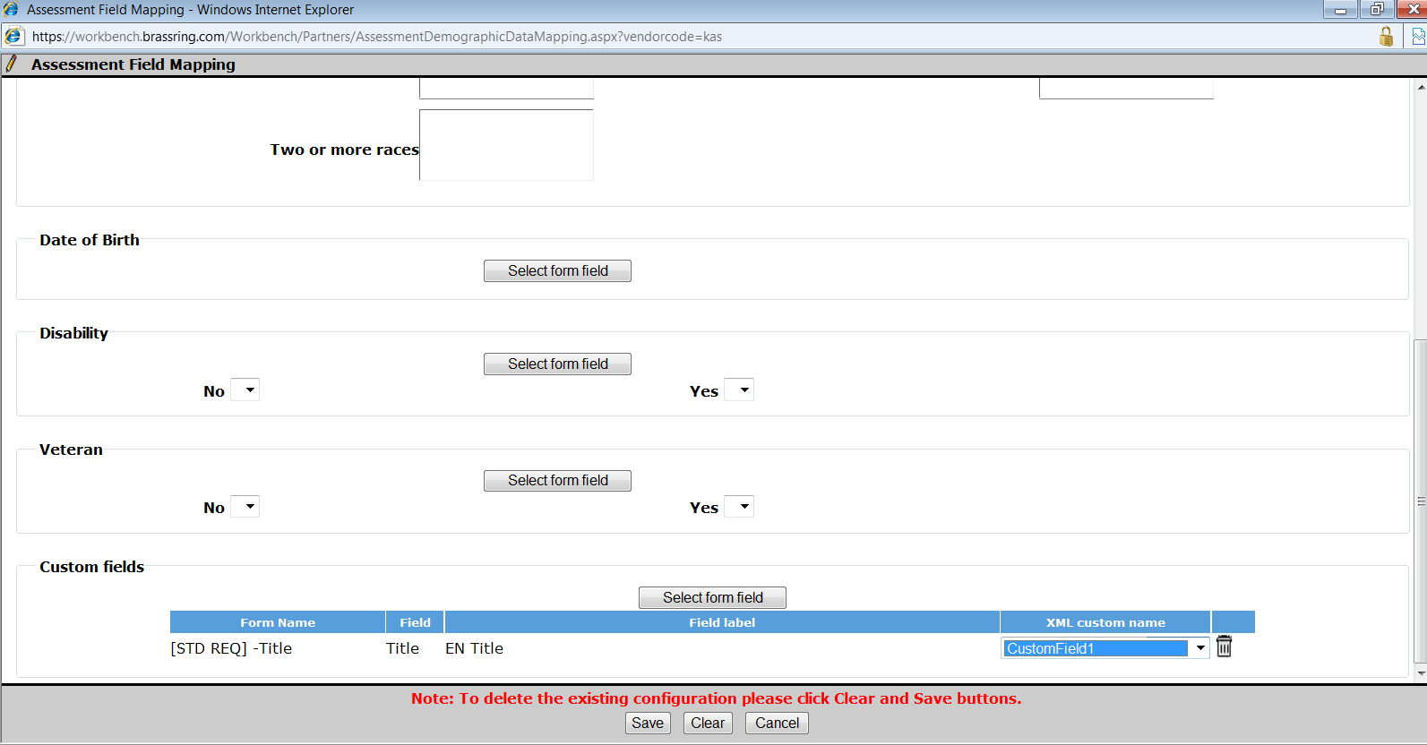

Configure Assessment Vendor
Path: WB > Tools > Integrations > Default Banding Configuration

Clients can configure up to 10 distinct bands to help sort/sift candidates based on assessment results. Banding is not in effect until minimum and maximum scores have been defined for each assessment or assessment batch. Setting the defaults ensures consistency and expedites configuration at the assessment/assessment batch level. This is optional based on client requirements.

Once the default bands are configured, they will automatically pre-populate the banding detail when configuring specific Assessments and Assessment Batches. This significantly speeds up configuration and ensures consistency. The default bands include only the color and custom text to be displayed for the assessment results; the Min/Max required for each band requires an additional step, configured either per assessment or per assessment batch.

Please note: Banding configuration must be completed by a Signal Labs Talent team member.

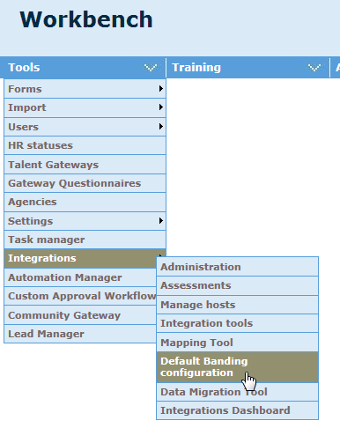

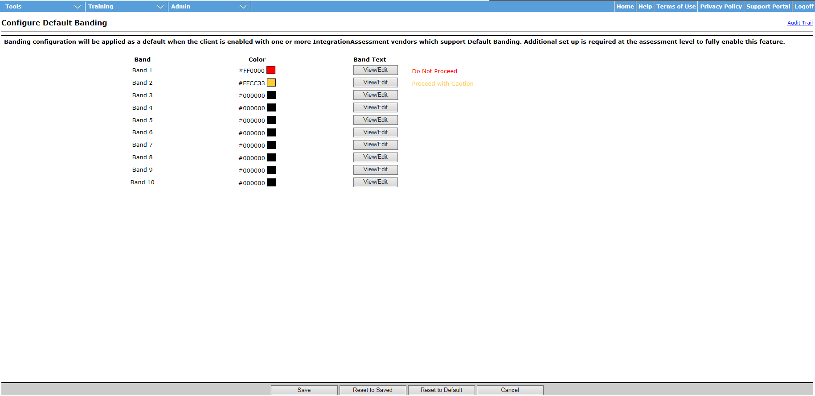

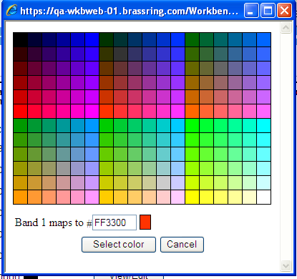

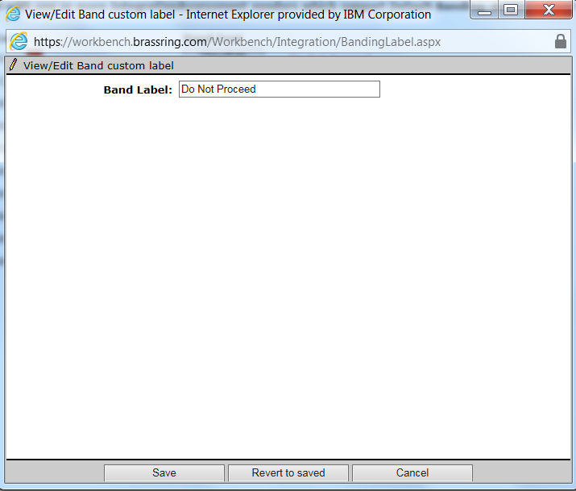

Configure Assessment Banding
WB > Tools > Integrations > Assessments > Select Assessment > Configure Banding

This step defines the minimum/maximum thresholds for individual assessments. The text defined here is what will show on the “KAS Assessment” candidate form and can be made outputable to display on the candidate grid so that users may quickly determine whether a candidate passed the assessment. You can bypass this step if using batches. However, if an assessment will be included in multiple batches, it streamlines the configuration process to have defaults set up at the assessment level.

Please note: Banding configuration must be completed by a Signal Labs Talent team member.

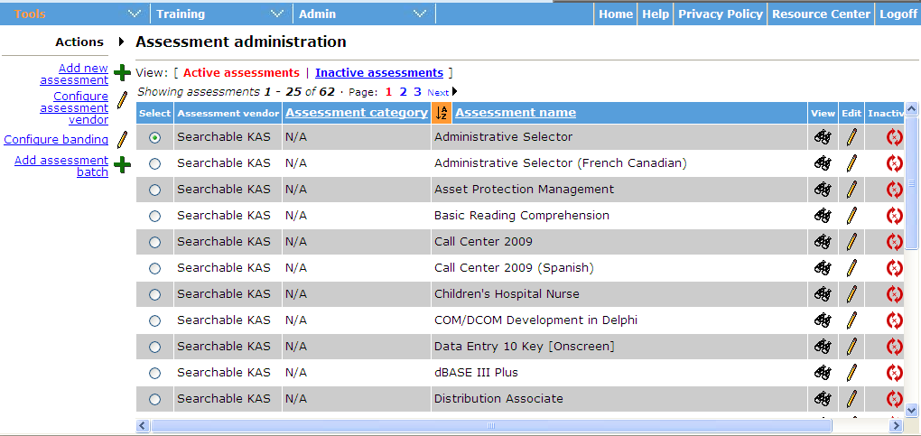

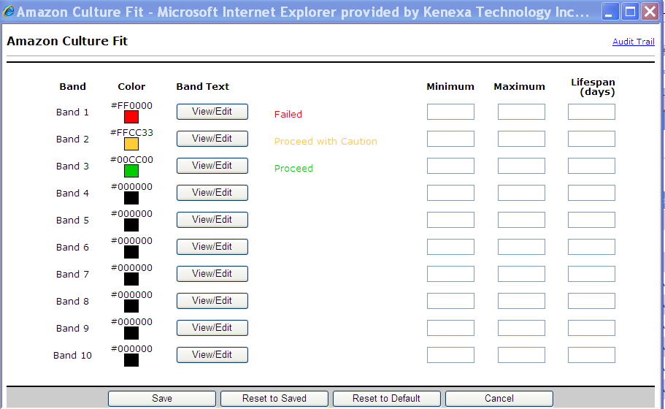

The default text and color are pre-populated based on the default banding definition; this eases configuration and ensures consistency. The text and color can also be modified per assessment. The minimum/maximum thresholds cannot overlap or candidates would meet both band criteria. The minimum/maximum score is based on the numeric value in the Result field on KAS Results form. For example, if the form displays 72%tile, then 72 would be used to determine which band the candidate falls within. Bands should be ordered from lowest score to highest, in other words, begin Band 1 min score with 0.

Assessment Batches

WB > Tools > Integrations > Assessments > Add assessment batch

Assessment batches are used when complex rules are required. A batch can contain multiple assessments; each requisition can have up to 6 batches attached. Each batch on the requisition can have a unique delivery method, for example: Batch1 is taken by the candidate as part of the application process; Batch2 is later automatically sent when the candidate is moved into a specific HR status. Another example is that Batch1 is used for Internal candidates and Batch2 is used for External candidates when different assessments are required for these groups. Each of the batch elements is described below. Batches can also be sent to candidates manually.

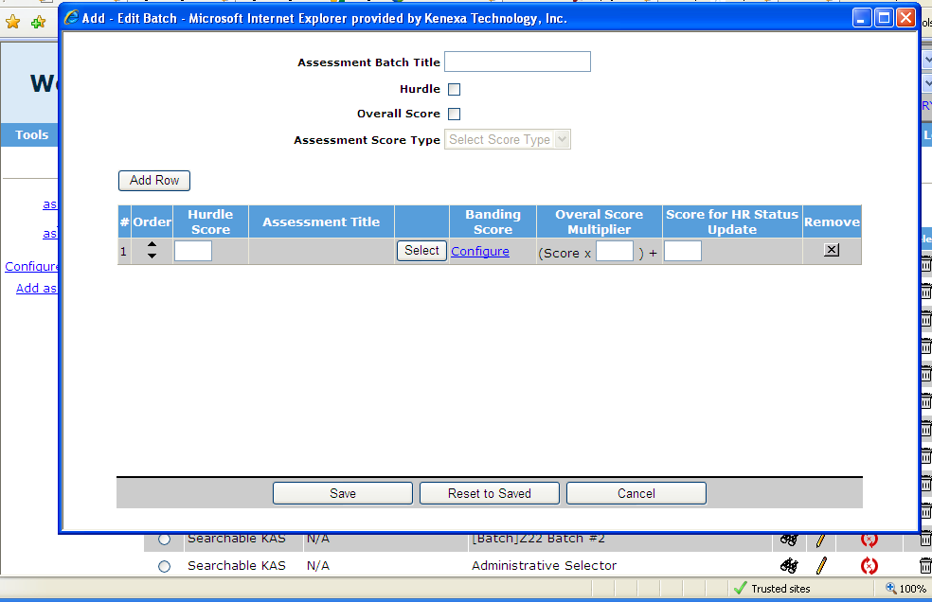

- Assessment Batch Title: Assessment Batch Title is the name displayed in the UI to identify the batch. Areas it will be displayed include: on the Req if fields-Batch 1 through Batch 6 are attached to the Req; when selecting a batch per TG on the posting page; on the candidate’s Integration tab; and in the Req folder grid.

- Hurdle: Checking this box enables the Hurdle Score column. Use this feature if you want to set a threshold score the candidate must pass in order to proceed to the next assessment in the batch. Note: batched assessments will be given consecutively within one assessment session. Candidates who meet or exceed the threshold are presented with the next assessment during the same browser session.

- Overall Score: Check this box to calculate an overall score for the batch. The client’s KAS consultant must determine whether this feature is appropriate for the client. Not all types of assessments can be included in this calculation. Note: this is rarely used!

- Overall Score Band: This functions like the assessment band but displays custom text/color results based on the candidate’s overall score for the batch.

- Assessment Score Type: This field becomes active when the Overall Score checkbox is checked. Use this field to select the type of score to be used for the overall score calculation. Please note: not all assessments will have a value for each of these scores; it is important to work with the assessment consultant to determine which score type is valid for the assessments used in the batch. Score types available are: T-score, Z-score or Raw score.

- #/Order: The # column displays the order in which the assessments will be given. With the batch configuration, candidates are no longer able to choose in which order to take assessments when multiple assessments are required. This is now determined by the batch. Use the Order arrows to modify the sequence of the assessments.

- Hurdle Score: Enter the numeric value that the candidate must meet or exceed in order to proceed to the next assessment in the sequence. The score is based on the numeric value in the Result field on the KAS Result form, for example if the field value is 76%tile, the hurdle would be calculated using 76.

- Assessment Title: This displays the name of the assessment selected.

- Banding Score: Each assessment selected for the batch has its own banding configuration. By default, the banding set for the assessment in WB>Tools>Assessment>Configure Banding is automatically populated in the batch. If desired; you can modify the banding just for the batch.

- Overall Score Multiplier: This field defines how the overall score should be calculated. Each assessment’s score is multiplied by the amount entered in this column; then each of these totals is added together for the cumulative total or overall score. The overall score can be banded in the same manner the individual assessments can be. The client’s KAS consultant determines what these values should be. The field is not required, so can be left blank.

- Score for HR Status Update: The Score for HR Status Update determines whether the candidate passes the individual assessment. If successful on ALL assessments in the batch, then they will pass the batch, if they fail at least one assessment, then they will fail the batch. A numeric value is entered in the field for each required assessment, if the candidate meets or exceeds every assessment’s score then the “Update HR Status” field on the Overall Form displays “Yes”, if they fail the field displays “No”. Coupled with this, a RAM trigger must be built to update the candidate’s status.

- Batch Exemption: This optional feature can be used when certain candidates should be exempt from taking assessments. Typically, this would be internal candidates that have already proved themselves capable of the job, such as a Cashier that is making a job change from one store location to another. When the selected candidate form field matches the data in the requisition form field (screen 2 below), then the candidate will be exempt from the assessment.

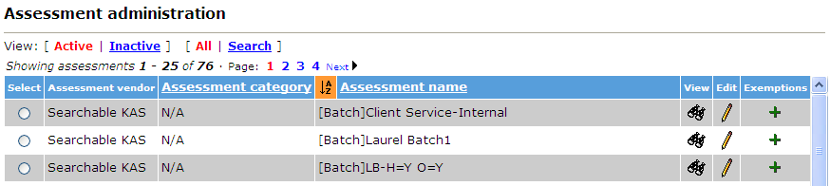

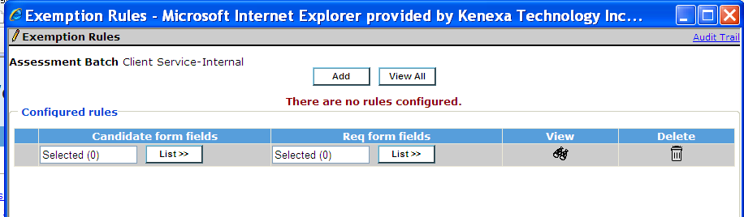

Custom Req Fields
WB > Tools > Forms > Reqs > Req Forms

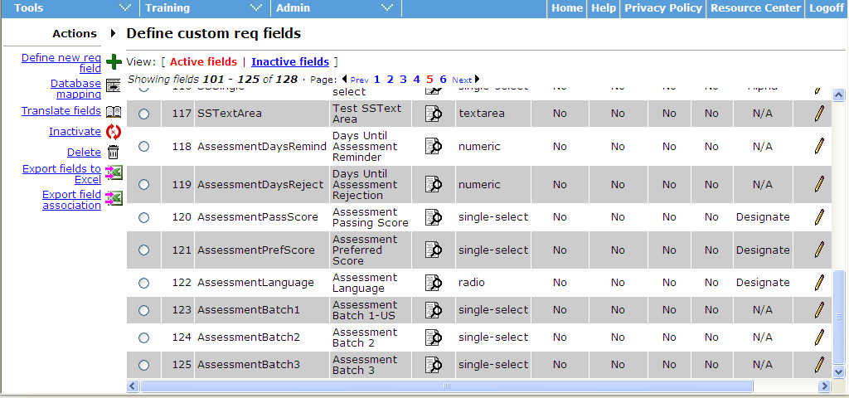

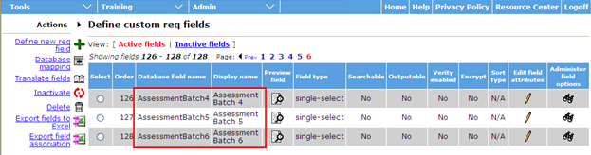
- AttachAssessments: this field displays all client assessments. It is best suited for environments without complex rules, ideally when only a single assessment is required for a req and all candidates, both internal and external, are required to take the assessment.

- AssessmentLanguage: this field determines whether the candidate must take the assessment in the locale of the gateway they’ve applied to (when the assessment is available in that locale) or if they will have the option to select the language of their choice. When the field is not present on the req, the system defaults to allowing the candidate to select to take the assessment in the language of their choice. As part of this functionality, only English titles for assessments will be displayed in BrassRing and attached to the requisition. KAS will determine which version of assessment will be given to the candidate, based on the req setting.

- AssessmentPassScore (used only with AttachAssessments): this field is used in tandem with the AttachAssessments field and Automation Manager Assessment trigger “Scoring Results.”. This is best when only one assessment is required for the req, or, if multiple assessments are required, they share a similar cut score. *This functionality has been largely replaced with RAM; therefore, it is recommended that this field not be used unless requisitions will only have a single assessment required.

- AssessmentPreferScore (used only with AttachAssessments): same as above but candidate can be updated to a unique HR status based on having a preferred score rather than a passing score. *This functionality has been largely replaced with RAM; therefore, it is recommended that this field not be used unless requisitions will only have a single assessment required.

- AssessmentDaysRemind : this is available for both AttachAssessments and for Batches, and is used with Automation Manager – Assessments-> Reminder Email. Candidates who have not completed ALL required assessments in the #days set per Req are sent a reminder email.

- AssessmentDaysReject: same as above. In this case the candidate is automatically updated to a new (rejection) HR status if they do not complete all their assessments within the designated timeframe.

- AssessmentBatch1-6 (only if enabled for batches): up to 6 distinct batches can be attached to an individual requisition. This provides flexibility around launch methods. For example: Batch 1 may be the set of assessments required for external candidates when they apply on the TG, Batch 2 may be a different set that is required for internal candidates, Batch 3 may be for all candidates that move into a certain HR status. Best Practices: Determine each batch’s launch method/purpose and rename the field accordingly so the end user can easily identify which candidates will be taking the assessments and when. For example, instead of “AssessmentBatch1”, rename to “TG Assessments – Internal”. (Note: if the label is changed, it will change on the TG settings “default assessment” too.)

Add custom req fields to the appropriate req templates. Tools > Forms > Reqs > Req forms > Administer Req fields (for the req template you would like to add the fields to) > Select Req fields
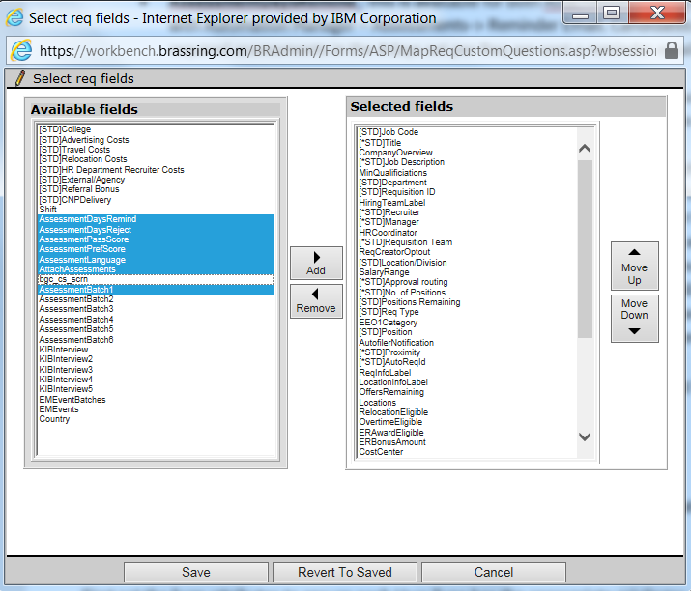

Configure Candidate Forms
WB > Tools > Forms > Candidate Forms

Two candidate forms are created for Searchable KAS; both are multiple/req/candidate.
- KAS Assessment
- KAS Overall Results (only used if batches are enabled)

First set the form attributes to ensure each User Type has the appropriate privileges. Note that many of the attributes are system defined and are not modifiable.

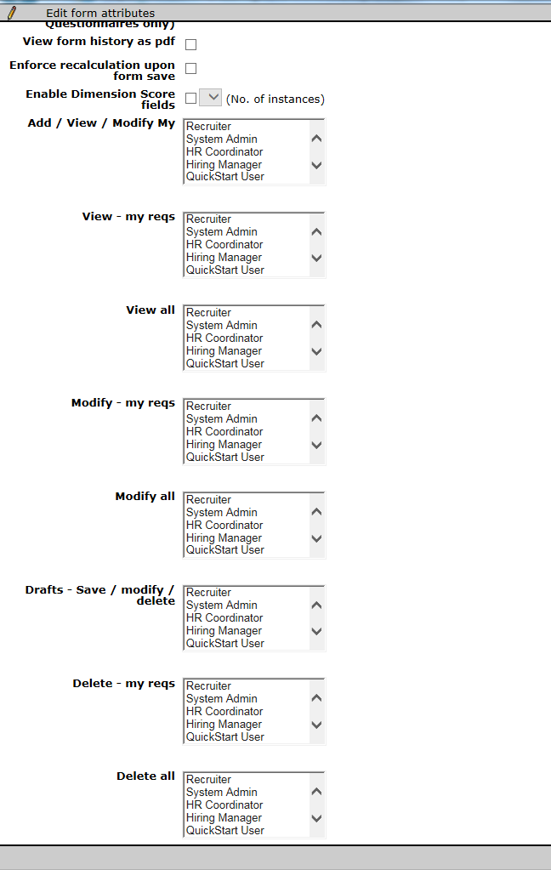

Next determine which fields need to be visible to each User Type and update those that will appear in the Req grid to be outputable. You can modify the field name to better suit the client’s environment.

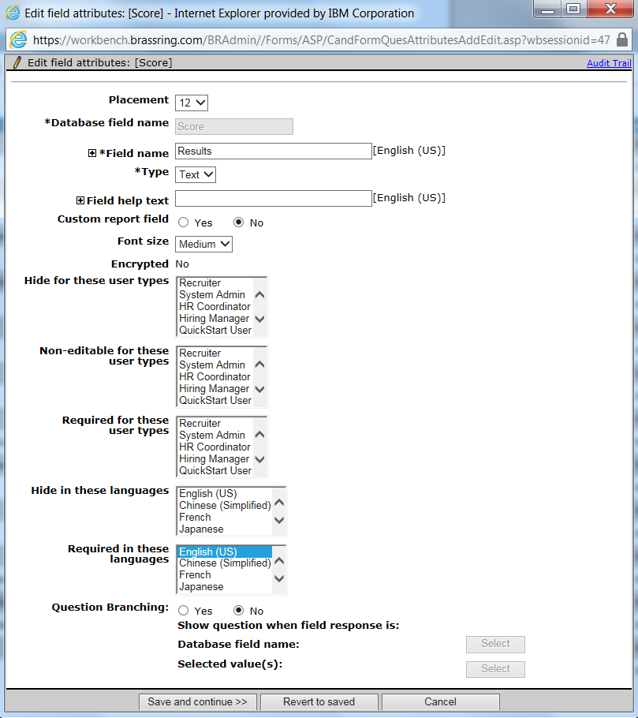

Fields available on KAS Assessment:
- Last Name
- First Name
- Requisition ID
- Assessment Batch Name – may be helpful if using batches, more likely will view this directly on form or in integration tab
- Assessment Code/ID – typically not meaningful to the 2xB user. It supports only alphanumeric characters. It can include 1 dot (.) in the string.
- Assessment Name – Yes, and it should be outputable if displaying results in grid. Supports alphanumeric and few special characters. Can contain only Latin-1 characters without embedded HTML tags
- AssessmentAdmin/RecruiterEmail
- Date of Assessment
- Elapsed Time
- Questions Correct – may be desired, more likely the “Results” or “KRB Band” field will be displayed
- Reporting Band – used for reporting, this contains the same custom banding text as “KRB Band” but is only in black/white so html tags are not included
- KRB Band – if configured for banding, this should be outputable
- Results – many clients will use this, many are switching to just displaying the band
- Link to Assessment Summary Page – desired by many clients
- Numeric Results – mainly used for behind the scenes purposes
- T Score – rarely used but some clients will want
- Z Score – rarely used but some clients will want
- Raw Score – rarely used but some clients will want
- Link to Assessment Report 2 – only for custom reports
- Link to Assessment Report 3 – only for custom reports

Fields available on KAS Overall Results:
- Date Created
- Candidate Last Name
- Candidate First Name
- Assessment Batch Name – yes, this is needed to identify the batch
- Batch Band UI – this will only be populated when using the Overall Score feature, this text will appear in color on the UI if configured to do so
- Batch Band reporting – this is for reporting purposes; it does not need to be displayed on the grid. This will have the same text as the Batch Band UI but will not have color. This field can be used with Automation Manager “RAM” triggers to automatically update the candidate’s HR status
- Batch Score – this will display the system calculated overall score, some clients may desire this
- HR Status Update – This field will display “Yes” if the candidate gets a passing score for all tests in the batch; a “No” if any test is not passed. It may be helpful to rename this field to something more intuitive such as “Assessments Passed”. This field can be used with Automation Manager “RAM” triggers to automatically update the candidate’s HR status.

User Type Privileges
WB > Tools > Users > User types > Edit type permissions > Integration

Seven privileges are available to be enabled per user type.

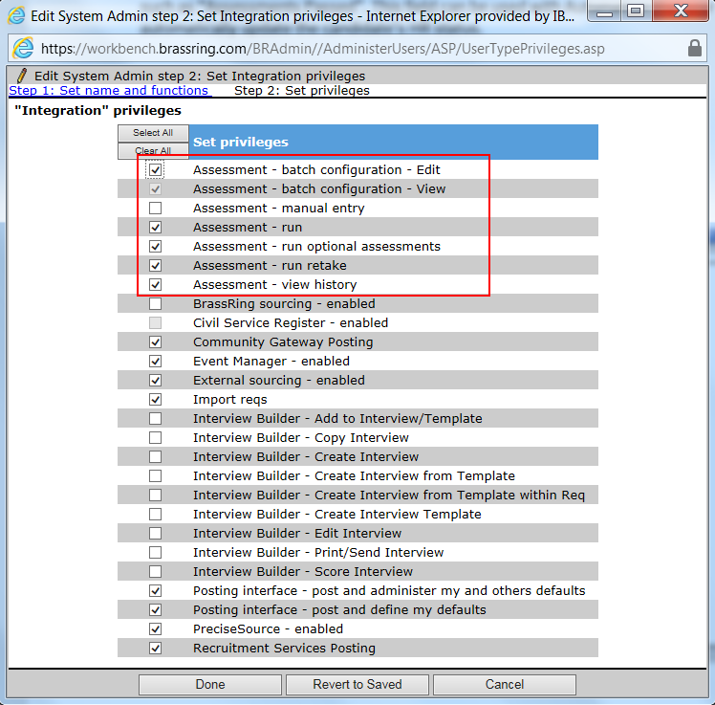

WB > Tools > Users > User types > Edit type permissions > Talent Gateway
One Talent Gateway privilege is available if the client is enabled for batches.

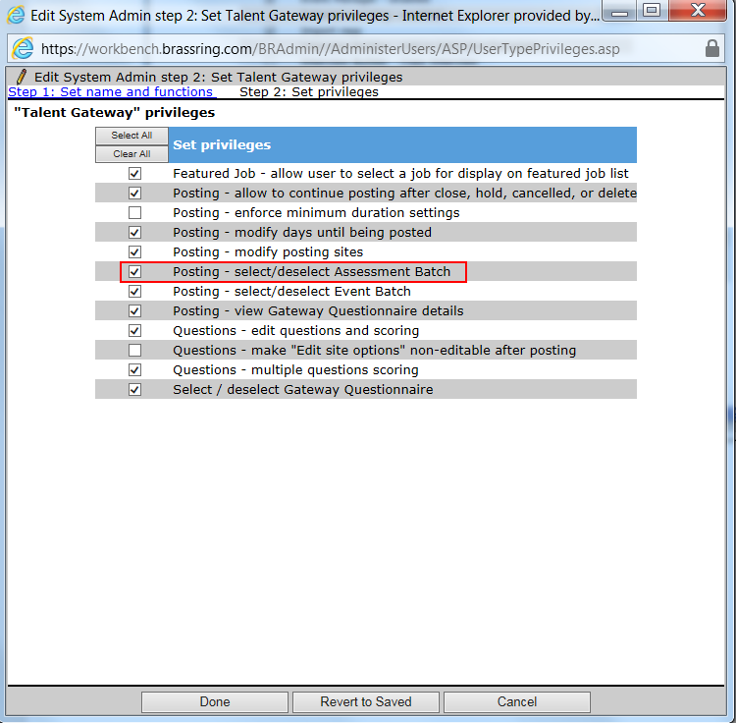

The eight privileges are as follows:
- Assessment - batch configuration – edit: Ability to edit the batch on the requisition (provides means to change cut scores only)
- Assessment - batch configuration – view: Ability to view the assessment batch configuration on the requisition
- Assessment – manual entry: This privilege enables the user to manually enter the assessment responses in the event the candidate completed a paper-based assessment. (This was created for a very specific client and should NOT be enabled as a general rule)
- Assessment – run: This privilege enables the user to manually run any assessment assigned to the apply requisition
- Assessment – run optional assessments: This privilege enables the user to manually run any assessment that is not assigned to the requisition
- Assessment – run retake: This privilege enables the user to manually run a previously completed assessment for a candidate to enable to candidate to retake the assessment. Note: Retake is not currently available with the 2xAssess integration; it will be fully supported in April 2013. Clients needing to provide retake functionality to candidates prior to this should submit a work ticket requesting the retake. Include the following details: Client, Environment, Candidate Name, BRUID, Assessment Name, ReqID
- Assessment – view history: This privilege enables the user to view the status history of assessments on the Talent record action log
- Posting – select/deselect Assessment Batch: This privilege enables the user to select which batch should be used for a specific Talent Gateway, note: only assessment batches selected for the requisition will be options presented on the posting page.

Talent Gateway Settings
WB > Tools > Talent Gateways > Edit
Several options are available on the TG Admin page:
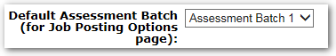

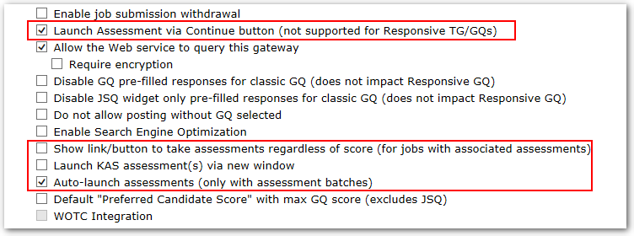

- Default Assessment Batch: this will cause the batch selected for this field on the requisition to serve as the default batch on the posting page. For example, if “Store Manager” batch is selected on the requisition for the AssessmentBatch1 field, and the TG is using AssessmentBatch1 as the default, then “Store Manager” will be defaulted on the posting page.

- Launch assessment via continue button (not supported for Responsive TG/GQs): enable this feature to take the candidate to the TG Assessment page via the continue button rather than displaying a link on the confirmation page. Prior to R12.3 B3, this was only available for single job applies. With the addition of the TG Assessment page, this can be used for multiple job applies (for Classic TGs/GQs only).

- Show link/button to take assessments regardless of score (for jobs with associated assessments): with this setting, candidates always take assessments, regardless of TG/GQ score. It removes the need to have scored questions and to designate a minimum score to administer assessments on the posting page.

- Launch assessment(s) via new window: for clients who host the Talent Gateway within an iFrame on their web site, there could be usability issues with assessments if they do not allocate enough space for the TG. In this case, if the space allocation cannot be increased and assessments are displaying scrollbars, it’s recommended that this option be checked so that assessments will launch via a new window and display properly. Note: this setting is ignored for Assess. Assess assessments will always launch in a new window for technical reasons, regardless of whether or not this setting is enabled.

- Auto-launch assessments (only with assessment batches): when using batches, this option will cause assessments to roll from one to the next rather than the candidate needing to click a fresh link to launch the next assessment required in the batch. It is Best Practice to always enable this feature.

Talent Gateway Text Customizations
WB > Tools > Talent Gateways > Text Customizations

- Landing Logged In tab

- The Assessment page link text and Assessment page summary text settings are only respected on Classic Talent Gateways. The Default site for assessment access for non-logged in profiles with matching locale setting is respected on both Classic and Responsive Talent Gateways.
- Configure the text for the link to the assessment page and the descriptive text provided for the link. Each locale must have a default TG set, in the event a candidate without a TG profile needs to access an assessment page. NOTE: This is true even if assessments will not be given as part of the application process. Since all assessments are delivered via the new TG Assessment page, the system must know which TG to route a candidate through.

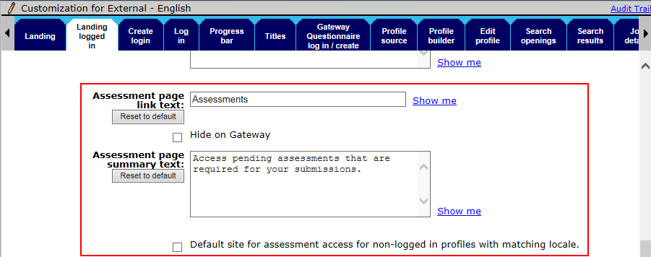

- Notifications tab
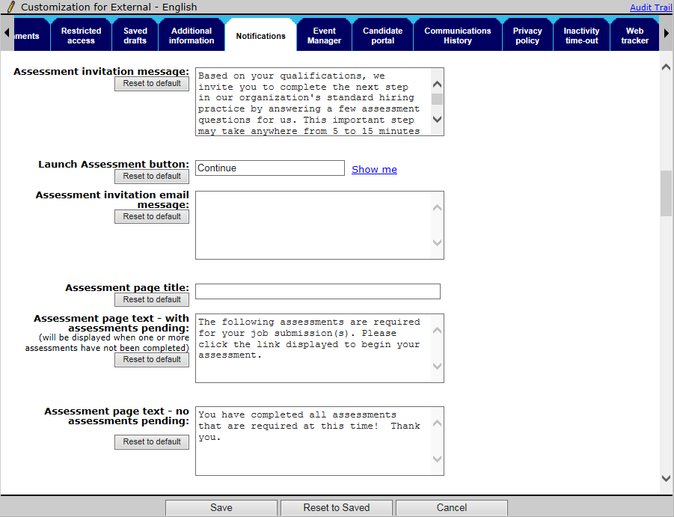

  - Assessment invitation message: this is the text that appears on the confirmation page when the candidate is required to take an assessment. Note: (for classic TGs only) if the assessment link needs to be displayed on the confirmation page, rather than launching via the continue button, the following must be added where the link should appear: “[URL]”

  - Launch Assessment button: (Only respected on Classic Talent Gateways) this field can be used to add custom text to the button on the confirmation screen; this can help make it clear to the candidate that they have not truly completed their application process yet.

  - Assessment invitation email message: create text here if candidates should receive email invitations in addition to having the assessment provided via the TG. If there is no message entered an email will not be sent.

  - Assessment page title: (Only respected on Classic Talent Gateways) this will replace the default ‘Pending Assessments” page title

  - Assessment page text - with assessments pending: (Only respected on Classic Talent Gateways) this is the instruction text that displays on the TG-Assessment page. Candidates see the outstanding assessments for all requisitions they have applied to on this page. This text displays when there are outstanding assessments

  - Assessment page text – no assessments pending: (Only respected on Classic Talent Gateways) this is the same as above but displays when no assessments are required.

Classic Gateway Questionnaires
WB > Tools > Gateway Questionnaires

You must add the assessment token to the confirmation page of the GQ in order for assessment invitation text to be displayed to the candidate. If the “Show link/button to take assessments regardless of score (for jobs with associated assessments)” TG Admin setting is not turned on, then the GQ needs at least one scored question, and the minimum score to launch assessments must be entered on the site questions page. If the “Launch assessment via continue button (not supported for Responsive TG/GQs)” setting is not enabled then the token = “[URL]” must be included in the invitation text in order to present the assessment link.

Insert text widget on confirmation page. Click Insert variable and select Assessment.

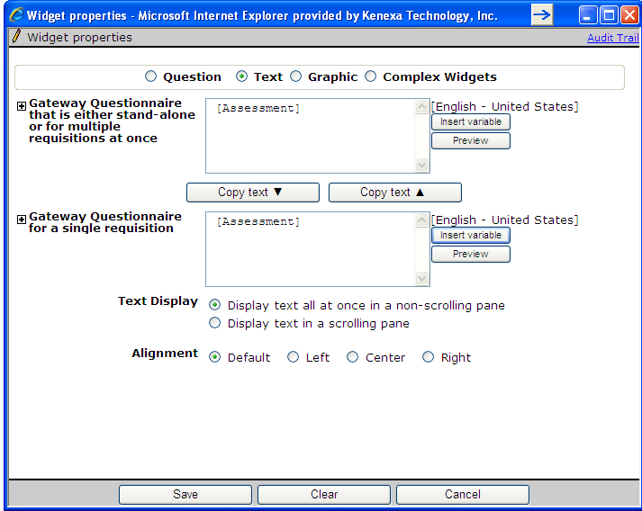

Rules Automation Manager Triggers
WB > Tools > Automation Manager > Admin

There are several triggers that can be set up for assessments through Rules Automation Manager (RAM). Automation Manager can no longer be used to create assessment triggers.

- Invite candidate to take assessment when they reach a designated HR status
- Send candidate an assessment reminder email if they have not completed ALL assessment within a specified amount of time.
- Automatically update a candidate’s HR status if they have not completed all assessments within a specified amount of time.
- Update HR status based on assessment result
- Update HR status based on batch assessment results
- Copy existing, valid, assessment results into requisitions

Send Assessment Invitation

The below RAM trigger is an example of a simple trigger that sends an invitation to take an assessment to the candidate when they hit a designated HR Status. Additional conditions can be added to limit the candidate pool that is invited to take the assessment. This method is typically used when assessments are not initiated at the time of job submission, but rather later on in the recruitment process.
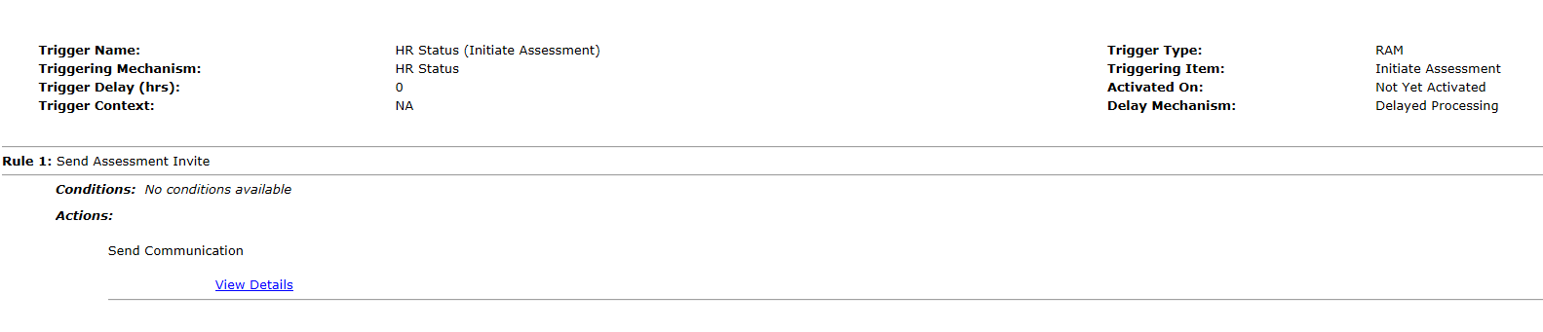

The following tokens can be added to communication templates depending on what URL you would like to include in the email.
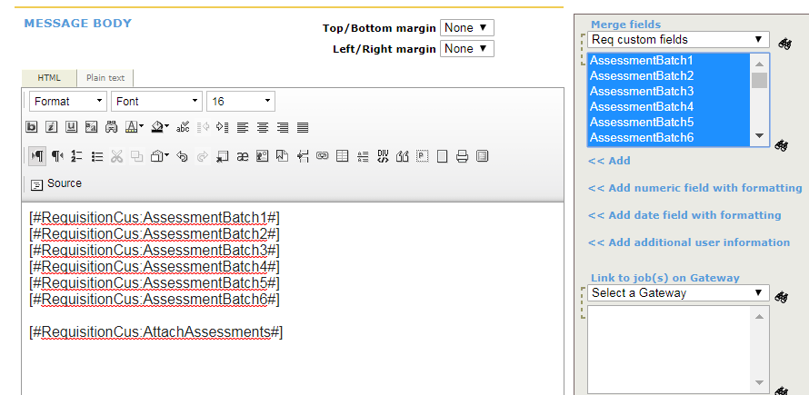

Send Assessment Reminder

The below RAM trigger is an example of a simple trigger that sends an assessment reminder if the candidate hasn’t taken the assessment within 72 hours of the assessment being initiated. Additional conditions and/or actions can be added to limit the candidate pool or to update the candidate’s status if they failed to take the assessment in this timeframe.

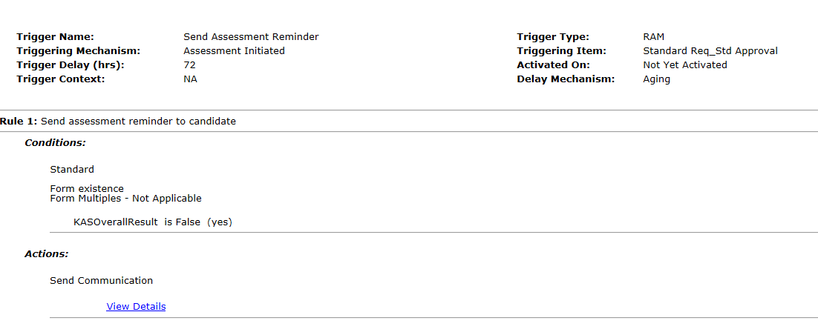

Update HR Status for Failure to Complete Assessments

The below RAM trigger is an example of a simple trigger that updates the candidate’s HR status if they have not taken the assessment within the defined period of time. Additional conditions and/or actions can be added to limit the candidate pool that this occurs for or additional actions that can take place.

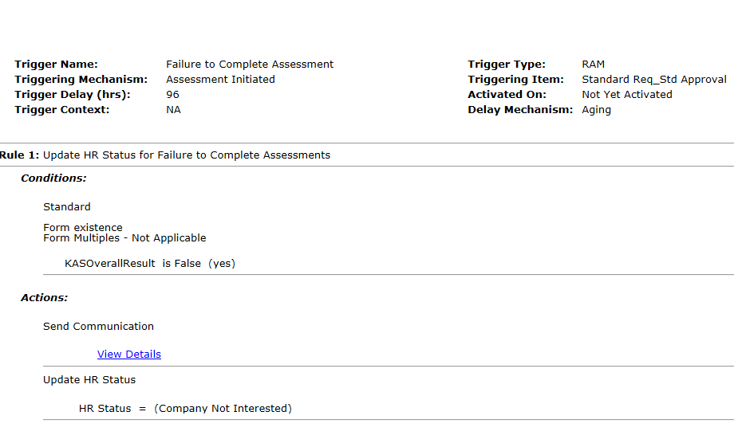

Copy Assessment Results When Submitted to Req

There are a variety of scenarios that this RAM trigger will assist with. The system will search for any assessments that are required for the receiving requisition and copy them, saving the recruiter the extra step of sending an assessment request:
- Candidate Search > File to Req:
- Req Folder > Move/Copy
- Application flow where assessments are not requested at the time of applying, but it’s desired to view existing results within the receiving req; should they exist.
- RAM > Move/Copy candidate
- Candidate Import

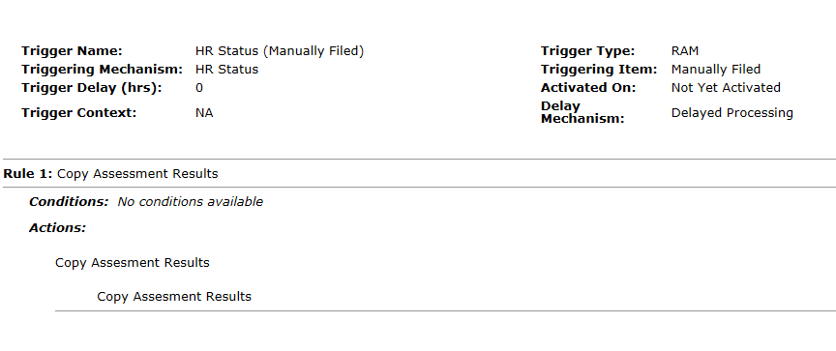

BrassRing User Experience

Creating and Posting a Req
Based on the client’s configuration, the following fields may be displayed on the Req for selection. These fields can be pre-set through Job Code Default Data or Req Import. Req Field Association (RFA) also supports the Attach Assessment field and the Assessment Batch 1-6 fields.

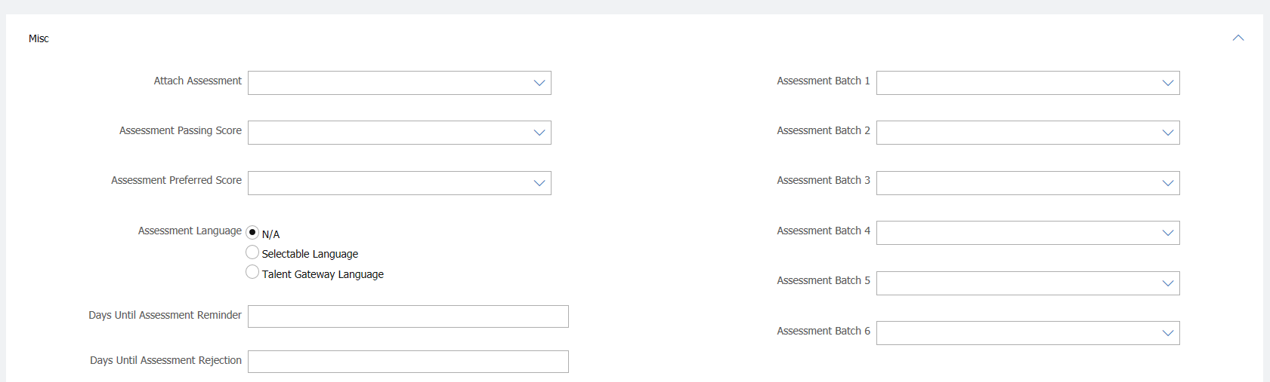

Posting Page (Batches Only)
When posting a requisition, the user can select the batch to be presented on each of the gateways the Req is posted to. This provides flexibility to accommodate unique requirements for internal versus external candidates.

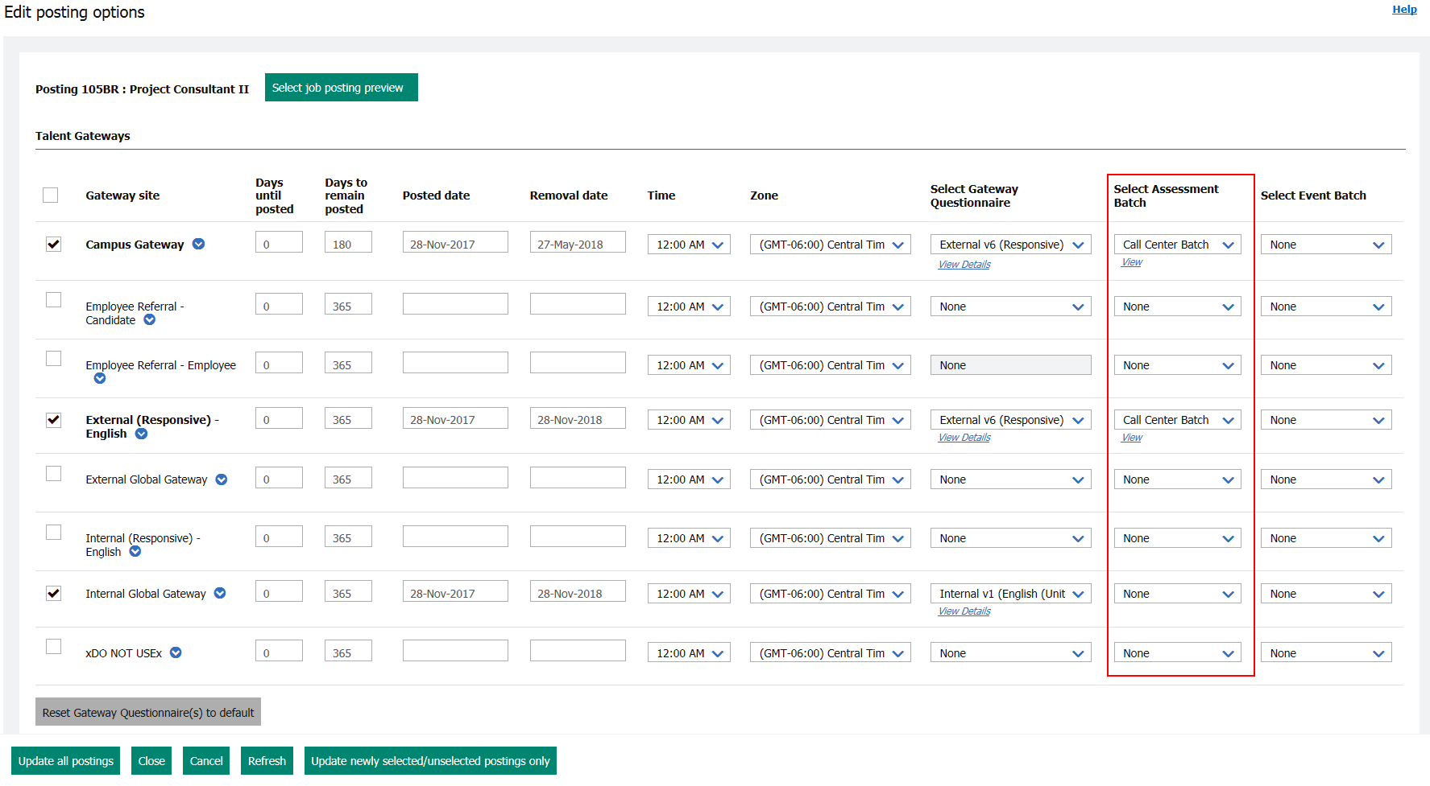

The batch can be pre-selected on the posting page based on the “Default Assessment Batch” TG setting noted in the Configuration Steps: Talent Gateway Settings section. If this TG field is populated, then, the requisition specific batch for the field noted will pre-populated on the posting page.

- Edit Site Questions
When a “Minimum score to administer assessment” is populated, then the TG/GQ must have at least one scored question. If the “Minimum score to administer assessment” is left at zero and the “Show link/button to take assessments regardless of score (for jobs with associated assessments)” TG setting is NOT enabled, assessments will not launch.

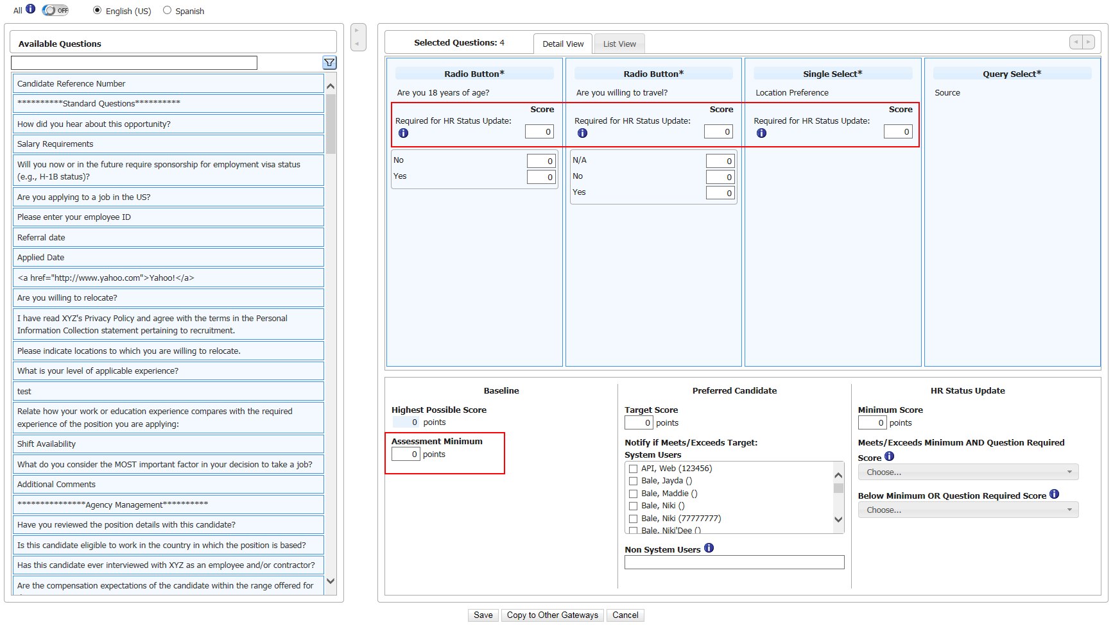

Run Assessment in BrassRing
For scenarios where the assessment is NOT configured to launch at the time of application, privileged BrassRing users can use the Run Assessment action to send an assessment to a candidate

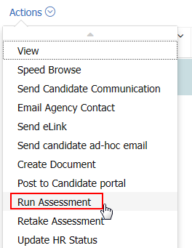

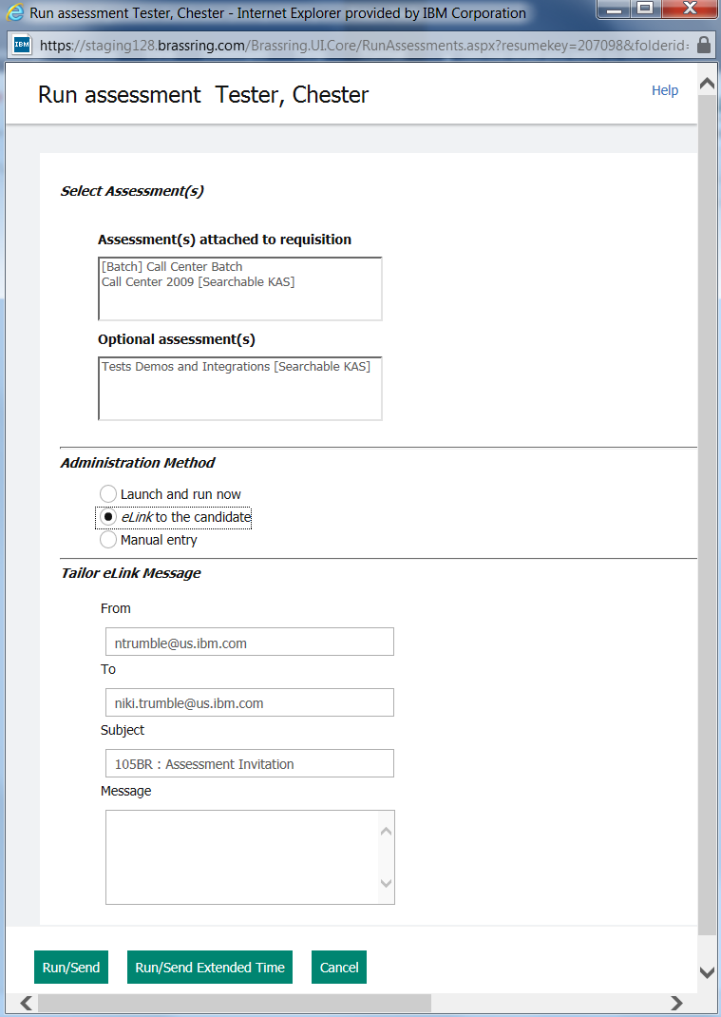

Retake Assessment
Retake Assessment functionality should be reserved for system administrators. This functions similarly to Run Assessment, however, only assessments that have previously been taken with results on file in BrassRing will be available for selection. Assessments that have been partially completed will not be available to select from.
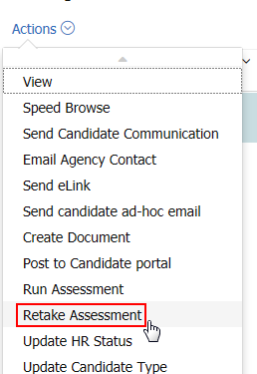

Assessment – View History
Assessment status can be seen on the Talent Record action log. Clients that prevent their users from viewing the actual assessment score (displaying instead only the Banding information), must remove the user’s privilege to view history. These users will still have access to see that the assessment form has been added, which is the indicator that the assessment is complete.

